Name ___________________________

Chapter 2: Age of Exploration Test
6.1.8.B.1.b, 6.1.8.C.1.a, 6.1.8.C.1.b, 6.1.8.D.1.b, 6.1.8.D.1.bc

Use the following words to complete the sentences below: (2 points each)

merchant colony empire plantation navigation

1. A ____________________ is a settlement or area under the control of another country.
2. A large farm on which a single crop is usually grown is called a ________________.
3. A ______________________ is person who buys and sells goods for profit.
4. An __________________________ is a large group of states or countries.
5. The process of planning a route and finding one’s location is called ________________.
6. Define the slave trade. (2 points) __________________________________________________________________________
__________________________________________________________________________
__________________________________________________________________________.

7.How was navigational technology helpful to explorers? (5 points)
___________________________________________________________________________
___________________________________________________________________________
___________________________________________________________________________
___________________________________________________________________________.
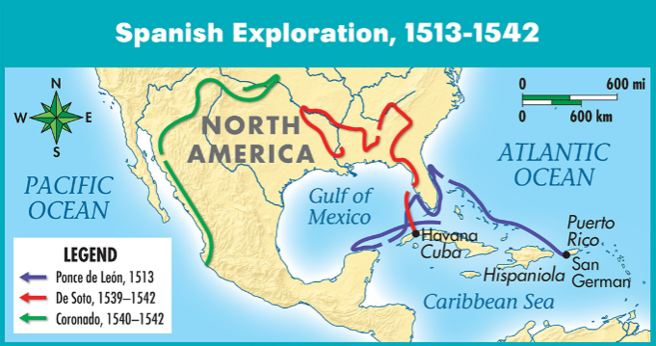
8.

Interpreting a Map (2 points each)
Write the answer to each question about the Spanish explorers.

- Where did Ponce de Leon begin his journey? _____________
- Which explorer started his expedition near the Pacific Ocean? _______________
Look at the map that compares the routes of Spanish explorers. Which expedition do you think is the most difficult? Support your answer. (4 points)
______________________________________________________________________________________________________________________________________________________________________________________________________________________________________________________________________________________________________________________________________________________________________________________________________________________________________________________________________________

9.Which event started the Columbian Exchange, and why did it happen? (3 points)
________________________________________________________________________________________________________________________________________________________________________________________________________________________________________________
10. Pick an explorer from this chapter that you learned about. Discuss what his reasons were for exploration, the country he explored for, the regions they explored, and the outcomes of their explorations. (10 points)
________________________________________________________________________________________________________________________________________________________________
________________________________________________________________________________________________________________________________________________________________
________________________________________________________________________________________________________________________________________________________________
11. Compare and contrast the explorers, Cortés and Magellan. Possible examples can include the country they explored for, their reason for exploring, what happened during their explorations, and the outcomes. (12 points)

Cortés
Magellan

