Name ___________________________

Chapter 1: The First Americans Test
6.1.4.B.6, 6.1.8.A.1.a, 6.1.8.D.1.a

Use the following words to complete the sentences below: (2 points each)

culture ancestor government economy council

1. A ____________________ is a body that makes decisions for the group.
2. An _______________________ is a relative that lived in the past.
3. A system by which a group makes, shares, and uses goods is ________________________.
4. A __________________________ is a system for making rules and decisions.
5. A way of life of a group of people is called ___________________________.
6. Define migrate (2 points): ______________________________________________________________________________________________________________________________________________________________________________________________________________.

7.Why were the Maya and the Aztec considered advanced civilizations (5 points)?
_____________________________________________________________________
_____________________________________________________________________
_____________________________________________________________________
_____________________________________________________________________
8. Describe the roles of Native American men and women in the t-chart below. (12 points)
Roles of Native American men | Roles of Native American women

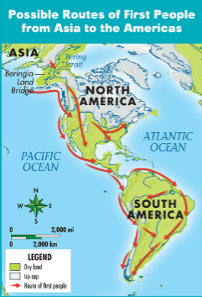 | 9. Use the map. Describe the directions of the routes and analyze why people might have migrated in those directions. (5 points)  ______________________________________  ______________________________________  ______________________________________  ______________________________________  ______________________________________  ______________________________________

10. Compare and contrast the resources used by Woodlands and Desert Southwest Indians. (16 points)

