**Directions:** **Multiple Choice:** Read the sentence. Then choose the answer in which the underlined word is used in the same way. Write the letter of the correct answer on the line.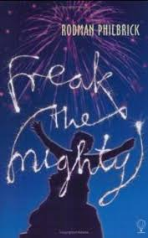

______1. ***“You don’t have to go, but it would be the*** *right* ***thing to do,” Gram said.***

**In which sentence does the word** right **mean the same thing as in the sentence above?**

A. When it comes to politics, Michael seems to lean towards the right.

B. The Declaration of Independence says all people have the right to life, liberty, and the

pursuit of happiness.

C. When Caroline took a right turn at the stoplight, she got lost.

D. Although I didn’t want to babysit my little sister, I knew it was the right way to spend my

evening.

______2. **“Now is that** fair, **to do that to a man? Lock him up for a crime he never did?”**

**In which sentence does the word** fair **mean the same thing as in the sentence above?**

A. I spent all day riding the roller coaster and viewing exhibitions at the state fair.

B. Because he is only a poor to fair speller, Joe always uses the spell check feature on his computer.

C. Bridget didn’t think it was fair that her brother didn’t have to do any chores.

D. She has such fair skin that she sunburns easily.

______3**. “Call that place whatever you want, but you are not to set** foot **over there,” Gram said.**

**In which sentence does the word** foot **mean the same thing as in the sentence above?**

A. My little sister looks like she’s grown a foot over the summer.

B. My foot ached after I stepped into the hole, so I visited the doctor.

C. The workers stood at the foot of the monument and estimated how long the repairs would take.

D. During the Second World War, many foot soldiers suffered from cold and exposure.

______4. “**And the next morning she** signs **the papers, and when we get to school the first day, Freak helps me find my name on the list and it’s true, we’re in all the same classes.”**

**In which sentence does the word** signs **mean the same thing as in the sentence above?**

A. The deaf man could not speak, so he made signs to show us what he wanted.

B. Abdul tried to follow the signs to the festival, but got lost.

C. Juan always signs his name with a big flourish.

D. My Aunt Gert, who is very superstitious, is always looking for signs of future events.

______5. **“Freak is all dressed up, too, he’s wearing this tweedy new suit jacket that has patches**

**on the elbows and Grim says all he needs is a** pipe **and he’ll look like quite the professor.”**

**In which sentence does the word** pipe **mean the same thing as in the sentence above?**

A. “Pipe down!” my older brother yelled, “I can’t hear myself think!”

B. When a water pipe under the street broke, we didn’t have water for several hours.

C. My mother, who has a sensitive nose, refuses to let my father smoke his pipe in the house.

D. Our church has a hundred-year-old pipe organ that fills the sanctuary with beautiful music.

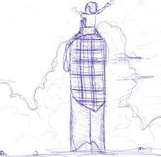

**CHAPTER 1: THE UNVANQUISHED TRUTH** *Grim out in the kitchen one night, after supper whispering to Gram had she noticed how much Maxwell was getting to look like Him? Which is the way he always talked about my father, who had married his dear departed daughter and produced, eek eek, Maxwell. Grim never says my father’s name, just Him, like his name is too scary to say. It’s more than just the way Maxwell resembles him, Grim says that night in the kitchen, the boy is like him, we’d better watch out, you never know what he might do while we’re sleeping. Like his father did. And Gram right away shushes him and says don’t ever say that, because little pictures have big ears, which makes me run to the mirror to see if it is my big ears made me look like Him.*

______6. **How do Maxwell’s grandparents, Grim and Gram, feel about Maxwell’s father?**

A. They love and miss him. B. They are afraid of him.

C. They want Maxwell to be just like him. D. They are glad their daughter married him.

______7. **Why doesn’t Gram want Maxwell to be like his father?**

A. His father did something bad.   
B. His father had big ears.

C. His father only produced one son and they wanted many grandchildren.

D. His father didn’t sleep well.

**CHAPTER 2: UP FROM THE DOWN UNDER** *That summer, let’s see, I’m still living in the basement, my own private down under, in the little room Grim built for me there. Glued up this cheap paneling, right? It sort of buckles away from the concrete cellar walls, a regular ripple effect, but do I complain about the crummy paneling, or the rug that smells like low tide? I do not. Because I like it in the down under, got the place all to myself and no fear of Gram sticking her head in the door and saying Maxwell dear, what are you doing? Not that I ever do much of anything. Grim has it fixed in his head I’m at a dangerous age and they need to keep me under observation. Like I might make bombs or start a fire. Or whack out the local pets with my trusty slingshot or whatever—except I never had a slingshot, it was Grim who had one when he was my age. The proof is right there in the family photo album. You can see this blurry little miniature Grim with no front teeth, grinning at the camera and yanking back on this prehistoric slingshot. Good for whacking mastodons, probably. “Just proper targets,” Grim says, closing up the photo album, end of discussion. Like, oops, better hide the evidence. Don’t want to give the dangerous boy any ideas. Not that I have any ideas. My brain is vacant, okay? I’m just this critter hiding out in the basement, drooling in my comic books or whatever. All right, I never actually drool, but you get the picture.*

______8. **Maxwell likes living in the basement because**

A. it is very attractive. B. he has room for his stuff there.

C. he has more privacy there. D. his grandfather used to live in a basement.

______9. **How does Maxwell feel about himself?**

A. He thinks his brain is full of good ideas. B. He thinks he is good at sports.

C. He thinks he needs more friends. D. He doesn’t think he is very smart.

______10. **Why doesn’t Maxwell’s grandfather want him to know he had a slingshot as a boy?**

A. He can’t afford to buy Maxwell a slingshot.

B. He fears Maxwell will do something dangerous if he gets a slingshot.

C. He is ashamed that he used to kill mastodons with his slingshot.

D. He is afraid Maxwell will kill mastodons with it.

______11. **How does Grim feel about Maxwell?**

A. He thinks Maxwell doesn’t study enough. B. He fears Maxwell might become dangerous.

C. He is proud of Maxwell. D. He wants Maxwell to have more hobbies.

______12. **Maxwell likes to spend time -**

A. playing with his slingshot. B. drooling.

C. reading comic books. D. renovating his basement bedroom.

______13. **What can we infer from this paragraph about Grim’s finances?**

A. He can afford to buy anything he wants. B. He doesn’t have much money to fix up the house.

C. He can’t afford to buy Maxwell a slingshot. D. Money is very important to him.

______14. **Who is the narrator of this story?**

A. Grim B. Gram C. You can’t tell. D. Maxwell

**CHAPTER 4: WHAT FRIGHTENED THE FAIR GWEN** *“Right,” I say. “I saw that on TV.” Freak sighs and rolls his eyes. “Ah, yes,” he says. “Television, the opiate of the massives.” For about the eleventh time I go, “Huh?” “Opiate, a drug,” he says. “Massive, that means large and heavy. Thus television is the drug of fat heads. Opiate of the massives.” “You don’t have a TV?” I asked Freak. “Of course I have a television,” he says. “How else could I watch Star Trek? Matter of fact, I watch tons of tube, but I also read tons of books so I can figure out what’s true and what’s fake, which isn’t always easy. Books are like truth serum—if you don’t read, you can’t figure out what’s real.” This time I don’t say huh because then I might have to explain how I’m an L.D., and reading books is the last thing I want to do, right after trimming my toenails with a lawn mower, gargling nails, and eating worms for breakfast. Of course Freak has probably already guessed I’m a learning disabled, because he’s had a look around my room and it isn’t exactly the public library. “I’ll lend you some of my books, Maxwell,” he says. “Cool,” I say, like it’s just what I’ve been waiting for, another chance to prove I’m a butthead. Then we both hear it at the same time, this voice calling his name and sounding real worried. “The Fair Gwen,” he says. “I gotta beam out of here.” I go up and open the bulkhead door and his mother is in the back yard and she’s looking at the little red wagon. She catches sight of me coming up out of the down under and it’s like somebody shot her. Like she’s scared out of her mind. “Kevin?” she says. “I’m looking for a little boy.” Freak is huffing and puffing as he humps himself up the steps and the Fair Gwen grabs Freak and puts him in the wagon and I swear, she almost runs home, like if she doesn’t get away quick something really bad is going to happen. Freak is in the wagon and he’s trying to look back at me trying to shrug his shoulders and let me know he doesn’t understand what got into the Fair Gwen, but I know. It’s pretty simple, really. She’s scared of me.*

______15. **Why doesn’t Maxwell read much?**

A. He doesn’t own any books. B. He has learning disabilities and can’t read very well.

C. He is too busy watching Star Trek. D. He has already read all the books in his house.

______16. **Why does Gwen run home with Kevin?**

A. She’s late for dinner. B. It’s time to watch Star Trek.

C. She’s scared of Maxwell. D. She’s afraid she’s lost.

______17. **What does Kevin think of his mom’s behavior?**

A. He thinks she is right to be scared. B. He doesn’t understand why she is afraid.

C. He thinks she always acts like this. D. He knows why she is scared of Maxwell.

______18. **Kevin thinks it is important to -**

A. dress well for school. B. ride in his wagon.

C. know what is true and what is not. D. read comic books.

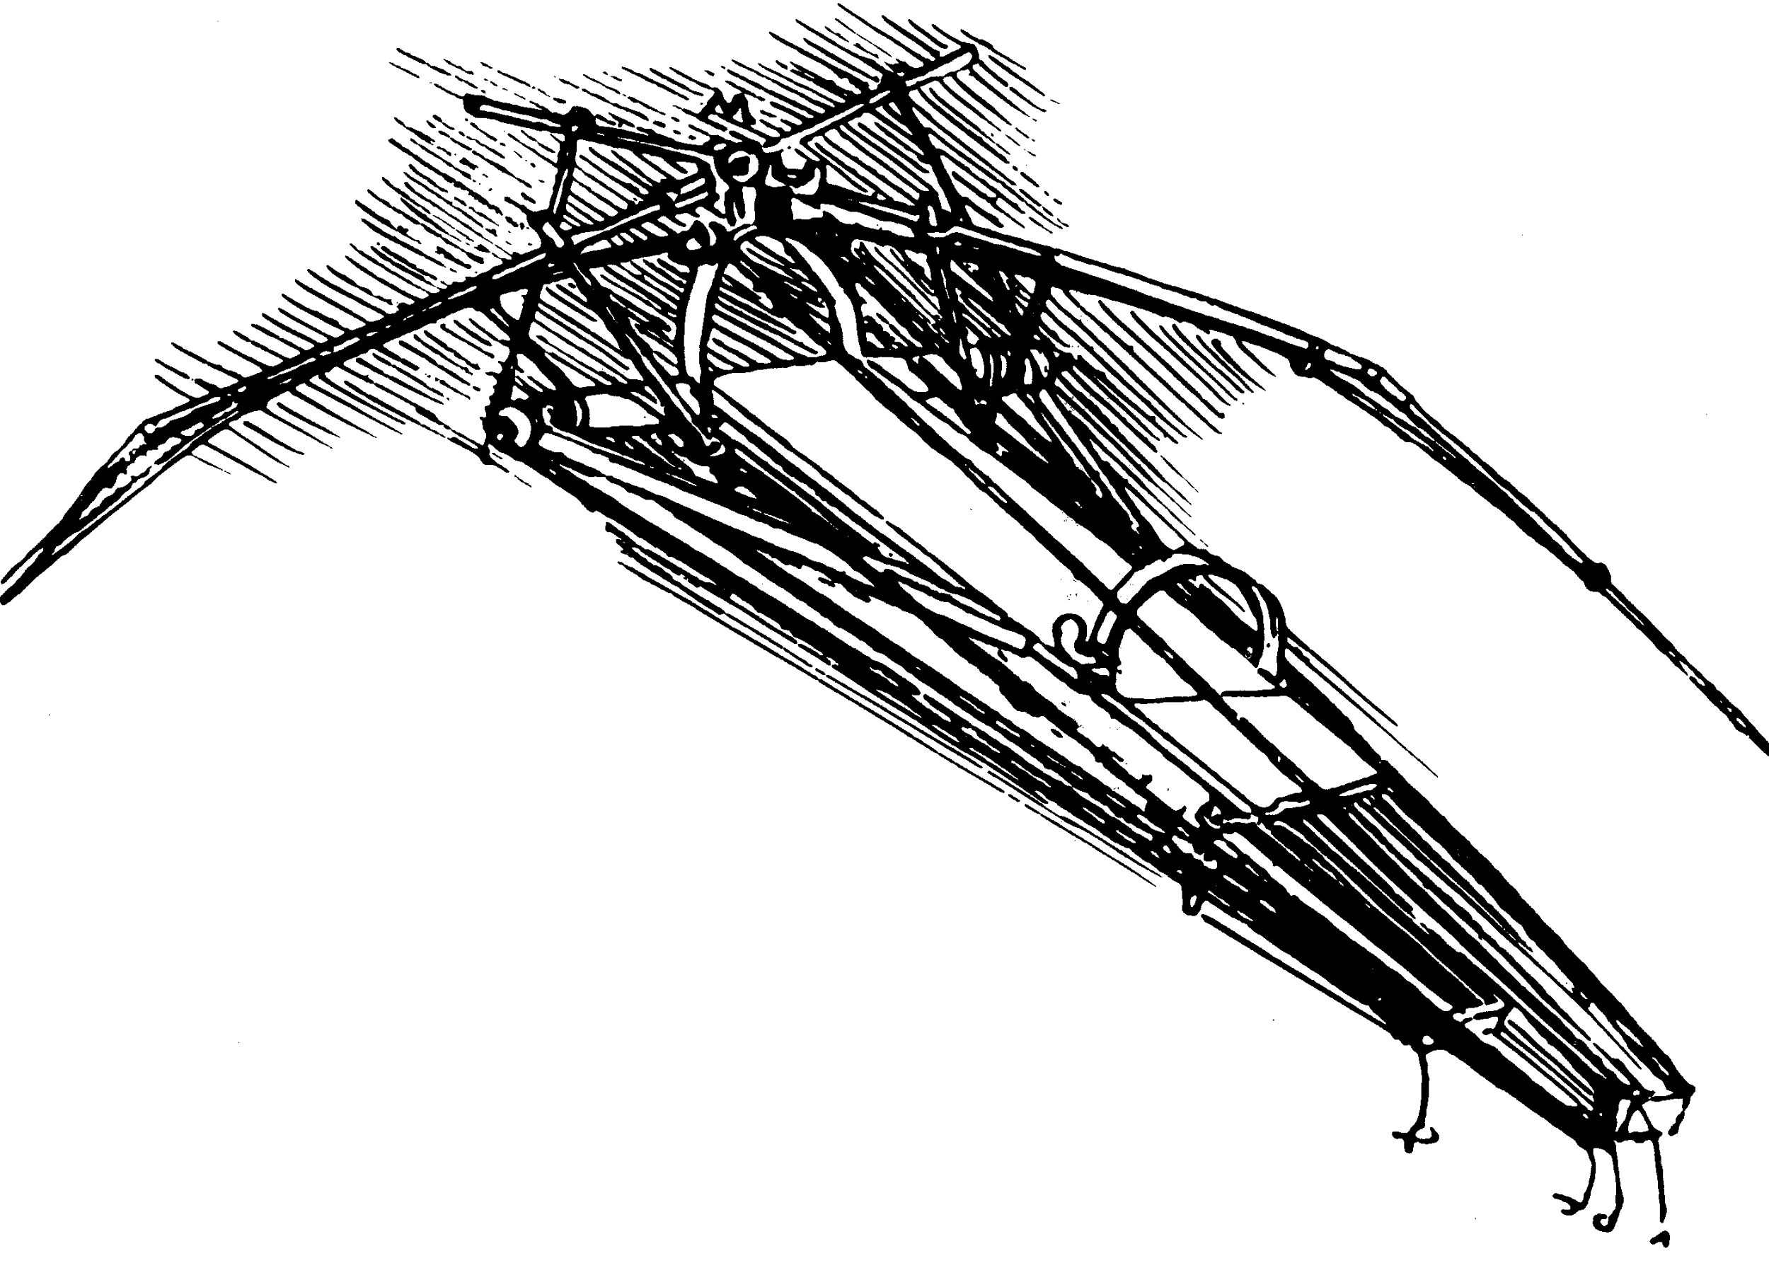

**CHAPTER 13: AMERICAN CHOP SUEY** *“Maxwell, this is not about your class work, or even about school. This is about your, uhm, father,” the principal said. My, uhm, father. Which makes me wish all of a sudden I’d done something wrong and Mrs. Addison was just giving me detention. She takes a deep breath and folds her hands together like she’s praying and she says, “A request has been forwarded to me from the parole board. A request from your father. Maxwell, your father wants to know if—” “I don’t want to hear it!” I jump up and cover my ears, holding my hands real tight. “Don’t want to hear it! Don’t want to hear it! Don’t! Don’t! Don’t!” What happens when you go nuts in the principal’s office, she calls in the school nurse, and the two of them are trying to hug me and calm me down, and it’s like I’m back in day care or something. “Maxwell?” Mrs. Addison is saying. She’s trying to pry my hands away from my ears. “Maxwell, please forget about it, okay? Forget I said it. You don’t have to do anything you don’t want to do, okay? And I’ll make sure of that, I promise. I swear on my honor, he can’t make you do anything you don’t want to do. I’m going to make that very clear to the parole board, and to his lawyer. Very clear indeed.” Finally I take my hands off my ears, which wasn’t really working because I could still hear everything they said, and big surprise, I’m sitting in the corner of the room, down on the floor with my knees all hunched up, and I don’t even remember how I got here.*

______19. **From the information in this passage, we can infer that -**

A. Maxwell misses his father. B. Maxwell’s father does not want to see him.

C. Maxwell does not want any contact with his father. D. Maxwell has good memories of his father.

______20. **What word best describes Mrs. Addison?**

A. unconcerned B. concerned C. mean D. distant

______21. **Based on the passage, which prediction is most likely?**

A. Maxwell will try to see his father. B. Mrs. Addison will expel Maxwell.

C. Maxwell’s father will try to see him. D. Mrs. Addison will make Maxwell see his father.

---------------------------------------------------------------------------------------------------------------------------------------------------

______22. **Narration:**  **The first person point of view helps the reader**

1. identify important locations B. notice Freak’s unusual vocabulary

C. understand Max’s thoughts and feelings D. understand all of the character’s thoughts and feelings

______23. **Author’s Purpose: The author most likely wrote this story to**

A. introduce readers to advanced vocabulary.

B. show how friendship can change a person.

C. raise awareness about serious medical conditions.

D. show readers that grandparents sometimes make better parents.

______24.  **Why does Max live with his grandparents?**

A. Grim and Gram live closer to Kevin B. Max’s mother died and his father is in prison

C. Max likes having the whole basement to himself. D. Grim and Gram need someone to take care of them

______25. **Conflict:**  **What is Max’s main problem or conflict in the story?**

A. Max cannot control his kicking B. Max’s teachers always pick on him 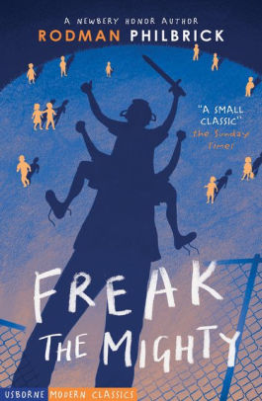

C. Max misses his father, who is in prison D. Max struggles with his learning diabilities

and his father’s parole.

______26.  **Elements of Literature: One theme in the novel is**

1. Every child deserves a mother
2. Adventures lead only to trouble
3. Neighbors should always spend the holidays together
4. True friendships are not based on outward appearances

______27. **Organization:**  **The author organizes this story by-**

A. describing Freak’s memories B. discussing Freak’s adventures

C. describing a series of events in Max’s life D. comparing and constrasting Max’s and Freak’s lives

______28.  **Text Evidence: Which sentence from the book supports the idea that Max feels a great loss after Freak dies?**

1. *And now that I’ve written a book, who knows, I might even read a few.*
2. *Not too long after that-this was winter by then-I saw Loretta Lee in the street*
3. *I don’t know if this makes sense, but for a long time I felt like I was a balloon and somebody had let the air out of me.*
4. *So I went [to school] and I hated every minute of it, and I especially hated how people kept feeling sorry for me, as if it was me who died.*

______29. **How does Grim change at the end of the book?**

A. He is no longer frightened by Max B. He no longer thinks Max deserves coffee

C. He decides Max should sleep upstairs on the foldout D. He wishes he and Gram had put Max up for

adoption

______30. **What event sparked the partnership of Freak the Mighty?**

1. They were playing basketball at school and Max picked Kevin up because he was too short to shoot the ball and couldn’t easily move on the court.
2. Max Lifted Kevin up to get the ornithopter out of the tree.
3. They were celebrating the 4th of July, enjoying the fireworks
4. They were trying to escape from Tony D.

______31. **Figurative Language**: **What does the idiom, *“spitting image of your old man”* mean?**

1. Max can spit like his father
2. Max and his father have the same personality
3. Max and his father have the same physical characteristics
4. Max doesn’t get along with his father so he spits at him.

______32. **Figurative Language: What does Kevin mean when he uses the metaphor, “*Television is the opiate for the massives*” ?**

1. TV is for people with a lot of mass.
2. TV is a drug and stops people from thinking for themselves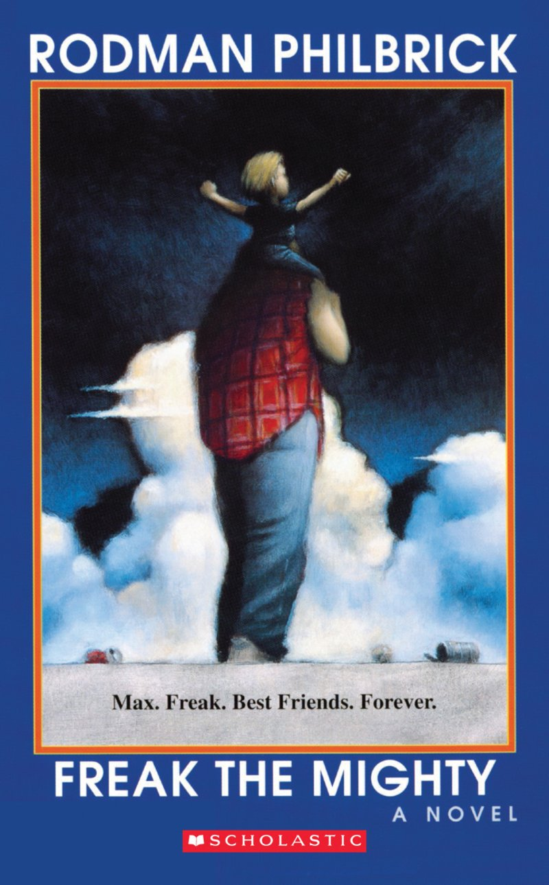
3. TV makes a person smarter by making their brain larger
4. Kevin was telling Max he didn’t have a TV.

______33. **Figurative Language: When he was stuck in the millpond, Max described himself as a *“big fence post.”*  What does this simile mean?**

1. He can’t move.
2. He’s there to protect and provide privacy.
3. He isn’t smart.
4. Max never changes.

34. **Create a Venn diagram for Max** and **Kevin below using these terms.**

| smart lives with grandparents dislikes school avoids reading  very tall learning disabled physically handicapped loves to read  lives with his mom very small chivalrous |
| --- |

**____________________ ____________________**

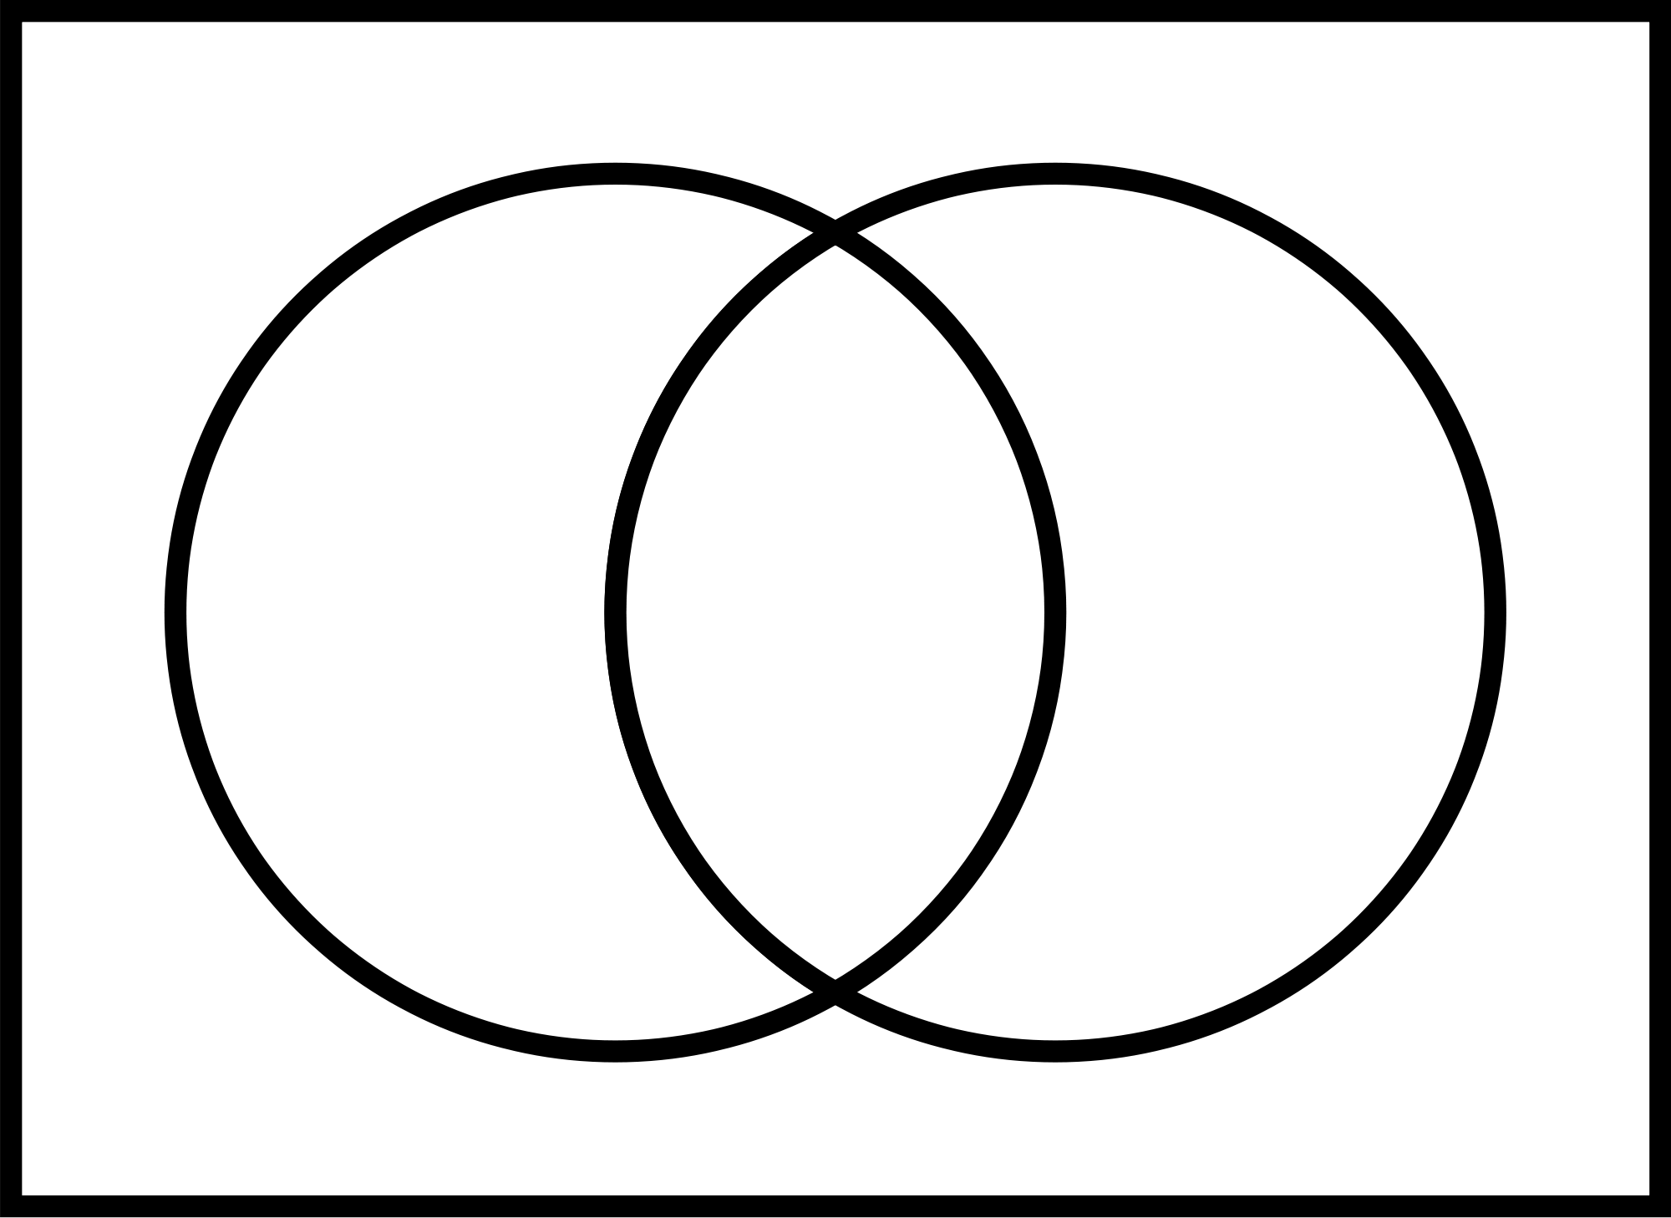

35. **Number these events in the correct order.**

______Kevin moves into the duplex next to Max’s home.

______Kevin chokes on chop suey.

______Max records their memories in a blank book Kevin gives him.

______Max and Kevin become Freak the Mighty.

______Max is kidnapped by his father.

36.-38. **Short Answer: Directions:**  Please respond completely to **THREE** of the following questions using text evidence to support your answer. Remember to restate the question. Use extra paper if necessary.

**TIPS:** PROOFREAD YOUR ANSWERS. Use page numbers when citing text.

A. How do Max and Freak “defeat” Tony D and his gang in the park? Use specific evidence from the text.

B. Would you consider this story to be a *triumph-* a happy story, or a *tragedy-* a sad story? Explain your answer using evidence from the text to support your response.

C. Max says about Kevin, “his heart just got too big for his body” (p. 157). Does he mean this literally or figuratively? Explain your response using text evidence.

D. Quote Analysis: “I’m not coming home, not in my present manifestation.” p.149 What does Kevin mean when he tells Max this? Explain clearly using specific evidence from the text.

E. Explain why Kevin and Max call themselves “Freak the Mighty”. Clearly explain your answer using evidence from the text to support your response.

F. When Kenny Kane tried to kill Loretta Lee, Max remembers something important from his past. Describe what he remembers. Then, explain the connection between Loretta Lee’s attempted murder and what Max remembered. Use evidence from the text to support your response.

G. Provide two of examples from the text that show how Kenny Kane treats Max more like a prisoner than a son. Why do you think he does that? Clearly explain your response.

________________________________________________________________________________________________________________________________________________________________________________________________________________________________________________________________________________________________________________________________________________________________________________________________________________________________________________________________________________________________________________________________________________________________________________________________________________________________________________________________________________________________________________________________

________________________________________________________________________________________________________________________________________________________________________________________________________________________________________________________________________________________________________________________________________________________________________________________________________________________________________________________________________________________________________________________________________________________________________________________________________________________________________________________________________________________________________________________________

________________________________________________________________________________________________________________________________________________________________________________________________________________________________________________________________________________________________________________________________________________________________________________________________________________________________________________________________________________________________________________________________________________________________________________________________________________________________________________________________________________________________________________________________

________________________________________________________________________________________________________________________________________________________________________________________________________________________________________________________________________________________________________________________________________________________________________________________________________________________________________________________________________________________________________________________________________________________________________________________________________________________________________________________________________________________________________________________________

________________________________________________________________________________________________________________________________________________________________________________________________________________________________________________________________________________________________________________________________________________________________________________________________________________________________________________________________________________________________________________________________________________________________________________________________________________________________________________________________________________________________________________________________

________________________________________________________________________________________________________________________________________________________________________________________________________________________________________________________________________________________________________________________________________________________________________________________________________________________________________________________

________________________________________________________________________________________________________________________________________________________________________________________________________________________________________________________________________________________________________________________________________________________________________________________________________________________________________________________

________________________________________________________________________________________________________________________________________________________________________________________________________________________________________________________________________________________________________________________________________________________________________________________________________________________________________________________

________________________________________________________________________________________________________________________________________________________________________________________________________________________________________________________________________________________________________________________________________________________________________________________________________________________________________________________

________________________________________________________________________________________________________________________________________________________________________________________________________________________________________________________________________________________________________________________________________________________________________________________________________________________________________________________

________________________________________________________________________________________________________________________________________________________________________________________________________________________________________________________________________________________________________________________________________________________________________________________________________________________________________________________