Read the short essays on John Joseph Pershing and Thurgood Marshall. How did Pershing and Marshall reveal themselves as leaders? (Definition of leader: a person who has an influence.)
Write an essay comparing these two leaders.

John Joseph Pershing

 | 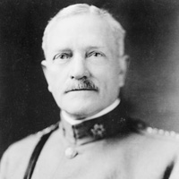  General John Joseph Pershing |  | Born: September 13, 1860  Died: July 15, 1948  John Joseph Pershing began his career as a schoolteacher in Missouri when a notice in the paper inspired him to give the U.S. Military Academy at West Point in New York a try. By his last year, he had earned the honor of being chosen first captain of the Corps of Cadets. His later military postings and combat experiences in places such as Cuba and Mexico provided him with valuable knowledge. During the First World War General John Pershing was the commander of the American Expeditionary Force (AEF) in Europe. After the war he was promoted to general of the armies, a position previously held only by George Washington. Toward the end of his life he spent a great deal of time writing his memoirs, My Experiences in the World War,which won the Pulitzer Prize for history in 1932.

Thurgood Marshall

 | 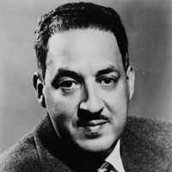  Thurgood Marshall |  | Born: July 2, 1908  Died: January 24, 1993  Thurgood Marshall was the first African-American member of the U.S. Supreme Court. He served on the court from 1967 until he retired in 1991. Earlier in his career, Marshall worked as a lawyer for the National Association for the Advancement of Colored People (NAACP) and helped win the 1954 landmark desegregation case, Brown v. Board of Education of Topeka, Kansas. Throughout his life, Marshall used the law to promote civil rights and social justice.

