8th Grade ELA Scope and Sequence, aligned with the New Jersey Student Learning Standards (NJSLS)
This plan is built around thematic units. The 8th-grade year demands a significant leap in analytical rigor. The focus shifts to evaluating the strength and relevance of evidence, analyzing an author's allusions and analogies, and writing sophisticated arguments that skillfully address counterclaims.

🏃‍♀️ Ongoing Foundational Skills (Taught Daily, All Year)
These skills are practiced continuously and integrated into all units.
- Vocabulary Development (L.8.4): Determining the meaning of unknown words using context clues, knowledge of Greek and Latin affixes and roots, and reference materials.
- Conventions of Grammar (L.8.2): Demonstrating command of conventions, including the correct use of punctuation (commas, ellipses, dashes) to indicate pauses or breaks.
- Speaking & Listening (SL.8.1): Engaging in collaborative discussions, citing evidence, and responding thoughtfully to diverse perspectives.

🍂 September: The Power of Evidence
- Unit Theme: Identity & The Individual; Finding Your Voice
- Unit Focus: Establishing workshop routines. Mastering the year's core reading skill: Citing the textual evidence that most strongly supports an analysis (a shift from 7th grade's "several pieces").

Standards Spotlight
- Reading (RL.8.1 & RI.8.1): Citing the textual evidence that most strongly supports an analysis of what the text says explicitly as well as inferences drawn from the text.
- Writing (W.8.3): Writing narratives that use effective technique (e.g., dialogue, pacing, description), a well-structured event sequence, and a reflective conclusion.
- Language (L.8.1d): Recognizing and correcting inappropriate shifts in verb voice and mood.

🎃 October: Analyzing Author's Craft
- Unit Theme: Suspense & Surprise; Historical Fiction
- Unit Focus: Analyzing how an author creates an effect. How do specific incidents, lines of dialogue, or word choices (analogies, allusions) propel the plot and reveal character?

Standards Spotlight
- Reading Literature (RL.8.3): Analyzing how particular lines of dialogue or incidents in a story propel the action, reveal aspects of a character, or provoke a decision.
- Reading Literature (RL.8.4): Determining the meaning of words and phrases, including figurative language, and analyzing the impact of specific word choices, such as analogies or allusions to other texts.
- Writing (W.8.9a): Drawing evidence from literary texts to support analysis (e.g., analytical paragraphs on author's craft).

🦃 November: Informational Text & Central Idea
- Unit Theme: Science & Society; Technology's Impact
- Unit Focus: Analyzing the development of a central idea, including its relationship to supporting ideas. Writing a multi-paragraph informative text.

Standards Spotlight
- Reading Informational Text (RI.8.2): Determining a central idea of a text and analyzing its development, including its relationship to supporting ideas.
- Reading Informational Text (RI.8.5): Analyzing the structure of a specific paragraph, including the role of particular sentences in developing and refining a key concept.
- Writing (W.8.2): Writing informative/explanatory texts that use domain-specific vocabulary, varied transitions, and a formal style.

❄️ December: Delineating & Evaluating Arguments (Reading)
- Unit Theme: Media Literacy; Current Events; Persuasion
- Unit Focus: This is a crucial reading unit. Students will learn to delineate (trace) an author's argument and evaluate its soundness, identifying irrelevant evidence or flawed reasoning.

Standards Spotlight
- Reading Informational Text (RI.8.8): Delineating and evaluating the argument and specific claims in a text, assessing whether the reasoning is sound and the evidence is relevant and sufficient; recognizing when irrelevant evidence is introduced.
- Reading Informational Text (RI.8.6): Determining an author's point of view and analyzing how the author acknowledges and responds to conflicting evidence or viewpoints.
- Language (L.8.1b): Forming and using verbs in the active and passive voice.

🧊 January: Writing the Argumentative Essay
- Unit Theme: Taking a Stand; Social Issues
- Unit Focus: This is the major 8th-grade writing unit. Students will write a formal argument that acknowledges and skillfully distinguishes counterclaims, a significant step up from 7th grade.

Standards Spotlight
- Writing (W.8.1): Writing arguments to support claims with clear reasons and relevant evidence.
  - W.8.1b: Support claim(s) with logical reasoning and relevant evidence, using credible sources and acknowledging and distinguishing the claim(s) from alternate or opposing claims.
- Writing (W.8.4): Producing clear and coherent writing with development, organization, and style appropriate to task, purpose, and audience.
- Language (L.8.1c): Forming and using verbs in the indicative, imperative, conditional, and subjunctive mood.

❤️ February: The Research Project
- Unit Theme: Inquiry & Investigation (Student-Choice Topics)
- Unit Focus: Conducting short research projects. The 8th-grade emphasis is on generating new, related questions for further research and adhering to a standard citation format.

Standards Spotlight
- Writing (W.8.7): Conducting short research projects to answer a question, drawing on several sources and generating additional focused questions for further investigation.
- Writing (W.8.8): Gathering relevant information from multiple credible sources; quoting or paraphrasing while avoiding plagiarism; and following a standard citation format (e.g., MLA, APA).
- Writing (W.8.6): Using technology to produce, publish, and collaborate on writing.

🌷 March: Connecting to the Classics (Allusion)
- Unit Theme: Myths, Legends, & Modern Interpretations
- Unit Focus: This unit targets a key 8th-grade standard: analyzing how modern texts are built on foundational stories. Students will read/summarize myths or traditional stories, then analyze modern works that allude to them.

Standards Spotlight
- Reading Literature (RL.8.9): Analyzing how a modern work of fiction draws on myths, traditional stories, or religious works, including rendering new character types or themes.
- Writing (W.8.9a): Writing a comparative analysis of a modern and a traditional text.
- Language (L.8.1a): Understanding and using verbals (gerunds, participles, infinitives).
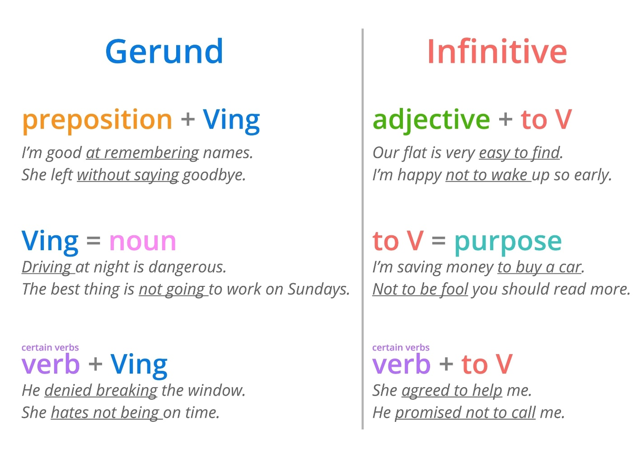
Shutterstock

🌎 April: Poetry & Drama
- Unit Theme: Justice & Injustice; Human Rights
- Unit Focus: Analyzing how figurative language and structure create meaning in poetry and drama. This unit often centers on a class play (e.g., The Diary of Anne Frank) or a poetry collection.

Standards Spotlight
- Reading Literature (RL.8.4): Analyzing the impact of analogies and allusions on meaning and tone in poetry and prose.
- Reading Literature (RL.8.3): Analyzing how dialogue in a play reveals character and provokes decisions.
- Language (L.8.5): Interpreting figurative language (e.g., verbal irony, puns) in context.

☀️ May: Synthesis Across Media & Texts
- Unit Theme: Text-to-Screen; Fact vs. Interpretation
- Unit Focus: Comparing and contrasting texts in different formats. How does a film adaptation stay faithful to, or depart from, its source text? Where do two authors disagree on the same historical event?

Standards Spotlight
- Reading Literature (RL.8.7): Analyzing the extent to which a filmed or live production of a story or drama stays faithful to or departs from the text, evaluating the choices made by the director or actors.
- Reading Informational Text (RI.8.9): Analyzing a case where two or more texts provide conflicting information on the same topic and identifying where the texts disagree on matters of fact or interpretation.
- Writing (W.8.9b): Writing a comparative analysis of a text and its film adaptation.

🎓 June: Culminating Projects & Reflection
- Unit Theme: Looking Back, Moving Forward
- Unit Focus: Publishing a "capstone" project (e.g., a final research presentation, a digital portfolio). Reflecting on the year's growth and preparing for high school.

Standards Spotlight
- Speaking & Listening (SL.8.4): Presenting claims and findings, emphasizing salient points with relevant evidence, sound reasoning, and a clear line of reasoning.
- Speaking & Listening (SL.8.5): Integrating multimedia and visual displays into presentations to clarify information and add interest.
- Activity: "This I Believe" speeches, digital portfolios, or presenting a final argument/research project.

