3rd Grade Science Scope and Sequence, aligned to NJSLS-S (NGSS)
This sequence follows the TCI order of Physical Science > Life Science > Earth Science. This progression allows students to build inquiry skills with concrete physical labs early in the year before moving to the observation-heavy life and earth sciences in the spring.

🍎 September: Forces and Motion (Unit 1)
- Focus: Understanding balanced and unbalanced forces and predicting motion.
- TCI Context: Students investigate how pushes and pulls affect objects.
- Key Concepts:
  - Forces: A push or a pull.
  - Balanced vs. Unbalanced: If forces are balanced, an object stays still. If unbalanced, it moves.
  - Patterns: Predicting future motion based on observed patterns.
- NJSLS-S / NGSS:
  - 3-PS2-1: Plan and conduct an investigation to provide evidence of the effects of balanced and unbalanced forces on the motion of an object.
  - 3-PS2-2: Make observations and/or measurements of an object’s motion to provide evidence that a pattern can be used to predict future motion.

🎃 October: Magnetic Interactions (Unit 2)
- Focus: Investigating non-contact forces (magnetism and gravity) and engineering solutions.
- TCI Context: Students explore magnetic fields and solve a problem using magnets.
- Key Concepts:
  - Non-Contact Forces: Forces that act at a distance (electric, magnetic).
  - Polarity: Attraction and repulsion (North/South poles).
  - Engineering Design: Applying magnetic concepts to solve a problem (e.g., designing a latch or a maglev concept).
- NJSLS-S / NGSS:
  - 3-PS2-3: Ask questions to determine cause and effect relationships of electric or magnetic interactions.
  - 3-PS2-4: Define a simple design problem that can be solved by applying scientific ideas about magnets.

🦃 November: Life Cycles (Unit 3, Part 1)
- Focus: Comparing the diverse life cycles of different organisms.
- TCI Context: Students plant seeds or observe mealworms/butterflies (depending on kit availability) to track growth.
- Key Concepts:
  - Common Stages: Birth, Growth, Reproduction, Death.
  - Diversity: How plant life cycles differ from animal life cycles.
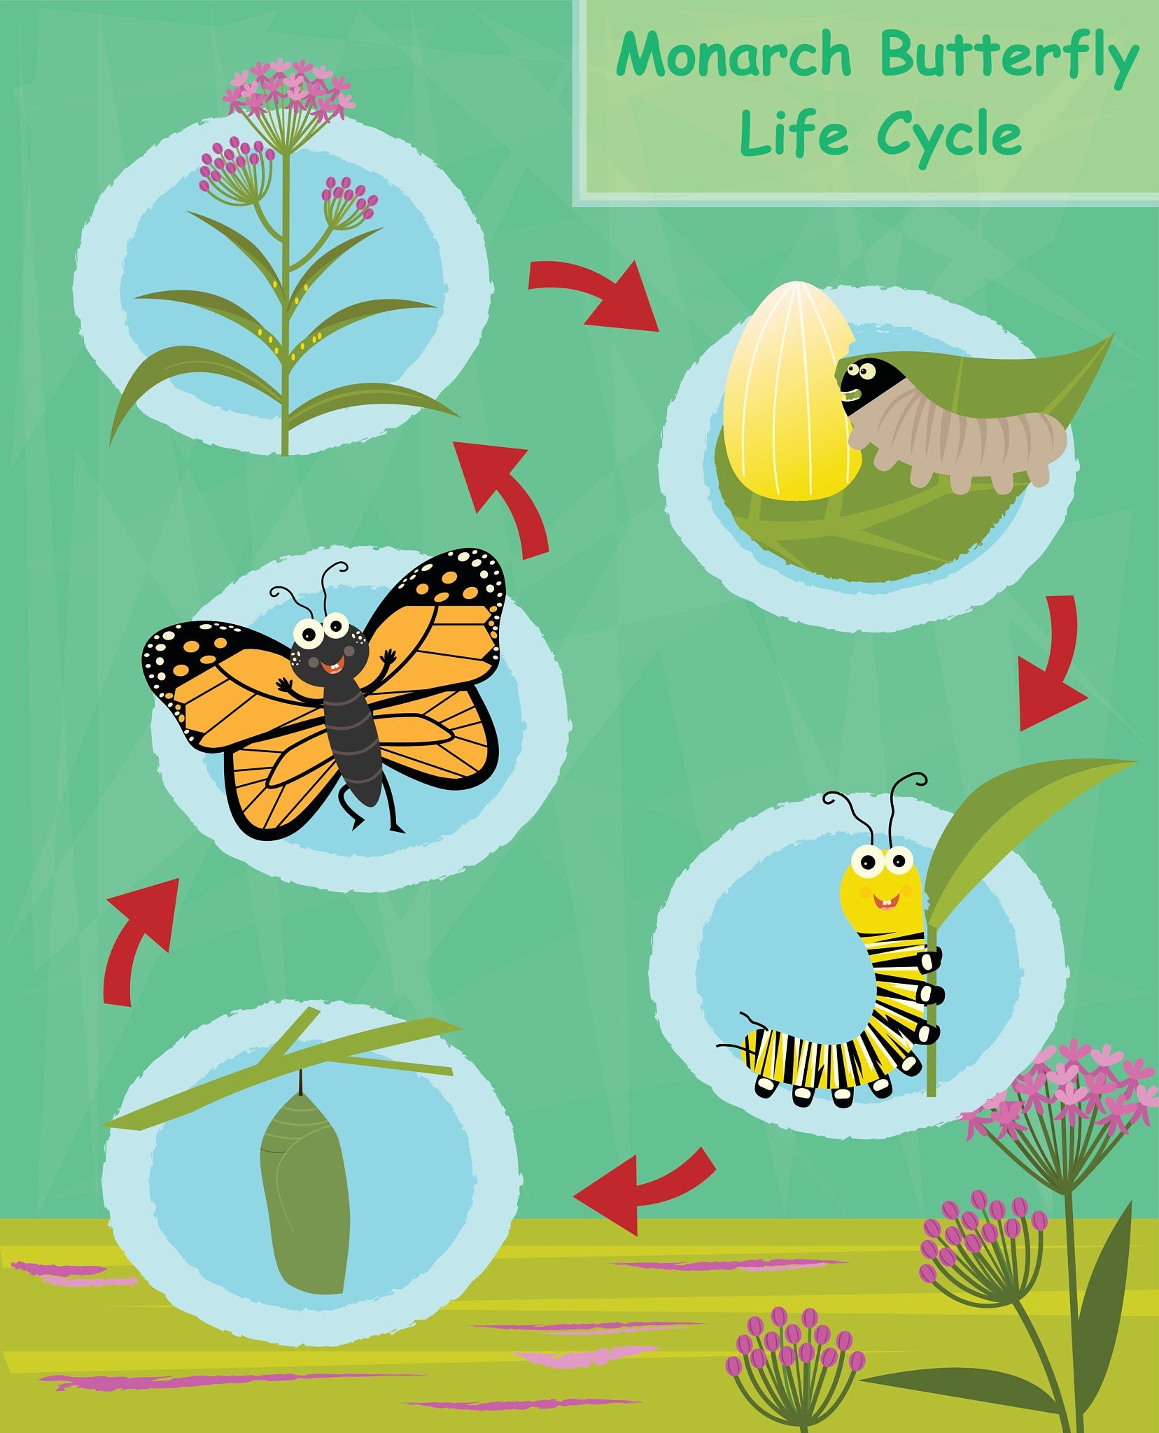
Getty Images
- NJSLS-S / NGSS:
  - 3-LS1-1: Develop models to describe that organisms have unique and diverse life cycles but all have in common birth, growth, reproduction, and death.

❄️ December: Traits and Heredity (Unit 3, Part 2)
- Focus: Understanding inherited traits versus environmental traits.
- TCI Context: Analyzing family traits and how the environment affects growth.
- Key Concepts:
  - Inheritance: Offspring look like, but not exactly like, their parents.
  - Variation: Differences in traits among the same species.
  - Environmental Influence: How diet, weather, or training changes traits (e.g., a plant in the dark vs. light).
- NJSLS-S / NGSS:
  - 3-LS3-1: Analyze and interpret data to provide evidence that plants and animals have traits inherited from parents.
  - 3-LS3-2: Use evidence to support the explanation that traits can be influenced by the environment.

☃️ January: Adaptations and Survival (Unit 4, Part 1)
- Focus: How animals survive in groups and how specific traits help survival.
- TCI Context: Simulations regarding group behavior and camouflage/predation.
- Key Concepts:
  - Social Behavior: Animals working in groups (bees, wolves, ants) to survive.
  - Natural Selection: Organisms with advantages (camouflage, speed) survive and reproduce.
- NJSLS-S / NGSS:
  - 3-LS2-1: Construct an argument that some animals form groups that help members survive.
  - 3-LS4-2: Use evidence to construct an explanation for how the variations in characteristics among individuals of the same species may provide advantages in surviving.

❤️ February: Ecosystems and Environmental Change (Unit 4, Part 2)
- Focus: Fossils as evidence of the past and what happens when habitats change.
- TCI Context: Examining fossil records and current environmental shifts.
- Key Concepts:
  - Fossils: Evidence of organisms that lived long ago and their environments.
  - Habitat Change: When the environment changes, some organisms survive, some move, and some die.
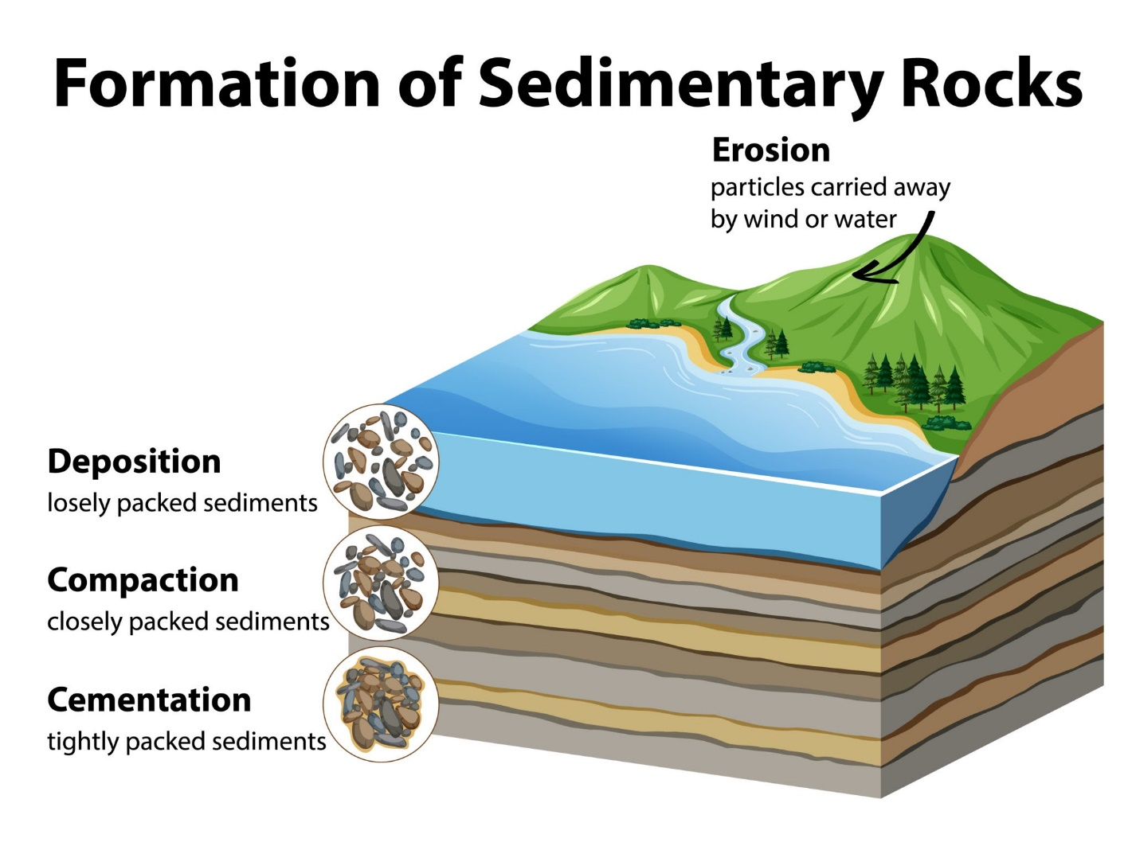
Getty Images
- NJSLS-S / NGSS:
  - 3-LS4-1: Analyze and interpret data from fossils to provide evidence of the organisms and the environments in which they lived long ago.
  - 3-LS4-4: Make a claim about the merit of a solution to a problem caused when the environment changes and the types of plants and animals that live there may change.

🍀 March: Weather Patterns (Unit 5, Part 1)
- Focus: Recording weather data to identify patterns.
- TCI Context: Students use weather tools (thermometers, rain gauges) to track local weather.
- Key Concepts:
  - Data Collection: Measuring temperature, precipitation, wind direction, and wind speed.
  - Seasonal Patterns: Understanding typical weather for different times of the year.
- NJSLS-S / NGSS:
  - 3-ESS2-1: Represent data in tables and graphical displays to describe typical weather conditions expected during a particular season.

🌷 April: Climate (Unit 5, Part 2)
- Focus: The difference between weather (short-term) and climate (long-term).
- TCI Context: Comparing weather data across different regions of the world.
- Key Concepts:
  - Climate Zones: Tropical, Temperate, Polar.
  - Long-term Data: Looking at averages over many years.
- NJSLS-S / NGSS:
  - 3-ESS2-2: Obtain and combine information to describe climates in different regions of the world.

🐜 May: Natural Hazards & Engineering (Unit 5, Part 3)
- Focus: Understanding hazardous weather and designing solutions to reduce impact.
- TCI Context: Engineering challenge to build a structure that withstands wind or flooding.
- Key Concepts:
  - Hazards: Hurricanes, tornadoes, floods, lightning.
  - Mitigation: How humans build roofs, levees, and lightning rods to stay safe.
  - Engineering Process: Design, Test, Improve.
- NJSLS-S / NGSS:
  - 3-ESS3-1: Make a claim about the merit of a design solution that reduces the impacts of a weather-related hazard.
  - 3-5-ETS1-1: Define a simple design problem reflecting a need or a want.

☀️ June: Capstone Engineering Review
- Focus: Reviewing major concepts through an integrated engineering lens.
- Context: Revisit a favorite investigation from the TCI year (e.g., the Maglev train or the Weather-safe house) and improve the design.
- Key Concepts:
  - Constraints and Criteria: What are the rules and goals of the build?
  - Peer Feedback: Analyzing why one design failed and another succeeded.
- NJSLS-S / NGSS:
  - 3-5-ETS1-2: Generate and compare multiple possible solutions to a problem.
  - 3-5-ETS1-3: Plan and carry out fair tests in which variables are controlled.

