6th Grade Math Scope and Sequence, aligned with the New Jersey Student Learning Standards (NJSLS)
This plan prioritizes the major work of 6th grade: connecting ratio and rate to whole number multiplication and division, completing the understanding of division of fractions, and introducing negative numbers and algebraic expressions.

🍎 September: The Number System (Part 1 - Computation)
- Focus: Building computational fluency as a foundation for the year.
- Key Concepts:
  - Fluency with Division: Fluently dividing multi-digit numbers using the standard algorithm (e.g., $1520 \div 25$).
  - Decimal Operations: Fluently adding, subtracting, multiplying, and dividing multi-digit decimals using standard algorithms.
  - GCF & LCM: Finding the Greatest Common Factor (GCF) of two numbers (e.g., GCF of 18 and 24) and the Least Common Multiple (LCM) of two numbers (e.g., LCM of 6 and 8).
- Key NJSLS:
  - 6.NS.B.2: Fluently divide multi-digit numbers.
  - 6.NS.B.3: Fluently add, subtract, multiply, and divide multi-digit decimals.
  - 6.NS.B.4: Find GCF and LCM.

🎃 October: The Number System (Part 2 - Fraction Division)
- Focus: Completing the understanding of operations with fractions.
- Key Concepts:
  - Dividing Fractions: Interpreting and computing quotients of fractions.
  - Models: Using visual fraction models and story contexts to represent division (e.g., "How many 3/4-cup servings are in 2/3 of a cup of yogurt?").
  - Algorithm: Understanding and applying the "invert and multiply" algorithm ($a/b \div c/d = ad/bc$).
- Key NJSLS:
  - 6.NS.A.1: Interpret and compute quotients of fractions and solve word problems.

🦃 November: Ratios & Proportional Relationships
- Focus: Understanding ratio concepts and using ratio language. This is a major 6th-grade domain.
- Key Concepts:
  - Ratio Language: Understanding the concept of a ratio and using language like "For every..." "To..." (e.g., The ratio of wings to beaks is 2:1).
  - Unit Rates: Understanding the concept of a unit rate (e.g., $a/b$ associated with a ratio $a:b$) and using rate language (e.g., "5 miles per hour").
  - Equivalent Ratios: Using tables, tape diagrams, and double number lines to find and reason about equivalent ratios.
- Key NJSLS:
  - 6.RP.A.1: Understand the concept of a ratio.
  - 6.RP.A.2: Understand the concept of a unit rate.
  - 6.RP.A.3a, 3b: Use ratio and rate reasoning to solve problems (tables, tape diagrams, unit pricing, constant speed).

❄️ December: Ratios & Proportional Relationships (Part 2 - Percents)
- Focus: Applying ratio reasoning to percents and measurement conversions.
- Key Concepts:
  - Percents: Finding a percent of a quantity as a rate per 100 (e.g., 30% of 60 is 18).
  - Finding the Whole: Solving problems involving finding the whole, given a part and the percent.
  - Measurement Conversion: Using ratio reasoning to convert measurement units (e.g., converting 36 inches to feet using the ratio 12 in : 1 ft).
- Key NJSLS:
  - 6.RP.A.3c: Find a percent of a quantity.
  - 6.RP.A.3d: Use ratio reasoning to convert measurement units.

☃️ January: Expressions & Equations (Part 1 - Expressions)
- Focus: Introducing algebraic expressions and properties.
- Key Concepts:
  - Exponents: Writing and evaluating numerical expressions involving whole-number exponents (e.g., $3^4 = 3 \times 3 \times 3 \times 3$).
  - Algebraic Expressions: Writing, reading, and evaluating expressions in which letters stand for numbers (e.g., "Subtract 5 from $n$" is $n - 5$).
  - Parts of an Expression: Identifying parts using terms like variable, coefficient, term, and constant.
  - Properties: Applying the properties of operations (especially the distributive property) to generate equivalent expressions (e.g., $3(2 + x) = 6 + 3x$ and $24x + 18y = 6(4x + 3y)$).
- Key NJSLS:
  - 6.EE.A.1: Write and evaluate expressions with exponents.
  - 6.EE.A.2: Write, read, and evaluate algebraic expressions.
  - 6.EE.A.3, 6.EE.A.4: Apply properties to generate equivalent expressions.

❤️ February: Expressions & Equations (Part 2 - Solving Equations)
- Focus: Solving one-step equations and inequalities.
- Key Concepts:
  - What is a Solution?: Understanding that solving an equation means finding the value that makes the statement true.
  - One-Step Equations: Solving one-step equations of the form $x + p = q$ and $px = q$ (e.g., $x + 7 = 12$ and $4x = 24$).
  - One-Step Inequalities: Writing and solving one-step inequalities (e.g., $x > 5$).
  - Graphing Inequalities: Representing solutions of inequalities on a number line.
- Key NJSLS:
  - 6.EE.B.5: Understand solving an equation or inequality.
  - 6.EE.B.7: Solve one-step equations.
  - 6.EE.B.8: Write and graph one-step inequalities.

🍀 March: The Number System (Part 3 - Rational Numbers)
- Focus: Extending the number system to include negative numbers.
- Key Concepts:
  - Positive & Negative Numbers: Using positive and negative numbers to represent real-world quantities (e.g., temperature, elevation, debt).
  - The Number Line: Locating rational numbers (integers and fractions/decimals) on a number line.
  - Opposites & Absolute Value: Understanding opposites (e.g., -5 and 5) and the absolute value of a number as its distance from zero.
  - Ordering: Comparing and ordering rational numbers.
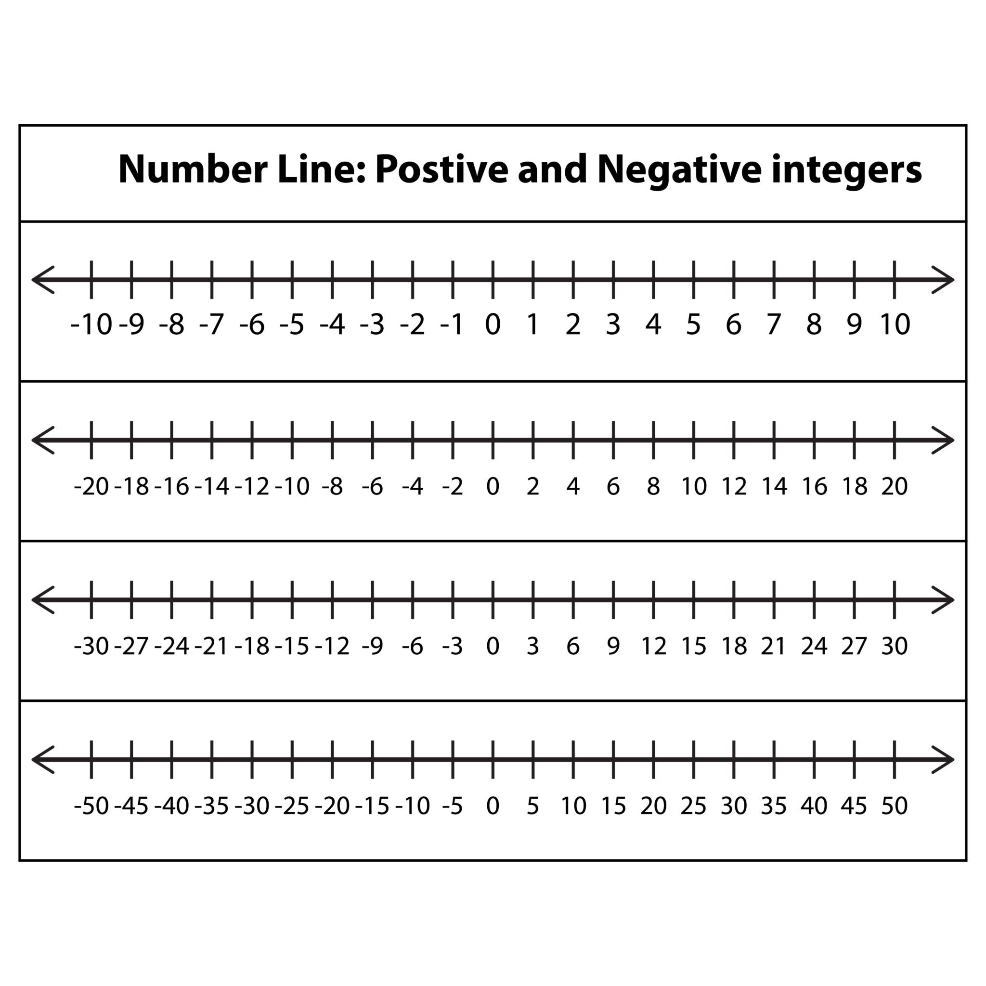
Getty Images
- Key NJSLS:
  - 6.NS.C.5: Understand positive and negative numbers.
  - 6.NS.C.6: Understand a rational number as a point on the number line.
  - 6.NS.C.7: Understand ordering and absolute value of rational numbers.

🌷 April: Geometry (Part 1 - Area & The Coordinate Plane)
- Focus: Applying number sense to geometry.
- Key Concepts:
  - The Coordinate Plane: Drawing polygons in the coordinate plane (all four quadrants) given coordinates for the vertices.
  - Distance on the Plane: Using absolute value to find the distance between points with the same first or second coordinate (e.g., distance between (-2, 3) and (4, 3)).
  - Area: Finding the area of triangles, special quadrilaterals (parallelograms, trapezoids), and polygons by composing or decomposing them into simpler shapes.
- Key NJSLS:
  - 6.NS.C.8: Solve problems by graphing points in all four quadrants.
  - 6.G.A.1: Find the area of triangles, quadrilaterals, and polygons.
  - 6.G.A.3: Draw polygons in the coordinate plane.

☀️ May: Geometry (Part 2 - Surface Area & Volume)
- Focus: Extending geometric measurement to 3D figures.
- Key Concepts:
  - Volume: Finding the volume of right rectangular prisms with fractional edge lengths (e.g., $V = lwh$).
  - Nets: Representing 3D figures (prisms and pyramids) using nets made of rectangles and triangles.
  - Surface Area: Using nets to find the surface area of 3D figures.
- Key NJSLS:
  - 6.G.A.2: Find the volume of rectangular prisms with fractional edge lengths.
  - 6.G.A.4: Represent 3D figures using nets and find surface area.

⛱️ June: Statistics & Probability
- Focus: Developing an understanding of statistical variability and summarizing data.
- Key Concepts:
  - Statistical Questions: Recognizing a statistical question as one that anticipates variability (e.g., "How old are the students in my school?" vs. "How old am I?").
  - Data Displays: Displaying numerical data in dot plots, histograms, and box plots.
  - Measures of Center: Calculating and interpreting the mean, median, and mode.
  - Measures of Variability: Describing data spread using range and Interquartile Range (IQR).
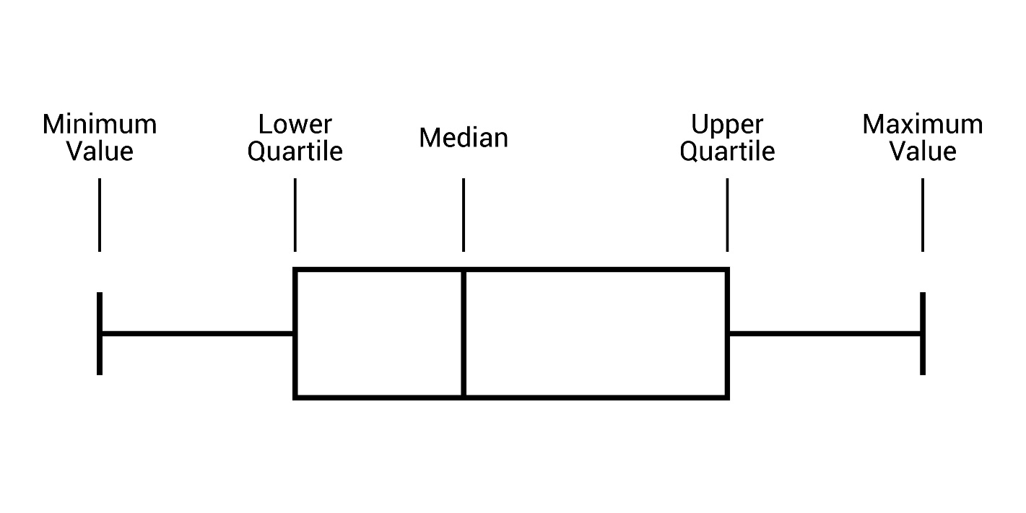
Shutterstock
- Key NJSLS:
  - 6.SP.A.1, 6.SP.A.2, 6.SP.A.3: Understand statistical variability and measures of center/spread.
  - 6.SP.B.4, 6.SP.B.5: Display and summarize numerical data.

