2nd Grade Math Scope and Sequence, aligned with the New Jersey Student Learning Standards (NJSLS)
This plan focuses on building deep number sense with 2- and 3-digit numbers, applying those skills to real-world contexts like money and measurement, and introducing the foundational concepts for multiplication and fractions.

🍎 September: Routines, Data & Fact Fluency
- Focus: Establishing math routines, reviewing 1st-grade facts, and organizing data.
- Key Concepts:
  - Fact Fluency: Strategies for solving addition and subtraction facts within 20 (e.g., doubles, make-a-ten). Goal: Fluency by end of year.
  - Data: Collecting, sorting, and representing data.
  - Graphing: Drawing and interpreting picture graphs and bar graphs (with up to four categories).
  - Odd & Even: Identifying numbers as odd or even.
- Key NJSLS:
  - 2.OA.B.2: Fluently add and subtract within 20.
  - 2.MD.D.10: Draw a picture graph and a bar graph to represent data.
  - 2.OA.C.3: Determine whether a group of objects has an odd or even number.

🎃 October: Place Value to 1,000
- Focus: Understanding the "hundreds" place.
- Key Concepts:
  - Place Value: Understanding that a "hundred" is a bundle of 10 tens.
  - Representing Numbers: Reading, writing, and representing numbers to 1,000 using standard form (735), word form (seven hundred thirty-five), and expanded form ($700 + 30 + 5$).
  - Counting: Skip-counting by 5s, 10s, and 100s within 1,000.
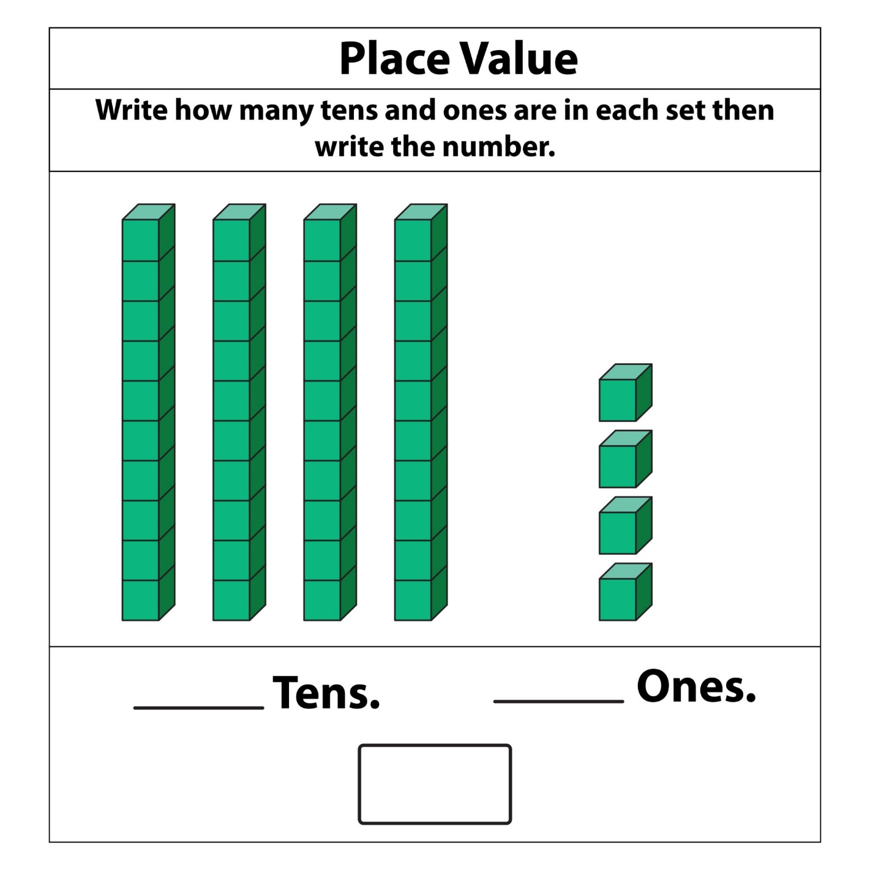
Getty Images
- Key NJSLS:
  - 2.NBT.A.1: Understand that the three digits of a three-digit number represent amounts of hundreds, tens, and ones.
  - 2.NBT.A.2: Count within 1000; skip-count by 5s, 10s, and 100s.
  - 2.NBT.A.3: Read and write numbers to 1000.

🦃 November: 2-Digit Addition & Word Problems
- Focus: Adding within 100 with and without regrouping.
- Key Concepts:
  - Strategies: Using place value charts, base-ten blocks, number lines, and properties of operations to add.
  - Regrouping: Understanding when to "make a new ten."
  - Word Problems: Solving one-step addition word problems (put together, add to).
- Key NJSLS:
  - 2.NBT.B.5: Fluently add and subtract within 100.
  - 2.OA.A.1: Use addition and subtraction within 100 to solve one- and two-step word problems.
  - 2.NBT.B.9: Explain why addition and subtraction strategies work, using place value.

❄️ December: 2-Digit Subtraction
- Focus: Subtracting within 100 with and without regrouping.
- Key Concepts:
  - Strategies: Using place value charts, base-ten blocks, number lines, and the relationship between addition and subtraction.
  - Regrouping: Understanding when to "decompose" or "unbundle" a ten.
  - Word Problems: Solving one-step subtraction word problems (take from, take apart, compare).
- Key NJSLS:
  - 2.NBT.B.5: Fluently add and subtract within 100.
  - 2.OA.A.1: Continue with subtraction word problems.

☃️ January: 3-Digit Addition & Subtraction
- Focus: Applying 2-digit strategies to larger numbers.
- Key Concepts:
  - Comparing Numbers: Using <, >, and = to compare three-digit numbers.
  - Adding & Subtracting 10/100: Mentally adding or subtracting 10 or 100 from a given number.
  - 3-Digit Operations: Adding and subtracting within 1,000 using models and place value strategies. (Fluency is not expected, but understanding is).
- Key NJSLS:
  - 2.NBT.A.4: Compare two three-digit numbers.
  - 2.NBT.B.8: Mentally add 10 or 100 to a given number... and subtract 10 or 100.
  - 2.NBT.B.7: Add and subtract within 1000, using concrete models or drawings.

❤️ February: Money
- Focus: Applying addition and subtraction skills to a real-world context.
- Key Concepts:
  - Coin Identification: Identifying pennies, nickels, dimes, and quarters and their values.
  - Counting Collections: Finding the total value of a group of coins (e.g., 2 dimes, 3 nickels, 4 pennies).
  - Word Problems: Solving word problems involving money ($ and ¢ symbols).
- Key NJSLS:
  - 2.MD.C.8: Solve word problems involving dollar bills, quarters, dimes, nickels, and pennies, using $ and ¢ symbols.

🍀 March: Measurement (Length)
- Focus: Understanding standard units of length.
- Key Concepts:
  - Tools: Selecting and using appropriate tools (rulers, yardsticks, meter sticks, measuring tapes).
  - Units: Measuring in inches, feet, centimeters, and meters.
  - Estimation: Estimating lengths.
  - Comparing Lengths: Measuring two objects and finding the difference in length.
- Key NJSLS:
  - 2.MD.A.1: Measure the length of an object by selecting and using appropriate tools.
  - 2.MD.A.3: Estimate lengths using units of inches, feet, centimeters, and meters.
  - 2.MD.A.4: Measure to determine how much longer one object is than another.

🌷 April: Time & Data (Line Plots)
- Focus: Telling time to the nearest 5 minutes and introducing line plots.
- Key Concepts:
  - Telling Time: Telling and writing time from analog and digital clocks to the nearest five minutes.
  - A.M. & P.M.: Understanding the difference.
  - Line Plots: Measuring objects and generating measurement data, then plotting that data on a line plot.
- Key NJSLS:
  - 2.MD.C.7: Tell and write time from analog and digital clocks to the nearest five minutes, using a.m. and p.m.
  - 2.MD.D.9: Generate measurement data... [and] show the data by making a line plot.

☀️ May: Geometry & Fractions
- Focus: Identifying shapes and partitioning them into equal shares.
- Key Concepts:
  - 2D & 3D Shapes: Identifying triangles, quadrilaterals, pentagons, hexagons, and cubes by their attributes (e.g., number of angles, faces).
  - Partitioning: Dividing rectangles and circles into two, three, or four equal shares.
  - Fraction Language: Using the words halves, thirds, fourths, half of, a third of, etc.
- Key NJSLS:
  - 2.G.A.1: Recognize and draw shapes having specified attributes.
  - 2.G.A.3: Partition circles and rectangles into two, three, or four equal shares.

⛱️ June: Foundations for Multiplication & Review
- Focus: Connecting repeated addition to multiplication and reviewing key concepts.
- Key Concepts:
  - Arrays: Using repeated addition to find the total number of objects in rectangular arrays (e.g., 5 rows of 3).
  - Equal Groups: Building on odd/even to see groups.
  - Spiral Review: Reviewing major concepts from the year (place value, 2-digit operations, money) through games and projects.
- Key NJSLS:
  - 2.OA.C.4: Use addition to find the total number of objects arranged in rectangular arrays... (Foundation for multiplication).
  - (Review) All major 2.NBT and 2.OA standards.

