1st Grade Math Scope and Sequence, aligned with the New Jersey Student Learning Standards (NJSLS)
This plan is structured to build foundational number sense first, then move into operations, place value, and finally geometry and measurement applications.

🍎 September: Building Routines & Number Sense
- Focus: Establishing math routines, counting, and sorting.
- Key Concepts:
  - Counting, reading, and writing numbers 0-20.
  - Counting forward from any number (not just 1).
  - Sorting objects by attributes (color, size, shape).
  - Introduction to data: organizing and representing data with up to three categories (e.g., class surveys).
- Key NJSLS:
  - 1.NBT.A.1: Count to 120, starting at any number. (Begin with 0-20).
  - 1.MD.C.4: Organize, represent, and interpret data with up to three categories.

🎃 October: Introduction to Addition
- Focus: Understanding addition as "putting together" and "adding to."
- Key Concepts:
  - Solving addition word problems (add to, put together) within 10.
  - Using objects, drawings, and fingers to model addition.
  - Relating counting to addition (counting on).
  - Introducing the "+" (plus) and "=" (equal) signs.
- Key NJSLS:
  - 1.OA.A.1: Use addition and subtraction within 20 to solve word problems. (Focus on addition within 10).
  - 1.OA.C.5: Relate counting to addition and subtraction (e.g., by counting on 2 to add 2).
  - 1.OA.C.6: Add and subtract within 20. (Focus on addition within 10).

🦃 November: Introduction to Subtraction
- Focus: Understanding subtraction as "taking from" and "taking apart."
- Key Concepts:
  - Solving subtraction word problems (take from, take apart) within 10.
  - Using objects and drawings to model subtraction.
  - Understanding subtraction as an unknown-addend problem (e.g., $10 - 8$ by finding the number that makes 10 when added to 8).
  - Relating counting to subtraction (counting back).
- Key NJSLS:
  - 1.OA.A.1: Continue with word problems, now focusing on subtraction within 10.
  - 1.OA.B.4: Understand subtraction as an unknown-addend problem.
  - 1.OA.C.5: Relate counting to subtraction.

❄️ December: Addition & Subtraction Strategies
- Focus: Developing strategies for fluency within 10 and understanding the relationship between addition and subtraction.
- Key Concepts:
  - Fact Families: Understanding the inverse relationship ($3+4=7$, $4+3=7$, $7-3=4$, $7-4=3$).
  - Properties of Operations: Commutative property (turn-around facts: $3+4 = 4+3$) and Associative property (making 10).
  - Understanding the meaning of the equal sign (true/false equations: $6 = 6$, $7 = 8 - 1$).
  - Solving word problems involving "comparison" (e.g., "How many more?").
- Key NJSLS:
  - 1.OA.B.3: Apply properties of operations as strategies to add and subtract.
  - 1.OA.D.7: Understand the meaning of the equal sign.
  - 1.OA.D.8: Determine the unknown whole number in an addition or subtraction equation.

☃️ January: Place Value (Tens and Ones)
- Focus: Building the foundation for two-digit numbers.
- Key Concepts:
  - Understanding that 10 can be thought of as a "bundle of ten ones."
  - Representing numbers 11-19 as one ten and some ones.
  - Understanding the two digits of a two-digit number represent amounts of tens and ones.
  - Reading, writing, and counting to 120.
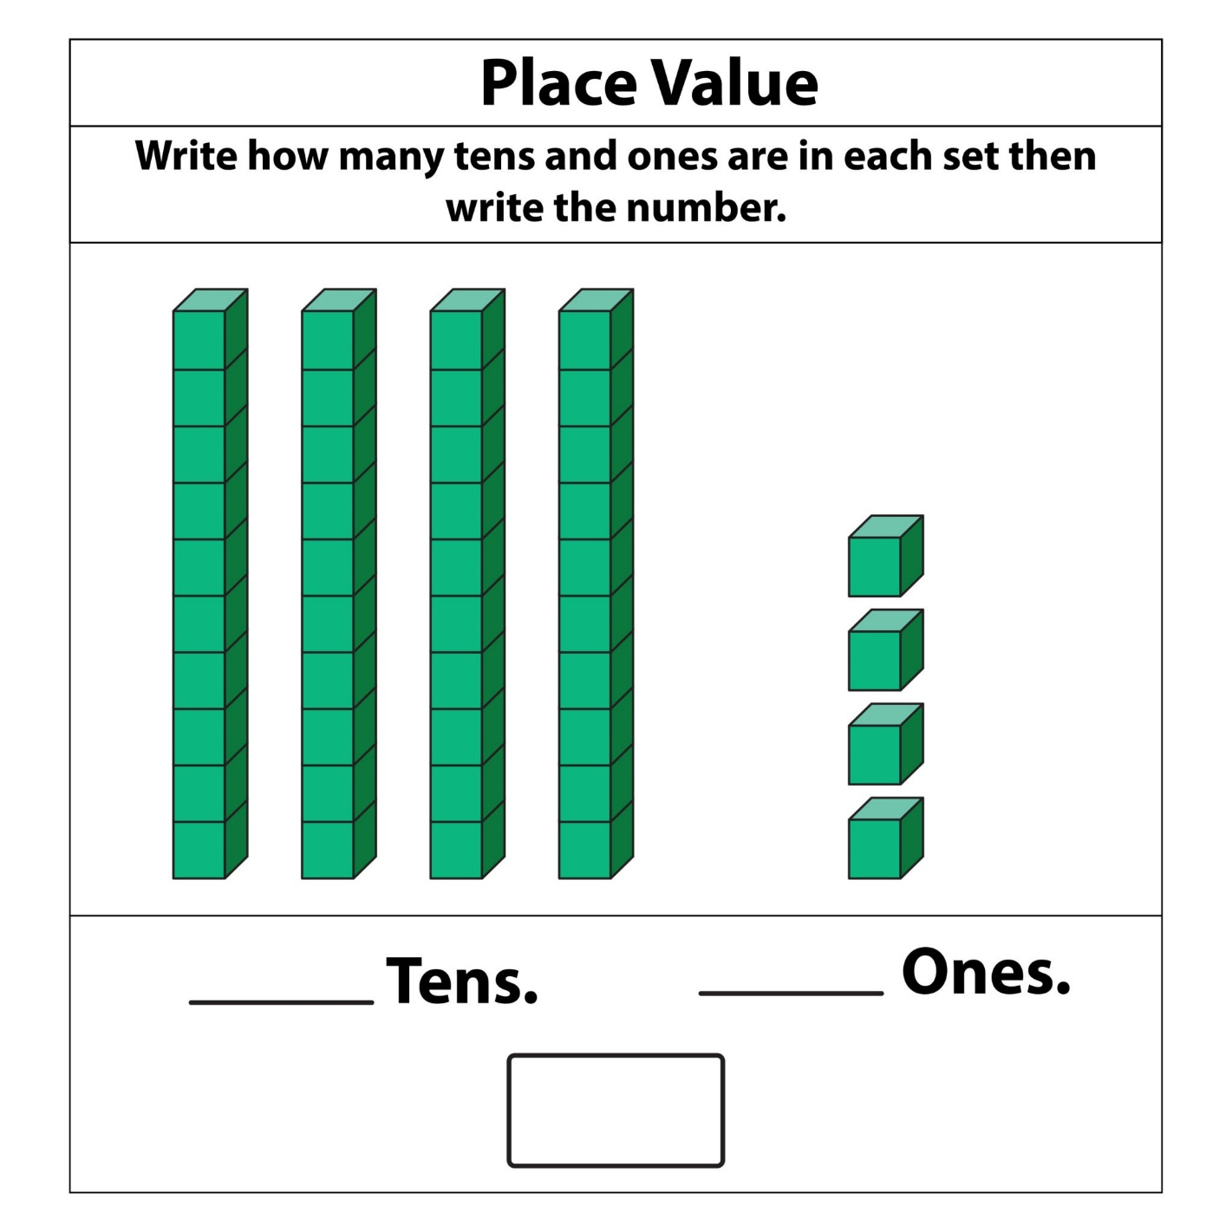
Getty Images
- Key NJSLS:
  - 1.NBT.A.1: Count to 120, read and write numerals.
  - 1.NBT.B.2: Understand that the two digits of a two-digit number represent amounts of tens and ones.

❤️ February: Comparing & Using Place Value
- Focus: Using place value to compare numbers and begin two-digit addition.
- Key Concepts:
  - Comparing numbers: Using <, >, and = to compare two-digit numbers based on tens and ones.
  - 10 more / 10 less: Mentally finding 10 more or 10 less than a number without counting.
  - Adding within 100: Adding a two-digit number and a one-digit number (e.g., $23 + 5$).
  - Adding within 100: Adding a two-digit number and a multiple of 10 (e.g., $23 + 20$).
- Key NJSLS:
  - 1.NBT.B.3: Compare two two-digit numbers.
  - 1.NBT.C.4: Add within 100 (a two-digit number and a one-digit number; a two-digit number and a multiple of 10).
  - 1.NBT.C.5: Given a two-digit number, mentally find 10 more or 10 less.

🍀 March: Measurement
- Focus: Measuring length using non-standard units.
- Key Concepts:
  - Ordering three objects by length; comparing two objects directly.
  - Measuring the length of an object using non-standard units (e.g., paper clips, cubes).
  - Understanding that measurements must have no gaps or overlaps.
- Key NJSLS:
  - 1.MD.A.1: Order three objects by length; compare the lengths of two objects.
  - 1.MD.A.2: Express the length of an object as a whole number of length units (using non-standard units).

🌷 April: Telling Time & Data Review
- Focus: Telling time to the hour and half-hour; applying data skills.
- Key Concepts:
  - Identifying the hour and minute hands on an analog clock.
  - Telling and writing time to the hour (e.g., 3:00).
  - Telling and writing time to the half-hour (e.g., 3:30).
  - Revisiting data (1.MD.C.4) by creating and interpreting tally charts, picture graphs, and bar graphs to answer "how many" and "how many more/less" questions.
- Key NJSLS:
  - 1.MD.B.3: Tell and write time in hours and half-hours using analog and digital clocks.
  - 1.MD.C.4: (Review and Apply) Represent and interpret data.

☀️ May: Geometry (2D & 3D Shapes)
- Focus: Identifying, describing, and composing shapes.
- Key Concepts:
  - Defining vs. Non-Defining Attributes: Understanding what makes a shape (e.g., a triangle is closed and has 3 sides) versus what doesn't (e.g., its color or size).
  - Identifying 2D shapes (squares, rectangles, triangles, circles, trapezoids, rhombuses, hexagons).
  - Identifying 3D shapes (cubes, rectangular prisms, cones, cylinders, spheres).
  - Composing new shapes from other shapes (e.g., using two triangles to make a rhombus).
- Key NJSLS:
  - 1.G.A.1: Distinguish between defining attributes vs. non-defining attributes.
  - 1.G.A.2: Compose two-dimensional shapes or three-dimensional shapes.

⛱️ June: Partitioning & Year-End Review
- Focus: Introduction to fractions and reviewing all major concepts.
- Key Concepts:
  - Partitioning Shapes: Dividing circles and rectangles into two equal shares (halves) and four equal shares (fourths or quarters).
  - Using fraction language ("half of," "fourth of").
  - Review: Spiral review of all 1.OA, 1.NBT, and 1.MD standards through games, projects, and learning centers.
  - Building fluency for addition and subtraction facts within 20.
- Key NJSLS:
  - 1.G.A.3: Partition circles and rectangles into two and four equal shares.
  - 1.OA.C.6: (Review) Fluently add and subtract within 20.

