Kindergarten Math September-to-June Scope and Sequence, aligned with the New Jersey Student Learning Standards (NJSLS)
This plan is built on a logical progression, starting with concrete number sense and moving to abstract concepts like addition and subtraction. The domains are integrated, but Counting and Cardinality (K.CC) is the foundational focus for most of the year.

🏃‍♀️ Ongoing Mathematical Practices (Practiced Daily, All Year)
These skills are the "how-to" of math and are integrated into every lesson:
- Make sense of problems and persevere in solving them. (e.g., trying a different strategy when one doesn't work).
- Reason abstractly and quantitatively. (e.g., understanding that the number "3" represents three real-world objects).
- Model with mathematics. (e.g., using blocks, drawings, or a ten-frame to show a number).
- Use appropriate tools strategically. (e.g., choosing to use a number line or counters).

🍂 September: Unit 1 - Building a Math Community
- Unit Theme: Routines, Sorting, and Numbers 0-5
- Unit Focus: Establishing math routines. Understanding how to sort objects and beginning to count and recognize numbers 0-5.
- Standards Spotlight:
  - K.MD.B.3: Classify objects into given categories (e.g., "all the red blocks," "all the big buttons"). Count the number of objects in each category.
  - K.CC.A.3: Write numbers 0-5.
  - K.CC.B.4: Understand the relationship between numbers and quantities (connecting 1, 2, 3, 4, 5 to that many objects).
  - K.CC.B.4a: When counting, pair each object with one and only one number name (one-to-one correspondence).

🎃 October: Unit 2 - Counting & Comparing Sets
- Unit Theme: How Many? (Numbers 0-10)
- Unit Focus: Mastering one-to-one correspondence. Counting to find "how many?" and comparing two groups to see which has "more" or "less."
- Standards Spotlight:
  - K.CC.B.5: Count to answer "how many?" questions about as many as 20 things. (Focus on 0-10 this month).
  - K.CC.C.6: Identify whether the number of objects in one group is greater than, less than, or equal to the number of objects in another group.
  - K.CC.A.3: Write numbers 0-10.

🦃 November: Unit 3 - Shapes All Around
- Unit Theme: Counting On & 2D Shapes
- Unit Focus: Continuing to build the counting sequence (to 20). Identifying and describing 2D (flat) shapes.
- Standards Spotlight:
  - K.CC.A.1: Count to 100 by ones. (This is a year-long goal; aim for 20-30).
  - K.CC.A.2: Count forward beginning from a given number (e.g., "Start at 4... 4, 5, 6...").
  - K.G.A.2: Correctly name shapes regardless of their orientation or size (e.g., square, circle, triangle, rectangle, hexagon).
  - K.G.B.4: Analyze and compare 2D shapes, describing attributes like number of sides and corners.
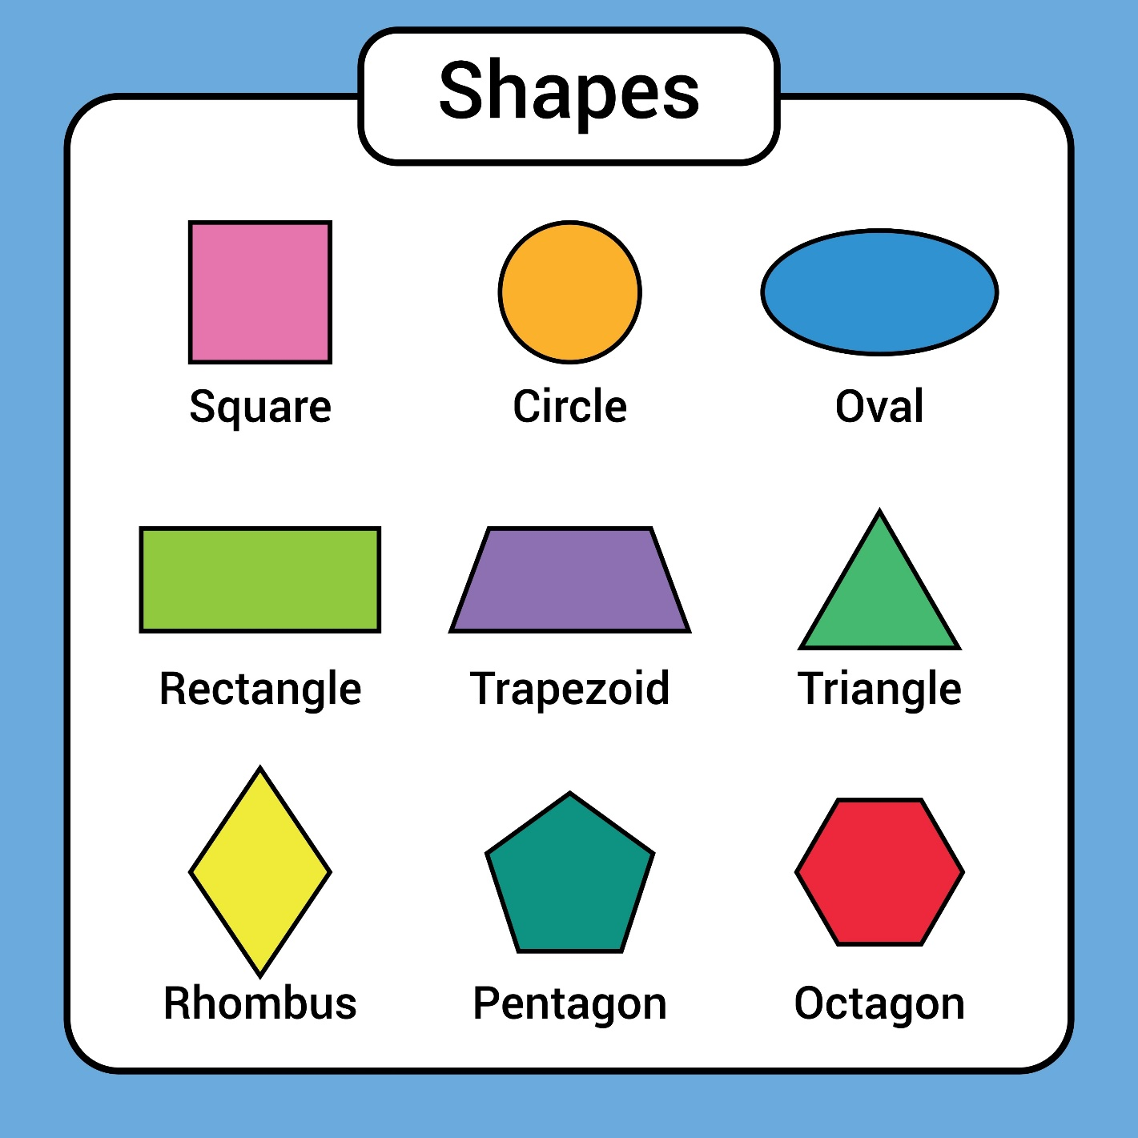
Shutterstock

❄️ December: Unit 4 - Introduction to Addition
- Unit Theme: Putting Together
- Unit Focus: Understanding addition as "putting together" or "adding to." Solving simple addition problems using objects and drawings.
- Standards Spotlight:
  - K.OA.A.1: Represent addition with objects, fingers, mental images, drawings, or sounds (e.g., claps).
  - K.OA.A.2: Solve addition word problems (within 10). (e.g., "There are 3 red apples and 2 green apples. How many apples in all?").

🧊 January: Unit 5 - Introduction to Subtraction
- Unit Theme: Taking Apart
- Unit Focus: Understanding subtraction as "taking apart" or "taking from." Solving simple subtraction problems.
- Standards Spotlight:
  - K.OA.A.1: Represent subtraction with objects, fingers, drawings, etc.
  - K.OA.A.2: Solve subtraction word problems (within 10).
  - K.OA.A.5: Begin practicing fluency for addition and subtraction within 5. (e.g., 2+1, 3-2).

❤️ February: Unit 6 - Partners of 10 & 3D Shapes
- Unit Theme: Making 10 & Solid Shapes
- Unit Focus: Decomposing numbers (especially "making 10"). Identifying and describing 3D (solid) shapes.
- Standards Spotlight:
  - K.OA.A.3: Decompose numbers less than or equal to 10 into pairs in more than one way (e.g., 7 = 3 + 4 and 7 = 5 + 2).
  - K.OA.A.4: For any number from 1 to 9, find the number that makes 10 when added to it.
  - K.G.A.2: Correctly name 3D shapes (e.g., cube, cone, cylinder, sphere).
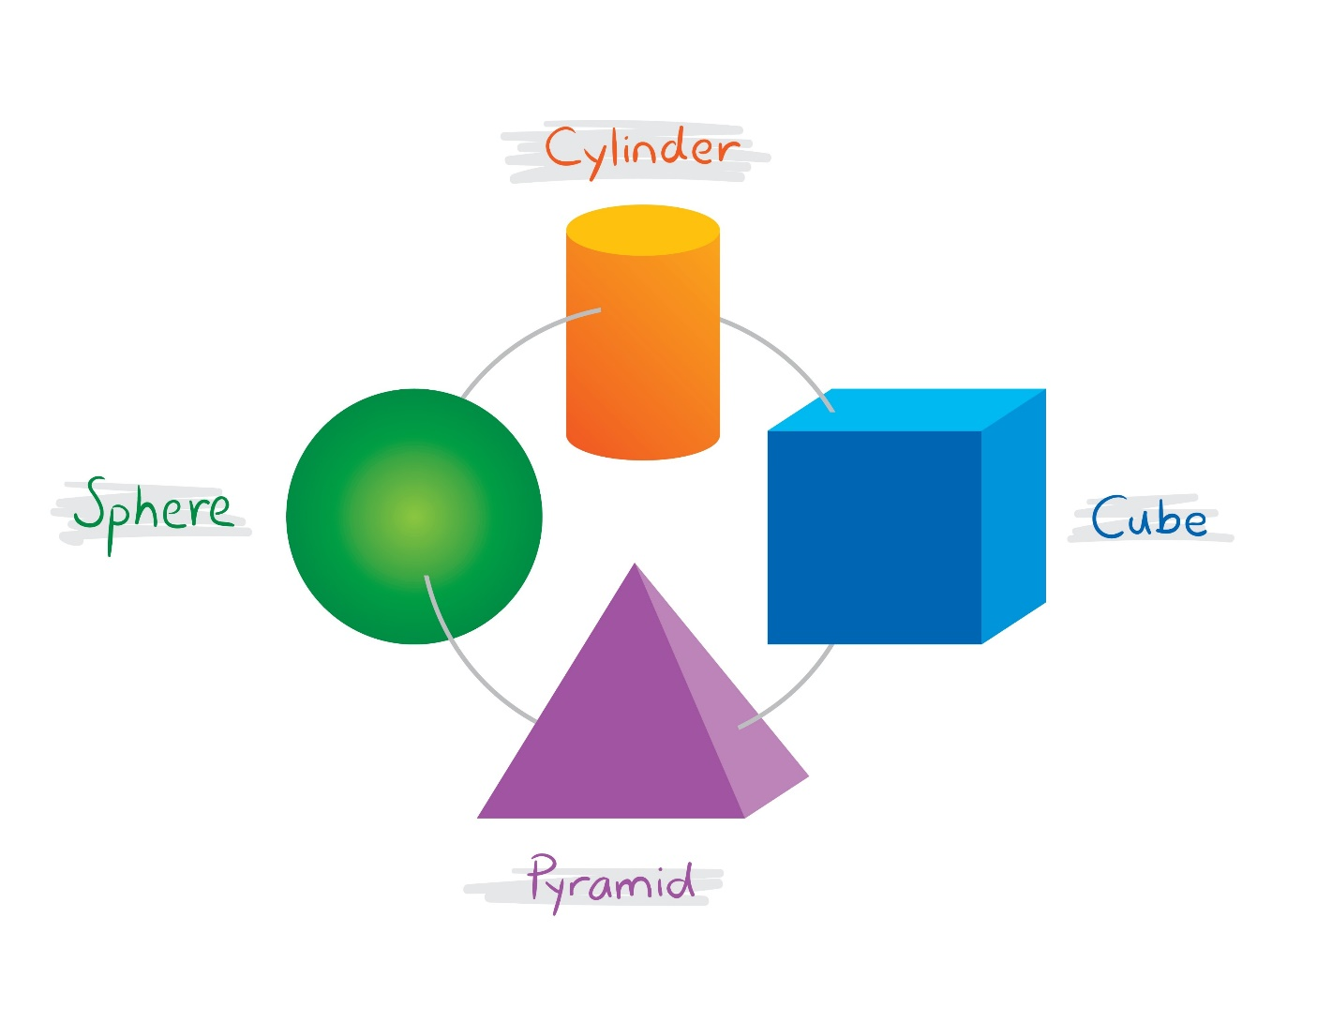
Shutterstock
* **K.G.B.4:** Analyze and compare 2D ("flat") and 3D ("solid") shapes.

🌷 March: Unit 7 - Understanding "Teen" Numbers
- Unit Theme: Numbers 11-19 (Place Value)
- Unit Focus: This is a critical unit. Students understand that "teen" numbers are made of "a ten and some ones." This is the foundation of place value.
- Standards Spotlight:
  - K.NBT.A.1: Compose and decompose numbers from 11 to 19 into ten ones and some further ones (e.g., 14 is 10 + 4).
  - K.CC.A.1: Continue counting to 100 by ones. (Aim for 50-75).
  - K.CC.A.3: Write numbers 0-20.

🌎 April: Unit 8 - Measurement
- Unit Theme: Describing Our World
- Unit Focus: Describing and comparing objects using measurable attributes (length, height, weight).
- Standards Spotlight:
  - K.MD.A.1: Describe measurable attributes of objects, such as length or weight.
  - K.MD.A.2: Directly compare two objects with a measurable attribute in common (e.g., "Which is longer? Which is heavier?").

☀️ May: Unit 9 - Counting to 100
- Unit Theme: The 100 Chart
- Unit Focus: Mastering the counting sequence to 100 by ones and by tens.
- Standards Spotlight:
  - K.CC.A.1: Count to 100 by ones and by tens.

🎓 June: Unit 10 - Putting It All Together
- Unit Theme: Ready for First Grade!
- Unit Focus: Reviewing all major concepts (addition, subtraction, shapes, counting) in preparation for 1st grade.
- Standards Spotlight:
  - K.G.A.1: Describe the relative position of objects (e.g., above, below, beside, in front of, behind).
  - Review all K.OA and K.CC standards through games, learning centers, and problem-solving activities.

