3rd Grade ELA September-to-June Scope and Sequence, aligned with the New Jersey Student Learning Standards (NJSLS)
This plan is built around thematic units, with key standards spiraling. The 3rd-grade year marks a significant shift from "learning to read" to "reading to learn," with a heavy focus on citing textual evidence, understanding nonfiction text structures, and writing developed, multi-paragraph pieces.

🏃‍♀️ Ongoing Foundational Skills (Taught Daily, All Year)
These skills are the bedrock of 3rd grade and are practiced continuously, not just in one unit.
- Phonics & Word Recognition (RF.3.3): Decoding multisyllabic words; knowing and applying grade-level phonics and word analysis skills; reading common prefixes (e.g., un-, re-, dis-) and suffixes (e.g., -ful, -less, -er, -est).
- Fluency (RF.3.4): Reading grade-level text with purpose and understanding, reading prose and poetry with accuracy, appropriate rate, and expression.
- Speaking & Listening (SL.3.1, SL.3.6): Engaging in collaborative conversations, building on others' ideas, and speaking in complete, appropriate sentences to express ideas.

🍂 September: Building a Community of Readers & Writers
- Unit Theme: Who We Are; Our Community
- Unit Focus: Establishing workshop routines, building reading stamina, and introducing the year's most important skill: citing textual evidence. Mastering the personal narrative.

Standards Spotlight
- Reading (RL.3.1 & RI.3.1): Asking and answering questions to demonstrate understanding, referring explicitly to the text as the basis for the answers.
- Writing (W.3.3): Writing a personal narrative that establishes a situation, uses dialogue and descriptions of actions/thoughts/feelings, and provides a sense of closure.
- Language (L.3.2c): Using commas and quotation marks in dialogue (a key 3rd-grade skill).
- Language (L.3.1a): Explaining the function of nouns, pronouns, verbs, adjectives, and adverbs.

🎃 October: Navigating Nonfiction
- Unit Theme: The World Around Us; Animals; Biographies
- Unit Focus: Identifying the main idea of a text and supporting it with key details.

Standards Spotlight
- Reading (RI.3.2): Determining the main idea of a text; recounting the key details and explaining how they support the main idea.
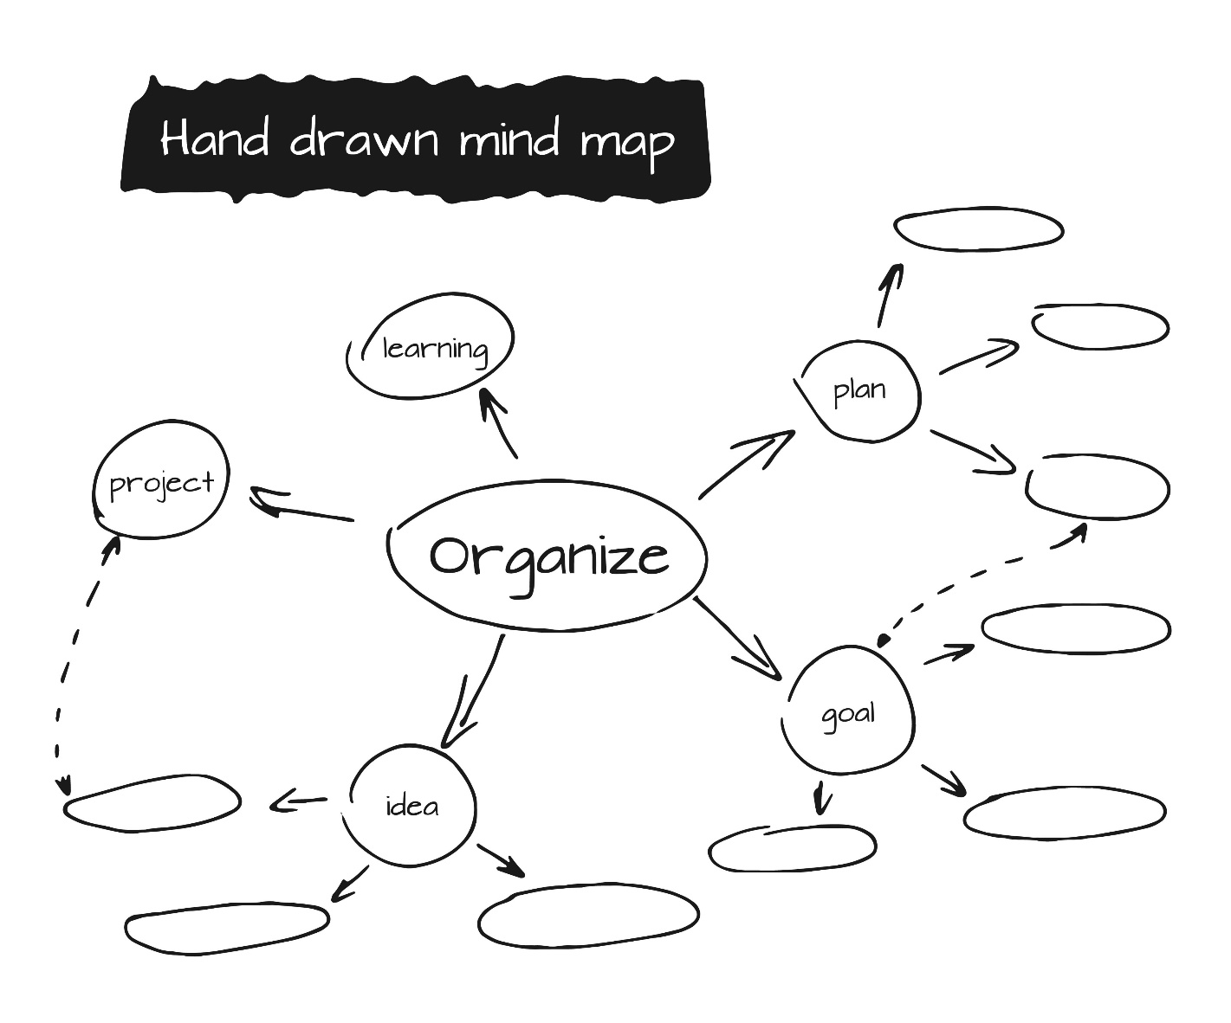
Shutterstock
- Reading (RI.3.7): Using information gained from illustrations (e.g., maps, photographs) and the words in a text to demonstrate understanding.
- Writing (W.3.2): Writing an informative/explanatory text that introduces a topic, groups related information, and uses facts and definitions (e.g., a "main idea" paragraph).
- Language (L.3.1b, d, e): Forming and using regular and irregular plural nouns and verbs; using subject-verb agreement.

🦃 November: Understanding Characters & Culture
- Unit Theme: Folktales, Fables, and Myths; Gratitude
- Unit Focus: Analyzing characters in depth and determining the central message or lesson of a story.

Standards Spotlight
- Reading (RL.3.2): Recounting stories, including fables, folktales, and myths from diverse cultures; determining the central message, lesson, or moral and explaining how it is conveyed.
- Reading (RL.3.3): Describing characters in a story (e.g., their traits, motivations, feelings) and explaining how their actions contribute to the plot.
- Writing (W.3.1): Writing an opinion piece that introduces a topic, states an opinion, and provides reasons to support it (e.g., "My favorite character is... because...").
- Language (L.3.1g): Forming and using comparative and superlative adjectives and adverbs (e.g., big, bigger, biggest).

❄️ December: Comparing Perspectives
- Unit Theme: Different Voices, Different Versions; Holidays
- Unit Focus: Comparing and contrasting stories and informational texts; distinguishing point of view.

Standards Spotlight
- Reading (RL.3.6): Distinguishing their own point of view from that of the narrator or those of the characters.
- Reading (RL.3.9): Comparing and contrasting the themes, settings, and plots of stories written by the same author about the same or similar characters.
- Reading (RI.3.9): Comparing and contrasting the most important points and key details presented in two texts on the same topic.
- Writing (W.3.2): Writing an informative piece that compares and contrasts (e.g., using a Venn diagram to structure a paragraph).
- Language (L.3.1h): Using coordinating and subordinating conjunctions (and, or, but, so, because).

🧊 January: The "Expert" Project: Informational Writing
- Unit Theme: Biographies (MLK); Science Topics (e.g., Weather, Matter)
- Unit Focus: Becoming "experts" on a topic and writing a multi-paragraph informational report.

Standards Spotlight
- Reading (RI.3.3): Describing the relationship between a series of historical events, scientific ideas, or steps in a procedure (e.g., first, next, then).
- Writing (W.3.2): Writing an informative text that groups related information into paragraphs, includes illustrations, and provides a concluding statement.
- Writing (W.3.5): With guidance, strengthening writing through the writing process (planning, drafting, revising, editing).
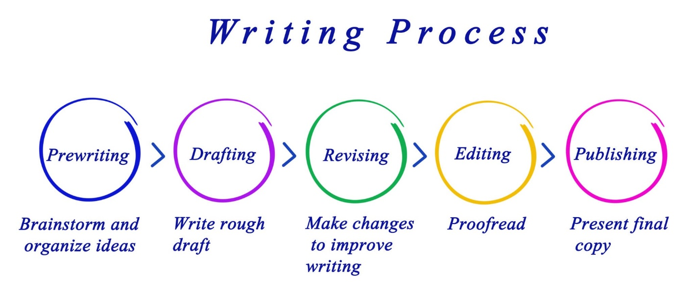
Getty Images
- Language (L.3.1c): Using abstract nouns (e.g., childhood, courage, justice).

❤️ February: The Power of Persuasion & Poetry
- Unit Theme: Making a Change; Expressing Ourselves
- Unit Focus: Writing a structured, multi-paragraph opinion piece and exploring literal vs. nonliteral language.

Standards Spotlight
- Reading (RL.3.4): Determining the meaning of words and phrases, distinguishing literal from nonliteral language (e.g., figurative language like similes).
- Reading (RL.3.5): Referring to parts of stories, dramas, and poems using terms like chapter, scene, and stanza.
- Writing (W.3.1): Writing a complete opinion piece with an organizational structure: an introduction that states the opinion, paragraphs that provide reasons, and a conclusion.
- Language (L.3.5): Understanding figurative language; distinguishing shades of meaning.

🌷 March: Unlocking Text Structures
- Unit Theme: Science & The Natural World
- Unit Focus: Identifying and using nonfiction text structures (cause/effect, sequence, problem/solution) to understand texts.

Standards Spotlight
- Reading (RI.3.8): Describing the logical connection between sentences and paragraphs in a text (e.g., cause/effect, comparison, sequence).
- Reading (RI.3.3): Applying understanding of sequence to scientific procedures and cause/effect to natural phenomena.
- Writing (W.3.2): Writing an informative piece that uses a text structure (e.g., a "how-to" piece using sequential language).
- Language (L.3.1i): Producing simple, compound, and complex sentences.

🌎 April: The Short Research Project
- Unit Theme: Our Planet; Animals; Biographies
- Unit Focus: Conducting a short research project, from note-taking to final product.

Standards Spotlight
- Writing (W.3.7): Conducting short research projects that build knowledge about a topic.
- Writing (W.3.8): Recalling information from experience or gathering information from print and digital sources; taking brief notes on sources and sorting evidence.
- Reading (RI.3.5): Using text features and search tools (e.g., keywords, hyperlinks) to locate information efficiently.
- Language (L.3.2g): Using glossaries and dictionaries to determine word meaning.

☀️ May: Genre Study: Fantasy & Realistic Fiction
- Unit Theme: Magic, Mystery, and Real-Life Adventures
- Unit Focus: Applying all reading analysis skills to a high-interest genre; writing a creative, developed narrative.

Standards Spotlight
- Reading (All RL): Applying skills of character analysis (RL.3.3), central message (RL.3.2), and point of view (RL.3.6) to a new genre.
- Reading (RL.3.10): By the end of the year, reading and comprehending literature at the high end of the grades 2–3 text complexity band.
- Writing (W.3.3): Writing a creative fictional narrative that applies strong story structure, dialogue, and description.
- Language (Review): Reviewing all grammar and conventions in the context of editing.

🎓 June: Reflecting & Publishing
- Unit Theme: Looking Back, Looking Forward
- Unit Focus: Celebrating growth, publishing a final piece, and preparing for 4th grade.

Standards Spotlight
- Writing (W.3.4, W.3.6): Producing and publishing writing (independently and with technology) for a specific purpose and audience (e.g., creating a "How to Succeed in 3rd Grade" guide for next year's class).
- Speaking (SL.3.4): Presenting on a topic or text, speaking clearly at an understandable pace, and including relevant details.
- Reading (All): Independent reading projects to demonstrate fluency and comprehension.

