Name Date
Read each question carefully. Determine the best answer to the question from the four answer choices provided.

1 Read the excerpt from Article II of the Articles of Confederation.
“Each state retains its sovereignty, freedom and independence, and every Power, Jurisdiction and right, which is not by this confederation expressly delegated to the United States, in Congress assembled.”
According to the excerpt, how did the Articles of Confederation define Congress’ role?
A Congress would be required to approve the laws of each state.
B Congress would retain only the specific powers it was delegated by the Articles.
C Congress would oversee the sovereignty of each state in accordance to the Articles.
D Congress would maintain legal jurisdiction over the government of each state.

2 Why is it important for people to serve on juries when they are called upon to do so?
A Serving on a jury protects the rights of someone accused of a crime.
B Serving on a jury ensures that lawyers provide adequate counsel to all defendants.
C Serving on a jury helps prevent a defendant from receiving a punishment considered cruel and unusual.
D Serving on a jury provides all Americans with an opportunity to fulfill at least one of their civic duties.

3 What freedoms did many states guarantee in their constitutions? Choose the TWO correct answers.
A trial by jury
B freedom from taxation
C the right to vote for every citizen
D freedom of religion

4 Look at the map.
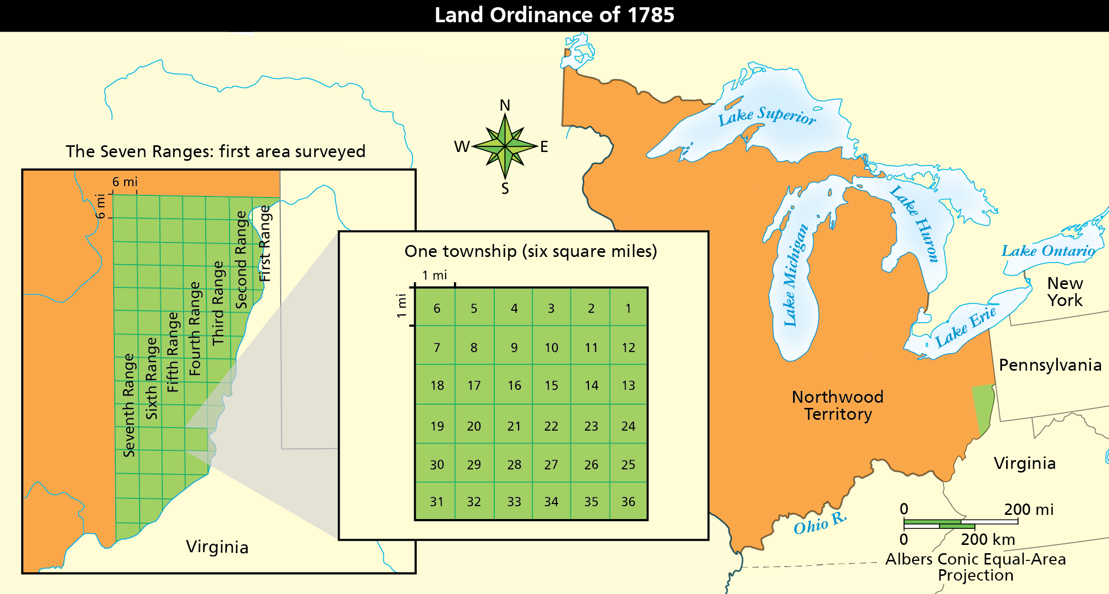
According to the map, approximately how many total sections were available in the Fifth Range?
A 13
B 36
C 468
D 504

5 What prompted the call to rewrite the Articles of Confederation?
A Americans wanted to win independence by unifying the nation.
B Limitations on the central government led to an economic downturn.
C The country needed a national court system to deal with uprising colonists.
D The nation’s westward expansion made it necessary to modify the document.

6 Why did the Great Compromise establish a two-house legislature?
A to fairly represent all states
B to allow for population growth
C to provide checks and balances
D to prevent unconstitutional laws

7 What did the Virginia and New Jersey Plans have in common? Choose the TWO correct answers.
A Both had three branches of government.
B Both had one chief executive chosen by the legislature.
C Both had a legislative branch that included elected representatives.
D Both had the judicial branch chosen by the executive branch.
8 Read Chief Justice John Marshall’s opinion in the case Marbury v. Madison (1803).
“It is emphatically the province and duty of the Judicial Department to say what the law is. Those who apply the rule to particular cases must, of necessity, expound [explain] and interpret that rule. If two laws conflict with each other, the Courts must decide on the operation of each. So, if a law be in opposition to the Constitution, if both the law and the Constitution apply to a particular case, so that the Court must either decide that case conformably [corresponds] to the law, disregarding the Constitution, or conformably to the Constitution, disregarding the law, the Court must determine which of these conflicting rules governs the case. . .”
How does Chief Justice Marshall’s opinion reflect the role of the judicial branch in government?
A His opinion confirms that the branch should disregard laws in order to strictly follow the content of the Constitution.
B His opinion maintains that the judicial branch shall confer with the other branches in its interpretation of the laws.
C His opinion gives power to the judicial branch to declare two opposing laws as equally constitutional on their own merits.
D His opinion demonstrates the need for the judicial branch to decide how laws are applied on a case-by-case basis.

9 Which statement reflects the ideas from the Magna Carta that influenced the writing of the U.S. Constitution?
A People have the right to give their general consent to any new taxes.
B People have the right to a trial by jury and to own private property.
C People have the right to remove elected officials if they abuse their power.
D People have the right to bear arms and not to be imprisoned without being charged.

10 Look at the photograph.
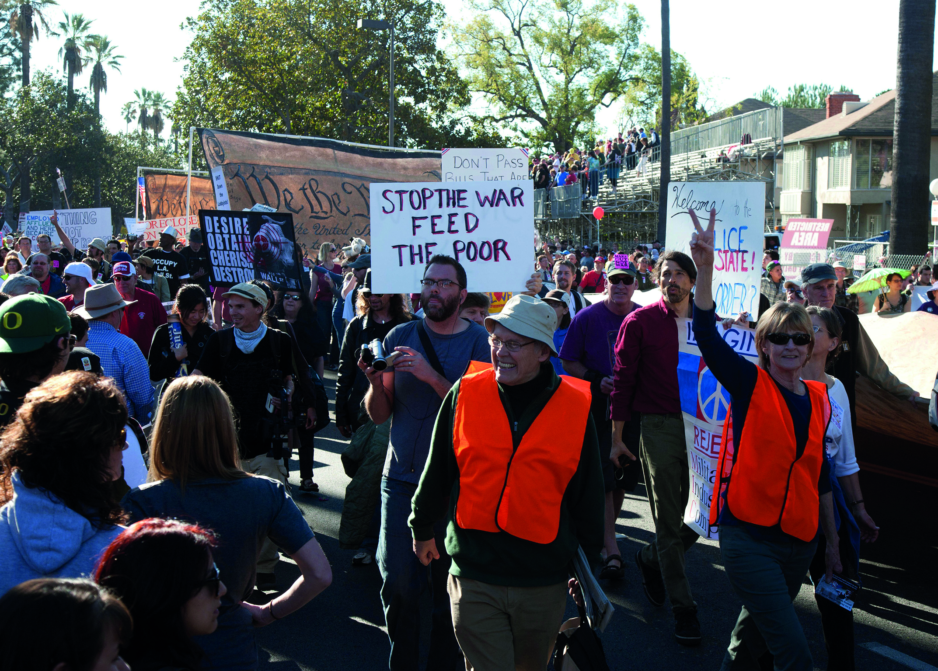
Which statement best characterizes what these Americans are doing?
A They are demonstrating citizens’ responsibility to follow laws and rules.
B They are demonstrating citizens’ responsibility to treat others with respect and courtesy.
C They are exercising citizens’ right to assemble peacefully.
D They are exercising citizens’ right to participate in their community.

11 How did the Federalist Papers generate support for ratifying the Constitution?
A by explaining how the Constitution would protect states’ rights
B by explaining how the national government would weaken the states
C by explaining how the Constitution would require a bill of rights
D by explaining how the government would not function without the Constitution

12 Which aspects of the U.S. Constitution drew inspiration from the English Bill of Rights? Choose the TWO correct answers.
A encouraging citizenship and the common good
B officials and leaders must also obey the law
C regularly held elections of officials
D the right of habeas corpus

13 How does the Constitution reflect the principle of popular sovereignty?
A by limiting the amount of power of the government
B by placing protections on the civil rights of the nation’s citizens
C by implementing safeguards against the abuse of power
D by allowing the people to choose their representatives

14 Read the excerpt from the U.S. Constitution.
“The Migration or Importation of such Persons as any of the States now existing shall think proper to admit, shall not be prohibited by the Congress prior to the Year one thousand eight hundred and eight, but a Tax or duty may be imposed on such Importation, not exceeding ten dollars for each Person.”
What is the main idea of this clause?
A Congress may not restrict the importation of slaves until 1808.
B Congress can require a tax from immigrants coming to the United States before 1808.
C Congress may allow states, who pay a $10 tax, the right to import slaves.
D Congress is prohibited from placing any restrictions on imports and migration.

15 Why is James Madison considered to be the “Father of the Constitution”?
A His ideas about democratic government influenced the writing of the Constitution.
B He wrote the Declaration of Independence.
C He wrote the Anti-Federalist Papers, protecting the rights of the states.
D He developed the Great Compromise.

16 Which of the following groups gained greater political rights when amendments were added to the Constitution?
A American Indians
B African Americans
C Asian Americans
D Hispanic Americans

17 Which of the following grievances included in the Declaration of Independence was addressed in the Bill of Rights?
A “For imposing Taxes on us without our Consent. . . .”
B “For depriving us in many cases, of the benefits of Trial by Jury. . . .”
C “For taking away our Charters, abolishing our most valuable Laws, and altering fundamentally the Forms of our Governments. . . .”
D “For suspending our own Legislatures, and declaring themselves invested with Power to legislate for us in all cases whatsoever.”

18 What effect did the Three-Fifths Compromise have on the southern states?
A It helped increase the number of slaves traded.
B It gave the South the power to outvote the North.
C It limited the number of states that allowed slavery.
D It gave those states more representation in Congress.

19 Read the quotation.
“All bills of credit emitted, monies borrowed, and debts contracted by, or under the authority of Congress, before the assembling of the united states, in pursuance of the present confederation, shall be deemed and considered as a charge against the united states, for payment and satisfaction whereof the said united states, and the public faith are hereby solemnly pledged.”
—Articles of Confederation, Article XII
The main goal of this Article is to
A provide funding for public services and the running of the central government.
B place the responsibility of financing the central government on the states.
C prevent the nation from collapsing from debt.
D ensure the government had financial power and authority over the individual states.

20 Which of the following are examples of republicanism, as set forth by the Constitution? Choose the TWO correct answers.
A Citizens elect representatives to carry out their will.
B The federal government has the power to coin money and declare war.
C The government is divided into three branches: legislative, executive, and judicial.
D Representatives vote according to their judgment, but remain open to the opinions of their constituents.

Short Answer

Read each question, and write your answer in complete sentences.

21 How did John Locke’s Two Treatises of Government contribute to the civil rights protections included in the U.S. Constitution?

22 Why was the principle of civic virtue important to the Founding Fathers?

23 What problems can arise from the Constitution’s elastic clause?

24 How did the Great Compromise peacefully settle the debate of the Virginia and New Jersey Plans?

25 How can the electoral college create a situation like the result of the 2016 presidential election?
2016 Presidential Election
Candidate | Popular Vote | Electoral College Vote
Hillary Clinton | 65,794,399 | 227
Donald Trump | 62,955,202 | 304
Source: https://www.archives.gov/federal-register/electoral-college/2016/election-results.html

