Name Date
Read each question carefully. Determine the best answer to the question from the four answer choices provided.

1 After the war, transportation in the South suffered MOST because
A transporting Union troops and their supplies caused delays for southerners.
B southern ports had suffered damage from bombing.
C much of the South’s stock of horses had died in battle.
D most of the railroad tracks in the South had been destroyed.

2 Look at the graph of the economies of the North and South.
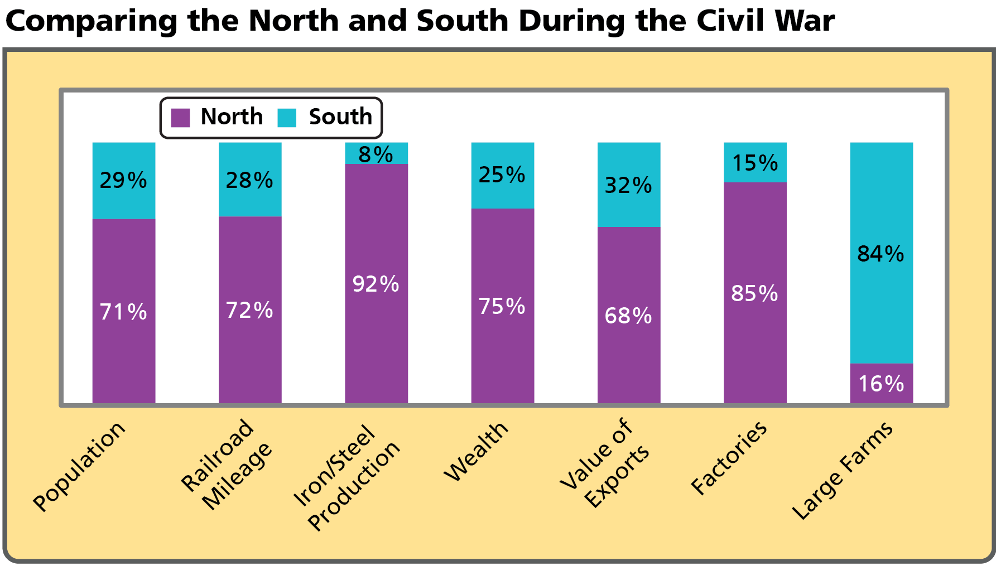
Based on the graph, which industry’s decline would hurt the southern economy the MOST?
A iron production
B agriculture
C manufacturing
D railroad construction

3 Which of the following phrases would a Republican congressman likely have used to describe President Johnson’s Reconstruction plans?
A too lenient
B very harsh
C well-balanced
D difficult to accomplish

4 Look at the picture.
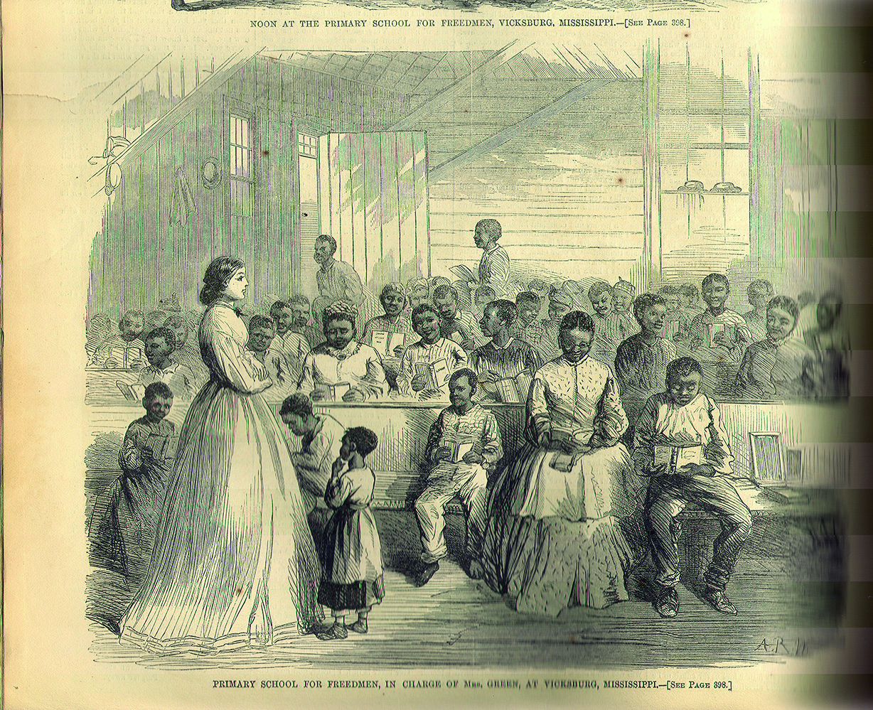
Which of the following conclusions about the Freedmen’s Bureau is BEST supported by the illustration?
A It assisted only African Americans.
B It employed only women.
C It provided education to people of all ages.
D Its students passed the literacy requirements for voting.

5 Look at the table about the Civil War amendments.
Amendment | Reform
Thirteenth | Outlawed slavery and involuntary servitude
Fourteenth | ?
Fifteenth | ?
Which statements replace the question marks in the table? Choose the TWO correct answers.
A Fourteenth: Defined citizens as people born in the United States or naturalized
B Fourteenth: Established the Freedmen’s Bureau
C Fifteenth: Removed the right to vote from all former Confederate officers
D Fifteenth: Extended the right to vote to African American male citizens

6 Which statement BEST summarizes President Lincoln’s plan for Reconstruction?
A Lincoln wanted to punish the Confederacy for seceding.
B Lincoln thought it would be easiest to consider that the Confederacy had never seceded.
C Lincoln wanted the South to declare that they were wrong to secede from the Union.
D Lincoln felt it would be a long struggle before the Confederacy would agree to rejoin the Union.

7 Which of the following was MOST helpful in advancing the Reconstruction reforms of Radical Republicans in Congress?
A the support of the Supreme Court
B the cooperation of moderate Republicans
C the impeachment of the President
D the consent of southern Democrats

8 Read the statement.
“It almost seemed, sometimes, as if I had been away only a day or two and had just taken up the farm work where I had left off.”
—Union soldier, on returning home at the end of the Civil War
Which of the following factors contributed to the experience described by this soldier?
A The South had lost more soldiers.
B The Union forces had won the war swiftly.
C Most of the battles had taken place in the South.
D Most Union soldiers returned to their former jobs.

9 Why did Republicans in Congress attempt to impeach President Andrew Johnson?
A They disagreed over plans for Reconstruction.
B They believed Johnson was guilty of taking bribes.
C They disagreed over the election of President Grant.
D They opposed the Fifteenth Amendment, but he supported it.

10 __________ and __________ were accused of taking advantage of southerners after the Civil War.
A Freedmen; radicals
B Klansmen; sharecroppers
C Scalawags; carpetbaggers
D Democrats; Republicans

11 Look at the picture.
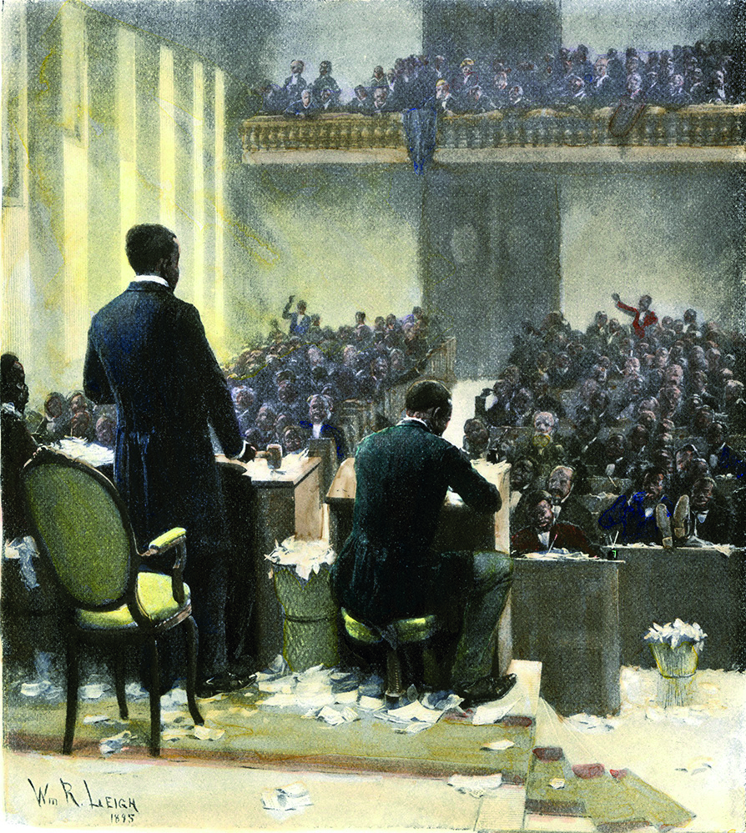
This image of the South Carolina legislature illustrates the impact of the
A Amnesty Act.
B southern scalawags.
C Reconstruction Acts.
D sharecropping system.

12 What happened after the Fifteenth Amendment was ratified?
A Women gained the right to vote.
B African Americans were able to vote freely in all following elections.
C The amendment was revoked due to political controversy.
D New methods were found to prevent African Americans from voting.

13 Which of the following was a key contrast between scalawags and carpetbaggers?
A Scalawags supported Reconstruction.
B Most carpetbaggers were Republicans.
C Carpetbaggers helped African Americans.
D Scalawags were southerners.

14 Read the passage.
“Even after the Emancipation Proclamation, two more years of war, service by African American troops, and the defeat of the Confederacy, the nation was still unprepared to deal with the question of full citizenship for its newly freed black population. The Reconstruction implemented [put into use] by Congress, which lasted from 1866 to 1877, was aimed at reorganizing the Southern states after the Civil War, providing the means for readmitting them into the Union, and defining the means by which whites and blacks could live together in a non-slave society. The South, however, saw Reconstruction as a humiliating, even vengeful imposition [annoyance] and did not welcome it.
During the years after the war, black and white teachers from the North and South, missionary organizations, churches and schools worked tirelessly to give the emancipated population the opportunity to learn. Former slaves of every age took advantage of the opportunity to become literate. Grandfathers and their grandchildren sat together in classrooms seeking to obtain the tools of freedom.”
According to the passage, many southerners disagreed with Reconstruction because it
A provided little opportunity for southern states to rejoin the Union.
B gave Congress too much control over southern states.
C failed to provide education to freed people.
D encouraged African Americans to join the working class in factories.

15 In which of the following areas did Reconstruction have the most positive effect?
A education
B agriculture
C urbanization
D poverty reduction

16 Read the passage.
“It was the 15th Amendment, ratified in 1870, which finally gave African Americans the right to vote. It states that ‘the right of citizens of the United States to vote shall not be denied or abridged by the United States or by any state on account of race, color, or previous condition of servitude.’ In practice, however, it took almost 100 more years and the passage of the Voting Rights Act of 1965 to remove barriers such as poll taxes, literacy tests, and intimidation that prevented African Americans and other people of color from freely exercising their right to vote. Note that the 15th Amendment makes no mention of sex. It was not until the passage of the 19th Amendment in 1920 that women were explicitly given the vote.”
—Library of Congress, America’s Library
According to the passage, why did it take almost 100 years after ratification of the Fifteenth Amendment for the right to vote to become meaningful for all U.S. citizens? Choose the TWO correct answers.
A “vote shall not be denied or abridged”
B “barriers such as poll taxes, literacy tests, and intimidation”
C “makes no mention of sex”
D “previous condition of servitude”

17 Look at the map.
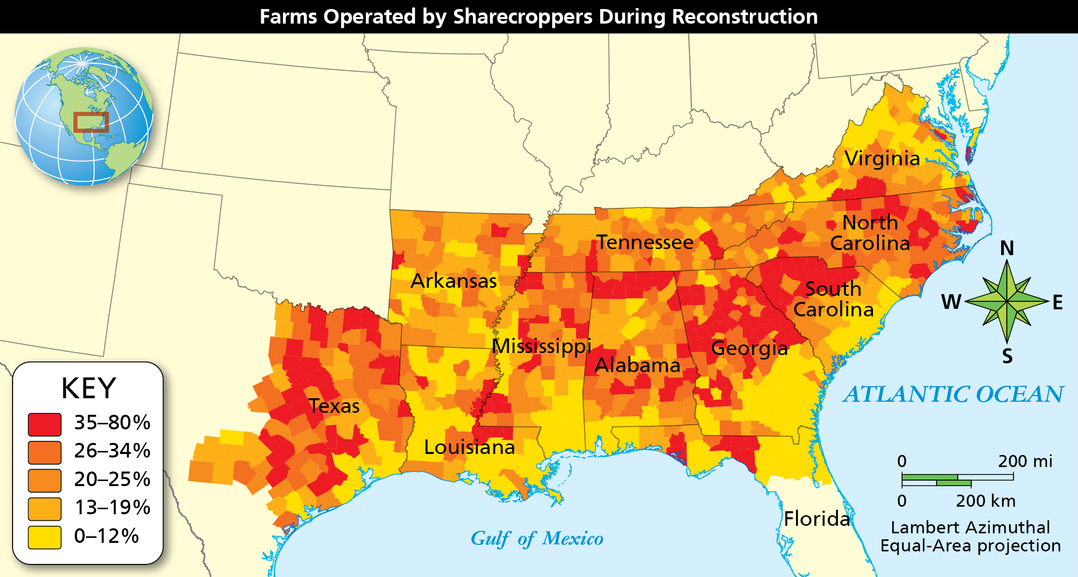
What pattern can you find in sharecropping as shown on this map?
A Few sharecroppers lived in Texas while many lived in Louisiana.
B In Georgia and South Carolina, sharecropping was more common in inland areas than coastal areas.
C Sharecropping was more common in areas farther south and less common in northern parts.
D Sharecropping was common everywhere in the South except Georgia and South Carolina.

18 Why would the loss of farms make it especially difficult for the southern economy to recover?
A Many southern industries would fail without the crops.
B The southern economy was largely based on agriculture.
C Most southerners could not afford to rebuild their farms.
D The South would not be able to grow surplus crops for sale.

19 Read the passage.
“But in view of the Constitution, in the eye of the law, there is in this country no superior, dominant, ruling class of citizens. There is no caste here. Our Constitution is color-blind, and neither knows nor tolerates classes among citizens. In respect of civil rights, all citizens are equal before the law.”
—Justice John Harlan, dissenting opinion, Plessy v. Ferguson (1896)
According to Justice Harlan in the passage, how does the legal system view discrimination according to the Constitution?
A It insists that all citizens are equal before the law.
B It asserts that some groups are superior to others.
C It does not recognize the equality of some citizens.
D It allows states to decide whether to discriminate.

Short Answer

Read each question, and write your answer in complete sentences.

20 Explain why President Lincoln’s assassination put the future of the nation in question.

21 Compare and contrast the Reconstruction plans of President Johnson and the Radical Republicans in Congress.

22 Describe the causes and effects of Radical Reconstruction.

23 Summarize the role of African Americans in southern politics during Reconstruction. Provide an example of an important African American political figure from this period.

24 How did the sharecropping system work, and why did it create problems for both sharecroppers and small landowners?

25 After the end of Reconstruction, were African Americans in the South able to keep the gains they had made during the Civil War and Reconstruction? Provide evidence to support your answer.

