Name Date
Read each question carefully. Determine the best answer to the question from the four answer choices provided.

1 Study the illustration.
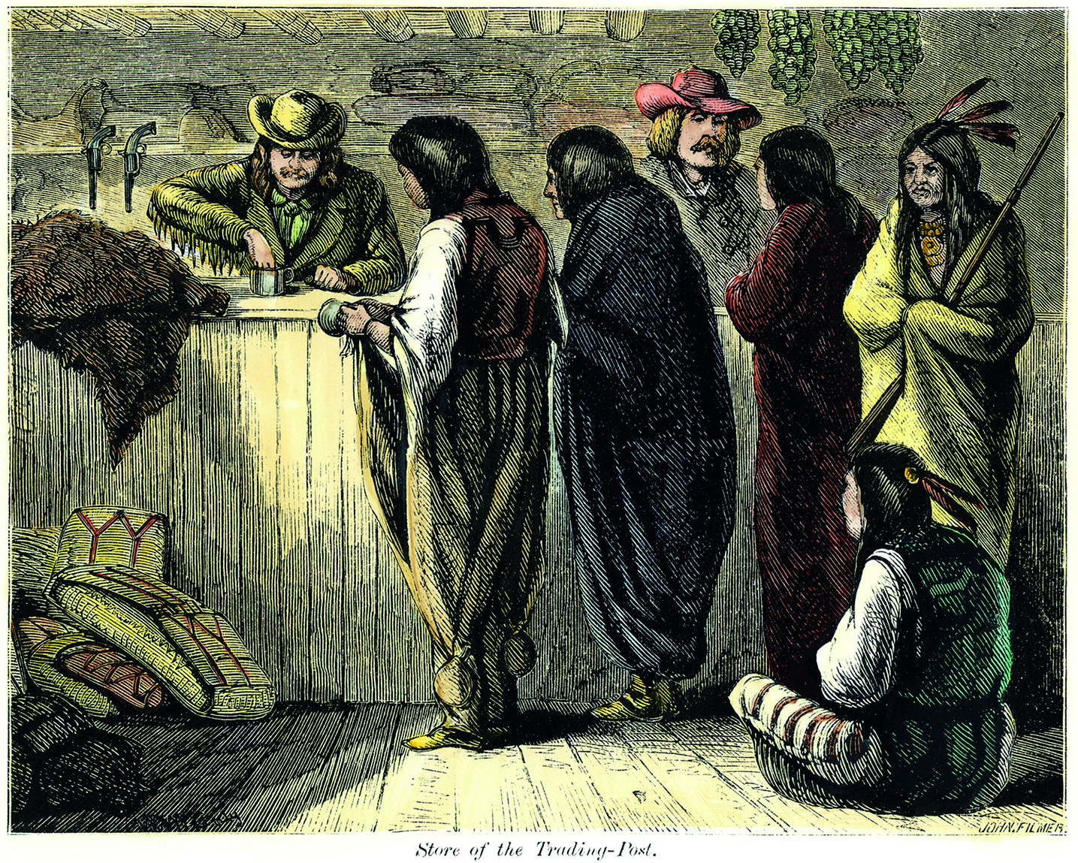
In what way does this image relate to Tecumseh’s opinion about the relationship between American Indians and white settlers?
A It shows the cultural exchange supported by Tecumseh.
B It shows the dependence on whites that Tecumseh criticized.
C It shows American Indians learning from whites, which Tecumseh encouraged.
D It shows whites taking advantage of American Indians, which Tecumseh resented.

2 What were TWO of the causes of the War of 1812?
A Britain arming American Indians
B Britain attacking New Orleans
C Britain banning trade with the United States
D Britain seizing American ships

3 Which of President Jefferson’s actions did NOT reflect his belief that the federal government had only those powers spelled out in the Constitution?
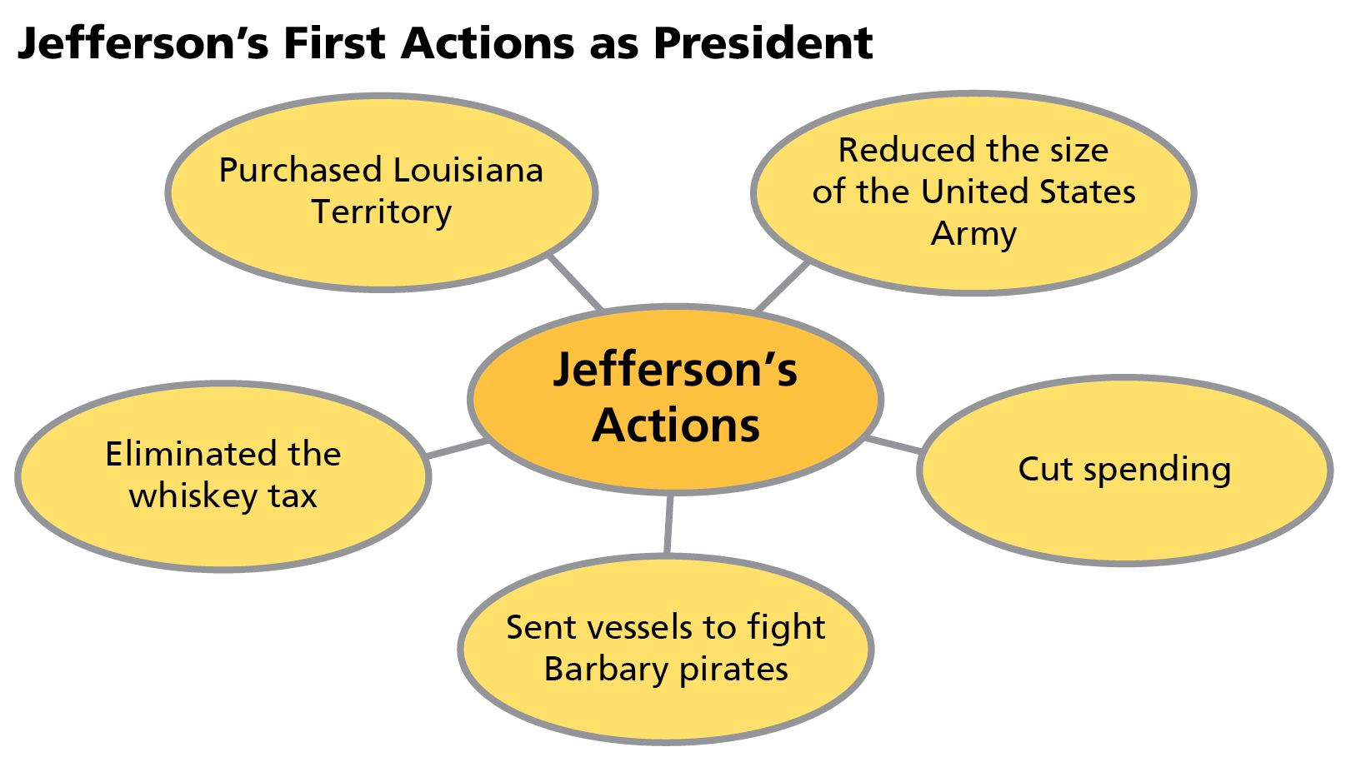
A the purchase of the Louisiana Territory
B the elimination of the whiskey tax
C the cutting of federal spending
D the reduction in the size of the U.S. Army

4 Why were northern states in favor of Hamilton’s protective tariff?
A The tariff protected northern manufacturers from paying any additional fees when exporting their products.
B The tariff allowed northern manufacturers to charge higher prices for their products.
C The tariff made products produced in the North less expensive than imported products.
D The tariff had less of an effect on businesses in the North than it did on those in the South.

5 Read the excerpt.
“On October 20, 1803, the Senate ratified the Louisiana Purchase Treaty by a vote of twenty-four to seven. The agreement, which provided for the purchase of the western half of the Mississippi River basin from France at a price of $15 million, or approximately four cents per acre, doubled the size of the country and paved the way for westward expansion beyond the Mississippi.”
Based on the excerpt, which of the following statements can be inferred about the effect the Louisiana Purchase would have on the United States?
A Because of the high cost of the purchase, the United States would struggle even more with the public debt.
B Because of the treaty, the French could no longer pose a threat against the United States.
C Because of the purchase of the territory, Americans could now legally start settling regions in the West.
D By ratifying the treaty, the Senate confirmed that presidents have the power to purchase land.

6 What caused conflicts between white settlers and American Indians during the early 1800s? Choose the TWO correct answers.
A the Treaty of Greenville
B Britain’s support of American Indians
C disagreements over land use
D competition for natural resources

7 Why did Jefferson and the Democratic Republicans oppose policies that favored manufacturing
and trade?
A The Democratic Republicans felt manufacturing and trade posed a threat to slavery in
the South.
B The Democratic Republicans believed they would negatively affect American trade relations with other nations.
C The Democratic Republicans felt manufacturing and trade would corrupt the nation and give power only to the wealthy.
D The Democratic Republicans believed manufacturing and trade would reduce agricultural production and cause Americans to rely on foreign goods.

8 How did Hamilton attempt to create a stable economic system? Choose the TWO correct answers.
A by cutting the federal budget
B by establishing a national bank
C by introducing a ban on imported goods
D by placing a tax on liquor

9 The passage of the Alien and Sedition Acts led directly to the
A decline of the Federalist Party’s control of Congress and the presidency.
B demand for and eventual ratification of the Twelfth Amendment.
C claim that states had the right to determine the constitutionality of a law.
D increase in voters who would vote for the Democratic Republicans.

10 Study the illustration.
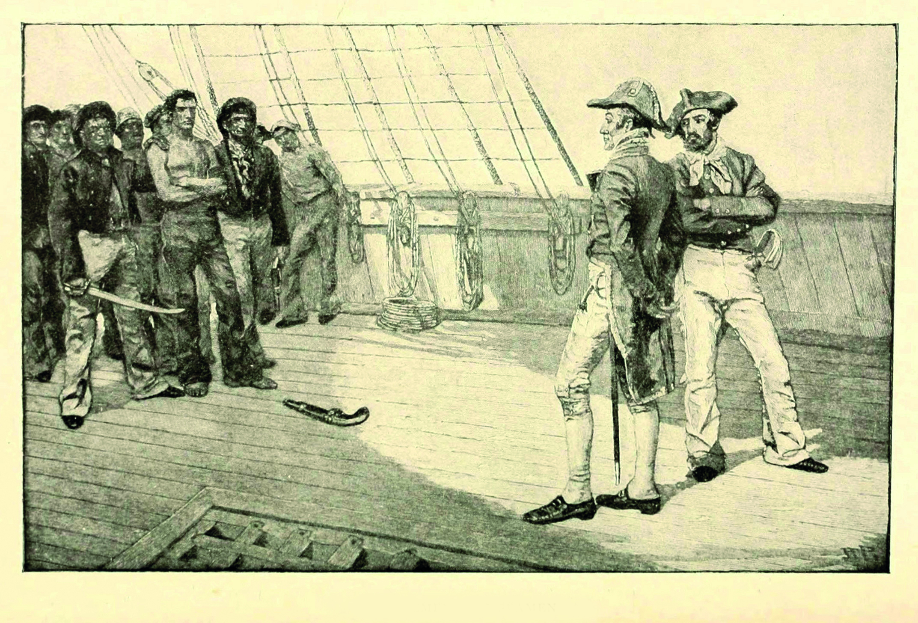
Which of the issues that eventually led to the War of 1812 does this illustration show?
A the American trade embargo
B the impressment of American sailors
C the British blockade of American ports
D the British support of American Indians

11 How did Jefferson’s views differ from Hamilton’s? Choose the TWO correct answers.
A Jefferson wanted a smaller federal government.
B Jefferson wanted close ties with Britain rather than France.
C Jefferson supported policies that favored business leaders.
D Jefferson opposed the Bank of the United States.

12 Why did Jefferson favor a laissez-faire attitude toward the nation’s economy?
A It reduced government spending.
B It promoted American-made goods.
C It lowered taxes on American goods.
D It lessened government interference.

13 How did the Treaty of Greenville settle the ongoing conflict between American Indians and
white settlers?
A By signing the treaty, both sides promised to end their violent attacks on each other.
B By signing the treaty, both sides agreed to become allies and fight together against
common enemies.
C The treaty required white settlers to return land taken from the American Indians.
D The treaty gave American Indians payment for their lands.

14 Read the excerpt.
“Europe has a set of primary interests which to us have none; or a very remote relation. Hence she must be engaged in frequent controversies, the causes of which are essentially foreign to our concerns. . . . Why, by interweaving our destiny with that of any part of Europe, entangle our peace and prosperity in the toils of European ambition. . .?”
—George Washington, Farewell Address
Which of the following statements BEST summarizes Washington’s viewpoint on American foreign policy as expressed in the excerpt?
A The United States can take advantage of Europe’s ambition.
B The United States should limit interaction with Europe to commerce.
C Europe’s interests are similar to those of the United States and should be supported if
they are threatened.
D The United States should not become involved in European politics.

15 How would Clay’s American System with high tariffs on imported goods have benefited the West and South?
A He expected that money from tariffs would be used to help farmers ship their goods to
the North.
B He expected that northerners would use their profits to buy farm goods from the West
and South.
C He expected that the South and West would profit by importing goods from countries on which the United States did not impose the tariff.
D He expected that state-constructed roads, which would make the transportation of goods from each region profitable, would be built from the funds.

16 Why did some Federalists criticize Adams’s refusal to declare war on France? Choose the TWO correct answers.
A They thought a war would weaken the Democratic Republicans.
B They thought a war would topple Napoleon’s regime.
C They thought a war would enable the United States to expand.
D They thought a war would strengthen the country’s military.

17 How did the election of 1796 increase political tensions?
A After the Revolution, women demanded an equal voice and vote in politics.
B President John Adams and Vice President Thomas Jefferson belonged to different political parties and did not agree on government policy.
C Northerners were unhappy that southerners, who counted enslaved people as part of the population, had so much more representation in Congress.
D Farmers and shopkeepers were angry that the wealthy elite controlled the major leadership of the government.

18 Read the quotation.
“Our judges are as honest as other men, and not more so. They have, with others, the same passions for party, for power, and the privilege of their corps [group of people] . . . and their power the more dangerous as they are in office for life, and not responsible, as the other functionaries are, to the elective control.”
—Thomas Jefferson, letter to William Charles Jarvis, Sept. 28, 1820
This excerpt comes from a letter Jefferson wrote in response to the Supreme Court’s decision in Marbury v. Madison. What was Jefferson’s greatest concern?
A He was concerned that the decision gave the Supreme Court too much authority.
B He was concerned by the fact that judges were not elected.
C He was concerned that judges could be easily influenced by political parties.
D He was concerned that the decision set a dangerous precedent for cases heard by the Supreme Court.

19 How did life change for ordinary Americans in the early years of the republic? Choose the TWO correct answers.
A More Americans moved to cities to work in factories.
B More Americans had easy access to books.
C More Americans practiced an organized religion.
D More Americans received a public education.

20 Revolutions in Latin America led to
A the overthrow of wealthy creole control.
B freedom for American Indians.
C newly independent neighbors for the United States.
D the creation of the League of Latin American Provinces.

Short Answer

Read each question, and write your answer in complete sentences.

21 Explain why President Washington issued the Neutrality Proclamation in 1793.

22 Compare and contrast the arguments of Hamilton and Jefferson regarding the Bank of the
United States.

23 Summarize the reasons why John Adams was not reelected as President in the election of 1800.

24 Summarize the purpose and results of the Lewis and Clark expedition.

25 Read the excerpt.
“We […] declare that we should consider any attempt on their part to extend their system to any portion of this hemisphere as dangerous to our peace and safety. With the existing colonies or dependencies of any European power we have not interfered and shall not interfere. But with the Governments who have declared their independence […] we could not view any interposition [interference] for the purpose of oppressing them […] by any European power in any other light than as the manifestation of an unfriendly disposition toward the United States.”
—President James Monroe, December 2, 1823
From what act or statement is this quotation excerpted? In your own words, what did Monroe declare in this statement, and what was its effect?

