Name Date
Read each question carefully. Determine the best answer to the question from the four answer choices provided.

1 Look at the table showing the results of the French and Indian War.
Territorial Results of French and Indian War
Great Britain | France
- Gained Canada  - Gained all French lands east of the Mississippi River | - Lost all former territories except two islands in the Gulf of St. Lawrence and islands in the West Indies
Based on the table, which statement summarizes one result of the French and Indian War?
A It was the cause of the American Revolution.
B It gave British colonists more freedom.
C It marked the end of French power in North America.
D It destroyed the American Indian alliances

2 Why did the British want to expand their control into the Ohio Valley in the mid-1700s?
A to force the French out of North America
B to put French settlers there under English rule
C to demonstrate Britain’s strength to France and Spain
D to gain access to the region’s natural resources

3 Which important roles did American women take during the revolution? Choose the TWO correct answers.
A caring for wounded soldiers
B serving in state legislatures
C working in factories
D running family businesses

4 Look at the image of Chief Pontiac rallying American Indians against the British colonists.
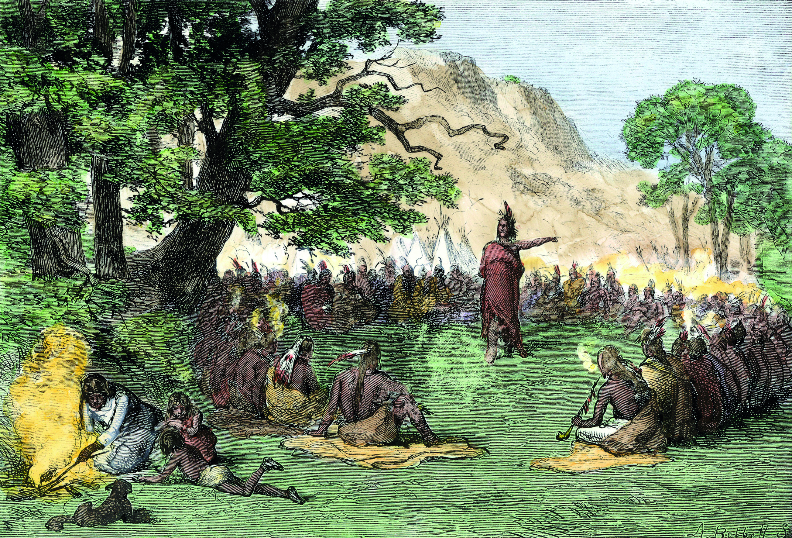
Which event caused the action shown in the image?
A The British were building farms and forts on American Indian lands.
B French settlers had moved into lands west of the Appalachians.
C French and British colonists were overhunting the wildlife in western lands.
D American Indians wanted payment for their service in the French and Indian War.

5 How did the Stamp Act contribute to the Boston Massacre?
A British officials ordered their troops to fire on any colonist who opposed the Stamp Act, which led to the massacre.
B Colonists angered by British taxes took out their frustrations on British troops, which eventually led the troops to fire at the colonists.
C British troops stationed in Boston enforced heavier taxes on colonists than the Stamp Act allowed, which led to the clash.
D Colonists boycotted items on which the Stamp Act was imposed, which was illegal under British law and punishable by death.

6 What event led to the first shots being fired at the battles of Lexington and Concord?
A The attempt by the British to seize colonial military stores.
B The rejection of the Olive Branch Petition by King George III.
C The writing and public reading of the Declaration of Independence.
D The blockade of the port of Boston by the British navy.

7 Look at the table of the participants in the Revolutionary War.
Participants in the Revolutionary War
- Bernardo de Gálvez
- Friedrich von Steuben
- Casmir Pulaski
- Thaddeus Kosciusko
Which description identifies the role of the people in the table?
A admirals who led the American navy
B traitors captured by the Continental Army
C British generals controlling the colonies
D Europeans who aided Patriot forces

8 Which of the following excerpts is a grievance of the American colonists that was included in the Declaration of Independence?
A “We hold these truths to be self-evident, that all men are created equal, that they are endowed by their Creator with certain unalienable Rights, that among these are Life, Liberty and the pursuit of Happiness.”
B “Such has been the patient sufferance of these Colonies; and such is now the necessity which constrains them to alter their former Systems of Government.”
C “He has dissolved Representative Houses repeatedly, for opposing with manly firmness his invasions on the rights of the people.”
D “We, therefore, the Representatives of the United States of America. . . solemnly publish and declare, That these United Colonies are, and of Right ought to be Free and Independent States . . .”

9 Which statement describes a reason for the French forts across North America? Choose the TWO correct answers.
A to protect the major ports that existed in North America at the time
B to serve as trading posts with American Indian traders
C to allow for easier transportation of troops and supplies
D to defend French territory from European colonial expansion

10 Look at the table of British actions after the French and Indian War.
British Actions
Proclamation of 1763
Stamp Act
Writs of Assistance
Townsend Acts
Which of the following was a result of these actions?
A The colonists were given representation in Parliament.
B A new American identity developed.
C Large numbers of settlers left the colonies.
D Local merchants became wealthy from taxes.

11 What motivated most African American soldiers to fight in the Revolutionary War with the Patriots?
A the hope that the war would also bring an end to slavery
B the desire to become free after serving in the Patriot army
C the fear of what would happen if they did not fight in the war
D the need to protect their families

12 Read the quote from the Albany Plan of Union.
“That humble Application be made for an Act of the Parliament of Great Britain, by Virtue of which, one General Government may be formed in America, including all the said Colonies, within and under which Government, each Colony may retain its present Constitution”
Which statements identify two goals of this document for colonial leaders? Choose the TWO correct answers.
A a declaration of war on Britain
B a united colonial defense
C an amendment to colonial documents
D an alliance with the Iroquois

13 What effect did the capture of Fort Ticonderoga have on the fighting in Boston between the American colonists and the British?
A The British left Boston when they saw the fort’s cannons positioned on Dorchester Heights above Boston.
B The British delayed American troops from joining the fight in Boston because of the battle at the fort.
C The Americans were able to use the fort’s cannons to destroy the British ships blockading Boston’s port.
D The Americans lost the Battle of Bunker Hill because of the number of cannons the British had acquired from the fort.

14 Read the quote from the Olive Branch Petition sent to King George III after Lexington and Concord.
“We . . . beseech [beg] your Majesty . . . to procure [get] us relief . . . and to settle peace through every part of your dominions . . . measures . . . taken for preventing the further destruction of the lives of your Majesty’s subjects; and that such statutes [laws] as more immediately distress [upset] any of your Majesty’s colonies may be repealed.”
Which actions resulted from this document? Choose the TWO correct answers.
A The colonists agreed to stop protesting.
B The fighting in the colonies continued.
C Parliament offered a peace agreement.
D The king sent more troops to the colonies.

15 Which factors helped the Patriots win the war? Choose the TWO correct answers.
A more advanced weapons
B support of all American Indians
C alliances with European countries
D familiarity with American geography

16 What actions by the British and southern Loyalists caused many southern colonists to side with the Patriots?
A conducting raids on the major supply ports along the coast
B killing innocent colonists on the western frontier
C establishing alliances with southern American Indians
D carrying out brutal attacks during the campaign in the Carolinas

17 Which of the following would be considered an example of Prime Minister George Grenville’s use of the mercantile system?
A a decrease in trade regulations restricting British subjects from trading with other European nations and American Indians
B a decrease in the amount of items exported from Britain to its colonies
C an increase in the tax on imports into the colonies in order to pay for the cost of running the British navy
D an increase in the number of merchants with access to major colonial ports

18 Look at the timeline of some events of the Revolutionary War.
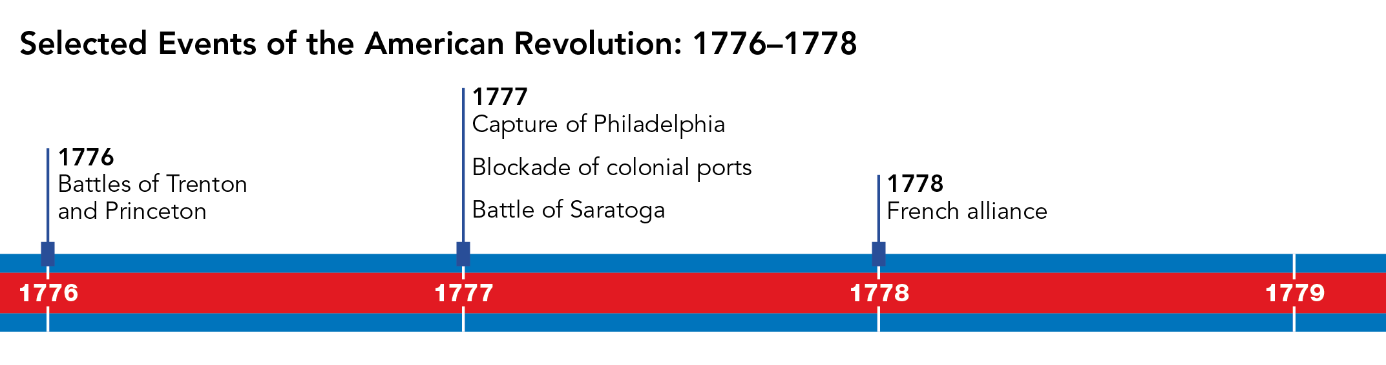
Which events led to American victory in the war? Choose the THREE correct answers.
A Battles of Trenton and Princeton
B Capture of Philadelphia
C Battle of Saratoga
D French alliance
E Blockade of colonial ports

Short Answer

Read each question, and write your answer in complete sentences.

19 Explain why France and Spain would send the Patriots supplies and later choose to side with them during the Revolutionary War.

20 Describe the views of the British government and the American colonists on the Proclamation of 1763.

21 Summarize the events that led to the Boston Tea Party.

22 Summarize Benjamin Franklin’s Albany Plan of Union.

23 How did treatment of the Algonquians and the Hurons by the French lead these American Indian groups to side with the French during the French and Indian War?

24 Explain how peaceful colonial protests against the Stamp Act led to revolution. Consider the Stamp Act Congress, boycotts, calls for free enterprise, and Parliament’s actions.

25 Read the quote from the Declaration of Independence.
“The history of the present King of Great Britain is a history of repeated injuries and usurpations [taking things without right], all having in direct object the establishment of an absolute Tyranny over these States.”
Why did colonial leaders include this sentence in the Declaration of Independence?

