Name Date
Read each question carefully. Determine the best answer to the question from the four answer choices provided.

1 Horace Mann believed that reforming the American educational system was important because
A it would help people get better jobs.
B it would help in the fight to end slavery.
C it would help in the fight for gender equality.
D it would help people become better Christians.

2 Look at the map.
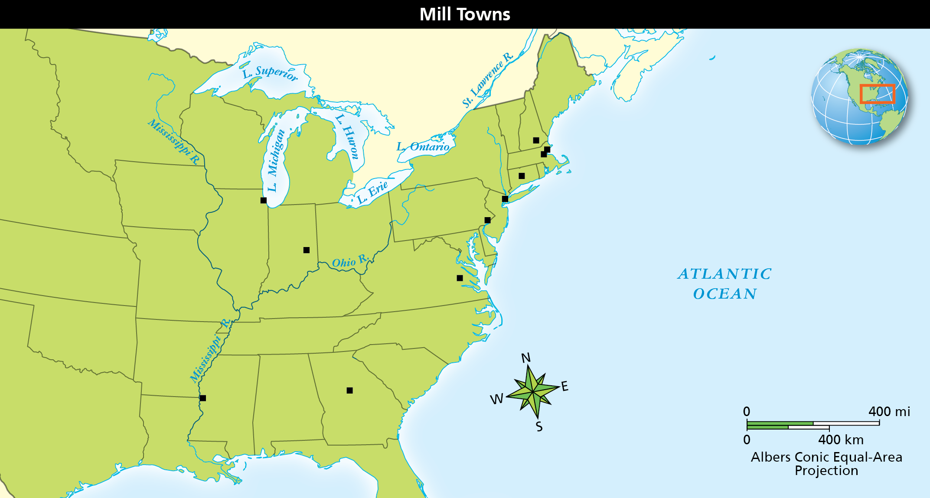
Based on the information on the map, what can you infer about industry in the United States?
A Manufacturing was a key part of the economy in the Northeast.
B Agriculture was the major economic activity in the South.
C Mills in the Northeast needed to be close to ports to make it easier to transport factory-made goods.
D Population levels in the Midwest made it difficult to support the amount of labor required to industrialize.

3 What was significant about Seneca Falls for the women’s rights movement?
A It was where women publicly demanded equal rights.
B It was the site of the first college willing to admit women.
C It was the first time women were allowed to vote in a local election.
D It was where the first women’s trade union met.

4 Look at the cause-and-effect diagram about economic factors in the early United States.
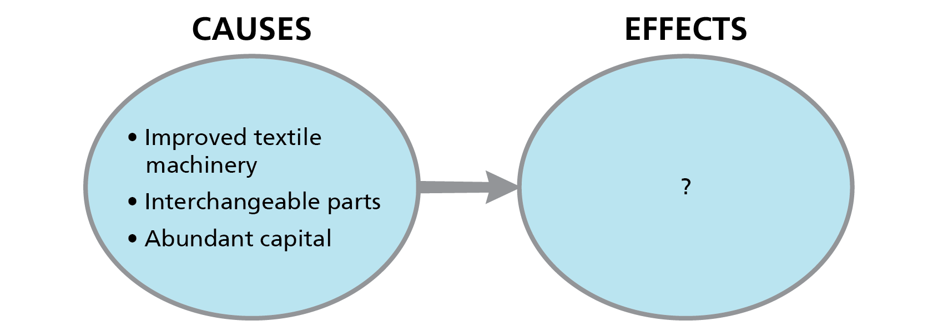
Which statements identify the effect of the causes shown in the diagram? Choose the TWO correct answers.
A The start of the American industrial revolution
B The growth of towns and cities
C The decline of immigration
D The outlawing of child labor

5 What is the MAIN reason that many German immigrants moved west soon after arriving in the United States?
A They were seeking economic opportunities.
B They had difficulty learning English.
C They disliked large cities.
D They had fled Germany to escape revolutions.

6 What complaint did southerners make about William Lloyd Garrison in connection with Nat Turner?
A He supplied the weapons Turner used in his revolt.
B His leadership in the Underground Railroad gave Turner a way to escape to the North.
C He promoted slave revolts like Turner’s with his abolitionist writings.
D He encouraged Turner’s revolt with his antislavery speeches in Congress.

7 Why did Quakers and other religious leaders in the North oppose slavery?
A They believed it was a sin for one person to own another person.
B They realized there were many African American Quakers.
C They felt African Americans should be fairly paid for their work.
D They thought that slavery did not reflect American values.

8 Which events occurred as a result of the Industrial Revolution in the United States? Choose the TWO correct answers.
A The labor reform movement helped establish trade unions.
B Many free African Americans became skilled workers.
C The population grew and had more ethnic and religious diversity.
D Living conditions in growing cities became safer and cleaner.
E New immigrants were welcomed by all native-born Americans.

9 Read the quote from Sojourner Truth.
“Look at me! Look at my arm! I have ploughed and planted, and gathered into barns, and no man could head me! And ain’t I a woman? I could work as much and eat as much as a man—when I could get it—and bear the lash as well! And ain’t I a woman? I have borne thirteen children, and seen most all sold off to slavery, and when I cried out with my mother’s grief, none but Jesus heard me! And ain’t I a woman?”
—Sojourner Truth, Address to the Women’s Rights Convention in Akron, Ohio, 1851
Which sentence from Sojourner Truth’s speech addresses BOTH abolition and women’s
rights issues?
A “I have ploughed and planted, and gathered into barns, and no man could head me!”
B “And ain’t I a woman?”
C “I could work as much, and eat as much as a man—when I could get it—and bear the lash
as well!”
D “I have borne thirteen children and seen most all sold off to slavery, and when I cried out with my mother’s grief, none but Jesus heard me!”

10 Which of the following is a subject often painted by artists of the Hudson River School?
A man’s relationship with nature
B vivid landscapes in the Northeast
C industrialization’s effect on nature
D stories from Greek and Roman mythology

11 Which statement BEST describes the general route of the Underground Railroad?
A It brought enslaved people to northern states where slavery had been abolished.
B It brought enslaved people to rural areas where they could hide from slaveholders.
C It brought enslaved people to safe houses in the South where they reunited with their families.
D It brought enslaved people to western lands where they could escape the reach of the federal government.

12 Read the quote from the Seneca Falls Declaration of Sentiments.
“The history of mankind is a history of repeated injuries and usurpations on the part of man toward woman . . .
He has never permitted her to exercise her inalienable right to the elective franchise.
He has compelled her to submit to laws, in the formation of which she had no voice. . . .
He has made her, if married, in the eye of the law, civilly dead.
He has taken from her all right in property, even to the wages she earns.”
Which statements identify rights the women at Seneca Falls demanded? Choose the TWO
correct answers.
A freedom of speech
B the right for married women to own property
C the right to bear arms
D the right to vote
E the right to get a divorce

13 Read the quote from Frederick Douglass.
“We were worked in all weathers. It was never too hot or too cold; it could never rain, blow, hail, or snow too hard for us to work in the field. Work, work, work. . . . The longest days were too short for him and the shortest nights too long for him.”
—Frederick Douglass, Narrative of the Life of Frederick Douglass, An American Slave
Which statement BEST paraphrases the view expressed in this quote?
A Enslaved people had to work no matter what the weather conditions were.
B Enslaved people were required to work into the night as well as through the entire day.
C Enslaved people’s work was never enough to satisfy a slaveholder.
D Enslaved people’s lives were difficult and tiring.

14 Read the quote from Thoreau’s “Civil Disobedience.”
“I heartily accept the motto, ‘That government is best which governs least.’ . . . this government never of itself furthered any enterprise [project]. . . . It does not keep the country free. It does not settle the West. It does not educate. . . . I ask for . . . a better government.”
According to the quote, what is Thoreau’s view of the U.S. government?
A It is better than the governments of other countries.
B It has made the country a modern nation.
C It needs more power to complete projects.
D It does very little to help the people.

15 Which of the following occurred as the United States industrialized? Choose the TWO
correct answers.
A Factories were built in mild climates.
B People moved from the countryside to towns and cities for jobs.
C Immigrants were blocked from factory jobs.
D Factory towns developed along rivers.

16 Look at the table of city growth between 1820 and 1860.
City | 1820 | 1840 | 1860
New York | 123,786 | 312,710 | 813,669
Boston | 43,298 | 93,383 | 565,529
Philadelphia | 62,738 | 93,665 | 177,848
Source: Historical Statistics of the United States
Which factor was the MAIN reason for the data shown in the table?
A the elimination of slavery in the North
B the growth of industrialization and the development of factories
C the expansion of plantations and the spread of slavery
D the escalation of urbanization throughout the Northeast

17 Why were there fewer industries in the South than in the North in the mid-1800s? Choose the TWO correct answers.
A The North had more natural resources for manufacturing.
B People in the South with money bought farmland and enslaved workers.
C The North refused to allow immigrants to move to southern areas.
D Many people in the South lacked the money to buy manufactured products.

18 Read the quote from Song of Myself.
“At home on the hills of Vermont or in the woods of Maine, or the Texan ranch, comrade of Californians, comrade of free North-Westerners. . . . of every hue and caste am I, of every rank
and religion.”
—Walt Whitman, Song of Myself
Whitman composed these lines as a way to
A point out the vastness of the United States.
B display the wide array of social classes found in each region.
C comment on the religious differences among regions.
D celebrate the different regions and people that make up the nation.

19 Look at the image of sheet music.
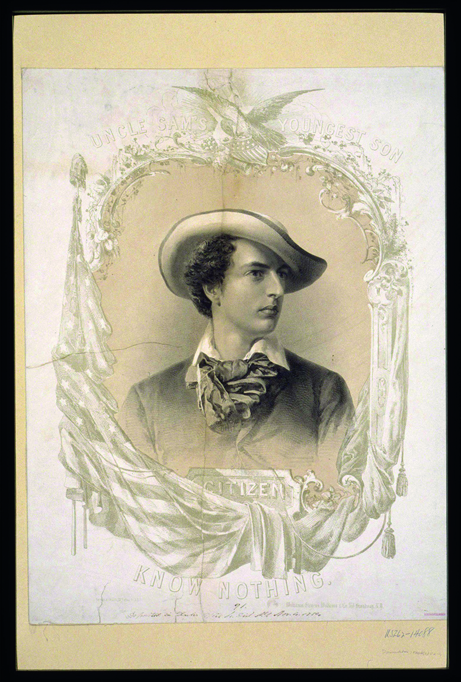
The text on the sheet music reads, “Uncle Sam’s Youngest Son: Citizen Know-Nothing.” Which topics might the lyrics discuss? Choose the TWO correct answers.
A expanding to western areas
B opposition to Roman Catholics
C hostility to immigrants
D problems with urbanization
E excitement about exploration

Short Answer

Read each question, and write your answer in complete sentences.

20 Compare and contrast the lives of enslaved African Americans in the South and free African Americans in the North during the early 1800s.

21 Why do you think the Industrial Revolution led to so many advances in technology?

22 Describe the initial challenges of constructing an effective railroad system.

23 Provide examples to explain how American art changed during the early to mid-1800s.

24 Look at the graph of U.S. cotton production from 1800 to 1850.
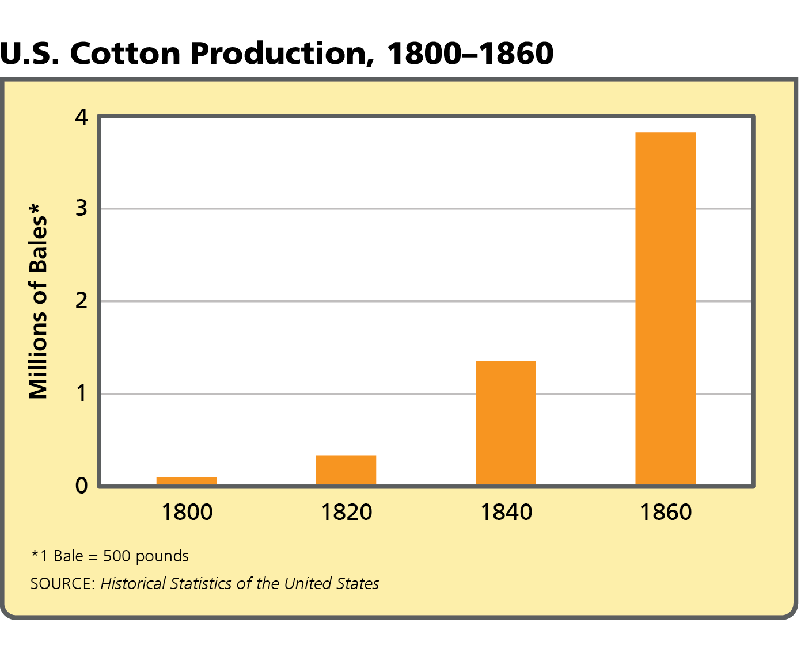
Describe some of the changes in the United States that caused the change in production.

25 Explain how politics and religion led to an American era of reform during the early and mid-1800s.

