Name Date
Read each question carefully. Determine the best answer to the question from the four answer choices provided.

1 Read the excerpt from President Lincoln’s Gettysburg Address.
“[T]hat we here highly resolve [decide] that these dead shall not have died in vain—that this nation, under God, shall have a new birth of freedom—and that government of the people, by the people, for the people, shall not perish from the earth.”
Which of the following best summarizes Lincoln’s meaning in this last sentence of his Gettysburg Address?
A Soldiers must be given more power in the government because of their actions in the war.
B Americans should honor the sacrifice of soldiers by continuing democratic government.
C Presidents should decide important issues, including the debates over slavery.
D Government of the people, by the people, and for the people is no longer important.

2 Toward the end of the Civil War, how did General Grant’s actions affect southern civilians?
A He allowed those living in the South to keep ownership of their land.
B He ordered his generals to impose a “total war” strategy on the South.
C He ordered his army to rebuild rural areas in the South damaged by the war.
D He made sure that slavery was allowed to continue in the South.

3 Beginning with the earliest, which of the following shows the correct order of events related Gettysburg and Vicksburg?
A Siege of Vicksburg begins; Union forces win the Battle of Gettysburg; Union forces gain control of the Mississippi River; President Lincoln delivers the Gettysburg Address
B Union forces win the Battle of Gettysburg; Union forces gain control of the Mississippi River; President Lincoln delivers the Gettysburg Address; Siege of Vicksburg begins
C Union forces gain control of the Mississippi River; President Lincoln delivers the Gettysburg Address; Siege of Vicksburg begins; Union forces win the Battle of Gettysburg
D President Lincoln delivers the Gettysburg Address; Siege of Vicksburg begins; Union forces win the Battle of Gettysburg; Union forces gain control of the Mississippi River

4 Study the image.
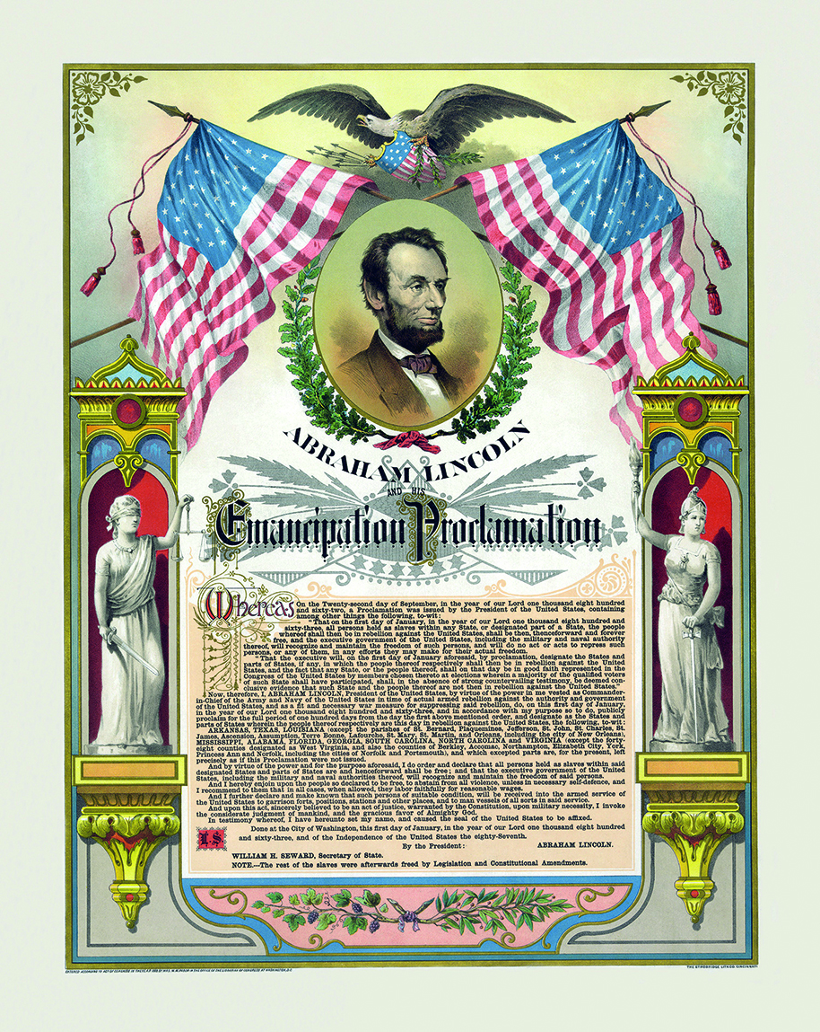
The document shown in this image freed enslaved African Americans in
A the Union slave states.
B the Confederate states in rebellion against the Union.
C both the Union states and the Confederate states.
D the Confederate states that were under Union control.

5 The main reason the Confederacy eventually began drafting soldiers from ages 17 to 50 was because
A many soldiers deserted the Confederacy in favor of the Union.
B the rising death tolls forced the Confederacy to enlist more soldiers.
C Confederate leaders thought the key to victory was a large infantry.
D over half of the Confederate soldiers were imprisoned by the Union.

6 Select the answers that best complete the statement below.
As part of the Missouri Compromise, __________ was admitted to the Union as a free state and __________ was admitted as a slave state.
A Missouri; Maine
B Missouri; Kentucky
C Kentucky; Missouri
D Maine; Missouri

7 Which of the following were advantages held by the Confederacy as the war began? Select the TWO correct answers.
A a larger population
B defending their way of life
C more manufacturing
D fighting mostly on home territory
E more railroads to transport troops and supplies

8 Look at the photograph of Vicksburg.
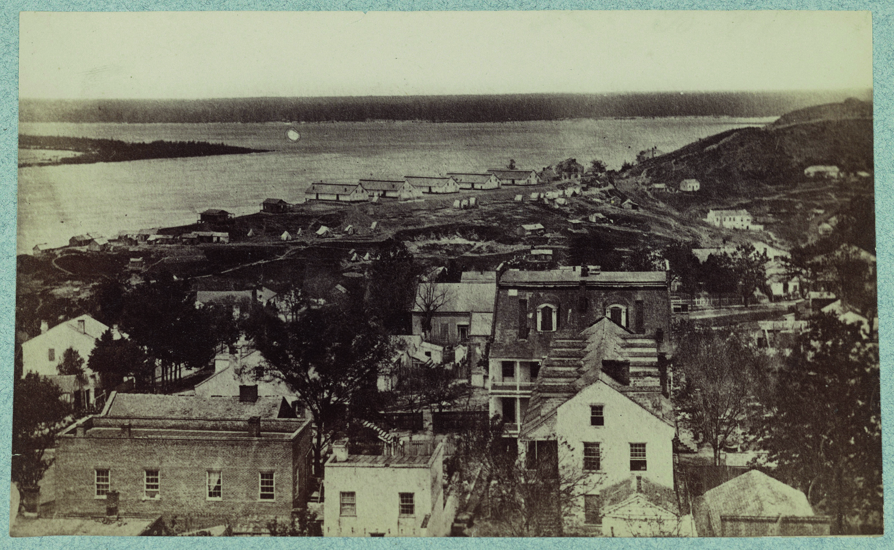
Based on the photograph, why was the capture of Vicksburg so important for Union forces?
A the city’s industries
B the city’s location on a river
C the city’s distance from other battlefields
D the city’s large civilian and military population

9 Why did the Kansas-Nebraska Act anger many northerners?
A They reasoned that it unfairly challenged the Compromise of 1850.
B They were convinced the new act would lead to violence in the West.
C They suspected it was a political move enacted to increase property taxes in the West.
D They thought it went against the Missouri Compromise’s promise to keep slavery from spreading.

10 Look at the image.
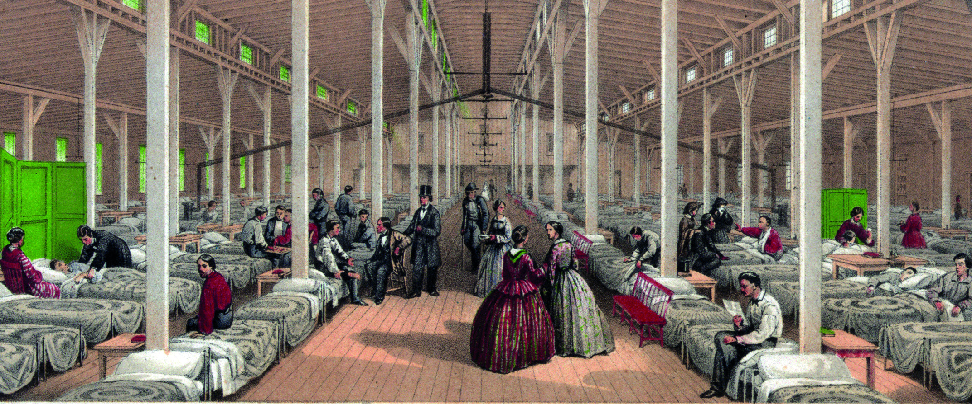
What contribution to the war effort is shown in this image?
A medical and surgical technique development
B women accompanying their wounded husbands to a field hospital
C women’s involvement as nurses
D the creation of the American Red Cross

11 Why might some southerners have been surprised when Lincoln was elected President?
A Lincoln had not previously been involved in politics or government.
B Lincoln’s name had not appeared on ballots in most southern states.
C Lincoln did not have as much support as the nominee from the South.
D Lincoln’s nomination had not been announced in the states of the South.

12 According to Lincoln, why did the Constitution give him the right to suspend habeas corpus?
A During wartime, people were not guaranteed the right to a trial.
B Not enough judges were available to hear cases during the war.
C The draft riots were examples of rebellion that threatened the public safety.
D Confederate soldiers had committed treason against the United States.

13 Why did the Confederates finally surrender at Appomattox?
A The Confederates had run out of their weapons and ammunition.
B Lee knew that the Union was outnumbered by the Confederates.
C The Confederates had lost every battle leading up to Appomattox.
D Lee knew the Confederates were no longer in a position to fight effectively.

14 Look at the chart.
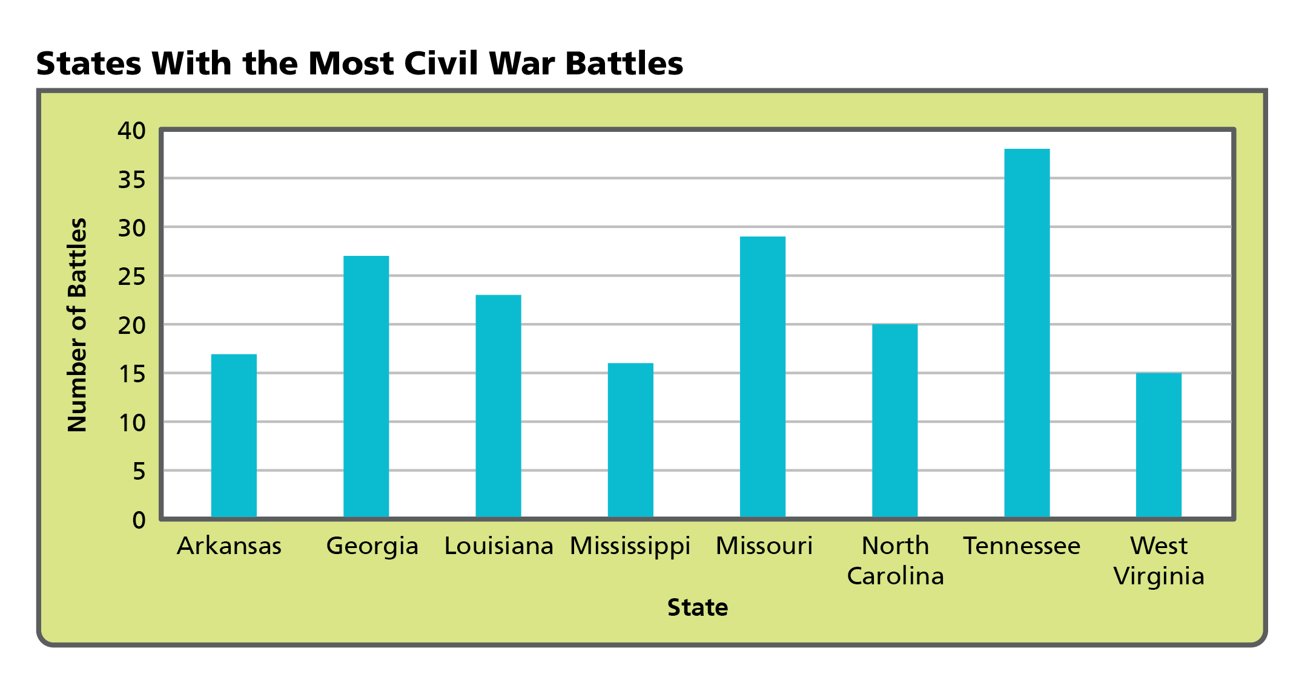
Which of the following BEST explains the difference between Tennessee and Mississippi on this graph?
A Mississippi had more battles because it was on the coast.
B Mississippi had fewer battles because it was on the Mississippi River.
C Tennessee had many more battles because it was closer to Union territory.
D Tennessee had many more battles because it remained part of the Union.

15 As the leader of the Republican Party, Lincoln was outspoken in his views on slavery and expressed them during the debates of 1858. Which of the following would BEST reflect his views?
A Compromise of 1850
B Dred Scott decision
C Kansas-Nebraska Act
D Wilmot Proviso

16 Despite southern protests, what gave the western territories the right to request to enter the Union as free states?
A the Wilmot Proviso
B secession of states
C popular sovereignty
D the Missouri Compromise

17 Which of the following is most likely the reason for Brown’s lack of emotion during his sentencing?
A He accepted the fact that what he had done was wrong.
B He was confident the charges would be dropped by a federal court.
C He was sure his raid would lead to the immediate abolition of slavery.
D He knew his actions would bring national attention to the abolitionist movement.

18 How did the governor’s order that only officers from Georgia could command Georgia’s troops demonstrate a problem in the South?
A The troops were often turning against one another.
B The troops were fighting for individual states.
C The Confederate military had difficulty organizing itself.
D The Confederate military only answered to state governors.

19 Read the following excerpt from a Confederate soldier’s letter home to his family in 1862.
“Our regiment did not have many wounded nor killed but a good many taken prisoners. . . . Pa, I want you to have me a pair of boots made. Those shoes you had made for me ripped all to pieces. Our regiment used everything we had. I have no blanket nor any clothes but what I have got.”
What aspect of war does this soldier’s letter exhibit?
A Many soldiers were killed or wounded in most battles.
B About 25 percent of Confederate soldiers deserted during the war.
C Soldiers suffered from poor conditions and inadequate supplies.
D Soldiers had to forage the countryside for food.

20 How did the Fugitive Slave Act of 1850 strengthen the Fugitive Slave Act of 1793? Choose the TWO correct answers.
A The new law required all citizens to help catch African Americans trying to escape slavery, and be subject to a fine or jail time if they refused.
B The new law did not make it compulsory for northerners to participate in the capture of runaways if they did not support slavery.
C The new law set up higher incentives for judges who freed slaves rather than send them back to the South.
D The new law set up special courts to handle runaway cases and judges were given an incentive for deciding that the accused was an escaped slave.

Short Answer

Read each question, and write your answer in complete sentences.

21 Explain how Harriet Beecher Stowe’s novel Uncle Tom’s Cabin supported the abolitionist movement, and the reaction the book stirred.

22 What impact did the Supreme Court ruling in the Dred Scott v. Sanford case have on life in the United States?

23 How did the 1860 election reflect the growing sectional differences in the United States?

24 Compare the leadership roles of Abraham Lincoln and Jefferson Davis.

25 Look at the image.
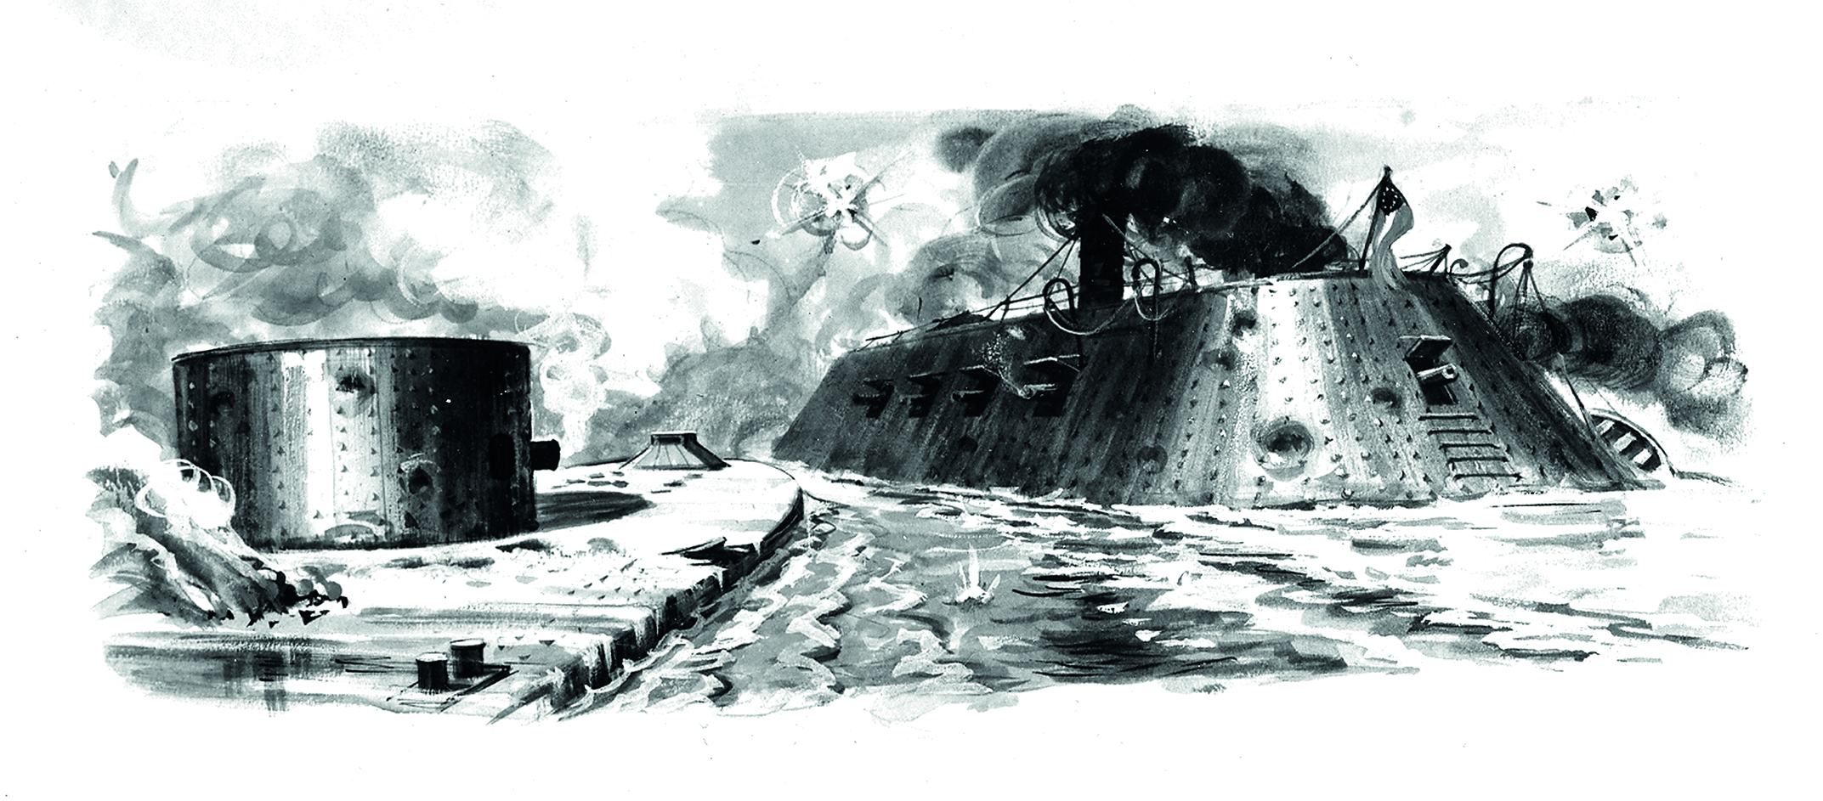
What Civil War strategy does the image represent?

