**Visual and Performing Arts:**

**Appendix D: English Language Learners (ELLs)**

In addition to specific instruction in English as a Second Language (ESL), ELLs need all teachers to use specific techniques, accommodations, and practices to help them 1) access and understand subject-specific content, and 2) learn English language vocabulary, grammar, mechanics, and usage throughout their instructional day.

Teachers should use the WIDA Can-Do descriptors to match instructional practices to the language skill levels aligned to the student’s WIDA score (1-6 scale)

Grade 9-12 WIDA Can-Do Descriptors

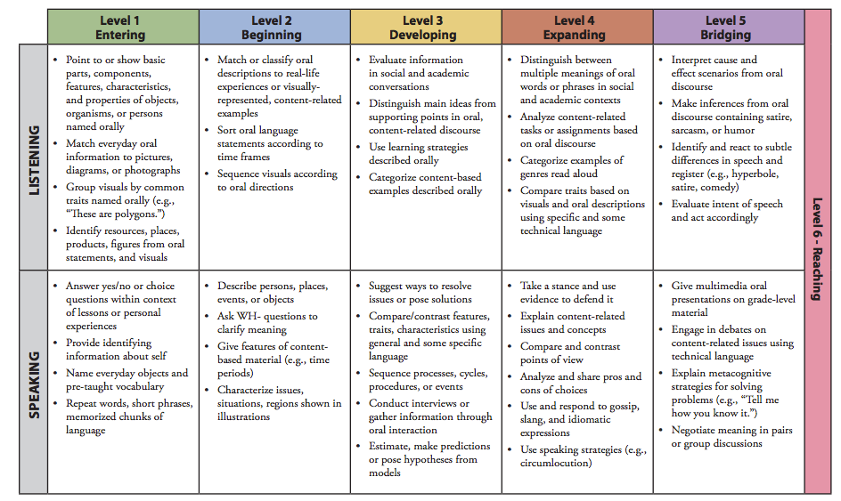

Grade 9-12 WIDA Can-Do Descriptors

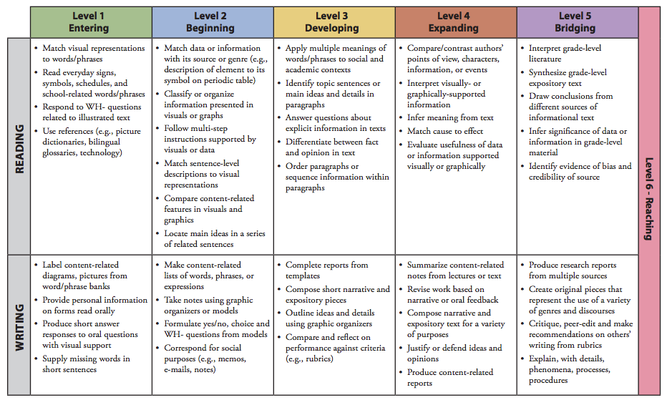

Materials from WIDA Consortium, available <https://www.wida.us/standards/CAN_DOs/>

Also see ELL curriculum scaffolds, available online with Lindenwold Public Schools curriculum maps.