**Visual and Performing Arts**

**Appendix A: Accommodations and Modifications**

**for Special Education Students**

In general, special education students are expected to perform to the same standards as general education students. They are typically subject to the same state accountability measures, testing requirements, curricular expectations, and graduation requirements as their general education counterparts. Given this, special education students should be taught the standard written curriculum as much as possible, with consideration to accommodations and modification written in the student’s Individualized Educational Plan (IEP).

Some exceptions apply, however. Some students with significant disabilities are exempted from testing and accountability requirements. Others must be provided with modified and/or accommodated materials, tests, or instructional practices. These modifications and accommodations are typically outlined in the student’s IEP. However, teachers of special education students are encouraged and expected to use any instructional practice that will help a student master material.

**Key Definitions[1]**

**Accommodations**

* Accommodations are “intended to lessen the effects of a student’s disability,” and provide *access* to the general education curriculum. They do not result in changed expectations for the child, and do not significantly change or reduce curricular or assessment expectations, although the *environment* may be changed in these areas.

Accommodations may include, *but are not limited to*, extra time, graphic organizers, extended time, scribes, etc.

Accommodations may be written into an IEP, but teachers are free to use accommodations to help students succeed as needed. Teachers should use resources such as supervisors and/or LDTCs in this work.

**Modification**

* Modifications change what is expected of a student and should occur only when written into an IEP. They are *not* used at the teacher’s discretion.

**Teaching Students with Special Needs: Resources**

***Learning Styles***

| **Learning Style** | **Visual** |
| --- | --- |
| **Characteristics** | Preference for seen or observed things, including pictures, diagrams, demonstrations, displays, handouts, films, flip-charts, etc.  Thinks in terms of “show me,” and “let’s have a look at that” and will be best able to perform a new task after reading the instructions or watching someone else do it first. |
| **Tips for Accommodating** | * Use maps, flow charts, or webs to organize materials * Highlight and color code books/notes to organize and relate material * Have students pick out key words and ideas in their own writing and highlight them in different colors to reveal organization * Write out checklists of needed formulas, commonly misspelled words, etc. * Write out and use flash cards for review of material * Draw pictures or cartoons of concepts * Write down material on slips of paper and move them around into proper sequence. (Can be done on PC too) |

| **Learning Style** | **Auditory** |
| --- | --- |
| **Characteristics** | Preference for the transfer of information through listening: the spoken word, of self or others, of sounds and noises.  Use phrases such as ‘tell me’, ‘let’s talk it over’ and will be best able to perform a new task after listening to instructions from an expert. |
| **Tips for Accommodating** | * Engage the student in conversation about the subject * Question students about the material * Ask for oral summaries of material * Have them tape lectures and review them with you * Have them tape themselves reviewing material and listen to it together * Read material aloud to them * Use a talking calculator * Have them put material to a rhythm or tune and rehearse aloud |

| **Learning Style** | **Kinesthetic** |
| --- | --- |
| **Characteristics** | Preference for physical experience - touching, feeling, holding, doing, practical hands-on experiences.  Use phrases such as ‘let me try’, ‘how do you feel?’ and will be best able to perform a new task by going ahead and trying it out, learning as they go. |
| **Tips for Accommodating** | * Write out checklists of materials to be learned or looked for * Trace words and diagrams on paper * Use textured paper and experiment with different sizes of pens, pencils, and crayons to write down information * Use role-play or dramatize concepts. Students can move objects around to dramatize a concept or act out the concept themselves. * Ask the student to envision a scene in which the material to be learned is being used or acted out somehow.  For example: a student could imagine being a character in a novel. * Have the student take notes (on paper, word processor, in textbooks) while reading or listening. * Use some form of body movement (snapping fingers, pacing, mouthing ideas) while reciting material to be learned. |

*Adapted from University of Massachusetts: Dartmouth*

[*http://www.umassd.edu/dss/resources/facultystaff/howtoteachandaccommodate/howtoaccommodatedifferentlearningstyles/*](http://www.umassd.edu/dss/resources/facultystaff/howtoteachandaccommodate/howtoaccommodatedifferentlearningstyles/)

Some research suggests that multiple intelligences may also affect how students learn. Howard Gardner’s seminal work on this topic offers a good starting point to understanding how multiple intelligences can relate to student performance and teacher instructional decision-making.

Howard Gardner online: <http://www.tecweb.org/styles/gardner.html>

An online guide to understanding multiple intelligences: <http://www.tecweb.org/styles/gardner.html>

Also see the infographic on the following page:

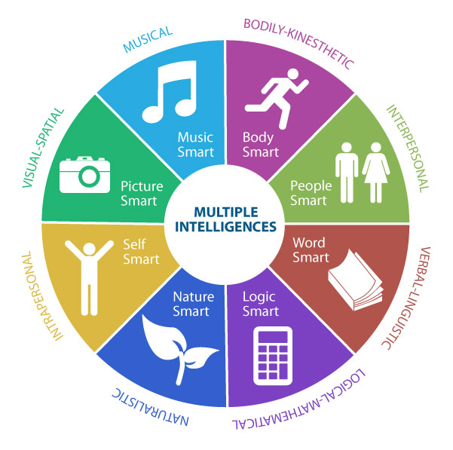*Image form Boise State University:* [*https://aae.boisestate.edu/know-your-learning-style/*](https://aae.boisestate.edu/know-your-learning-style/)

[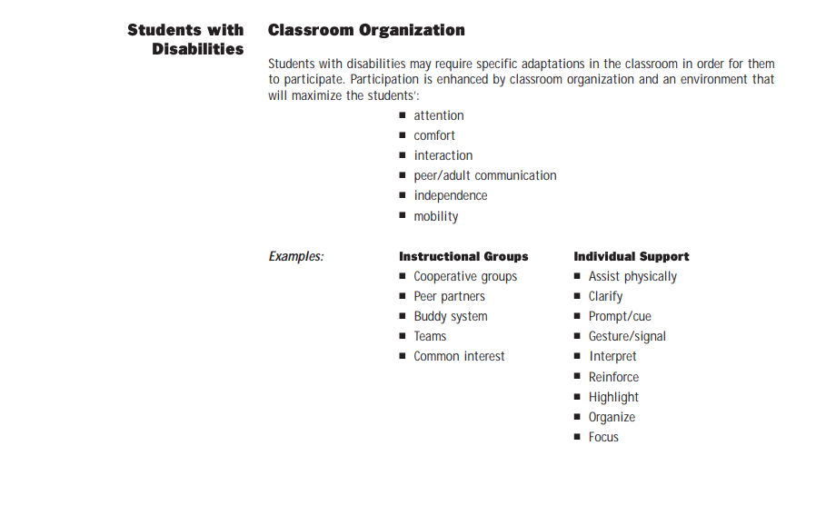](https://aae.boisestate.edu/know-your-learning-style/)

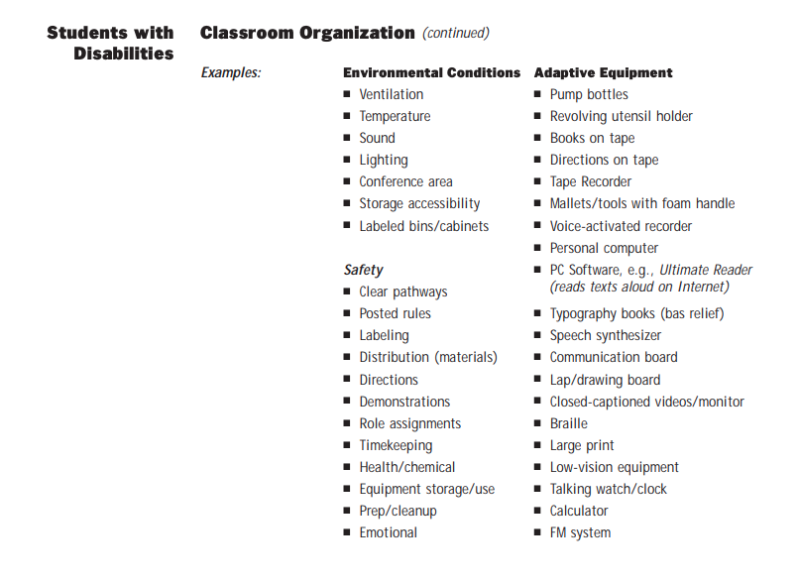

Extensive research, tools, tips, and guidelines for special education in the VPA context is available in the following resource:

* The Kennedy Center: <http://education.kennedy-center.org/pdf/Professional_Papers_Vol_1.pdf>
* “Connecting the Arts and Special Education” (CEC): <http://community.cec.sped.org/darts/new-item2>
* National Art Education Association: <https://www.arteducators.org/search?topic=special-needs>
* “Instructional Adaptations for Students with Diverse Needs” (NJDOE): <https://www.state.nj.us/education/archive/frameworks/arts/chap5.pdf>

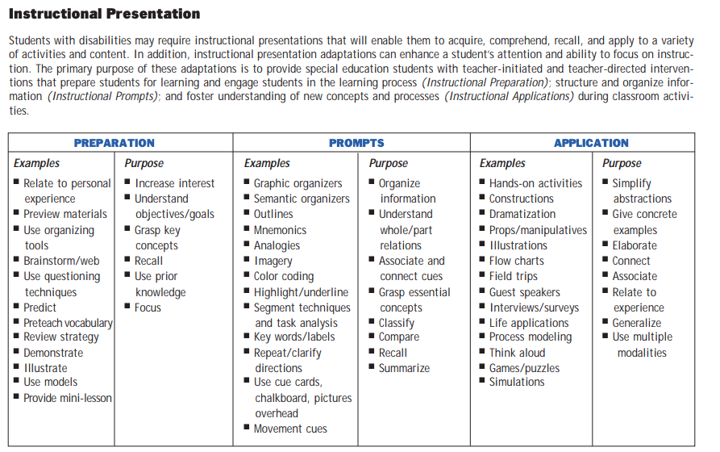

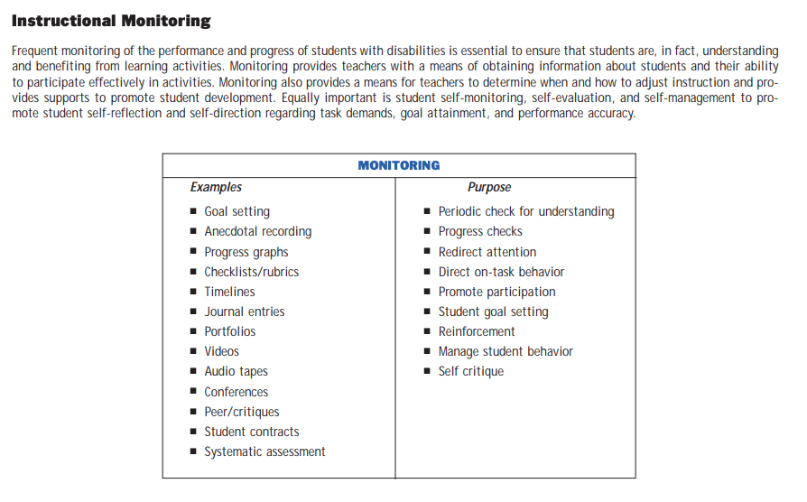

**Excerpts from NJDOE VPA Curriculum Framework,** [**https://www.state.nj.us/education/archive/frameworks/arts/chap5.pdf**](https://www.state.nj.us/education/archive/frameworks/arts/chap5.pdf)

**Visual and Performing Arts**

**Appendix B: Universal Design for Learning (UDL)**

One of the most research-supported instructional techniques for teaching struggling learners and students with various learning styles is through UDL. UDL is organized around teacher creation of “choice menus” that offer students a range of tasks or assignments that are tagged with standard(s), learning style preferences, and more. Teachers can then offer students the agency to choose their own route to mastering all of the standards for a particular lesson.

UDL is organized around providing multiple means for students in three areas:

* multiple means of **engagement**
* multiple means of **representation**
* multiple means of **action and expression**

The infographic on the following page explains these topics more fully.

The CAST website contains an enormous variety of resources for understanding UDL and using it in classrooms.

The links below provide a wealth of UDL knowledge for teachers, administrators, parents, and students:

CAST: <http://www.cast.org/our-work/about-udl.html#.VrJILjYrLzI>

National Center for UDL: <http://www.udlcenter.org/>

UDL Theory and Practice: <http://udltheorypractice.cast.org/home?4>

[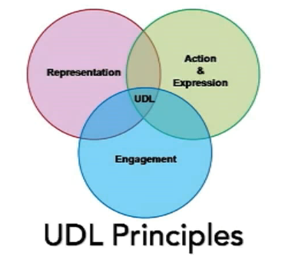](http://udltheorypractice.cast.org/home?4)

[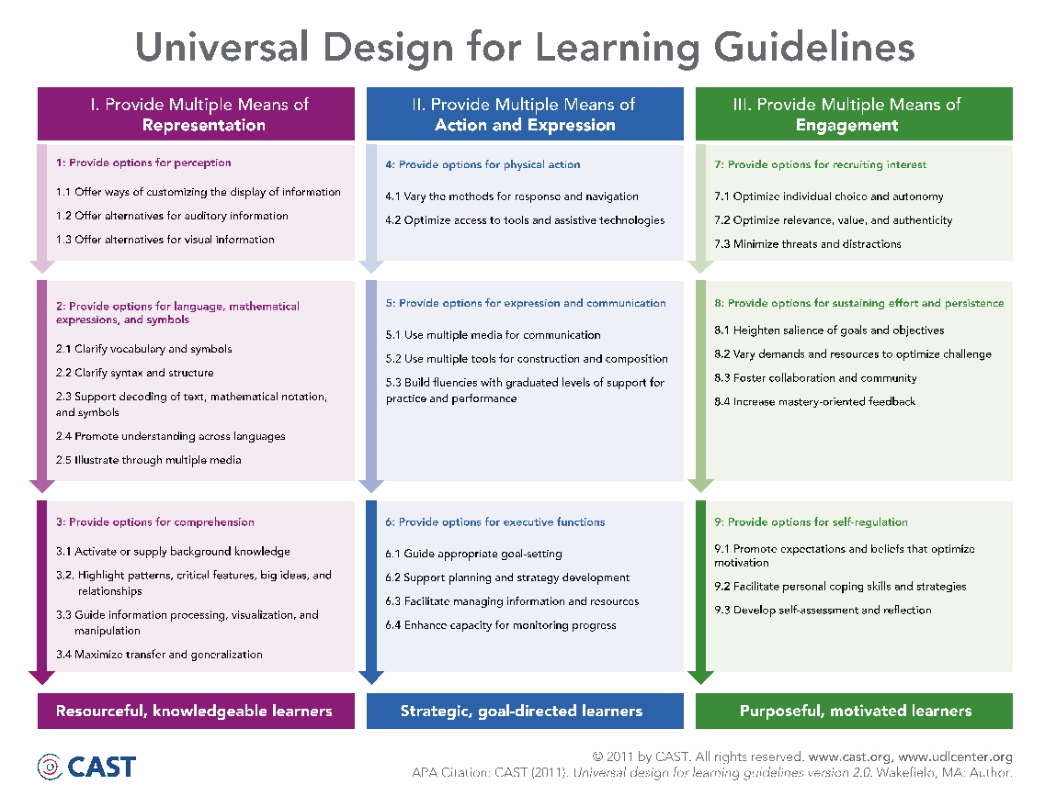](http://udltheorypractice.cast.org/home?4)

**Visual and Performing Arts:**

**Appendix C: Gifted and Talented**

The NJDOE defines gifted and talented as:

“*Those students who possess or demonstrate high levels of ability, in one or more content areas, when compared to their chronological peers in the local district and who require modification of their educational program if they are to achieve in accordance with their capabilities.”[2]*

All schools are required to provide GT students with opportunities to develop themselves fully. While this requirement is met programmatically through, for example, pull-out enrichment, GT-for-all classes, and Honors, AP, and independent study classes, it is important that teachers of all grades and subjects differentiate their instruction for GT students.

***Teaching Gifted Learners***

| Curriculum | Consider curriculum condensing—how can you streamline the curriculum to make time for students to explore advanced or self-directed topics?  Choose learning experiences organized by key concepts and principles of a discipline  Topics that let students grapple with meaningful, real-world problems and pose plausible solutions  Classrooms that provide both structure and choice  Curriculum should not be limited to standard curriculum. |
| --- | --- |
| Instruction | May need a more rapid instructional pace or a pace that allows for deeper understanding and knowing  Skill application at a higher degree of difficulty. Consider how multi media and technology may play a role. Expectations should include deeper thinking, greater leaps of insight, and comfort with probability and ambiguity in proposing solutions.  Teachers should work to support students taking responsible risks with challenging material. Students should be supported as they move through productive failure at challenging material. Many GT students are averse to failure and will only challenge themselves to the point where they know they can succeed. Teachers should push students out of their comfort zones and help them cope with failure and see the benefits of using it as a learning experience.  Instruction should not be teacher-centered or be based primarily on teacher transfer of fact-based knowledge to students. |
| Assessment | Teachers should encourage gifted students to consider how they can best show mastery of concepts. Students should be involved in creating assessment rubrics and judging their work against high standards that they co-create.  Assessments should combine structure with choice and allow for multiple means of demonstration of mastery. Students should be free to determine the best ways that their mastery can be demonstrated, with teacher consultation.  Assessments should not be limited to typical, traditional, paper-based assessments. |

*Adapted from Tomlinson, C. A., “What it Means to Teach Gifted Learners Well”. Available:* [*http://www.nagc.org/resources-publications/gifted-education-practices/what-it-means-teach-gifted-learners-well*](http://www.nagc.org/resources-publications/gifted-education-practices/what-it-means-teach-gifted-learners-well)

**GT Resources**

National Society for Gifted and Talented: <http://www.nsgt.org/>

National Association for Gifted Children: <https://www.nagc.org/>

New Jersey Association for Gifted Children: <http://www.njagc.org/>

### Additional Specific Info for GT Students in the VPA Context

For GT students in VPA it is important to provide as many opportunities as possible for self-directed work that supports a student’s natural interests. Students may benefit from being afforded space to push boundaries in art in a safe space, where they can explore the furthest reaches of their artistic talent under the protection of the school. Students can also benefit from preparing for and engaging in public presentation or display or art, experiencing critique, providing critique, and analyzing artistic contributions.

[The Davidson Gifted Database: Arts](https://www.davidsongifted.org/Search-Database/topic/105196/entryType/1) and [Music](https://www.davidsongifted.org/Search-Database/topic/105195/entryType/1) provides many links to lessons, projects, assessments, and materials for GT students in visual art and music-- there are also plenty of materials for parents and families of GT students in order to better develop supportive parent partnerships for GT students.

1. Adapted from National Center for Learning Disabilities, (2005) <http://www.cehd.umn.edu/nceo/onlinepubs/NCLD/Accommodations.pdf>
2. http://www.state.nj.us/education/genfo/faq/faq_gandt.htm