**ELA Appendix A: Accommodations and Modifications**

**for Special Education Students**

In general, special education students are expected to perform to the same standards as general education students. They are typically subject to the same state accountability measures, testing requirements, curricular expectations, and graduation requirements as their general education counterparts. Given this, special education students should be taught the standard written curriculum as much as possible, with consideration to accommodations and modification written in the student’s Individualized Educational Plan (IEP).

Some exceptions apply, however. Some students with significant disabilities are exempted from testing and accountability requirements. Others must be provided with modified and/or accommodated materials, tests, or instructional practices. These modifications and accommodations are typically outlined in the student’s IEP. However, teachers of special education students are encouraged and expected to use any instructional practice that will help a student master material.

**Key Definitions[1]**

**Accommodations**

* Accommodations are “intended to lessen the effects of a student’s disability,” and provide *access* to the general education curriculum. They do not result in changed expectations for the child, and do not significantly change or reduce curricular or assessment expectations, although the *environment* may be changed in these areas.

Accommodations may include, *but are not limited to*, extra time, graphic organizers, extended time, scribes, etc.

Accommodations may be written into an IEP, but teachers are free to use accommodations to help students succeed as needed. Teachers should use resources such as supervisors and/or LDTCs in this work.

**Modification**

* Modifications change what is expected of a student and should occur only when written into an IEP. They are *not* used at the teacher’s discretion.

**Teaching Students with Special Needs in ELA: Resources**

***Learning Styles***

| **Learning Style** | **Visual** |
| --- | --- |
| **Characteristics** | Preference for seen or observed things, including pictures, diagrams, demonstrations, displays, handouts, films, flip-charts, etc.  Thinks in terms of “show me,” and “let’s have a look at that” and will be best able to perform a new task after reading the instructions or watching someone else do it first. |
| **Tips for Accommodating** | * Use maps, flow charts, or webs to organize materials * Highlight and color code books/notes to organize and relate material * Have students pick out key words and ideas in their own writing and highlight them in different colors to reveal organization * Write out checklists of needed formulas, commonly misspelled words, etc. * Write out and use flash cards for review of material * Draw pictures or cartoons of concepts * Write down material on slips of paper and move them around into proper sequence. (Can be done on PC too) |

| **Learning Style** | **Auditory** |
| --- | --- |
| **Characteristics** | Preference for the transfer of information through listening: the spoken word, of self or others, of sounds and noises.  Use phrases such as ‘tell me’, ‘let’s talk it over’ and will be best able to perform a new task after listening to instructions from an expert. |
| **Tips for Accommodating** | * Engage the student in conversation about the subject * Question students about the material * Ask for oral summaries of material * Have them tape lectures and review them with you * Have them tape themselves reviewing material and listen to it together * Read material aloud to them * Use a talking calculator * Have them put material to a rhythm or tune and rehearse aloud |

| **Learning Style** | **Kinesthetic** |
| --- | --- |
| **Characteristics** | Preference for physical experience - touching, feeling, holding, doing, practical hands-on experiences.  Use phrases such as ‘let me try’, ‘how do you feel?’ and will be best able to perform a new task by going ahead and trying it out, learning as they go. |
| **Tips for Accommodating** | * Write out checklists of materials to be learned or looked for * Trace words and diagrams on paper * Use textured paper and experiment with different sizes of pens, pencils, and crayons to write down information * Use role-play or dramatize concepts. Students can move objects around to dramatize a concept or act out the concept themselves. * Ask the student to envision a scene in which the material to be learned is being used or acted out somehow.  For example: a student could imagine being a character in a novel. * Have the student take notes (on paper, word processor, in textbooks) while reading or listening. * Use some form of body movement (snapping fingers, pacing, mouthing ideas) while reciting material to be learned. |

*Adapted from University of Massachusetts: Dartmouth*

[*http://www.umassd.edu/dss/resources/facultystaff/howtoteachandaccommodate/howtoaccommodatedifferentlearningstyles/*](http://www.umassd.edu/dss/resources/facultystaff/howtoteachandaccommodate/howtoaccommodatedifferentlearningstyles/)

Some research suggests that multiple intelligences may also affect how students learn. Howard Gardner’s seminal work on this topic offers a good starting point to understanding how multiple intelligences can relate to student performance and teacher instructional decision-making.

Howard Gardner online: <http://www.tecweb.org/styles/gardner.html>

An online guide to understanding multiple intelligences: <http://www.tecweb.org/styles/gardner.html>

Also see the infographic on the following page:

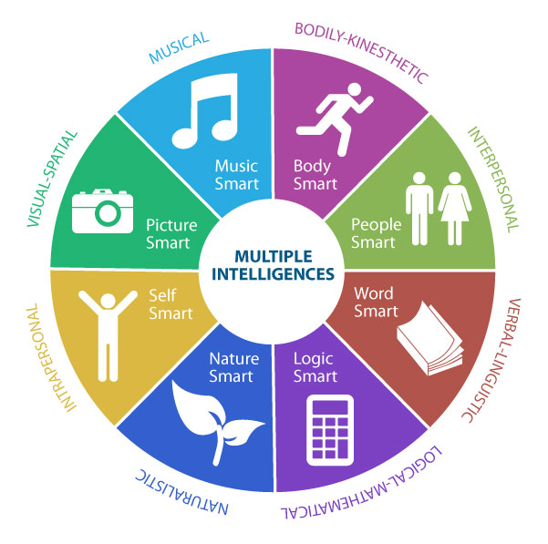*Image form Boise State University:* [*https://aae.boisestate.edu/know-your-learning-style/*](https://aae.boisestate.edu/know-your-learning-style/)

**ELA Appendix B: Universal Design for Learning (UDL)**

One of the most research-supported instructional techniques for teaching struggling learners and students with various learning styles is through UDL. UDL is organized around teacher creation of “choice menus” that offer students a range of tasks or assignments that are tagged with standard(s), learning style preferences, and more. Teachers can then offer students the agency to choose their own route to mastering all of the standards for a particular lesson.

UDL is organized around providing multiple means for students in three areas:

* multiple means of **engagement**
* multiple means of **representation**
* multiple means of **action and expression**

The infographic on the following page explains these topics more fully.

The CAST website contains an enormous variety of resources for understanding UDL and using it in classrooms.

The links below provide a wealth of UDL knowledge for teachers, administrators, parents, and students:

CAST: <http://www.cast.org/our-work/about-udl.html#.VrJILjYrLzI>

National Center for UDL: <http://www.udlcenter.org/>

UDL Theory and Practice: <http://udltheorypractice.cast.org/home?4>

[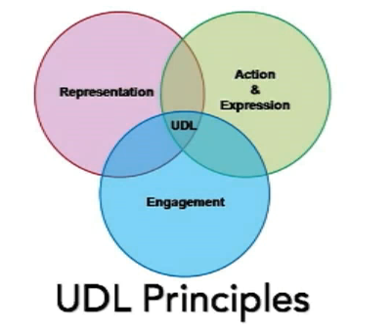](http://udltheorypractice.cast.org/home?4)

[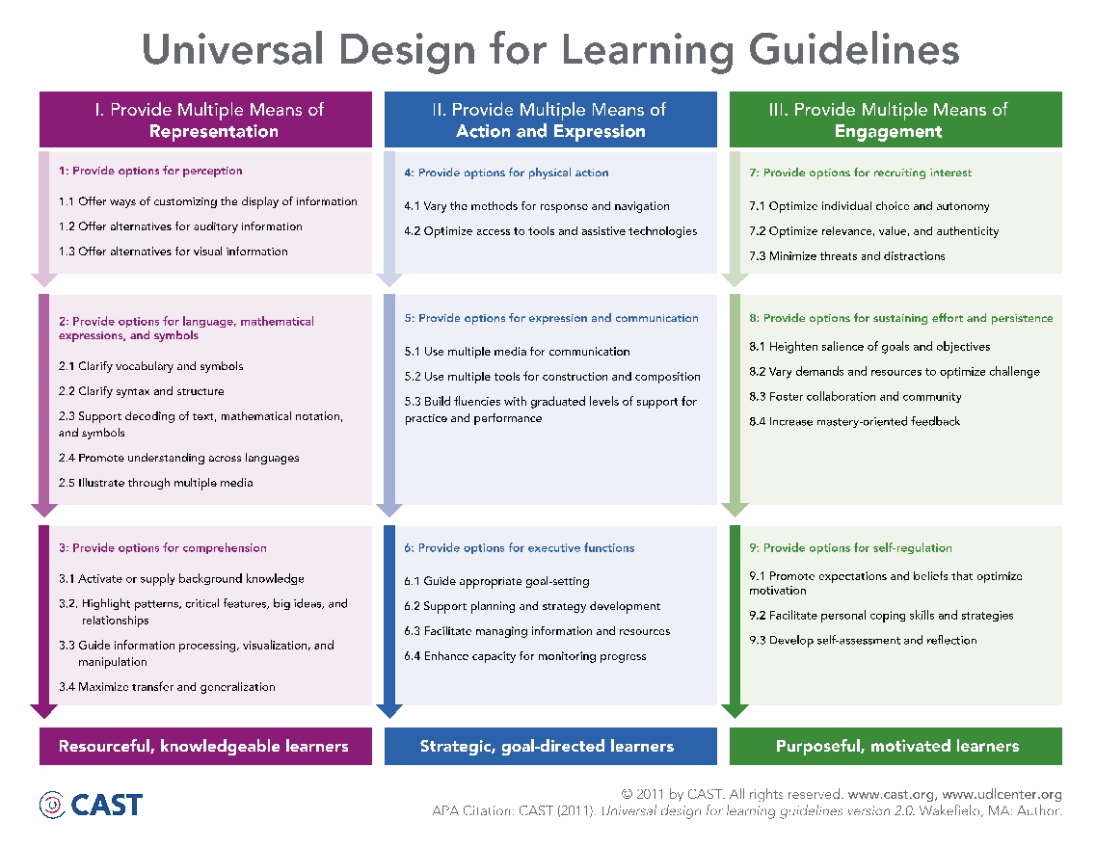](http://udltheorypractice.cast.org/home?4)

### Specific Info for Special Education in the ELA Context

*adapted from Council for Exceptional Children* (<https://www.cec.sped.org/News/Special-Education-Today/Need-to-Know/Need-to-Know-ELA-Standards-for-SWCIN>)

### [Shifting Literacy](http://udltheorypractice.cast.org/home?4)

[A key change in literacy is a move away from the idea of a ladder where each skill is dependent on the prior one, to our understanding of learning progressions. Universal Design for Learning (UDL), and the proliferation of accessible technology means that skills formerly considered prerequisites may now be supported with technology.](http://udltheorypractice.cast.org/home?4)

[**Learning progressions** encapsulate the idea that there are multiple paths to learn a skill or concept, and, given that premise, it may be possible to work around particular discrete “prerequisites” to achieve the larger understanding. For instance, phonics and phonemic awareness are important parts of decoding words, but other supports should be in place so that texts may be enjoyed and used as instructional resources. Knowing the alphabet is not going to help a student make sense of texts.](http://udltheorypractice.cast.org/home?4)

[**Building lessons with the three principles of UDL** (multiple means of representation, multiple means of expression, and multiple means of engagement) supports students with moderate to severe disabilities interacting with complex texts. UDL addresses some of the key changes outlined by the CCSS for literacy instruction:](http://udltheorypractice.cast.org/home?4)

1. [Focus on the ends rather than the means. Is it necessary for students to use a pencil for their rough draft and a pen for the final copy of their persuasive letter? Or, are there more essential understandings that are vital for literacy instruction? The essential understanding may be that students see writing as a form of communication, or that writing for different purposes requires different language and formats.](http://udltheorypractice.cast.org/home?4)
2. [Provide a range of complexity levels for the texts. This range does not always mean that the difficulty of the reading level is high. The Arrival by Shaun Tan is a complex text, and it has no words at all. We can provide opportunities to hear, see, and use different types of language by providing rich texts with interesting themes.](http://udltheorypractice.cast.org/home?4)

[**Using technology and other supports helps students access and make progress in higher levels of instruction.** Many teachers use social media and applications as tools for supporting literacy. Texting may be used to support students to improve spelling skills, take turns in conversations, stay on topic, and understand social rules. Media with a character limit (such as Twitter) may be a non-threatening way to write and respond to texts without the pressure of having to write a lot. Free, accessible, and mobile text-to-speech programs mean that a lack of phonemic awareness is no longer the barrier to literacy it once may have been. The days of high school students working endlessly on “A says ahhhh” should be over!](http://udltheorypractice.cast.org/home?4)

### 

### 

### [Providing Opportunities to Learn Literacy](http://udltheorypractice.cast.org/home?4)

### G[iven the importance of literacy, the question of how to teach grade-level standards to students with moderate to severe disabilities remains. Here are some principles to keep in mind:](http://udltheorypractice.cast.org/home?4)

1. [Understand the standards. General and special educators need to work together to develop universally designed, grade-level aligned instruction that is accessible and represents high expectations appropriate to literacy instruction in the age of information.](http://udltheorypractice.cast.org/home?4)
2. [Use evidence-based practices to maintain complexity and build comprehension. Using read-alouds, peer supports, and effective questioning that take into account the student’s mode of communication should be routine elements of high quality literacy instruction.](http://udltheorypractice.cast.org/home?4)
3. [Build on the principles of UDL for all aspects of literacy. Accessibility begins with creating lessons from a UDL perspective. Presume that barriers to learning result from the instruction or materials—not the student. A UDL approach to literacy makes it hard to believe there is any student we can’t support. Students who do not yet have phonemic awareness, have limited motor skills, or who are still building a communication system can still be readers and writers.](http://udltheorypractice.cast.org/home?4)
4. [Provide opportunities to learn across the day and across content areas. Literacy has different purposes and strategies for different content areas, and all of them are valuable skills and concepts for students to learn.](http://udltheorypractice.cast.org/home?4)
5. [Understand what it means for all students to build college and career readiness skills. College and career readiness skills have been identified as key cognitive strategies, academic knowledge and skills, academic behaviors, contextual skills and awareness, and self-determination. (Conley, 2007, Kearns et al., 2011). These are all functional skills.](http://udltheorypractice.cast.org/home?4)

[And remember, ***literacy happens everywhere*.** Literacy does not happen in separate blocks of time in the real world. However, because reading in math or science is different than reading literature literacy instruction must also occur across the day. For students with moderate to severe disabilities to have opportunities to learn we need to adopt a 21st-century definition of literacy and commit to using strategies like UDL as well as individualized supports.](http://udltheorypractice.cast.org/home?4)

**ELA Appendix C: Gifted and Talented**

The NJDOE defines gifted and talented as:

“*Those students who possess or demonstrate high levels of ability, in one or more content areas, when compared to their chronological peers in the local district and who require modification of their educational program if they are to achieve in accordance with their capabilities.”[2]*

All schools are required to provide GT students with opportunities to develop themselves fully. While this requirement is met programmatically through, for example, pull-out enrichment, GT-for-all classes, and Honors, AP, and independent study classes, it is important that teachers of all grades and subjects differentiate their instruction for GT students.

***Teaching Gifted Learners***

| Curriculum | Consider curriculum condensing—how can you streamline the curriculum to make time for students to explore advanced or self-directed topics?  Choose learning experiences organized by key concepts and principles of a discipline  Topics that let students grapple with meaningful, real-world problems and pose plausible solutions  Classrooms that provide both structure and choice  Curriculum should not be limited to standard curriculum. |
| --- | --- |
| Instruction | May need a more rapid instructional pace or a pace that allows for deeper understanding and knowing  Skill application at a higher degree of difficulty. Consider how multi media and technology may play a role. Expectations should include deeper thinking, greater leaps of insight, and comfort with probability and ambiguity in proposing solutions.  Teachers should work to support students taking responsible risks with challenging material. Students should be supported as they move through productive failure at challenging material. Many GT students are averse to failure and will only challenge themselves to the point where they know they can succeed. Teachers should push students out of their comfort zones and help them cope with failure and see the benefits of using it as a learning experience.  Instruction should not be teacher-centered or be based primarily on teacher transfer of fact-based knowledge to students. |
| Assessment | Teachers should encourage gifted students to consider how they can best show mastery of concepts. Students should be involved in creating assessment rubrics and judging their work against high standards that they co-create.  Assessments should combine structure with choice and allow for multiple means of demonstration of mastery. Students should be free to determine the best ways that their mastery can be demonstrated, with teacher consultation.  Assessments should not be limited to typical, traditional, paper-based assessments. |

*Adapted from Tomlinson, C. A., “What it Means to Teach Gifted Learners Well”. Available:* [*http://www.nagc.org/resources-publications/gifted-education-practices/what-it-means-teach-gifted-learners-well*](http://www.nagc.org/resources-publications/gifted-education-practices/what-it-means-teach-gifted-learners-well)

**GT Resources**

National Society for Gifted and Talented: <http://www.nsgt.org/>

National Association for Gifted Children: <https://www.nagc.org/>

New Jersey Association for Gifted Children: <http://www.njagc.org/>

### Additional Specific Info for GT Students in the ELA Context

For GT students it is important to provide as many opportunities as possible for application of students’ work into real-world contexts. Students should be given opportunities to publish work in print, and/or safe and monitored online spaces. Students should be provided with opportunities for public rendering of work and/or critique or commentary of ideas in a respectful and meaningful way.

[The Davidson Gifted Database](https://www.davidsongifted.org/Search-Database/topic/105126/entryType/2) provides many links to competitions and other forums where students have the opportunity to publish their work in a public space; in addition the database provides ample resources for teaching GT students in the context of ELA across various grade levels.

1. Adapted from National Center for Learning Disabilities, (2005) <http://www.cehd.umn.edu/nceo/onlinepubs/NCLD/Accommodations.pdf>
2. http://www.state.nj.us/education/genfo/faq/faq_gandt.htm