To Kill a Mockingbird Screenplay
Screenplay by Horton Foote
Novel by Harper Lee

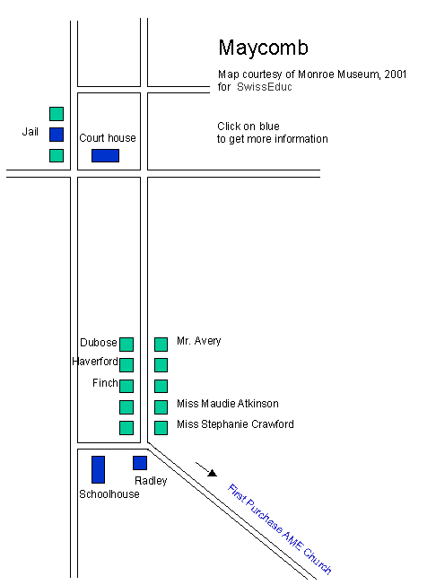
Name _______________________
Ms. Sullivan
Mrs. Martignetti

Jean Louise

Cunningham

Atticus

Calpurnia

Jem

Maudie

Dill

Stephanie

Mrs. Dubose

Judge

Hiram

Ewell

Walter

Tate

Helen

Man

Kelley

Tom

Sykes

Bailiff

Gilmer

Mayella

Foreman

Spence

Dr. Reynolds

Name: ________________________________________________ Block: __________

To Kill a Mockingbird Screenplay - Character Analysis

Directions: As you read a screenplay, you learn about each character. In the chart below, write a short description of the characters you meet. KEEP ADDING as the story continues.

Character | Description
Scout  (pg 3) | 6-year old girl, real name Jean Louise, daughter of Atticus, sister of Jem.
Mr. Cunningham

Jem
Miss. Maudie Atkinson
(pg 6)
Dill
(pg.7)
Miss. Stephanie Crawford
(pg. 7)

Calpurnia

Mr. Radley

Mrs. Henry Lafayette Dubose
(pg. 11)

Boo (Arthur) Radley
Atticus
Mr. Ewell
Walter Cunningham
Judge Taylor
Mayella Ewell

Name __________________________________ Block ___________
To Kill a Mockingbird Screenplay
Studyguide Pgs 1-22

Directions: Answer the questions IN COMPLETE SENTENCES

- What is the setting of the play? Be sure to be specific.

- Who is Jean Louise? Be very specifc.

- What did Mr. Cunningham bring to Atticus? Why?

- Why does Atticus tell Scout not to call him the next time Mr. Cunningham comes to the house?

- What are the full names/nicknames of the two children?

- Jem will only come down from the tree if Atticus does what?

- What are Jem’s three major complaints to Miss. Maudie?

8. Who is “the meanest man that ever took a breath of life” (pg. 9)? __________________

9. What are some rumors or superstitions about Boo as told by Jem?

10. Describe the Radley’s house/yard.
11. Why does Miss. Stephanie want Dill to stay away from the Radley house?

12. Describe the incident Miss. Stephanie tells the children about “the time Boo tried to kill his papa”.

13. Where do Jem and Scout go at 5:00pm? _______________________________________

14. Describe Mrs. Dubose and her house.

15. What does Atticus say about the flowers Mrs. Dubose has in her yard?

16. What does Jem whisper to Dill about how Mrs. Dubose changes? What lesson
can be learned from this?

17. Whose case does Judge Taylor want Atticus to take? ____________________________

Does he agree? ____________ Does he need to be convinced? ______________ (pg. 16)

18. What do we learn about courage and the children on pages 17-18?

19. Where do Jem, Dill, and Scout go to watch Atticus? ________________________
What is the trial about?

20. Describe Robert E. Ewell’s conversation with Atticus. What can be inferred?

Name __________________________________ Block ___________
To Kill a Mockingbird Screenplay
Studyguide Pgs 23-46

Directions: Answer the questions IN COMPLETE SENTENCES

- Why do Scout, Jem and Dill go to Boo Radley’s?

- What did Jem leave at Boo Radley’s house? _____________________________________

- What sound pierces the air while Jem is retrieving his pants?

- What does Atticus Miss. Stephanie about the commotion?

---------------------------concludes summer vacation---------------------------------------------

- Who does Scout beat up on the first day of school? _____________________________

- Why does Scout beat him up?

- Why do you think Jem invites Walter Cunningham to dinner?

- What can be inferred about the conversation surrounding guns between Atticus, Walter Jr, and Jem?

- What is it a sin to kill according to Atticus? Why? (32)

- What request does Walter Cunningham have at dinner?

- Why does Calpurnia scold Scout during dinner?

- What is Atticus trying to teach Scout when he says, “you never really understand a person until you consider things from his point of view… until you climb inside of his skin and walk around in it..” (34)

- What compromise do Atticus and Scout make on page 34?

- What is the name of the mad dog? ______________________________________________________

- What does Atticus do to the dog that surprises his children?

- Who is Helen Robinson? _______________________________________________________________

- Why does Atticus go to see Helen?

- Does Atticus believe that Bob Ewell will harm his children? _____________________________ What does he say?

- What is in the knothole in the oak tree in front of the Radley house that Jem puts in his pocket?

- Who did Scout fight at school and why? ______________________________________________

- What reason does Atticus give for defending Tom Robinson?

- What did Scout and Jem find in the knothole outside of the Radley house?

- What is special about them?

- Why does Mr. Radley fill the knothole with cement?

- What big secret does Jem share with Scout? (46) BE VERY SPECIFIC

- What is Dill’s latest story about his daddy?

Name __________________________________ Block ___________
To Kill a Mockingbird Screenplay
Studyguide 3 Pgs 46-82

Directions: Answer the questions IN COMPLETE SENTENCES

- Why does Atticus go to the jail?

- Describe in great detail the events that occur on pages 49-52 at the jail.

- How does Scout help Atticus at the jail?

- What is the “most excitin’ thing that ever happened that ever happened in this town?”

-----------------------------------------------The Trial-----------------------------------------------------------

- Where do the children sit and whom are they sitting with at the trial?

- What kind of injuries did Mayella Ewell have?

- With what hand does Mr. Ewell write his name? _______________________________________

- What does this prove?

- In your opinion, who do you think beat Mayella Ewell? Why?

- What does Mayella think of Atticus?

- What did Mayella ask Tom Robinson to do?

- Why does Atticus ask Tom to catch the glass with his left hand?

- Why can’t Tom use his left hand?

- What did Atticus say that Mayella did in his closing arguments?

- What is the verdict of the trial? __________________________________________________________

- What happened to Tom Robinson after the trial?

- What does Mr. Ewell do to Atticus Finch?

- What was Scout’s Halloween costume? (pg 73) _________________________________

- Why didn’t Scout want to leave the auditorium?

- Who does Scout think is trying to scare Jem and Scout on their walk home?

- Who saves Jem and Scout?

- What did Sheriff Tate say happened to Bob Ewell?

- Why does Tate say this happened?

- What really happened?

- What does Scout mean when she says it would be like “shooting a mockingbird.”

