PRINT- Students may take quiz at- https://quizizz.com/admin/quiz/563cee9af9e998ca32963347/authors-purpose
Author's Purpose
5 Questions
NAME :
CLASS :
DATE :
1.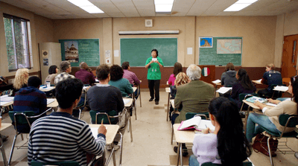What is the author's purpose of Passage #5?
a)to persuade the reader to move to smaller schoolb)to persuade for a reduction in class sizesc)to inform about the advantages and disadvantages of smaller classesd)to inform about class size at Patrick Henry High School
2.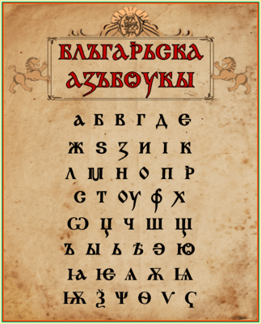What is the author's purpose of Passage #4?
a)to inform about the history of handwritingb)to critique the Roman Empire

c)to describe the Dark Agesd)to persuade as to the importance of good handwritin
3.What is the author's purpose of Passage 3?
a)to entertain the reader with a short anecdoteb)to entertain the reader by making him/her laughc)to inform the reader about the dangers of walking on the beachd)to inform the reader about barnacles
4.What is the author's purpose of Passage 2?
a)to inform you of the importance of exerciseb)to inform you about a safe way to lose weightc)to persuade you to purchase Slim Weight Patchd)to persuade you that patches are more effective than diet and exercise
5.What is the author's purpose of Passage 1?
a)to inform the reader of the dangers associated with nose-pickingb)to entertain the readerc)to describe Tiny Cooperd)to persuade the reader to be careful in choosing friends
Answer Key
1.b
2.a
3.d
4.c
5.b

