Scenario 1: A kid you know at school gets bitten by a weird insect that causes an ugly multicolored rash on her stomach, back and backside.

What should be CONSIDERED before anything is posted?

Inappropriate Post:

Appropriate Post:

Alternative way of communication:

Scenario 2: Someone writes in their personal journal. Another person copies what they wrote and posts it online.

What should be CONSIDERED before anything is posted?

Inappropriate Post:

Appropriate Post:

Alternative way of communication:

Scenario 3: Someone posts, “Have a good vacation,” on a friendʼs social media page.

What should be CONSIDERED before anything is posted?

Inappropriate Post:

Appropriate Post:

Alternative way of communication:

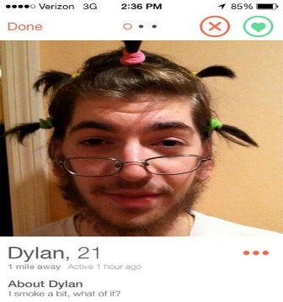
Scenario 4: You know a student made a fake social media account impersonating another student in a negative way and includes their personal information.
What should be CONSIDERED before anything is posted?

Inappropriate Post:

Appropriate Post:

Alternative way of communication:

