When something goes wrong what is your natural reaction?
Our behavior responses are so beautifully captured in the acronym 'OARBED' - the OAR (Ownership, Accountability and Responsibility) representing above the line behavior while BED (Blame, Excuse, Deny) is below the line.

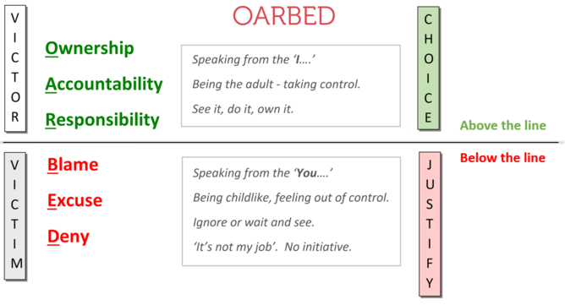

Perhaps your children have been playing a little too quietly and on investigation you discover sharpie marker all over the children’s bedroom.
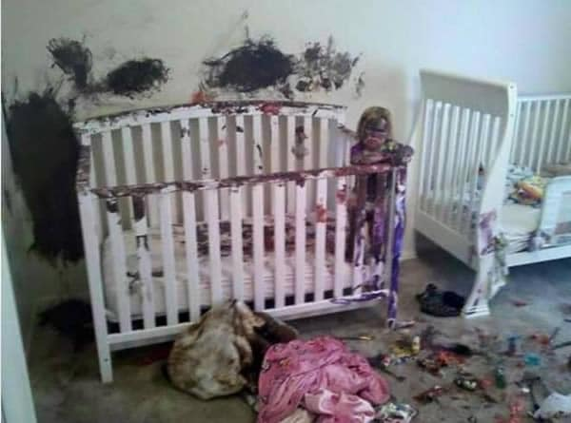
You immediately ask John if he made the mess. John's first response is denial; 'No it wasn't me'. So you ask Jane the same question. She uses another below the line response blame and says 'It was John', So, you allow John a chance to defend himself. He fires back an excuse; 'Jane told me to do it'.

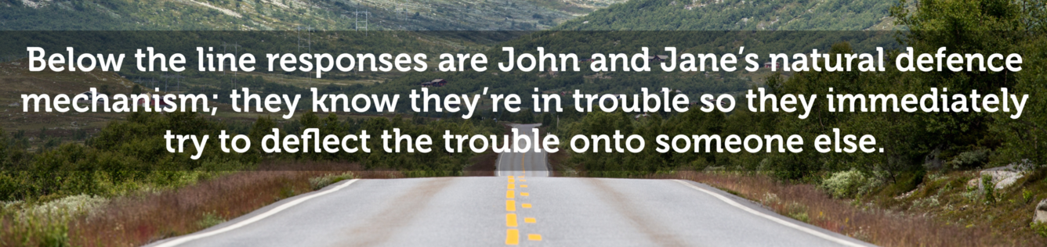

John and Jane are just kids. SO, this type of defense is natural. HOWEVER…
As young adults, when something goes wrong naturally our first thought is often below the line. However, we are better off in the long run to behave in an above the line way. To accept responsibility and take ownership and be accountable for our error.

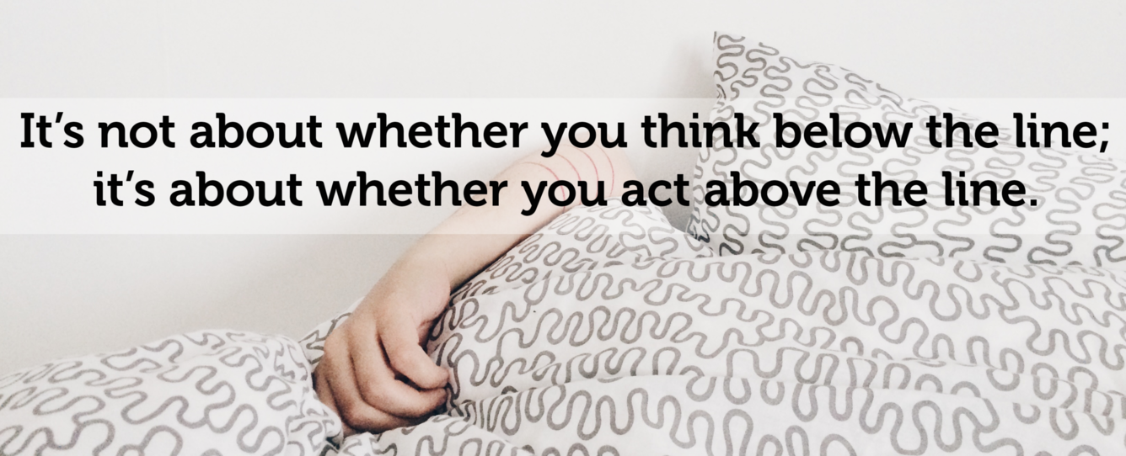

Of course, we're not very likely to get these above the line responses from John or Jane:
- Ownership: 'Sorry Dad it was me, I knew it was the wrong thing to do.
- Accountability: 'I'm sorry Dad, what can I do to make it up to you?'
- Responsibility: 'It's my fault Dad, I told John to do it.'

When we are operating below the line we are being a victim.
OARBED teaches us that, when we're operating below the line and being a victim, we are not in control. Responses spring to mind like 'I should', 'I could' or 'I might' - a below the line response comes from a place of fear.
On the contrary, when operating from above the line we are the victor and we are in control. Our responses will be 'I will', 'I can' and 'I must'. An above the line response comes from a place of courage.

