What is RESPECT? After viewing YouTube video, try to fill in each letter of the alphabet with a word associated with RESPECT. https://www.youtube.com/watch?v=w9QsOn5zoQg
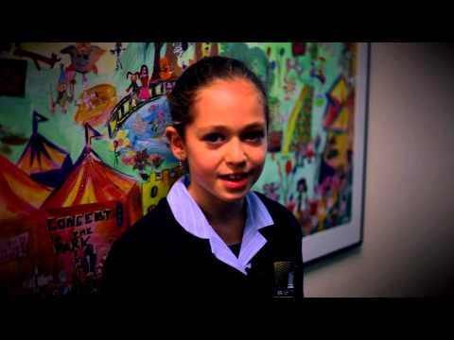 | What does the word 'Respect' mean to you? - YouTube  www.youtube.com

A S
B T
C U
D V
E W
F X
G Y
H Z
I
J
K
L
M
N
O
P
Q
R

