Each picture is of a BODY LANGUAGE that you probably have done at some point. Circle the message(s) it gives you ACCORDING TO THE VIDEO WE WATCHED. 15 most common body language mistakes
1. Lazy 2. Anxious 3. Bored 4. Interested
1. Lazy 2. Aggressive 3. Shy 4. Tired
1. Listening 2. Excited 3. Anxious 4. Weakness
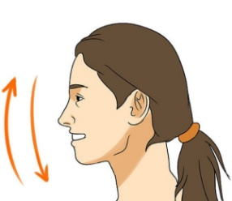 1. Tired 2. Aggressive 3. Understanding 4. Bored
1. Interested 2. Aggressive 3. Agreement 4. Shy
1. Shy 2. Tired 3. Defensive 4. Weakness
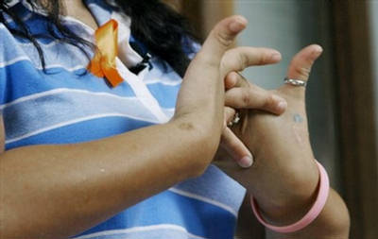 1. Shy 2. Nervous 3. Not interested 4. Listening
1. Angry 2. Tense 3. Defensive 4. Tired
1. Tired 2. Lying 3. Anxious 4. Bored
1. Aggressive 2. Lying 3. Tired 4. Not interested

1. Tired 2. Shy 3. Unfriendly 4. Weakness
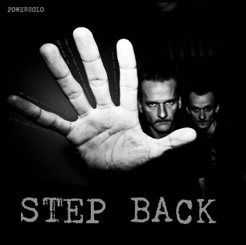 1. Defensive 2. Uncertain 3. Tired 4. Aggressive
1. Weakness 2. Tired 3. Aggressive 4. Interested
1. Tense 2. Anxious 3. Listening 4. Aggressive
1. Listening 2. Tired 3. Weakness 4. Not interested

