NAME___________________________________ PERIOD___
WHAT IS SHE SAYING????? Use the words or expresions below to match with the facial expressions the girl shows in each block. Write the number for the correct answer in each block.

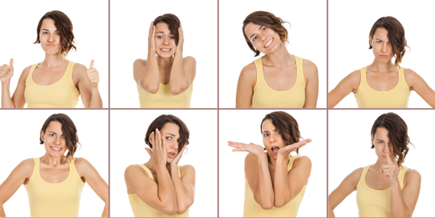

- Oh no, I completely forgot!
- Scolding
- Everything is perfect!
- What is that? [Frightened]
- Anger
- Good job!
- Needs an explanation
- Oh well

