NAME___________________________________ PERIOD___
WHAT IS SHE SAYING????? Use the words or expresions below to match with the facial expressions the girl shows in each block. Write the number for the correct answer under each block.

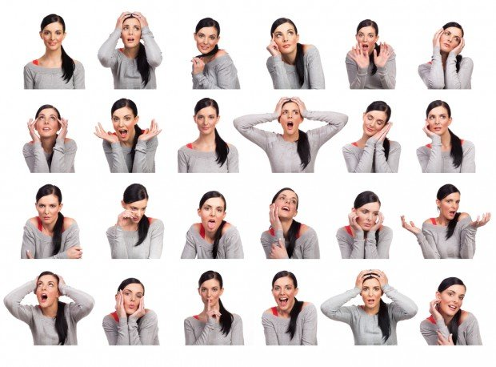
- I’m tired 13. Thinking
- That’s really bad news! 14. I’m looking sexy
- I don’t know 15. Flirty
- I have a headache. 16. Happiness
- Anger 17. This could be a class picture
- Frightened 18. Oh no! I completely forgot!
- Sadness 19. Daydreaming
- I’m so beautiful! 20. That’s adorable!
- Yuck! 21. Everything is good
- Can you keep a secret? 22. I’m bored
- Frustration 23. Shocked
- Sadness 24. Glamorous & looking great

