Aesop's Fables:
The Grasshopper and the Ants
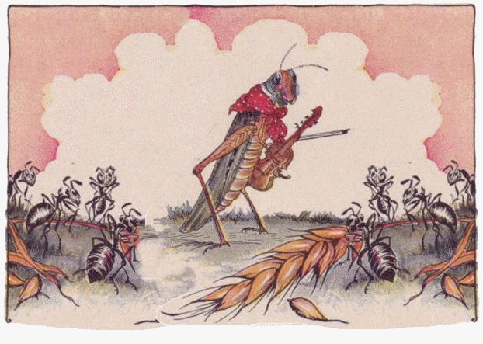
In a field one summer's day a grasshopper was hopping about, chirping and singing to its heart's content. A group of ants walked by, grunting as they struggled to carry plump kernels of corn.
"Where are you going with those heavy things?" asked the grasshopper.
Without stopping, the first ant replied, "To our ant hill. This is the third kernel I've delivered today."
"Why not come and sing with me," teased the grasshopper, "instead of working so hard?"
"We are helping to store food for the winter," said the ant, "and think you should do the same."
"Winter is far away and it is a glorious day to play," sang the grasshopper.
But the ants went on their way and continued their hard work.
The weather soon turned cold. All the food lying in the field was covered with a thick white blanket of snow that even the grasshopper could not dig through. Soon the grasshopper found itself dying of hunger.
He staggered to the ants' hill and saw them handing out corn from the stores they had collected in the summer. He begged them for something to eat.
"What!" cried the ants in surprise, "haven't you stored anything away for the winter? What in the world were you doing all last summer?"
"I didn't have time to store any food," complained the grasshopper; "I was so busy playing music that before I knew it the summer was gone."
The ants shook their heads in disgust, turned their backs on the grasshopper and went on with their work.
- Create a motto for this fable that has to do with RESPONSIBILITY: __________________________________________________________________________________________________________________________
- Look through the story CIRCLE and LABEL an example of each:
*Accountable *Responsibility * Excuse *Denial
3. There are 2 characters: the GRASSHOPPER and the ANTS.
Which performed ABOVE the OAR/BED line?_______________________
How do you know?__________________________________________________
Which performed BELOW the OAR/BED line?_______________________
How do you know?__________________________________________________
- The grasshopper cannot solve the problem now, but what can he do NOW so that he doesn’t starve THIS WINTER? ________________________________________________________________________________________________________________________________________________________________________________________________________________________________________________________________________________________________

