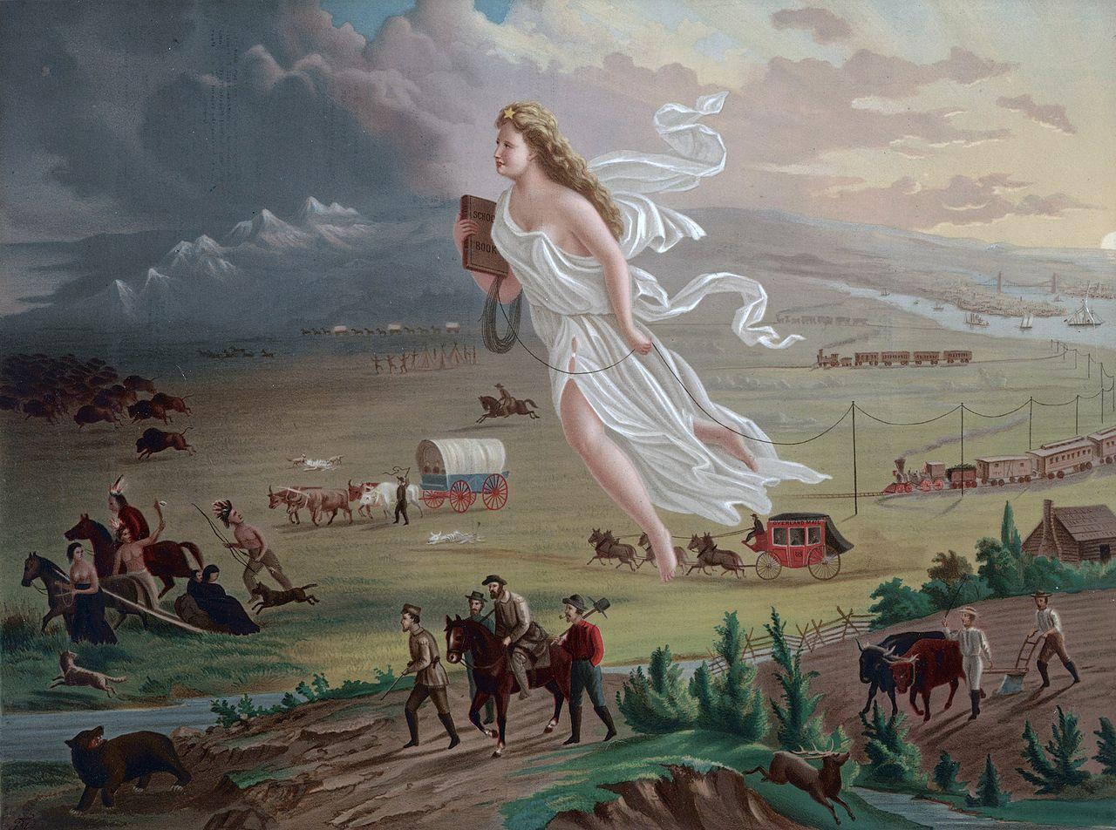
“Spirit of the Frontier”

Answer the questions below about the picture:
- Tell me what you see in this picture.
- What direction does it seem everyone is moving?
- Is someone leading them somewhere? Who?
- What type of transportation do you see?
- Why are they going this way?

