**Literary** **Analysis** **Sentence** **Starters…**

**Use these sentence starters to begin the different parts of your paper. You have three options for each part of your paper. Choose the one you think fits your material best. Remember these are suggestions only. You do not have to use them and they’re not a “fill in the blank” paper. You should vary your sentence structures so the paper doesn’t seem repetitive. Your paper must be on white lined paper with proper conventions.**

**Theses** **Starters:**

The author’s use of reveals the theme of

.

Insert Author’s Last Name uses literary devices such as

to show the reader the theme of

.

Through the use of literary devices like

, the theme of

in the novel is revealed.

**Body** **Paragraphs:** **Topic** **Sentence** **Starters**

Through the use of , the author reveals

.

The in the novel shows the reader

.

The novel uses , which shows the reader

.

**Body** **Paragraphs:** **Book** **Evidence** **Sentence** **Starters**

In the novel it says, (insert quote)

(Author’s Last Name pg. #).

Author’s Last Name writes, (insert quote)

(Author’s Last Name pg. #).

For example, when the authors describes , it says,

(insert quote)

(Author’s Last Name pg. #).

**Body Paragraphs: Commentary Sentence Starters**

This quote shows

.

From , we see

that .

By using , the reader understands .

**Conclusion** **Starters:**

Through the use of _, the author establishes

.

The author reveals , with the use of .

Literary devices like allow the

reader to understand that is the message behind the novel.

**Sample Literary Analysis Essay Outline**

**I. Introduction: Thesis**

a. Thesis: The author uses diction and imagery to reveal the theme that racism can be harmful to society.

**II. Body Paragraph: Imagery**

a. “She just fell down in the dirt. Just fell down in the dirt, like a giant with a big foot just came along and stepped on her” (Lee 240).

i. The author uses imagery here to show how racism affected Helen Robinson after Tom’s death. She’s been “crushed” by it because she’s lost her husband and her life is ruined.

b. “Her face was the color of a dirty pillowcase, and the corners of her mouth glistened with wet, which inched like a glacier down the deep grooves enclosing her chin. Old- age liver spots dotted her cheeks, and her pale eyes had black pinpoint pupils. Her hands were knobby, and the cuticles were grown up over her fingernails" (Lee 122).

i. This disgusting description of Ms. Dubose shows how hate and anger can be harmful. Ms. Dubose is described in such a grotesque way to show the reader how racism is a repulsive, harmful trait.

**Sample Body Paragraph…**

Topic Sentence-The author uses imagery to reveal the theme that racism is harmful to society. Transition-In chapter 25, when Dill explains to Scout what he saw when Atticus told Helen Robinson about her husband’s death, he says Evidence-“She just fell down in the dirt. Just fell

down in the dirt, like a giant with a big foot just came along and stepped on her” (Lee 240). Analysis-The author uses imagery here to show how racism affected Helen Robinson after Tom’s death. She’s been “crushed” by it because she’s lost her husband and her life is ruined. Transition- In chapter 9, Lee introduces the racist character of Ms. Dubose and writes, Evidence-“Her face was the color of a dirty pillowcase, and the corners of her mouth glistened with wet, which inched like a glacier down the deep grooves enclosing her chin. Old-age liver spots dotted her cheeks, and her pale eyes had black pinpoint pupils. Her hands were knobby, and the cuticles were grown up over her fingernails" (Lee 122). Analysis-This disgusting description of Ms. Dubose shows how hate and anger can be harmful. Ms. Dubose is described in such a grotesque way to show the reader how racism is a repulsive, harmful trait.

**Literary Analysis Essay Outline- MLA Format Outline**

(on a piece of notebook paper use the format below)

**I.** Introduction – Give a quick summary of the novel

**a.** Thesis – The author uses and to convey the theme of

.

**II.** Body Paragraph #1 – Literary Device #1

**a.** Quote #1

**i.** Explanation of the quote

**b.** Quote #2

**i.** Explanation of the quote

**III.** Body Paragraph #2- Literary Device #2

**a.** Quote #1

**i.** Explanation of quote

**b.** Quote #2

**i.** Explanation of the quote

**IV.** Conclusion- Restate your thesis

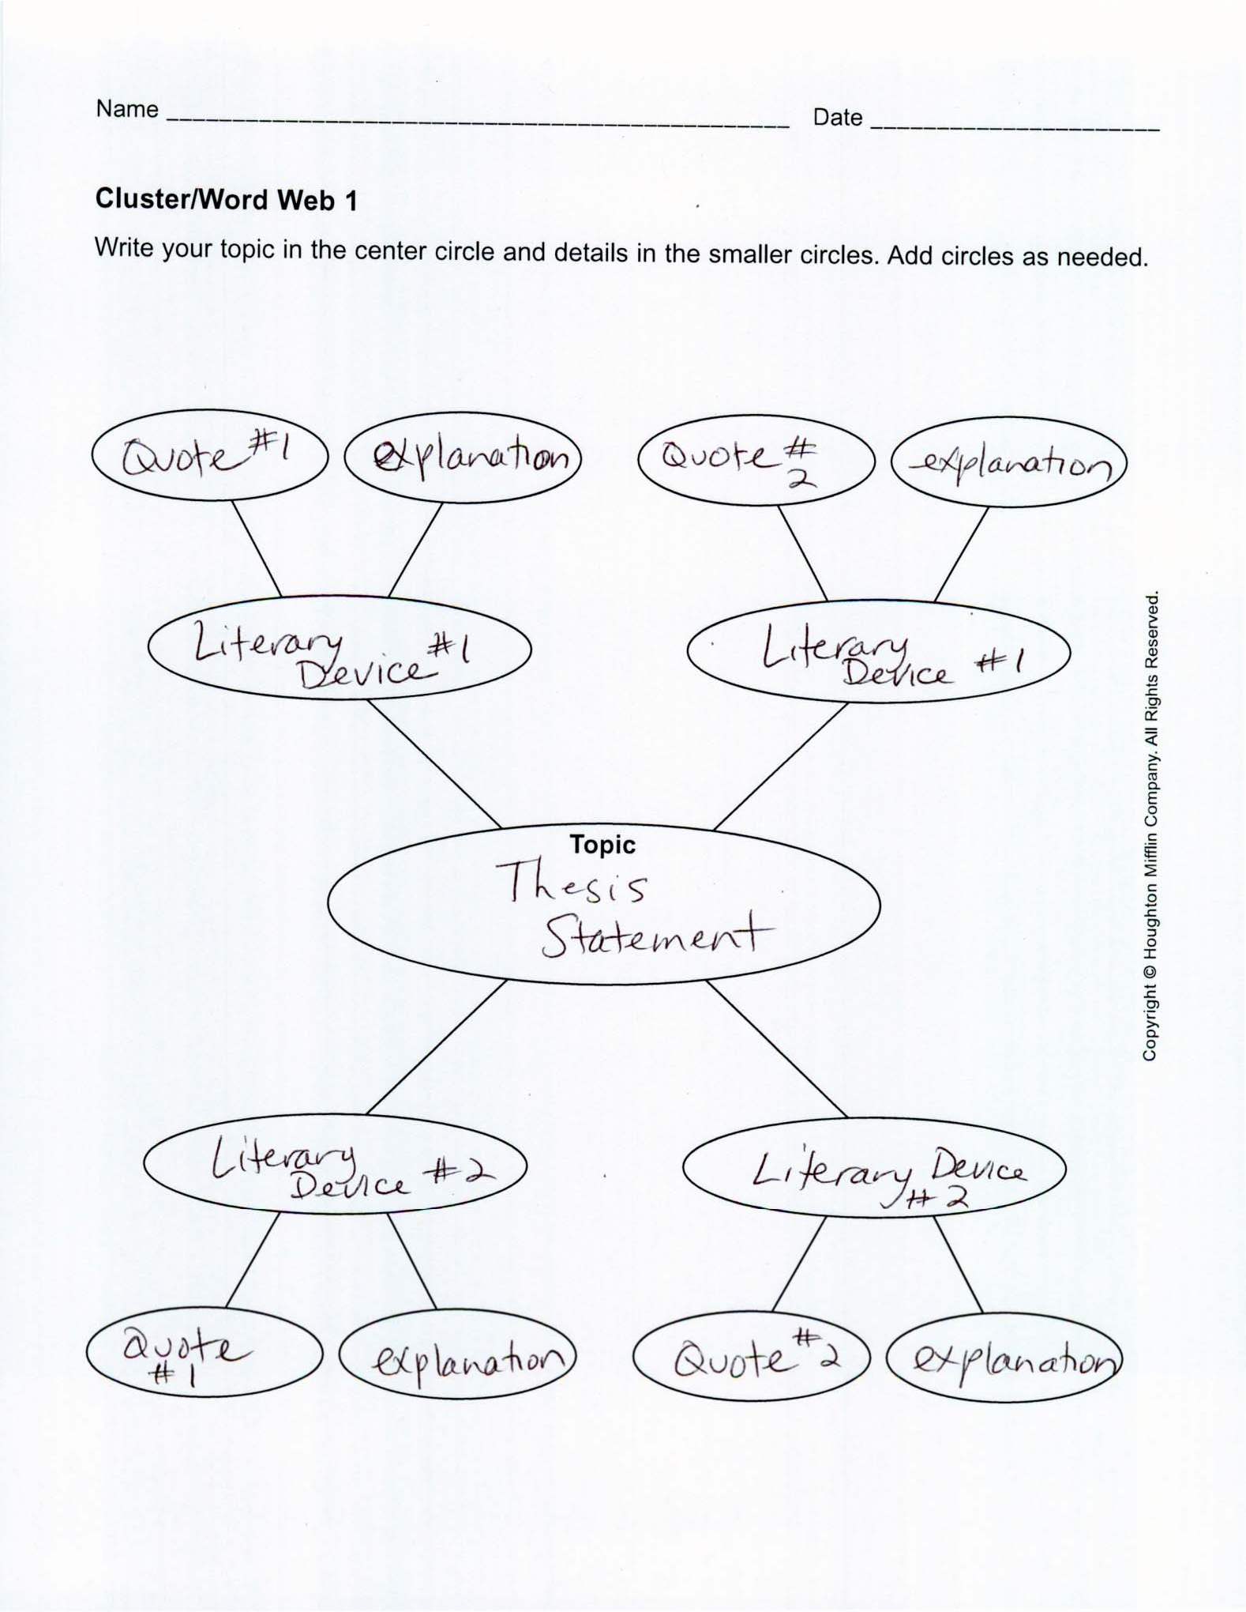

**SAMPLE LITERARY ANALYSIS**

One dimension of a diverse society is social class, which categorizes people based on how wealthy and affluent they are. While some people avoid judging others who are from a different social class, there are those who swear by it. *To Kill a* Mockingbird is a novel which takes place shortly after the Great Depression, a time when the lines that divide social classes were more greatly defined. In “To Kill a Mockingbird”, the author uses point of view and imagery to reveal the theme that social prejudice affects the way people interact with and view one another.

The novel is told from Scout’s perspective which creates an interesting division between reality and perspective. Because she is a child, she hasn’t formed society’s built in prejudices. The reader is forced to look at them through the unbiased eye of a child. For example, Scout does not understand why Aunt Alexandra does not want her to play with Walter Cunningham. Aunt Alexandra insists that Walter is, “trash” (Lee 225). Scout just sees Walter as a nice boy;

she does not see that she is from a higher class and should not socialize with someone from a lower class. Later on in the novel, we see her childlike perspective when she is at school and the children are giving current events. In the story it says, “Why she frowned when a child

recited from the Grit Paper, I never knew, but in some way it was associated with liking fiddling, eating syrupy biscuits for lunch, being a holy‐roller, singing *Sweetly Sings the Donkey* and pronouncing it dunkey, all of which the state paid teachers to discourage” (244). While Scout recognizes the differences between her and the “bus kids,” she cannot comprehend why the adults view them negatively. From her innocent perspective, the reader gets the idea that

social prejudice is senseless.

Lee uses detailed and disgusting descriptions when introducing characters who represent the lower classes. For example, in chapter three when she describes Burris Ewell it says, “His neck was dark gray, the backs of his hands were rusty, and his fingernails were black

to the quick” (Lee 26). When Lee first introduces Walter Cunningham, she mentions that he has hook worms from living an unclean lifestyle. Later she describes him as if, “he had been raised on fish food: his eyes, as blue as Dill Harris’s, were red‐rimmed and watery. There was no color in his face except at the tip of his nose…” (23). By using these negative, grotesque descriptions we get the sense that Walter’s lower class status is looked down upon by the middle and higher classes.

Through the use of a disconnected point of view and vulgar imagery, Lee establishes the divide between the social classes in Maycomb. She reveals the hidden truth that social class plays a role in how we all view one another with prejudice.