**---**

**[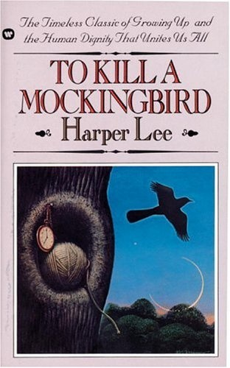](http://www.google.com/imgres?num=10&hl=en&gbv=2&biw=1501&bih=837&tbm=isch&tbnid=5rboPZsjK6m_AM:&imgrefurl=http://diaryofabookworm.wordpress.com/2012/04/19/catching-up-to-kill-a-mockingbird/&docid=9lwBh8G-nf6qmM&imgurl=http://diaryofabookworm.files.wordpress.com/2012/04/harper-lee.jpg&w=312&h=500&ei=TturT9-VPITLrQfB3tn6AQ&zoom=1&iact=hc&vpx=506&vpy=149&dur=1193&hovh=284&hovw=177&tx=97&ty=148&sig=102920354422303877234&sqi=2&page=1&tbnh=151&tbnw=94&start=0&ndsp=33&ved=1t:429,r:3,s:0,i:144)**

*To Kill a Mockingbird-* Screenplay

By: Horton Foote

Based on the novel by Harper Lee

Name_______________ Period______

**[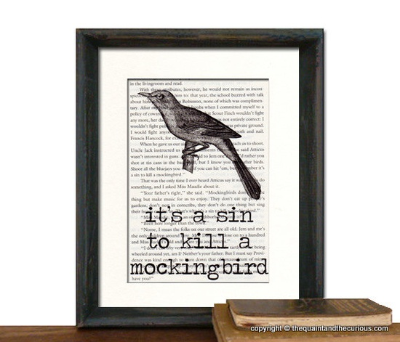](http://www.google.com/imgres?q=to+kill+a+mockingbird+book&um=1&hl=en&safe=off&client=safari&sa=X&rls=en&biw=1046&bih=619&tbm=isch&tbnid=ovOPQXigIsV21M:&imgrefurl=http://www.etsy.com/listing/92111630/to-kill-a-mockingbird-art-print-decor&docid=fcMh6hS8vK_1OM&imgurl=http://img3.etsystatic.com/il_570xN.329621451.jpg&w=570&h=489&ei=eu67T7y7LIuk8gSM5bioCg&zoom=1&iact=hc&vpx=594&vpy=179&dur=322&hovh=208&hovw=242&tx=144&ty=100&sig=101243907631941494959&page=3&tbnh=137&tbnw=160&start=48&ndsp=26&ved=1t:429,r:10,s:48,i:213)**

Pages 5- 15

Before

**THEME**:

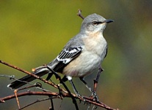 Read the passage about the mockingbird. Write a prediction on the meaning of the title: *To Kill a Mockingbird*.

If you’ve been hearing an endless string of 10 or 15 different birds singing outside your house, you might have a Northern Mockingbird in your yard. These slender-bodied gray birds apparently pour all their color into their personalities. They sing almost endlessly, even sometimes at night, and they flagrantly harass birds that intrude on their territories, flying slowly around them or prancing toward them, legs extended, flaunting their bright white wing patches.

**SETTING**

The author is from **Monroeville, Alabama**. **Maycomb** *(the setting of the book*) is said to have been modeled after this town. It takes place in 1932. How will this setting impact the story? ____________________________________________________________________________________________________________________________________________________

The story takes place in 1932. It says “There’s no hurry, for there’s nowhere to go and nothing to buy… and no money to buy it with.” (pg. 5) What’s special about this year and why is there no money?

____________________________________________________________________________________________________________________________________________________________________________________________________________________________________________________________________________________________________________________________________________________

During

1. Walter Cunningham trades hickory nuts for Atticus’ legal work. If there was a system of barter in this country and no money, what would you trade to get the items you needed such as food and clothing? Come up with two ideas. (pg. 6-7)

______________________________________________________________________________________________________________________________________________________________________

2) “The Cunninghams are country folks, farmers, and the crash hit them the hardest.” (pg. 7) Explain this quote.

____________________________________________________________________________________________________________________________________________________3) Draw a picture of the Radley house in the box below. Use the description of the house on pg. 11.

4) Create a wanted ad for Boo Radley based on the description on pg. 12-13.

5) Read pg.10 in the novel to find out who Boo Radley really is. Write a journal entry from Boo’s point of view on the story. Tell his side of the story.

_______________________________________________________________________________________________________________________________________________________________________________________________________________________________________________________________________________________________________________________________________________________________________________________________________________________________________________________________________________________________________________________________________________```````````````````````````````````````_________________________________________________________________________________________________________________

After

1. After you read pg. 3-13, fill in the chart about the characters you were just introduced to.

|  |  |
| --- | --- |
| **Character** | **What do you know about them?** |
| **Scout** |  |
| **Jem** |  |
| **Dill** |  |
| **Atticus** |  |
| **Boo Radley** |  |

1. Come up with 5 hashtags to summarize what these pages were about.

Pages 15- 30

Before

1. What dares did you use to have when you were younger or what was something that you were terrified of as a child? Explain.

__________________________________________________________________________________________

During

1. What happened to Scout and Jem’s mom? How old was Scout and Jem when this happened? What does Atticus plan to pass on to each of his children? (pg. 15-17)

___________________________________________________________________________________________________________________________________________________________________________________

1. Why did Judge Taylor visit Atticus that night? What did he want? (pg. 17-18) ______________________________________________________________________________
2. What did Scout dare Jem to do? Did he do it? (pg. 18-20) ______________________________________________________________________________
3. The three children go to the courthouse to see ____________________. But when they get there, they look for __________________ instead. In the box, draw a picture of Dill’s describing of what he sees going on in the courtroom. (pg. 21-22)
4. Mr. Ewell says “What kind of man are you? You got chillum of your own.” (Pg. 22) What does he mean by this? (pg. 23)

____________________________________________________________________________________________________________________________________________________________________________________

1. What happened to Jem’s pants? What happened to Jem after he goes back for his pants? (pg. 24-29)

____________________________________________________________________________________________________________________________________________________________________________________________________

1. Is Scout like other proper, Southern girls? Why or why not? (pg. 30-31)
2. ____________________________________________________________________________________________________________________________________________________________________________________

Pages 30-35 (and Ch. 2 in novel)

Before

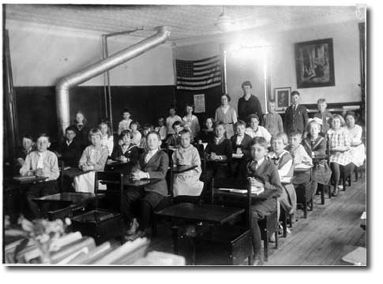 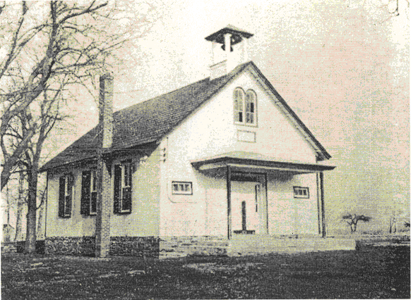

Analyze the two pictures above. Come up with three facts you can figure out from the pictures and write them in the boxes labeled F. Write a question about each fact in the Q box.

F

Q

F

Q

F

Q

During

**Read Chapter 2 in the novel (after page 30)**

1. What can you infer from the picture and what you read about Scout’s classroom? Put the two pieces together and make a statement about the education system during this time.
2. Discuss the scene. Fill in the Venn diagram showing the difference between the Finch, Ewell, and Cunningham families

**Finch Ewell**

**Cunningham**

1. Explain the title *To Kill a Mockingbird*. (pg. 32) How do you think this is going to relate to the novel? (pg. 33)

______________________________________________________________________________________________________________________________________________________________________________________________________________________________________________________________________________________________________

1. Atticus explains to Scout “you never really understand a person until you consider things from his point of view- until you climb into his skin and walk around in it.” (pg.35 ) Explain what this means.

________________________________________________________________________________________________________________________________________________________________________________________________________________________________________________________________________________________________________________________________________________________________________

1. If all people followed with this theory, how would it help life and society today?

___________________________________________________________________________________________________________________________________________________________________________________

1. What compromise did Atticus make with Scout? (pg. 35) _____________________________________________________________________________________
2. Do you feel the same way about school as Scout does? How are your feelings the same? How are they different?

_____________________________________________________________________________________________________________________________________________________________________________

After

**Question Matrix**- Based on the information you have read so far, create 7 questions using the words on the boxes to develop questions. An example has been completed for you using **Why and Did***=* ***Why******did*** *Atticus shoot the dog?*

|  |  |  |  |  |  |  |
| --- | --- | --- | --- | --- | --- | --- |
|  | **Will** | **Is** | **Would** | **Did** | **Are** | **Does** |
| **Who** |  |  |  |  |  |  |
| **What** |  |  |  |  |  |  |
| **Where** |  |  |  |  | Atticus shoot the dog. |  |
| **When** |  |  |  |  |  |  |
| **Why** |  |  |  |  |  |  |
| **How** |  |  |  |  |  |  |

Pages 35- 48

Before

1. Write in the box what you know about the Ewell family.

1-

2-

3-

4-

5-

6-

1. Knowing this information about the Ewell family, make a prediction on what could possibly happen in the future with Atticus in dealing with this family.

______________________________________________________________________________________________________________________________________________________________________________________________________________________________________________________________________________________________________

During

1. What did Atticus do to change the way Jem looked at him? (pg. 36) ________________________________________________________________________
2. What is Ewell’s problem with Atticus? If Atticus is a lawyer and doing his job, why is Bob Ewell angry? What did he expect from Atticus? (pg. 40-41)

_____________________________________________________________________________________________________________________________________________________________________________________________________________________________________________________________________________________________________

1. Who you think put the items in the knothole. Why did you chose this person.(pg. 42) ____________________________________________________________________
2. What could Scout have done instead of fighting Cecil Jacobs? (pg. 42)

__________________________________________________________________________________________________

1. What would have happened if Scout walked away from the fight? (pg. 42)

__________________________________________________________________________________________________

1. Develop 2 reasons Atticus is defending Tom Robinson? (pg. 43)
2. __________________________________________________________________________________________
3. ___________________________________________________________________________________________
4. Who do you think is giving all of the trinkets from the tree hole and why would they do this?

________________________________________________________________________________________________________________________________________________

1. What two secrets does Jem tell Scout? (pg. 45)

1-______________________________________________________________________

2--______________________________________________________________________

1. “ The news has gotten ‘round the county about my bringin’ Tom Robinson back to the jail. I heard there might be trouble from that bunch out at Old Sarum.” What trouble are they talking about? (pg. 47) ________________________________________________________________________________________________________________________________________________

After

**Summary pyramid**

**Row 1**- What is Tom’s wife’s name?

**Row 2**-Name of the person Scout fought.

**Row 3**- Two things found in the tree’s knothole.

**Row 4**- The reason Atticus decided to defend Tom Robinson.

**Row 5**- A prediction of what is going to happen after Tom Robinson is brought back into town.

_______________________________

___________________ ______________________

___________________________ _____________________________

____________________________________________________________________

_______________________________________________________________________________

Pages 48-66

Before

Name the four new objects the children found in the tree.

|  |  |
| --- | --- |
| 1) | 2) |
| 3) | 4) |

Tom is coming back to town for his trial. Write a letter from Tom to Helen expressing his fears and thoughts.

______________________________________________________________________________________________________________________________________________________________________________________________________________________________________________________________________________________________________________________________________________________________________________________________________________________________________________________________________________________________________________________________________________________________________________________________________________________________________________________________________________________________________________________________________________________________________________________________________________________________________________________________________________________________________________________________________________________________________________________________________________________________________________________________________________________________________________________________________________________________________________

During

1. Why is Atticus sitting outside of the jailhouse? (pg. 48-49)

__________________________________________________________________________

1. What do these men want? (pg. 49)

__________________________________________________________________________

1. What is the purpose in having Scout jump out unexpectedly into the group of men? (p. 50-52)

____________________________________________________________________________________________________________________________________________________

1. Fill in the thought bubble from Mr. Cunningham’s mind to explain why he had the angry mob leave. (pg. 52)
2. Imagine you were walking by and saw the whole scene with the mob and Atticus. Write a description of what happened. Remember the 5 W’s and H. (pg. 50-52) ________________________________________________________________________________________________________________________________________________________________________________________________________________________________________________________________________________________________
3. Imagine you are a news reporter in the courtroom getting ready to watch the trial. Describe the courtroom to its fullest. Explain the five senses. What did you see, smell, feel, taste, hear? Describing the courtroom with the five senses should be the first paragraph. The second paragraph should explain your thought on who was in the courtroom and what is going to happen. Don’t forget a headline. (pg. 55)

The Maycomb

Daily News

____________________________________________________________________________________________________________________________________________________________________________________________________________________________________________________________________________________________________________________________________________________________________________________________________________________________________________________________________________________________________________________________________

1. The trial is about to begin. Fill in the thought bubbles for each character. What is going through their heads.

Atticus Tom Robinson

1. Create a timeline of each person on the witness stands testimony. Use different colors to show the different people who are testifying. Put the colors and names in the key below. (pg. Tate- 55, Bob Ewell- 56, Mayella Ewell - 59)

KEY

1. Atticus is trying to prove something by asking about what eye was blackened. What is he trying to prove? (pg. 55,61)

__________________________________________________________________________________________________________________________________________________________

1. Write as if you were Tom Robinson listening to the Heck Tate, Bob Ewell, and Mayella as they testify. Explain your side of what happened on August 21, 1931. (pg. 63-65)

____________________________________________________________________________________________________________________________________________________________________________________________________________________________________________________________________________________________________________________________________________________________________________________________________________________________________________________________________________________________________________________________________________________________________________________________________________

1. What will happen if Tom is found guilty? What will happen if he is found NOT guilty? **Guilty**:

________________________________________________________________________________________________________________________________________________

**Innocent**:

________________________________________________________________________________________________________________________________________________

After

Write **3** things that don’t make sense from the trial thus far

1-_______________________ 2-___________________________3- __________________

Write **2** things you predict will happen next.

1-________________________________ 2- ____________________________________

Write if you think the jury will find Tom guilty or not-guilty.

________________________

Pages 66- 72

Before

1. During the recess of the trial, you are a newspaper reporter interviewing Tom’s wife regarding the trial. Write questions and answers relating to the trial.

**Reporter**: _________________________________________________________________

**Mrs. Robinson:** _____________________________________________________________

__________________________________________________________________________

**Reporter**: __________________________________________________________________

**Mrs. Robinson:** ____________________________________________________________

__________________________________________________________________________

**Reporter**: _________________________________________________________________

**Mrs. Robinson:** ____________________________________________________________

__________________________________________________________________________

1. Fill in the timeline from the story Tom Robinson tells. (pg. 66)

During

1. In the box below, write the evidence the jury has to find Tom guilty. In the other box, write the evidence the jury has to find Tom not-guilty. (p68)

|  |  |
| --- | --- |
| Guilty   * - * - * - | Not Guilty   * - * - * - |

1. What do you think the verdict WILL BE? _______________
2. What do you think the verdict SHOULD BE and WHY? ________________________________________________________________________________________________________________________________________________
3. Cite 3 captivating lines from Atticus’ closing argument. (pg. 66-67)
4. Why is it incredible the verdict took hours to come back versus minutes? (pg. 68)

__________________________________________________________________________

1. What is the final verdict? (pg. 68) _________________
2. The trial is over. Fill in the thought bubbles for each character. What is going through their heads.

**Bob Ewell**

**Mayella**

**Tom Robinson**

**Atticus**

1. What was your reaction to the guilty verdict? ________________________________________________________________________________________________________________________________________________
2. If this case took place during this decade, how would it have been different? Come up with four things that would have changed.

1-_____________________________________________________________________________________

2-_____________________________________________________________________________________

3-_____________________________________________________________________________________

4-_____________________________________________________________________________________

1. Explain what happened to Tom Robinson (pg. 70)

________________________________________________________________________________________________________________________________________________________________________________________________________________________

1. In the box below, draw a picture of the confrontation between Bob Ewell and atticus outside of the Robinson house.

After

1. Fill in the cause and effect chart with events that happened before the trial up to Bob Ewell spitting in Atticus’ face.

|  |  |
| --- | --- |
| **Cause** | **Effect** |
| Tom Robinson is nice to Mayella Ewell and helps her when she asks. |  |
|  | Mayella has a black eye. |
|  | Tom Robinson is found guilty of raping Mayella. |
| Atticus defends Tom Robinson. |  |
|  | Tom Robinson is killed |
|  | Bob Ewell spits in Atticus’ face. |

1. Think about the way the two men act throughout the story. Create a list of characteristics of the two men based on the way they have acted throughout the novel and design dating profiles for them.

**Atticus Finch**

**Characteristics**

_______________________________________________________________________________________________________________________________________

**Reasons I would be a good spouse:**

_______________________________________________________________________________________________________________________________________

**Likes**: _____________________________________________

**Dislikes**:

_____________________________________________

**Bob Ewell**

**Characteristics**

__________________________________________________________________________________________________________________________________________

**Reasons I would be a good spouse:**

__________________________________________________________________________________________________________________________________________

**Likes**: ______________________________________________

**Dislikes**:

_____________________________________________

1. Explain the similarities and differences between juries then and now? ________________________________________________________________________________________________________________________________________________

Pages 72-80

Before

**Question Matrix**- Based on the information you have read so far, create 7 questions using the words on the boxes to develop questions. An example has been completed for you using **Why and Did***=* ***Why******did*** *Atticus shoot the dog?*

|  |  |  |  |  |  |  |
| --- | --- | --- | --- | --- | --- | --- |
|  | **Is** | **Will** | **Might** | **Should** | **Are** | **Does** |
| **Who** |  |  |  |  |  |  |
| **What** |  |  |  |  |  |  |
| **Where** |  |  |  |  | Atticus shoot the dog. |  |
| **When** |  |  |  |  |  |  |
| **Why** |  |  |  |  |  |  |
| **How** |  |  |  |  |  |  |

During

1. Explain what happened to Jem and Scout on the way home from the Halloween pageant. Who was chasing them? Who is helped them? (pg. 74) ________________________________________________________________________________________________________________________________________________________________________________________________________________________
2. What happened to Jem? Who saved him? (pg. 75-76) ______________
3. What really happened to Bob Ewell? (pg. 76) ___________________________________
4. Who did this to him? _______________________________________
5. Why does Heck Tate say Bob killed himself and “let the dead bury the dead?” Why does he choose to do this? (pg. 79) ________________________________________________________________________________________________________________________________________________________________________________________________________________________
6. Explain what Scout means when she says “Well, it would sort of being like shooting a mockingbird, wouldn’t it?” (pg. 79) ________________________________________________________________________________________________________________________________________________________________________________________________________________________________________________________________________________________________

After

1. Relate the title to life today. Who are the mockingbirds today and why would it be a sin to kill them. Think outside of the box. Killing them may not literally mean to shoot them dead.

__________________________________________________________________________________________________________________________________________________________________________________________________________________________________________________________________________________________________________________________________________________________________________________________________________________________________________________________________