Name: _________________________________________________ Date: ________________________ Period: _______

**Electromagnetic Spectrum**

**Do Now:** What kinds of electromagnetic waves do you know about? What kinds have the most energy?

**Video 1:** Watch **The Electromagnetic Spectrum: NASA** and answer the following questions.

1. Name all of the categories of the electromagnetic spectrum. What is the same about the categories? What is different?
2. What is the relationship between wavelength and the amount of energy the wave carries?
3. What is the relationship between wavelength and frequency?
4. In the visible spectrum, which color of light has the most energy? Which has the least? How do the wavelengths differ?
5. Which type of electromagnetic radiation can give you a sunburn? Which type can be used for radar?
6. Which parts of the electromagnetic spectrum were you exposed to in the past year? How about today?

**Video 2:** Watch **Astronomical Images in Different Wavelengths** and answer the following questions.

1. Describe the similarities and differences between different pictures of the same object. Based on what you know about the electromagnetic spectrum, provide an explanation for these similarities and differences.
2. Why are some telescopes used on Earth while others are launched into orbit above Earth's atmosphere?
3. Why is it that we are looking at images that are described as having taken place hundreds or thousands of years ago?
4. What information can be obtained from a conventional photograph of a human body that cannot be obtained from an X-ray, a thermograph -- an image taken with an infrared camera that records temperature variations on the surface of the body, and a magnetic resonance image (MRI) -- an image of internal organs and soft tissues produced with magnetic fields and radio waves. What does the X-ray tell that the photograph and other images do not?
5. Are the images of the human body described above a useful analogy for someone learning to understand why it's helpful to create different kinds of images of objects in space? Why or why not?

Why do astronomers build radio telescopes and X-ray telescopes, in addition to the optical telescopes with which most people are familiar?

**Video 3:** Navigate through **NOVA | Tour the Electromagnetic Spectrum** to find the answers to the questions below.

1. What are electromagnetic waves?
2. What is a photon?
3. Name one manufactured device or natural phenomenon that emits electromagnetic radiation in each of the following wavelengths:
   1. radio
   2. microwave
   3. infrared
   4. visible light
   5. ultraviolet
   6. X-ray
   7. gamma ray
4. Which type(s) of electromagnetic radiation do human bodies emit? Which type(s) can our senses detect?
5. List three ways that electromagnetic radiation is used to improve our everyday lives.

**Task:** Let’s make our own Electromagnetic Spectrum! We’ve got chart paper, we’ve got markers and colored pencils. Decide which part of the spectrum you’d like to work on. The whole class is making one big spectrum for the classroom.

Here’s what needs to be on our chart:

* List the range of energies associated with each wavelength.
* Draw an object that is the size of a wavelength at each region of the spectrum.
* 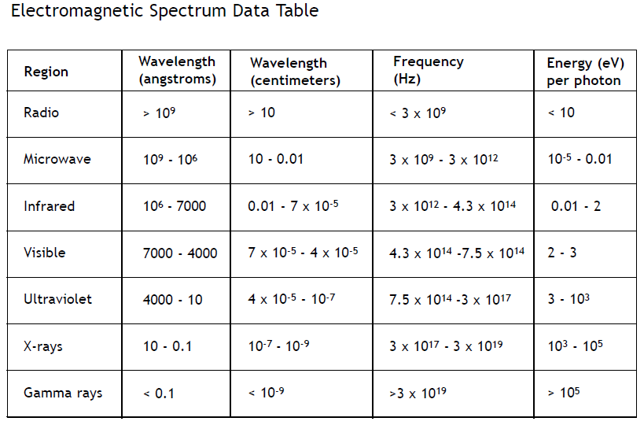Add pictures of common sources of electromagnetic radiation for each region of the spectrum.