Name: _____________________________________________________Date: ____________________ Period: _______
Work, Power, Energy Test (70 pts)

Multiple Choice (2 pts each): Mark the best answer for each question on the line.

- If you lift one load up two stories, how much work do you do compared to lifting one load up only one story?
  - Four times as much. c. The same amount.
  - Twice as much. d. One half as much.

- Which has a greater kinetic energy, a heavy truck at rest or a moving roller skate?
  - heavy truck c. they are equal
  - roller skate d. not enough information

- How much work is done on a 50 N rock that you lift 10 m straight up?
  - 500 J c. 10 J
  - 50 J d. 1 J

- How much work is done on a 60 N box of books that you carry horizontally across a 6 m room?
  - 0 J d. 10 J
  - 6 J e. 60 J
  - 360 J

- A 5 kg object is placed on the floor. An identical object is placed on a 1 meter high table. If both objects are at rest,
  - both objects have the same amount of total energy.
  - both objects have gravitational potential energy but neither has kinetic energy.
  - both objects have kinetic energy but only one has gravitational potential energy.
  - neither object has kinetic energy but one has gravitational potential energy.

- Assume that two cars, one red and one blue, have the same mass, but that the red car has twice the speed of the blue car. We then know that the red car has ___________ kinetic energy as the blue car.
  - twice as much c. four times as much
  - one half as much d. one fourth as much

- If Kelly the skater’s speed increases so he has three times the momentum, then his kinetic energy increases by
  - one third times.
  - three times.
  - nine times.
  - none of the above (KE remains the same).

- A 60 N object moves at 1 m/s. Its kinetic energy is approximately
  - 1 J. c. 60 J.
  - 3 J. d. more than 60 J.

- If an object has kinetic energy, then it also must have
  - impulse. d. acceleration.
  - force. e. none of the above.
  - momentum.

- The amount of gravitational potential energy possessed by an elevated object is equal to
  - the power used to lift it.
  - the distance it is lifted.
  - the force needed to lift it.
  - the work done in lifting it.
  - the value of the acceleration due to gravity.

- Three processes are described below. Choose one process in which there is work done on the system. The spring, Earth, and the cart are part of the system.
  - A relaxed spring rests upright on a tabletop. You slowly compress the spring. You then release the spring and it flies up several meters to its highest point.
  - A cart at the top of a smooth inclined surface coasts at increasing speed to the bottom (ignore friction).
  - A cart at the top of a smooth inclined surface slides at increasing speed to the bottom where it runs into and compresses a spring (ignore friction).

- Choose which statement describes a process in which an external force does negative work on the system. The person is not part of the system.
  - A person slowly lifts a box from the floor to a tabletop.
  - A person slowly lowers a box from a tabletop to the floor.
  - A person carries a bag of groceries horizontally from one location to another.
  - A person holds a heavy suitcase.

- Consider molecules of hydrogen gas and molecules of heavier oxygen gas that have the same kinetic energy. The molecules with the greater speed are
  - hydrogen.
  - Both have the same speed.
  - oxygen.

Lia pushes her little sister who is sitting on a sled. Lia’s sister and sled are initially at rest on a frozen lake. The system is Lia’s sister and the sled. Lia pushes her sister for 8 m. In each case friction and air resistance are so small they can be ignored. The graph below represents the force Lia exerts on her sister and the sled for a certain displacement. Use the graph to answer the questions below.
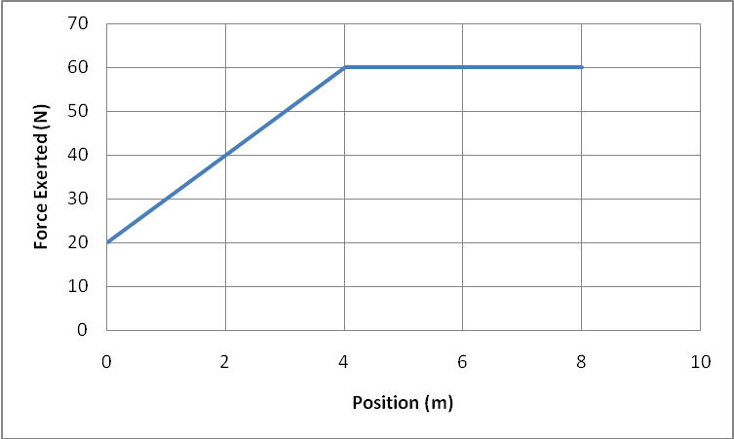

- Use the graph to determine the work done by Lia on the system while she is exerting the force on the sled.
  - 400 J
  - 320 J
  - 240 J
  - 160 J

- The combined mass of Lia’s sister and the sled is 20 kg, and Lia’s mass is 50 kg. Determine the final speed of the system.
  - 4 m/s
  - 4.9 m/s
  - 5.7 m/s
  - 6.3 m/s

Open Ended: Show all calculations, givens, and formulas. Circle your answer with units.

- (10 pts) Jay fills a wagon with sand (about 20 kg) and pulls it with a rope 30 m along the beach. He holds the rope 25° above the horizontal. The rope exerts a 20-N tension force on the wagon. How much work does the rope do on the wagon?

- (10 pts) A door spring is difficult to stretch.
  - What maximum force do you need to exert on a relaxed spring with a 1.2 x 10⁴ N/m spring constant to stretch it 6.0 cm from its equilibrium position? Draw a bar chart.

  - How much does the elastic potential energy of the spring change during that process?

  - Determine its change in elastic potential energy as it returns from the 6.0 cm stretch position to a 3.0 cm stretch position.

- (20 pts) A sled slides down a frictionless hill that is 17.6 m high. At the bottom of the hill, the sled hits a long patch of rough snow that slows down the sled by exerting an average force of 190 N on the sled. The mass of the sled and riders is 86 kg.
- Draw a picture of the process, identify the initial and final states of the process and specify the reference level you are using. Draw a bar chart.

- How fast is the sled traveling after sliding for 10 m on the rough snow?

- How far must the sled travel on the rough snow before it is traveling at ½ of its maximum speed?

- How far will the sled slide on the rough snow until it comes to rest?

- What is the change in internal energy of the system?

