Name: ____________________________________________________ Date: _____________________ Period: _______

**Momentum and Impulse**

**Test – 50 pts**

**Multiple Choice (2 pts each):** Please write the correct answer on the line. Only one answer is correct.

1. Which has more momentum, a large truck moving at 30 miles per hour or a small truck moving at 30 miles per hour?
   1. The large truck
   2. The small truck
   3. Both have the same momentum.
2. Compared to a sports car moving at 30 miles per hour, the same sports car moving at 60 miles per hour has
   1. the same momentum.
   2. twice as much momentum.
   3. four times as much momentum.
3. Ball A collides with ball B. The force ball A exerts on ball B ____________ compared to the force ball B exerts on ball A.
   1. is not equal in magnitude
   2. is less in magnitude and opposite in direction
   3. is equal in magnitude and opposite in direction
   4. is equal in magnitude and acts in the same direction
4. If the momentum of an object changes and its mass remains constant
   1. its velocity is changing.
   2. it is accelerating (or decelerating).
   3. there is a force exerted on it.
   4. All of the above.
5. The momentum change of an object is equal to the
   1. force exerted on it.
   2. velocity change of the object.
   3. impulse exerted on it.
   4. object’s mass times the force exerted on it.
6. Skelly the skater traveling at high speed needs a certain amount of force to stop him. More stopping force will be needed if he has
   1. more mass. c. less stopping distance.
   2. more momentum. d. all of these.
7. A Ping Pong ball launcher is fired. Compared to the impulse on the ball, the amount of impulse on the launcher is
   1. larger.
   2. smaller.
   3. the same.
8. The greatest change in momentum will be produced by
   1. a large force acting over a long time.
   2. a small force acting over a short time.
   3. a large force acting over a short time.
9. A moving freight car runs into an identical freight car (both have the same mass) at rest on the track. The cars stick together. Compared to the velocity of the first car before the collision, the velocity of the combined cars after the collision is
   1. twice as large.
   2. the same.
   3. one half as large.
   4. zero.
10. 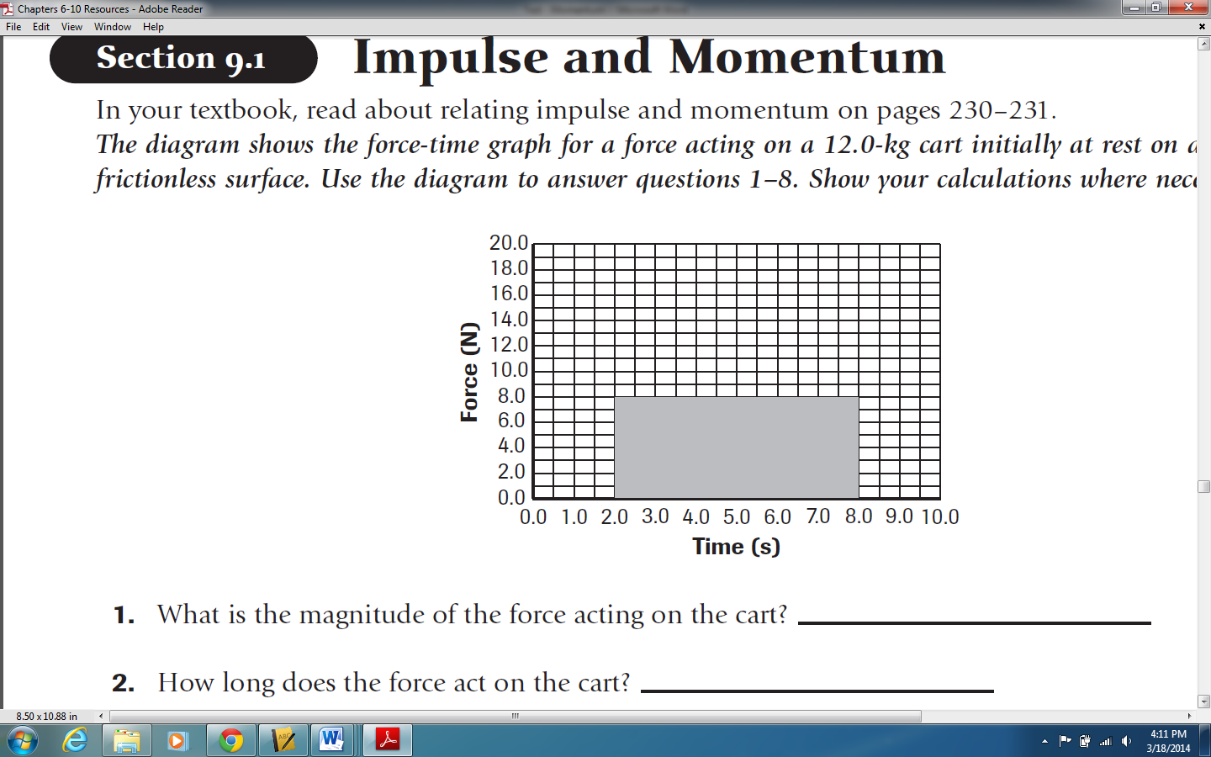In the graph to the right, how would impulse change if the force were increased to 16 N during the same time interval? Impulse would be
    1. twice as large.
    2. the same.
    3. one half as large.
    4. four times as large.
11. If a sports car with a mass of 1000 kg travels down the road with a speed of 20 m/s, the momentum is: (p= mv)
    1. 50 kg m/s. c. 20,000 kg m/s.
    2. 10,000 kg m/s. d. 400,000 kg m/s.
12. What impulse is needed to stop a 1,400 kg car traveling at 20 m/s?
    1. -70 Ns. c. -28,000 Ns.
    2. -280 Ns. d. -1400 Ns.
13. Two objects, A & B, have the same size and shape, but A has twice the mass of B. When they are dropped from a tower, they reach the ground at the same time, but A has a greater
    1. speed. c. momentum
    2. acceleration. d. All of these.
14. Why should an athlete follow through when swinging a bat or golf club?
    1. To increase the force.
    2. To increase the impulse.
    3. To increase the time.
    4. All of the above.
    5. B and C only.

**Short Answer:** Answer the following question in complete sentences. Show representations as appropriate.

1. (6 pts) Liv and Ty are standing on roller skates. Liv pushes Ty. What will happen to Liv and Ty after the push? Liv has a mass of 60 kg and Ty has a mass of 75 kg.

Draw motion diagrams and force diagrams for both people. Represent the process with a bar chart.

Explain in complete sentences what happens. Be sure to comment on velocity, change in velocity, force, and momentum.

**Open Ended:** Please show all work for full credit, including givens, formulas, computation, and answer with units.

1. (6 pts) A compact car, with mass 725 kg, is moving at 32.0 m/s toward the east. Sketch the moving car.
2. What are the magnitude and the direction of the car’s momentum? Draw an arrow on your sketch to represent the momentum vector.
3. A second car, with a mass of 2175 kg, has the same momentum. What is its velocity (magnitude and direction)?
4. (5 pts) A 0.5-kg toy truck moving at a velocity of 0.5 m/s collides head-on with a 0.75-kg toy truck that is at rest. The trucks become entangled and lock together. What is the velocity of the two toy trucks after the collision? Sketch, use a bar chart, and then solve.
5. (5 pts) The driver accelerates a 240.0 kg snowmobile, which results in a force being exerted that speeds up the snowmobile from 6.00 m/s to 28.0 m/s over a time interval of 60.0 s.
6. Sketch the event, showing the initial and final states.
7. Represent the process with a bar chart.
8. What is the snowmobile’s change in momentum? What is the impulse on the snowmobile?
9. What is the magnitude of the average force that is exerted on the snowmobile?

**Extra Credit:** A 300. kg bumper car is at rest. It encounters a force of 400 N for 0.30 seconds that sets it into motion. Over the next 3.0 seconds, it encounters a frictional force of 10 N. Finally, it encounters a force of 300 N for 0.50 seconds in the direction of motion. What is the final velocity of the bumper car?