Unit 9
Content Area: Guidance
Course(s): Career Awareness, Transitions, and Summer Safety
Time Period: May/June
Length: 6-8
Status: Published
Title Section
Department of Curriculum and Instruction

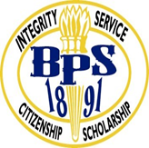
Belleville Public Schools
Curriculum Guide

Guidance
Grades 6-8

Belleville Board of Education
102 Passaic Avenue
Belleville, NJ 07109

Prepared by: Amanda Veniero

Dr. Richard Tomko, Superintendent of Schools
Mr. Thomas D’Elia, Director of Curriculum and Instruction
Ms. Diana Kelleher, District Supervisor of ELA/Social Studies
Mr. George Droste, District Supervisor of Math/Science

Board Approved: August 24, 2015

Unit Overview
- Career Awareness
- Transitions
- Summer Safety
- College and Job Readiness
- Career Planning
- Summer Employment

ASCA Model
Career Development
Standard B: Students will employ strategies to achieve future career success and satisfaction

C:B1.2 Identify personal skills, interests and abilities, and relate them to current career choice
C:B1.3 Demonstrate knowledge of the career planning process

Standard C: Students will understand the relationship between personal qualities, education and training, and the world of work

C.C1.3 Identify personal preferences and interests influencing career choice and success
C.C1.7 Understand that work is an important and satisfying means of personal expression

Exit Skills
By the end of Unit 9 students should be able to:
- Complete interest inventories
- Demonstrate a level of insight and awareness of their academic standing
- Begin process of developing career portfolio
- Identify at least one career of interest for further exploration
- Identify key steps in career planning
- Identify requirements for high school graduation

Enduring Understanding
Career Awareness used to describe a variety of activities that are available to students throughout their education in order to prepare them for success beyond their K-12 education.

Essential Questions
- How do I learn about my interests and natural abilities?
- How do I recognize what career related to my interests and abilities?
- How do I develop self-exploration in areas of skills, abilities and interests?
- How does school success and academic achievement help with future work opportunities?
- How do I research various occupations?

Learning Objectives
- Identify personal preferences and interests influencing career choice and success
- Demonstrate knowledge of the career-planning process
- Maintain a career-planning portfolio
- Begin self-exploration
- Identify interests and abilities as they relate to various occupations
- Understand that school success and academic achievement helps with future work opportunities

Interdisciplinary Connections
CCSS.ELALiteracy.SL.6.1, 7.1, 8.1 Engage effectively in a range of collaborative discussions (one-on-one, in groups, and teacher-led) with diverse partners on grade 6 topics, texts, and issues, building on others’ ideas and expressing their own clearly.

CCSS.ELALiteracy.RI.6.4, 7.4, 8.4 Determine the meaning of words and phrases as they are used in a text, including figurative, connotative, and technical meanings.

Alignment to 21st Century Skills & Technology
- English, reading or language arts
- Health

21st Century/Interdisciplinary Themes
- Global Awareness
- Health Literacy
.
.

21st Century Skills
- Communication and Collaboration | .
- Creativity and Innovation | .
- Critical thinking and Problem Solving | .
- Life and Career Skills | .
- Media Literacy | .

Technology Infusion
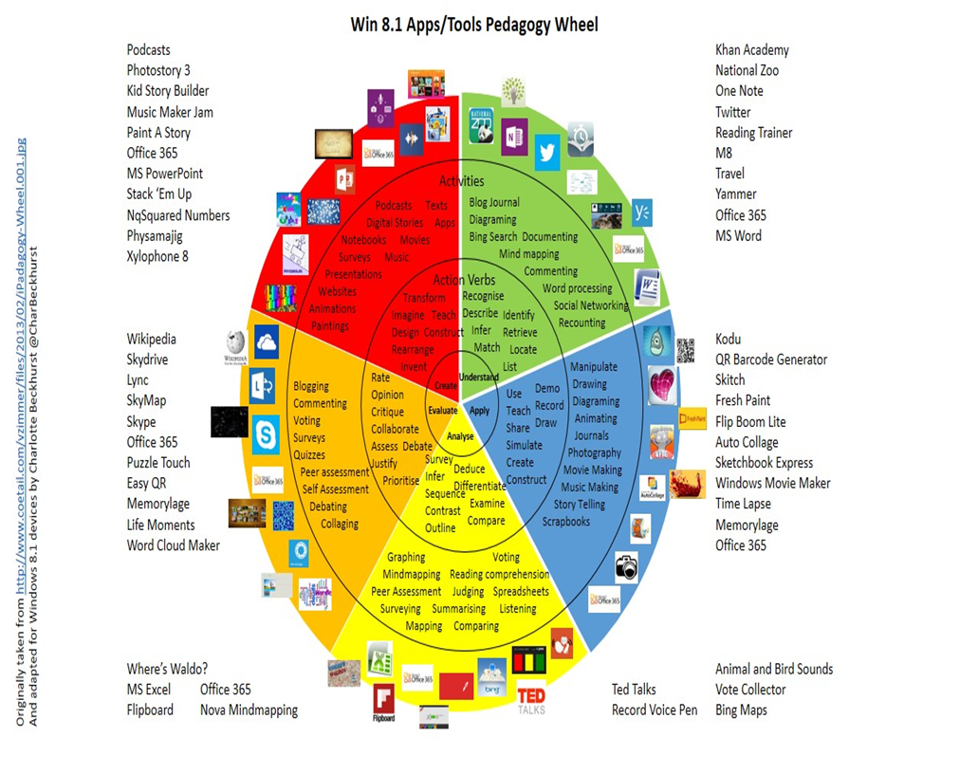

Differentiation
Resources:
- NJDOE: Instructional Supports and Scaffolds for Success in Implementing the Common Core State Standards http://www.state.nj.us/education/modelcurriculum/success/math/k2/

Special Education
- printed copy of board work/notes provided | .
- additional time for skill mastery | .
- assistive technology | .
- behavior management plan | .
- center-Based Instruction | .
- check work frequently for understanding | .
- computer or electronic device utilizes | .
- have student repeat directions to check for understanding | .
- highlighted text visual presentation | .
- modified assignment format | .
- multi-sensory presentation | .
- preferential seating | .
- preview of content, concepts, and vocabulary | .
- reduced/shortened reading assignments | .
- reduced/shortened written assignments | .
- secure attention before giving instruction/directions | .
- shortened assignments | .
- student working with an assigned partner | .
 | .
 | .

ELL
- teaching key aspects of a topic. Eliminate nonessential information | .
- using videos, illustrations, pictures, and drawings to explain or clarify | .
- allowing products (projects, timelines, demonstrations, models, drawings, dioramas, poster boards, charts, graphs, slide shows, videos, etc.) to demonstrate student’s learning; | .
- allowing students to correct errors (looking for understanding) | .
- decreasing the amount of work presented or required | .
- having peers take notes or providing a copy of the teacher’s notes | .

Intervention Strategies
- allowing students to correct errors (looking for understanding) | .
- teaching key aspects of a topic. Eliminate nonessential information | .
- allowing products (projects, timelines, demonstrations, models, drawings, dioramas, poster boards, charts, graphs, slide shows, videos, etc.) to demonstrate student’s learning | .
- allowing students to select from given choices | .
- collaborating (general education teacher and specialist) to modify vocabulary, omit or modify items to reflect objectives for the student, eliminate sections of the test, and determine how the grade will be determined prior to giving the test. | .
- decreasing the amount of work presented or required | .
- having peers take notes or providing a copy of the teacher’s notes | .
- using authentic assessments with real-life problem-solving | .
- using videos, illustrations, pictures, and drawings to explain or clarify | .

Evidence of Student Learning-CFU's
- Compare & Contrast | .
- Create a Multimedia Poster | .
- Define | .
- Describe | .
- Evaluate | .
- Evaluation rubrics | .
- Explaining | .
- Illustration | .
- Journals | .
- Pretests and Posttests
- Questionnaires
- Self- assessments | .
- Surveys

Primary Resources
- District Policies
- School Website
- Student/Parent Handbook
- Program of Studies

Ancillary Resources
Please list ALL other resources available to strengthen your lesson.

Sample Lesson
One Lesson per Curriculum must be in this lesson plan template. I.e. one lesson in one unit
Unit Name:
CCSS/NJCCCS:
Interdisciplinary Connection:
Statement of Objective:
Anticipatory Set/Do Now:
Learning Activity:
Student Assessment/CFU's:
Materials:
21st Century Themes and Skills:
Differentiation/Modifications:
Integration of Technology:

