Unit 8
Content Area: Guidance
Course(s): Fairness and Sharing
Time Period: April
Length: 6-8
Status: Published
Title Section
Department of Curriculum and Instruction


Belleville Public Schools
Curriculum Guide

Guidance
Grades 6-8

Belleville Board of Education
102 Passaic Avenue
Belleville, NJ 07109

Prepared by: Amanda Veniero

Dr. Richard Tomko, Superintendent of Schools
Mr. Thomas D’Elia, Director of Curriculum and Instruction
Ms. Diana Kelleher, District Supervisor of ELA/Social Studies
Mr. George Droste, District Supervisor of Math/Science

Board Approved: August 24, 2015

Unit Overview
- Fairness and Sharing
- Peer Support
- Team Building

ASCA Model
Academic Development
Standard A: Students will acquire the attitudes, knowledge, and skills that contribute to effective learning in school and across the life span.

A:A3.2 Demonstrate the ability to work independently, as well as the ability to work cooperatively with other students

Standard C: Students will understand the relationship of academics to the world of work and to life at home and in the community.

A:C1.1 Demonstrate the ability to balance school, studies, extracurricular activities, leisure time and family life.
A:C1.2 Seek co-curricular and community experiences to enhance the school experience.
A:C1.4 Demonstrate an understanding of the value of lifelong learning as essential to seeking, obtaining and maintaining life goals.

Exit Skills
By the end of Unit 8 students should be able to:
- Discuss the process of working cooperatively with each other
- Students can identify strategies for managing extra-curricular activities
- Continue to show cooperative behaviors daily

Enduring Understanding
Fairness is the condition of being just or impartial.

Sharing is to have a portion of something with another or others.

Essential Questions
- Is it possible to be fair to everyone?
- How do I learn to work well within a group?
- How should you treat people who are unfair to you?
- How does fairness affect your relationships with people?
- What is effective communication?

Learning Objectives
- Recognize that everyone has rights and responsibilities
- Respect alternative points of view
- Demonstrate how cooperation positively affects learning

Interdisciplinary Connections
CCSS.ELALiteracy.SL.6.1, 7.1, 8.1 Engage effectively in a range of collaborative discussions (one-on-one, in groups, and teacher-led) with diverse partners on grade 6 topics, texts, and issues, building on others’ ideas and expressing their own clearly.

Alignment to 21st Century Skills & Technology
- English, reading or language arts
- Health

21st Century/Interdisciplinary Themes
- Global Awareness
- Health Literacy
.
.

21st Century Skills
- Communication and Collaboration | .
- Creativity and Innovation | .
- Critical thinking and Problem Solving | .
- Life and Career Skills | .
- Media Literacy | .

Technology Infusion
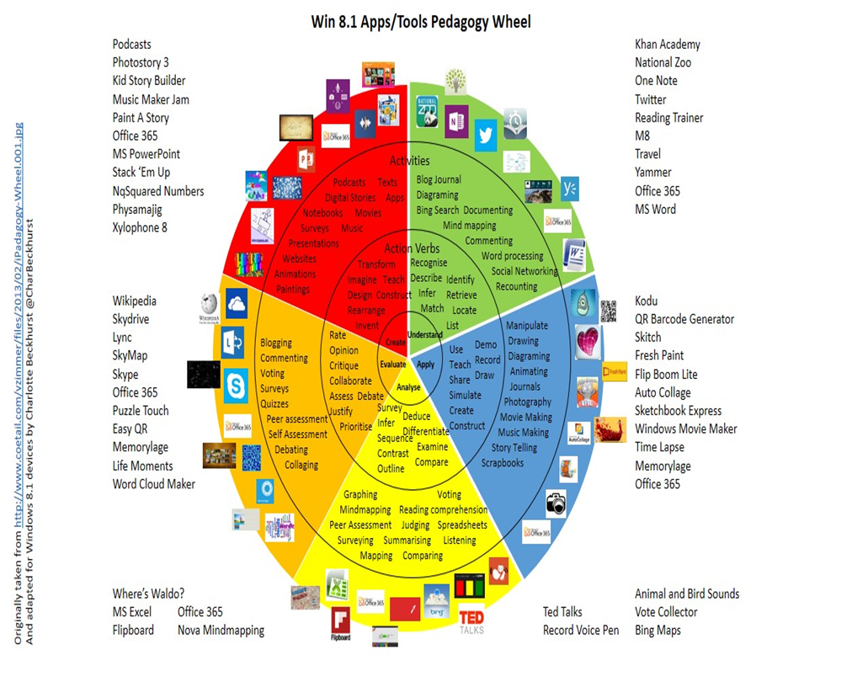

Differentiation
Resources:
- NJDOE: Instructional Supports and Scaffolds for Success in Implementing the Common Core State Standards http://www.state.nj.us/education/modelcurriculum/success/math/k2/

Special Education
- printed copy of board work/notes provided | .
- additional time for skill mastery | .
- assistive technology | .
- behavior management plan | .
- center-Based Instruction | .
- check work frequently for understanding | .
- computer or electronic device utilizes | .
- have student repeat directions to check for understanding | .
- highlighted text visual presentation | .
- modified assignment format | .
- multi-sensory presentation | .
- preferential seating | .
- preview of content, concepts, and vocabulary | .
- reduced/shortened reading assignments | .
- reduced/shortened written assignments | .
- secure attention before giving instruction/directions | .
- shortened assignments | .
- student working with an assigned partner | .
 | .
 | .

ELL
- teaching key aspects of a topic. Eliminate nonessential information | .
- using videos, illustrations, pictures, and drawings to explain or clarify | .
- allowing products (projects, timelines, demonstrations, models, drawings, dioramas, poster boards, charts, graphs, slide shows, videos, etc.) to demonstrate student’s learning; | .
- allowing students to correct errors (looking for understanding) | .
- decreasing the amount of work presented or required | .
- having peers take notes or providing a copy of the teacher’s notes | .

Intervention Strategies
- allowing students to correct errors (looking for understanding) | .
- teaching key aspects of a topic. Eliminate nonessential information | .
- allowing products (projects, timelines, demonstrations, models, drawings, dioramas, poster boards, charts, graphs, slide shows, videos, etc.) to demonstrate student’s learning | .
- allowing students to select from given choices | .
- collaborating (general education teacher and specialist) to modify vocabulary, omit or modify items to reflect objectives for the student, eliminate sections of the test, and determine how the grade will be determined prior to giving the test. | .
- decreasing the amount of work presented or required | .
- having peers take notes or providing a copy of the teacher’s notes | .
- using authentic assessments with real-life problem-solving | .
- using videos, illustrations, pictures, and drawings to explain or clarify | .

Evidence of Student Learning-CFU's
- Compare & Contrast | .
- Create a Multimedia Poster | .
- Define | .
- Describe | .
- Evaluate | .
- Evaluation rubrics | .
- Explaining | .
- Illustration | .
- Journals | .
- Pretests and Posttests
- Questionnaires
- Self- assessments | .
- Surveys

Primary Resources
- District Policies
- School Website
- Student/Parent Handbook
- Program of Studies

Ancillary Resources
Please list ALL other resources available to strengthen your lesson.

Sample Lesson
One Lesson per Curriculum must be in this lesson plan template. I.e. one lesson in one unit
Unit Name:
CCSS/NJCCCS:
Interdisciplinary Connection:
Statement of Objective:
Anticipatory Set/Do Now:
Learning Activity:
Student Assessment/CFU's:
Materials:
21st Century Themes and Skills:
Differentiation/Modifications:
Integration of Technology:

