Unit 3
Content Area: Guidance
Course(s): Trustworthiness and Self-Respect
Time Period: November
Length: 6-8
Status: Published
Title Section
Department of Curriculum and Instruction

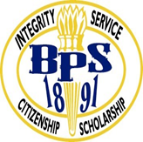
Belleville Public Schools
Curriculum Guide

Guidance
Grades 6-8

Belleville Board of Education
102 Passaic Avenue
Belleville, NJ 07109

Prepared by: Amanda Veniero

Dr. Richard Tomko, Superintendent of Schools
Mr. Thomas D’Elia, Director of Curriculum and Instruction
Ms. Diana Kelleher, District Supervisor of ELA/Social Studies
Mr. George Droste, District Supervisor of Math/Science

Board Approved: August 24, 2015

Unit Overview
- Trustworthiness and Self-Respect
- Character Education
- Honesty and Friendships

ASCA Model
Academic Development
Standard A: Students will acquire the attitudes, knowledge, and skills that contribute to effective learning in school and across the life span.

A:A3.1 Take responsibility for their actions

Personal/Social Development
Standard A: Students will acquire the attitudes, knowledge, and interpersonal skills to help them understand and respect self and others.

PS:A1.5 Identify and express feelings
PS:A1.6 Distinguish between appropriate and inappropriate behavior

Standard C: Students will understand safety and survival skills.

PS:C1.2 Learn about the relationship between rules, laws, safety and the protection of rights of the individual

Exit Skills
By the end of Unit 3 students should be able to:
- Give examples of appropriate behaviors
- Identify who to go to for help
- Identify and practice passive, aggressive, and assertive behaviors
- Identify qualities they value in friendships
- Handle difficult feelings

Enduring Understanding
Trustworthiness is the ability to be relied on as honest or truthful

Self-Respect is pride and confidence in oneself

Essential Questions
- How do my actions affect my friendships?
- What should I look for in a friend?
- What are the benefits of being truthful?
- How do I learn to have integrity?
- How does telling the truth help me grow?
- How do I value myself and others?
- Why is it important to be responsible?

Learning Objectives
- Distinguish between appropriate and inappropriate behaviors
- Identify and appropriately express feelings
- Take responsibility of their actions
- Discuss the differences between appropriate and inappropriate physical contact
- Identify situations requiring peer support and those that require adult assistance.

Interdisciplinary Connections
CCSS.ELALiteracy.SL.6.1, 7.1, 8.1 Engage effectively in a range of collaborative discussions (one-on one, in groups, and teacher-led) with diverse partners on grades 6, 7, and 8 topics, texts, and issues, building on others’ ideas and expressing their own clearly.

CCSS.ELALiteracy.RI.6.1, 7.1, 8.1 Cite textual evidence to support analysis of what the text says explicitly as well as inferences drawn from the text.
•
Alignment to 21st Century Skills & Technology
- English, reading or language arts
- Health

21st Century/Interdisciplinary Themes
- Global Awareness
- Health Literacy
.
.

21st Century Skills
- Communication and Collaboration | .
- Creativity and Innovation | .
- Critical thinking and Problem Solving | .
- Life and Career Skills | .
- Media Literacy | .

Technology Infusion
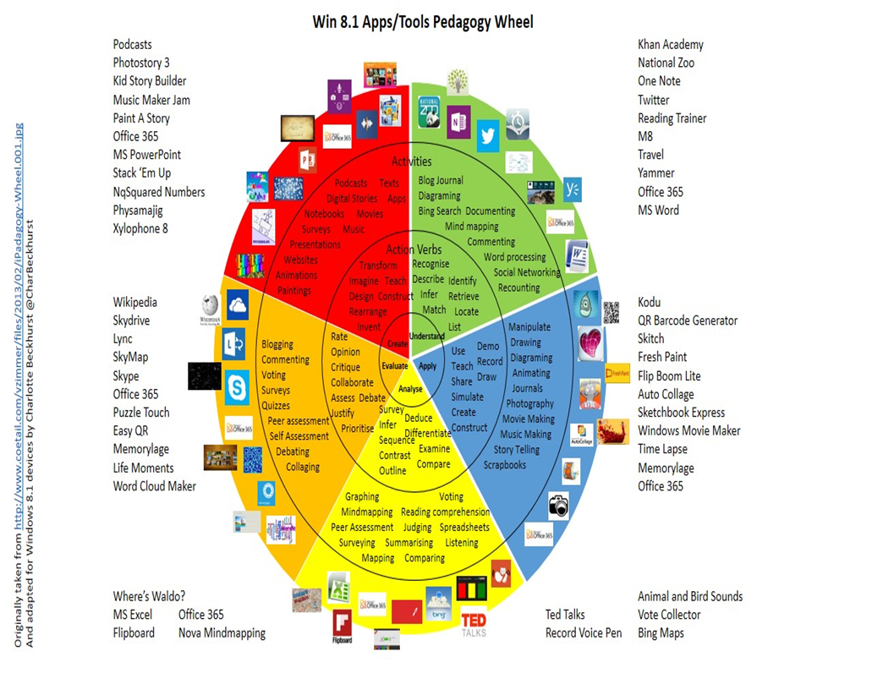

Differentiation
Resources:
- NJDOE: Instructional Supports and Scaffolds for Success in Implementing the Common Core State Standards http://www.state.nj.us/education/modelcurriculum/success/math/k2/

Special Education
- printed copy of board work/notes provided | .
- additional time for skill mastery | .
- assistive technology | .
- behavior management plan | .
- center-Based Instruction | .
- check work frequently for understanding | .
- computer or electronic device utilizes | .
- have student repeat directions to check for understanding | .
- highlighted text visual presentation | .
- modified assignment format | .
- multi-sensory presentation | .
- preferential seating | .
- preview of content, concepts, and vocabulary | .
- reduced/shortened reading assignments | .
- reduced/shortened written assignments | .
- secure attention before giving instruction/directions | .
- shortened assignments | .
- student working with an assigned partner | .
 | .
 | .

ELL
- teaching key aspects of a topic. Eliminate nonessential information | .
- using videos, illustrations, pictures, and drawings to explain or clarify | .
- allowing products (projects, timelines, demonstrations, models, drawings, dioramas, poster boards, charts, graphs, slide shows, videos, etc.) to demonstrate student’s learning; | .
- allowing students to correct errors (looking for understanding) | .
- decreasing the amount of work presented or required | .
- having peers take notes or providing a copy of the teacher’s notes | .

Intervention Strategies
- allowing students to correct errors (looking for understanding) | .
- teaching key aspects of a topic. Eliminate nonessential information | .
- allowing products (projects, timelines, demonstrations, models, drawings, dioramas, poster boards, charts, graphs, slide shows, videos, etc.) to demonstrate student’s learning | .
- allowing students to select from given choices | .
- collaborating (general education teacher and specialist) to modify vocabulary, omit or modify items to reflect objectives for the student, eliminate sections of the test, and determine how the grade will be determined prior to giving the test. | .
- decreasing the amount of work presented or required | .
- having peers take notes or providing a copy of the teacher’s notes | .
- using authentic assessments with real-life problem-solving | .
- using videos, illustrations, pictures, and drawings to explain or clarify | .

Evidence of Student Learning-CFU's
- Compare & Contrast | .
- Create a Multimedia Poster | .
- Define | .
- Describe | .
- Evaluate | .
- Evaluation rubrics | .
- Explaining | .
- Illustration | .
- Journals | .
- Pretests and Posttests
- Questionnaires
- Self- assessments | .
- Surveys

Primary Resources
- District Policies
- School Website
- Student/Parent Handbook
- Program of Studies

Ancillary Resources
Please list ALL other resources available to strengthen your lesson.

Sample Lesson
One Lesson per Curriculum must be in this lesson plan template. I.e. one lesson in one unit
Unit Name:
CCSS/NJCCCS:
Interdisciplinary Connection:
Statement of Objective:
Anticipatory Set/Do Now:
Learning Activity:
Student Assessment/CFU's:
Materials:
21st Century Themes and Skills:
Differentiation/Modifications:
Integration of Technology:

