Unit 5
Content Area: Guidance
Course(s): Citizenship and Goal Setting
Time Period: January
Length: 6-8
Status: Published
Title Section
Department of Curriculum and Instruction


Belleville Public Schools
Curriculum Guide

Guidance
Grades 6-8

Belleville Board of Education
102 Passaic Avenue
Belleville, NJ 07109

Prepared by: Amanda Veniero

Dr. Richard Tomko, Superintendent of Schools
Mr. Thomas D’Elia, Director of Curriculum and Instruction
Ms. Diana Kelleher, District Supervisor of ELA/Social Studies
Mr. George Droste, District Supervisor of Math/Science

Board Approved: August 24, 2015

Unit Overview
- Citizenship
- Goal Setting
- Community Services

ASCA Model
Academic Development
Standard B: Students will complete school with the academic preparation essential to choose from a wide range of substantial postsecondary options, including college.

A:B1.1 Demonstrate the motivation to achieve individual potential
A:B2.1 Establish challenging academic goals in elementary, middle and high school
A:B2.4 Apply Knowledge of aptitudes and interests to goal setting
A:B2.5 Use problem solving and decision making skills to assess progress toward educational goals

Personal/Social Development
Standard B: Students will make decisions, set goals and take necessary action to achieve goals.

PS:B1.9 Identify long and short term goals
PS:B1.10 Identify alternative ways of achieving goal
PS:B1.12 Develop and action plan to set and achieve realistic goals

Exit Skills
By the end of Unit 5 students should be able to:
- Identify strategies for reaching a goal
- Assess their areas of strengths and weaknesses
- Identify strategies for improvement
- Demonstrate decision-making and teamwork skills
- Identify values of importance to them
- List steps necessary to reach their long-term goals

Enduring Understanding
Citizenship is the duty and responsibility that come with being a member of a community.

Goal Setting the process of deciding what you want to accomplish and devising a plan to achieve the result you desire.

Essential Questions
- How do I distinguish between a short term and long term goal?
- How do I set goals for my time in middle school?
- How do I set goals for high school and college?
- How do I set goals for my transition into the next grade?

Learning Objectives
- Describe a goal
- Describe the difference between a long-term and short-term goal
- Learn to set long-term and short-term goals
- Demonstrate a goal setting process
- Demonstrate motivation to achieve full potential and reach desired goals
- Use problem-solving and decision-making skills to assess progress towards educational goals
- Identify alternative ways of achieving goals
- Know how to apply conflict resolution skills

Interdisciplinary Connections
CCSS.ELALiteracy.SL.6.1, 7.1, 8.1 Engage effectively in a range of collaborative discussions (one-on-one, in groups, and teacher-led) with diverse partners on grade 6 topics, texts, and issues, building on others’ ideas and expressing their own clearly.

CCSS.ELALiteracy.W.6.2, 7.2, 8.2 Write informative/explanatory texts to examine a topic and convey ideas, concepts, and information through the selection, organization, and analysis of relevant content.

Alignment to 21st Century Skills & Technology
- English, reading or language arts
- Health

21st Century/Interdisciplinary Themes
- Global Awareness
- Health Literacy
.
.

21st Century Skills
- Communication and Collaboration | .
- Creativity and Innovation | .
- Critical thinking and Problem Solving | .
- Life and Career Skills | .
- Media Literacy | .

Technology Infusion
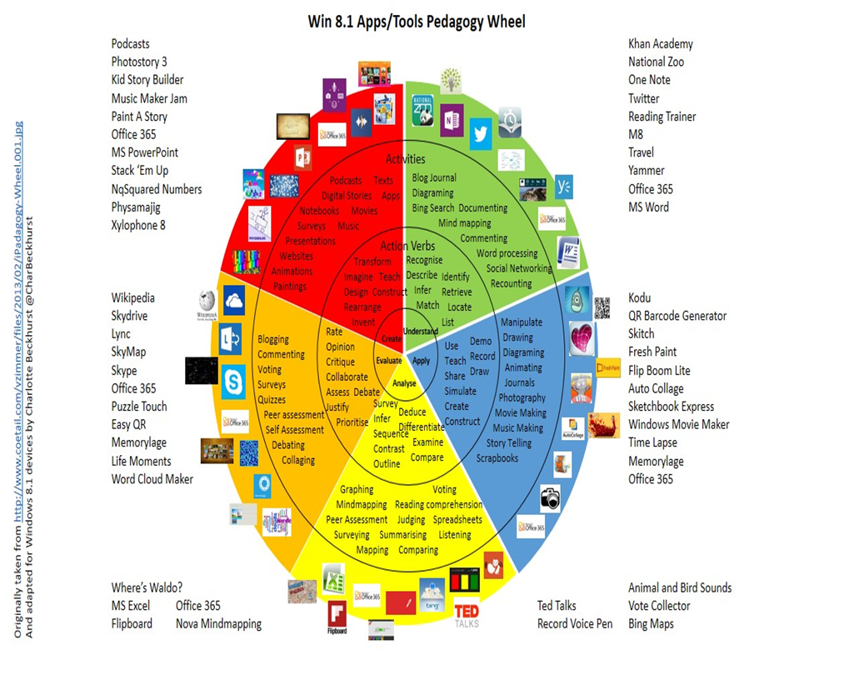

Differentiation
Resources:
- NJDOE: Instructional Supports and Scaffolds for Success in Implementing the Common Core State Standards http://www.state.nj.us/education/modelcurriculum/success/math/k2/

Special Education
- printed copy of board work/notes provided | .
- additional time for skill mastery | .
- assistive technology | .
- behavior management plan | .
- center-Based Instruction | .
- check work frequently for understanding | .
- computer or electronic device utilizes | .
- have student repeat directions to check for understanding | .
- highlighted text visual presentation | .
- modified assignment format | .
- multi-sensory presentation | .
- preferential seating | .
- preview of content, concepts, and vocabulary | .
- reduced/shortened reading assignments | .
- reduced/shortened written assignments | .
- secure attention before giving instruction/directions | .
- shortened assignments | .
- student working with an assigned partner | .
 | .
 | .

ELL
- teaching key aspects of a topic. Eliminate nonessential information | .
- using videos, illustrations, pictures, and drawings to explain or clarify | .
- allowing products (projects, timelines, demonstrations, models, drawings, dioramas, poster boards, charts, graphs, slide shows, videos, etc.) to demonstrate student’s learning; | .
- allowing students to correct errors (looking for understanding) | .
- decreasing the amount of work presented or required | .
- having peers take notes or providing a copy of the teacher’s notes | .

Intervention Strategies
- allowing students to correct errors (looking for understanding) | .
- teaching key aspects of a topic. Eliminate nonessential information | .
- allowing products (projects, timelines, demonstrations, models, drawings, dioramas, poster boards, charts, graphs, slide shows, videos, etc.) to demonstrate student’s learning | .
- allowing students to select from given choices | .
- collaborating (general education teacher and specialist) to modify vocabulary, omit or modify items to reflect objectives for the student, eliminate sections of the test, and determine how the grade will be determined prior to giving the test. | .
- decreasing the amount of work presented or required | .
- having peers take notes or providing a copy of the teacher’s notes | .
- using authentic assessments with real-life problem-solving | .
- using videos, illustrations, pictures, and drawings to explain or clarify | .

Evidence of Student Learning-CFU's
- Compare & Contrast | .
- Create a Multimedia Poster | .
- Define | .
- Describe | .
- Evaluate | .
- Evaluation rubrics | .
- Explaining | .
- Illustration | .
- Journals | .
- Pretests and Posttests
- Questionnaires
- Self- assessments | .
- Surveys

Primary Resources
- District Policies
- School Website
- Student/Parent Handbook
- Program of Studies

Ancillary Resources
Please list ALL other resources available to strengthen your lesson.

Sample Lesson
One Lesson per Curriculum must be in this lesson plan template. I.e. one lesson in one unit
Unit Name:
CCSS/NJCCCS:
Interdisciplinary Connection:
Statement of Objective:
Anticipatory Set/Do Now:
Learning Activity:
Student Assessment/CFU's:
Materials:
21st Century Themes and Skills:
Differentiation/Modifications:
Integration of Technology:

