Unit 4
Content Area: Guidance
Course(s): Responsibility
Time Period: December
Length: 6-8
Status: Published
Title Section
Department of Curriculum and Instruction


Belleville Public Schools
Curriculum Guide

Guidance
Grades 6-8

Belleville Board of Education
102 Passaic Avenue
Belleville, NJ 07109

Prepared by: Amanda Veniero

Dr. Richard Tomko, Superintendent of Schools
Mr. Thomas D’Elia, Director of Curriculum and Instruction
Ms. Diana Kelleher, District Supervisor of ELA/Social Studies
Mr. George Droste, District Supervisor of Math/Science

Board Approved: August 24, 2015

Unit Overview
- Responsibility
- Decision Making
- Stress and Conflict

ASCA Model
Academic Development
Standard B: Students will complete school with the academic preparation essential to choose from a wide range of substantial postsecondary options, including college.

A:B1.2 Learn and apply critical-thinking skills

Personal/Social Development
Standard B: Students will make decisions, set goals and take necessary action to achieve goals.

PS:B1.1 Use a decision making and problem solving model
PS:B1.2 Understand consequences of decisions and choice
PS:B1.4 Develop effective coping skills for dealing with problems
PS:B1.5 Demonstrate when, where and how to seek help for solving problems and making decisions
PS:B1.8 Know when peer pressure is influencing a decision

Exit Skills
By the end of Unit 4 students should be able to:
- Identify the steps necessary for making decisions
- Use a decision-making model to determine a course of action
- Choose positive solutions to various conflict situations
- Demonstrate ways to get help in school
- Use skills to handle difficult situations and identify peer pressure techniques

Enduring Understanding
Responsibility involves being a dependable and reliable person that is committed to following through on their obligations. Being responsible includes demonstrating a variety of positive character skills such as self-control, perseverance, initiative, effort and goal setting.

Essential Questions
- How do I learn to accept criticism and accept consequences?
- What strategies can I learn to avoid and resolve conflict?
- How do I strengthen my problem solving skills?
- How do I become a better decision maker?
- What is an appropriate response to a difficult situation?
- Why is accepting consequences beneficial?
- How do I learn to practice self-control?

Learning Objectives
- Learn and apply critical-thinking skills
- Understand consequences of decisions and choices
- Provide examples of how past decisions have affected present actions
- Identify and understand the importance of finding alternative to decisions
- Demonstrate when, where and how to seek help for solving problems and decision making
- Develop effective coping skills for dealing with problems

Interdisciplinary Connections
CCSS.ELALiteracy.SL.6.1, 7.1., 8.1 Engage effectively in a range of collaborative discussions (one-on one, in groups, and teacher-led) with diverse partners on grades 6, 7 and 8 topics, texts, and issues, building on others’ ideas and expressing their own clearly.

CCSS.ELALiteracy.RI.6.7, 7.7, 8.7 Integrate information presented in different media or formats (e.g., visually, quantitatively) as well as in words to develop a coherent understanding of a topic or issue.
• •
Alignment to 21st Century Skills & Technology
- English, reading or language arts
- Health

21st Century/Interdisciplinary Themes
- Global Awareness
- Health Literacy
.
.

21st Century Skills
- Communication and Collaboration | .
- Creativity and Innovation | .
- Critical thinking and Problem Solving | .
- Life and Career Skills | .
- Media Literacy | .

Technology Infusion
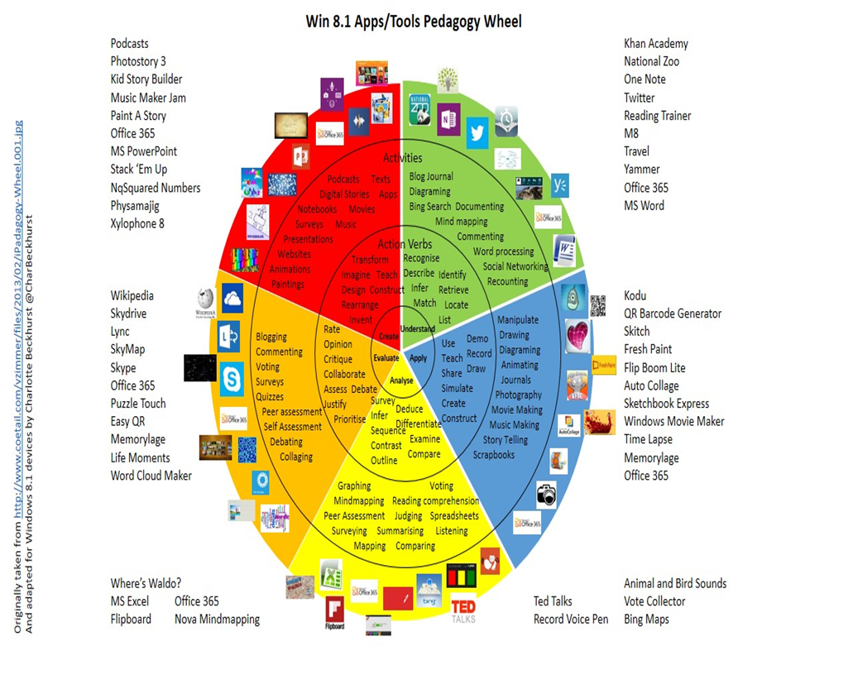

Differentiation
Resources:
- NJDOE: Instructional Supports and Scaffolds for Success in Implementing the Common Core State Standards http://www.state.nj.us/education/modelcurriculum/success/math/k2/

Special Education
- printed copy of board work/notes provided | .
- additional time for skill mastery | .
- assistive technology | .
- behavior management plan | .
- center-Based Instruction | .
- check work frequently for understanding | .
- computer or electronic device utilizes | .
- have student repeat directions to check for understanding | .
- highlighted text visual presentation | .
- modified assignment format | .
- multi-sensory presentation | .
- preferential seating | .
- preview of content, concepts, and vocabulary | .
- reduced/shortened reading assignments | .
- reduced/shortened written assignments | .
- secure attention before giving instruction/directions | .
- shortened assignments | .
- student working with an assigned partner | .
 | .
 | .

ELL
- teaching key aspects of a topic. Eliminate nonessential information | .
- using videos, illustrations, pictures, and drawings to explain or clarify | .
- allowing products (projects, timelines, demonstrations, models, drawings, dioramas, poster boards, charts, graphs, slide shows, videos, etc.) to demonstrate student’s learning; | .
- allowing students to correct errors (looking for understanding) | .
- decreasing the amount of work presented or required | .
- having peers take notes or providing a copy of the teacher’s notes | .

Intervention Strategies
- allowing students to correct errors (looking for understanding) | .
- teaching key aspects of a topic. Eliminate nonessential information | .
- allowing products (projects, timelines, demonstrations, models, drawings, dioramas, poster boards, charts, graphs, slide shows, videos, etc.) to demonstrate student’s learning | .
- allowing students to select from given choices | .
- collaborating (general education teacher and specialist) to modify vocabulary, omit or modify items to reflect objectives for the student, eliminate sections of the test, and determine how the grade will be determined prior to giving the test. | .
- decreasing the amount of work presented or required | .
- having peers take notes or providing a copy of the teacher’s notes | .
- using authentic assessments with real-life problem-solving | .
- using videos, illustrations, pictures, and drawings to explain or clarify | .

Evidence of Student Learning-CFU's
- Compare & Contrast | .
- Create a Multimedia Poster | .
- Define | .
- Describe | .
- Evaluate | .
- Evaluation rubrics | .
- Explaining | .
- Illustration | .
- Journals | .
- Pretests and Posttests
- Questionnaires
- Self- assessments | .
- Surveys

Primary Resources
- District Policies
- School Website
- Student/Parent Handbook
- Program of Studies

Ancillary Resources
Please list ALL other resources available to strengthen your lesson.

Sample Lesson
One Lesson per Curriculum must be in this lesson plan template. I.e. one lesson in one unit
Unit Name:
CCSS/NJCCCS:
Interdisciplinary Connection:
Statement of Objective:
Anticipatory Set/Do Now:
Learning Activity:
Student Assessment/CFU's:
Materials:
21st Century Themes and Skills:
Differentiation/Modifications:
Integration of Technology:

