Unit 2
Content Area: Guidance
Course(s): Harassment, Intimidation, & Bullying Awareness
Time Period: October
Length: 6-8
Status: Published
Title Section
Department of Curriculum and Instruction


Belleville Public Schools
Curriculum Guide

Guidance
Grades 6-8

Belleville Board of Education
102 Passaic Avenue
Belleville, NJ 07109

Prepared by: Amanda Veniero

Dr. Richard Tomko, Superintendent of Schools
Mr. Thomas D’Elia, Director of Curriculum and Instruction
Ms. Diana Kelleher, District Supervisor of ELA/Social Studies
Mr. George Droste, District Supervisor of Math/Science

Board Approved: August 24, 2015

Unit Overview
- Harassment, Intimidation, & Bullying Awareness
- Anti-Violence
- Week of Respect
- Red Ribbon Week
- School Safety

ASCA Model
Personal/Social Development
Standard A: Students will acquire the attitudes, knowledge, and interpersonal skills to help them understand and respect self and others.

PS:A2.3 Recognize, accept, respect and appreciate ethnic and cultural diversity

Standard C: Students will understand safety and survival skills.

PS:C1.2 Learn about the relationship between rules, laws, safety and the protection of rights of the individual
PS:C1.5 Demonstrate the ability to set boundaries, rights and personal privacy
PS:C1.9 Learn how to cope with peer pressure

Exit Skills
By the end of Unit 2 students should be able to:
- Discuss rights and responsibilities
- Use the skills to resolve a conflict
- Identify situations in which they feel pressured
- Identify problem solving skills
- Know who in the school to go to for assistance with an act on harassment, intimidation, or bullying

Enduring Understanding
Harassment, Intimidation, and Bullying means any gesture, any written, verbal or physical act or any electronic communication, whether it is a single incident or a series of incidents, that is: – reasonably perceived as being motivated by either any actual or perceived characteristic, such as race, color, religion, ancestry, national origin, gender, sexual orientation, gender identity and expression, or a mental, physical or sensory disability; or – by any other distinguishing characteristic; and that – takes place on school property, at any school-sponsored function, on a school bus, or off school grounds, as provided for in N.J.S.A. 18A:37-15.3, that substantially disrupts or interferes with the orderly operation of the school or the rights of other pupils.

Essential Questions
- What is HIB and how can I contribute in creating an environment where HIB is not accepted?
- How do I learn and apply conflict mediation and resolution skills?
- How do I respond to peer pressure effectively?

Learning Objectives
- Understand legal issues related to harassment, intimidation, and bullying
- Evaluate the effect that their behavior has on others
- Compare ways to deal with peer pressure
- Differentiate between situations requiring adult help and requiring peer support
- Demonstrate the ability to set boundaries and personal privacy

Interdisciplinary Connections
CCSS.ELALiteracy.SL.6.1, 7.1, 8.1 Engage effectively in a range of collaborative discussions (one-on one, in groups, and teacher-led) with diverse partners on grades 6, 7, and 8 topics, texts, and issues, building on others’ ideas and expressing their own clearly.

CCSS.ELALiteracy.RI.6.1, 7.1, 8.1 Cite textual evidence to support analysis of what the text says explicitly as well as inferences drawn from the text.

Alignment to 21st Century Skills & Technology
- English, reading or language arts
- Health

21st Century/Interdisciplinary Themes
- Global Awareness
- Health Literacy
.
.

21st Century Skills
- Communication and Collaboration | .
- Creativity and Innovation | .
- Critical thinking and Problem Solving | .
- Life and Career Skills | .
- Media Literacy | .

Technology Infusion
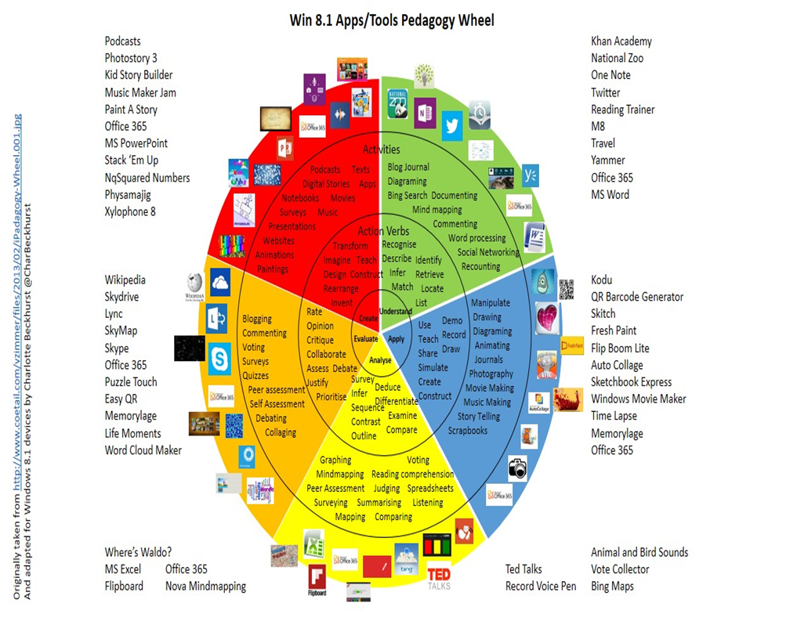

Differentiation
Resources:
- NJDOE: Instructional Supports and Scaffolds for Success in Implementing the Common Core State Standards http://www.state.nj.us/education/modelcurriculum/success/math/k2/

Special Education
- printed copy of board work/notes provided | .
- additional time for skill mastery | .
- assistive technology | .
- behavior management plan | .
- center-Based Instruction | .
- check work frequently for understanding | .
- computer or electronic device utilizes | .
- have student repeat directions to check for understanding | .
- highlighted text visual presentation | .
- modified assignment format | .
- multi-sensory presentation | .
- preferential seating | .
- preview of content, concepts, and vocabulary | .
- reduced/shortened reading assignments | .
- reduced/shortened written assignments | .
- secure attention before giving instruction/directions | .
- shortened assignments | .
- student working with an assigned partner | .
 | .
 | .

ELL
- teaching key aspects of a topic. Eliminate nonessential information | .
- using videos, illustrations, pictures, and drawings to explain or clarify | .
- allowing products (projects, timelines, demonstrations, models, drawings, dioramas, poster boards, charts, graphs, slide shows, videos, etc.) to demonstrate student’s learning; | .
- allowing students to correct errors (looking for understanding) | .
- decreasing the amount of work presented or required | .
- having peers take notes or providing a copy of the teacher’s notes | .

Intervention Strategies
- allowing students to correct errors (looking for understanding) | .
- teaching key aspects of a topic. Eliminate nonessential information | .
- allowing products (projects, timelines, demonstrations, models, drawings, dioramas, poster boards, charts, graphs, slide shows, videos, etc.) to demonstrate student’s learning | .
- allowing students to select from given choices | .
- collaborating (general education teacher and specialist) to modify vocabulary, omit or modify items to reflect objectives for the student, eliminate sections of the test, and determine how the grade will be determined prior to giving the test. | .
- decreasing the amount of work presented or required | .
- having peers take notes or providing a copy of the teacher’s notes | .
- using authentic assessments with real-life problem-solving | .
- using videos, illustrations, pictures, and drawings to explain or clarify | .

Evidence of Student Learning-CFU's
- Compare & Contrast | .
- Create a Multimedia Poster | .
- Define | .
- Describe | .
- Evaluate | .
- Evaluation rubrics | .
- Explaining | .
- Illustration | .
- Journals | .
- Pretests and Posttests
- Questionnaires
- Self- assessments | .
- Surveys

Primary Resources
- District Policies
- School Website
- Student/Parent Handbook
- Program of Studies

Ancillary Resources
Please list ALL other resources available to strengthen your lesson.

Sample Lesson
One Lesson per Curriculum must be in this lesson plan template. I.e. one lesson in one unit
Unit Name:
CCSS/NJCCCS:
Interdisciplinary Connection:
Statement of Objective:
Anticipatory Set/Do Now:
Learning Activity:
Student Assessment/CFU's:
Materials:
21st Century Themes and Skills:
Differentiation/Modifications:
Integration of Technology:

