Experiment 9: Using a Buzzer

Introduction
In this experiment, we will again bridge the gap between the digital world and the analog world. We'll be using a piezo buzzer that makes a small "click" when you apply voltage to it (try it!). By itself that isn't terribly exciting, but if you turn the voltage on and off hundreds of times a second, the piezo buzzer will produce a tone. And if you string a bunch of tones together, you've got music! This circuit and set of code blocks will create a simple sound machine.

Parts Needed
You will need the following parts:
- 1x micro:bit
- 1x Micro B USB Cable
- 1x micro:bit Breakout (with Headers)
- 1x Breadboard
- 14x Jumper Wires
- 1x Piezo Buzzer
- 2x Momentary Push Buttons
- 2x 10kΩ Resistors

Introducing the Piezo Buzzer
The buzzer is a small component with a piece of metal in it that moves when you apply a voltage across it. This motion causes a small sound, or "click."
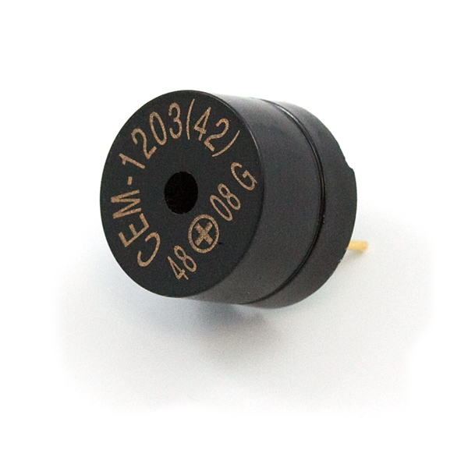
If you turn the voltage on and off fast enough, you get different beeps, squeals, chirps and buzzes. You will use PWM to control the speed of turning the piezo on and off --- and, in turn, the audio frequency coming out of the buzzer. Adjusting the PWM enables you to get legitimate notes out of the buzzer.
If you flip the buzzer over and look at the bottom, you will see that one pin has a (+) next to it. That pin gets connected to a signal from the P0 pin. The other pin should be connected to ground.
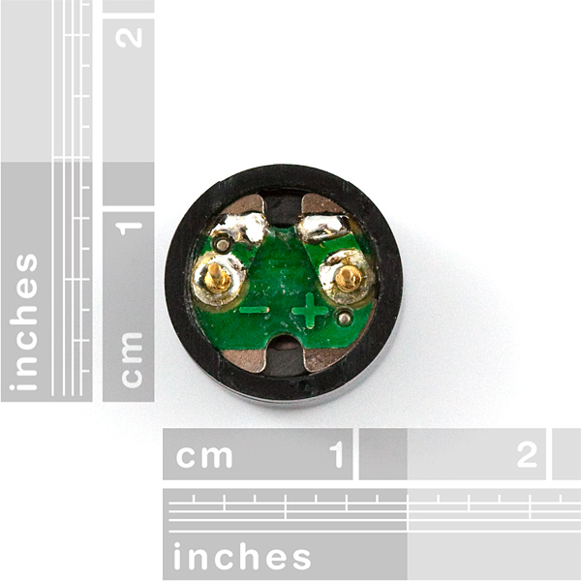

Hardware Hookup
Ready to start hooking everything up? Check out the wiring diagram below to see how everything is connected.
Polarized Components | Pay special attention to the component’s markings indicating how to place it on the breadboard. Polarized components can only be connected to a circuit in one direction.

Wiring Diagram for the Experiment
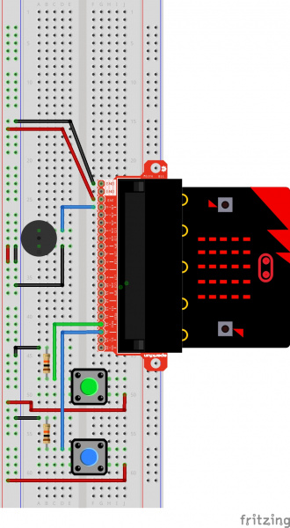
Having a hard time seeing the circuit? Click on the wiring diagram for a closer look.
Note: The full sized breadboard power rails have a break down the middle. If you end up using the lower half of the power rail you will need to jump between the upper end and lower end.

Run Your Script
Either copy and paste, or re-create the following code into your own MakeCode editor by clicking the open icon in the upper right-hand corner of the editor window. You can also just download this example by clicking the download button in the lower right-hand corner of the code window.
Note: You may need to disable your ad/pop-up blocker to interact with the MakeCode programming environment and simulated circuit!

Code to Note
Let's take a look at the code blocks in this experiment.
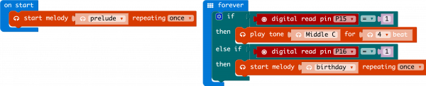
If you are having a hard time viewing this code, click on the image above to get a better look!

Start Melody Repeating
The Start Melody Repeating block takes all of the frustration out of getting music out of a microcontroller. It is as simple as selecting one of a number of songs that are preprogrammed into MakeCode and how many times you want it to repeat and you are done! Note that when a melody is playing no other code can run, this is called "blocking" code and has to be accounted for you in your program.

Play Tone for
The play tone for block is pretty standard if you are used to making sound with other microcontrollers. For example, tone() function in Arduino is pretty much the same as this block. The play tone for block accepts a note that you would like the buzzer to produce and the length of time in beats per second that you would like it to play. So if you are a musician, you are golden to write horrible robot music for your friends!

What You Should See
What you should see --- well, nothing! What you should hear --- a song should start as soon as the program starts to run on your micro:bit! When that song is done you can press one of the two buttons, and another song will start. Each button has its own song, and there's another song if you press both buttons at the same time. Enjoy your sound machine and feel free to swap out the song of your choice!
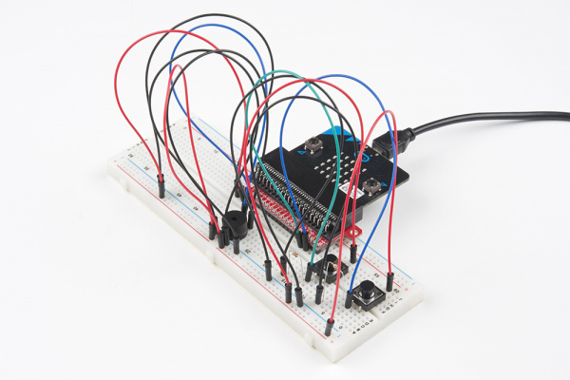
While the image shows black momentary pushbuttons, you can use any colored button as long as it is momentary pushbutton to trigger the sounds!

Troubleshooting

No Sound
Given the size and shape of the piezo buzzer, it is easy to miss the right holes on the breadboard. Try double-checking its placement.
Also, double check to make sure the push button is wired correctly. If you miswired it, then the circuit
Create your own song using just the tone blocks rather than the standard song options given from the start melody block.

