Mission Control:

I.I.T.R.P.

[Interdisciplinary Informational Text
Research Packet]
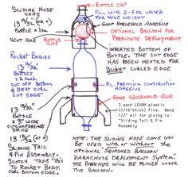

_________________________________

Bottle Rocket Transport System
B.R.T.S.
Mission Objectives:

1.) Water Bottle Rocket Construction
2.) Achieve maximum height in flight
3.) Maintain a flight of 5 seconds or more
4.) Safe transport of assigned cargo

Have you heard the saying, "It's not rocket science?"

Some people think rocket science is a difficult subject to understand. When someone says, "It's not rocket science," they mean that something is not too difficult. Rocket scientists are brilliant people, but rocket science is based on concepts you probably already understand.

The same basic science concepts and laws work in both huge NASA rockets and small paper ones.
- NASA

Standard Parts

There are the ‘basics’ in creating a Bottle Rocket Transport System. Included in these ‘basics’ are the components in the construction along with scientific principles. The following sections provide some ‘basics’ in constructing a ‘mediocre’ Water Bottle Rocket. In order to construct a BRT that fulfills all requirements, additional research is required. The following pages include information on:

- Nosecones
- Payload Systems
- Fins
- Recovery Systems
- Fuel/ Thrusters
- Scientific Principles

Nosecone
The term nose cone is used to refer to the forward most section of a rocket, guided missile or aircraft. The cone is shaped to offer minimum aerodynamic resistance. Nose cones are also designed for travel in and under water and in high-speed land vehicles.

Starting from the top of the rocket we have the nose cone, which is specifically designed to reduce drag on the rocket. To reduce the amount of drag on a rocket the nose cone must have an aerodynamic design to cut through the sky. There are many different types of nose cones and each one will respond differently to given conditions. Model rocket nose cones are built from lightweight plastics and in some cases wood.

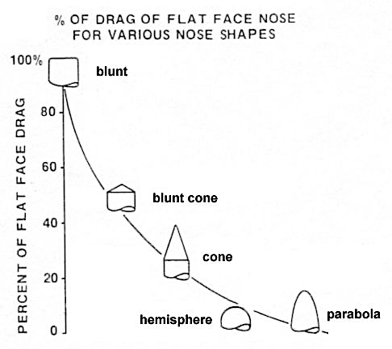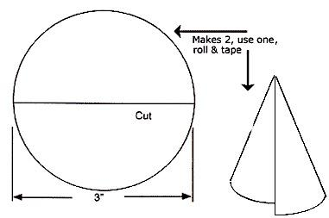

As a rocket moves through the air, friction between the rocket surface and the air (air drag) will slow it down. At the high velocities these rockets achieve, air drag becomes a very significant force. To reduce air drag, the rocket should be designed so that air passing over the surfaces of the rocket flows in smooth lines (stream lining) thus reducing drag to a minimum.

Payload System

The body tube is often where much of the cargo and other rocket essentials are carried. The parachute and recovery wadding is stuffed into the body tube and if a model rocket has a payload capsule this is where it is often located. The body tube (fuselage) is also carries an important design which helps the rocket fly. If a rocket's body tube (fuselage) is too short between the fins and the nose cone then the rocket may become unstable during flight. Rocket engines are placed in the bottom part of the body tube and in some cases the rocket engine will fall into the body tube as a recovery system.
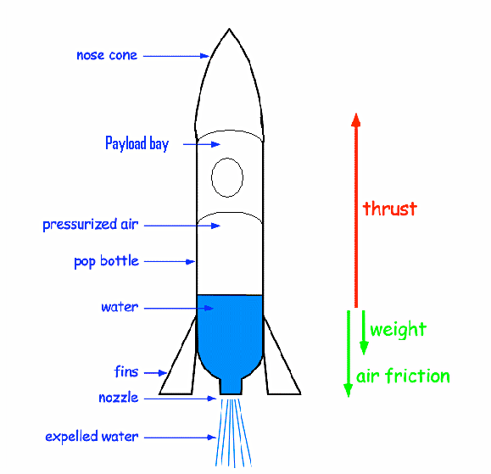

Fins
The primary use of the fins is to stabilize the rocket during flight. There are a number of different types of fin designs and when you build your own you have the option to customize them. These fins are often made from balsa wood which is lightweight, durable and easy to work with.

Without fins, your rocket will not fly straight. Typically, water bottle rockets have three or four fins attached at the neck of the bottle. Remember the larger the fins and the further back they are placed on the rocket, the further back the center of pressure (CP) will be thus increasing the stability of rocket flight. There are many fin variations possible. You will need some fine tuning to get the design right. Below are some fin design possibilities: use these or come up with your own design.

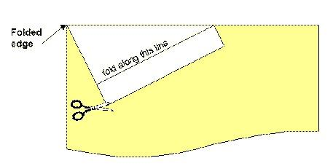

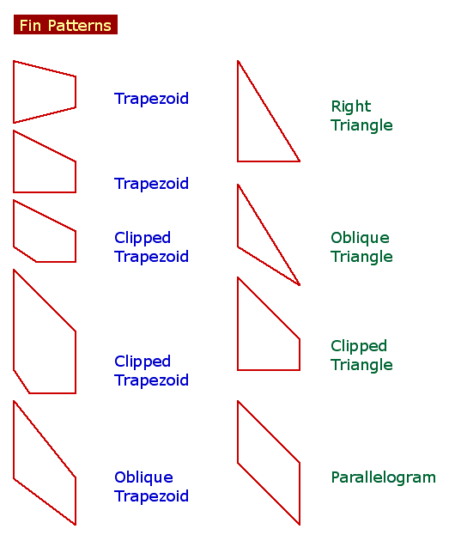

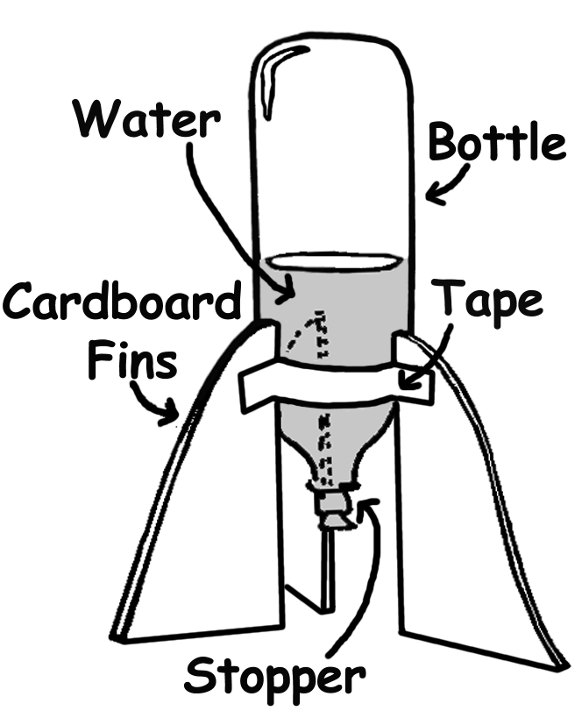
Stabilization

Recovery System

A parachute can be added to the nosecone of the rocket. The tricky part is getting the parachute to release on the way down rather than the way up. One method is to add a paper towel tube to the rocket, place a parachute inside the tube, and then attach the parachute to a tennis ball and then place the ball on the top of the tube. When the rocket reaches the end of it’s flight and turns to tumble to earth the ball falls off and deploys the parachute.

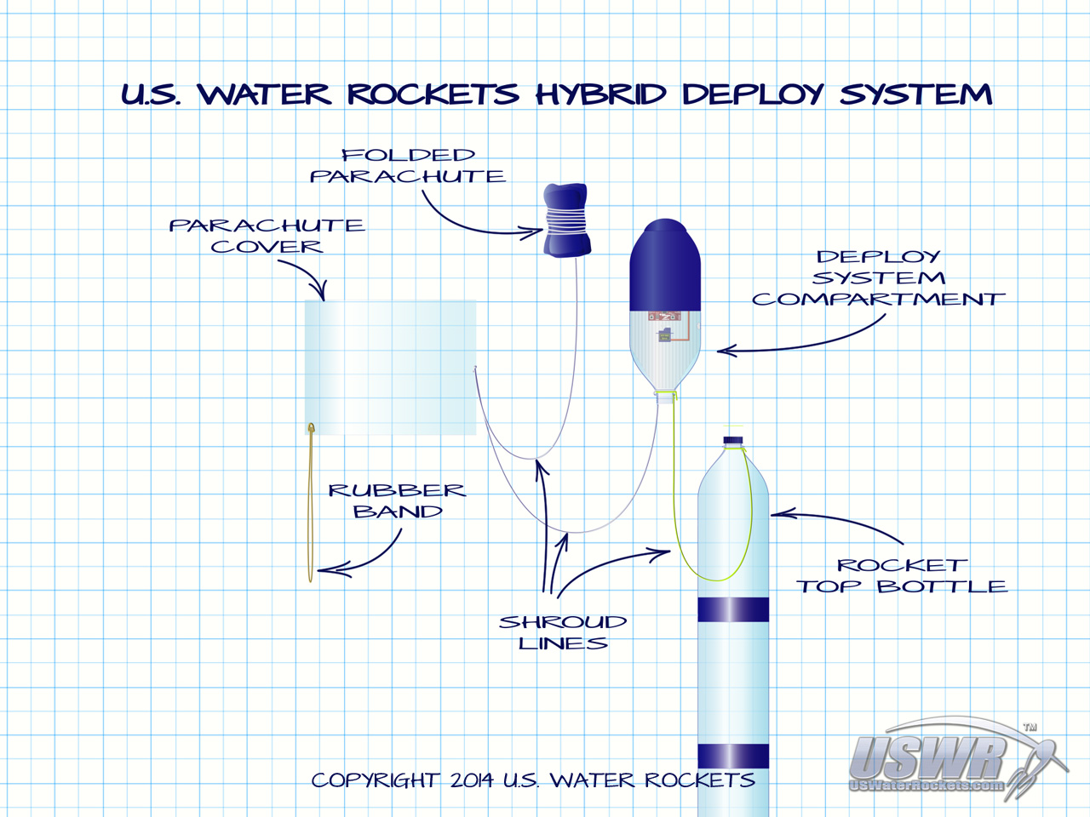

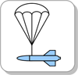 | Parachute  The rocket uses a parachute to increase drag to slow its descent.

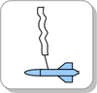 | Streamer  The rocket uses a ribbon instead of a parachute to create drag.

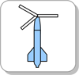 | Helicopter  A set of blades are deployed that spins the rocket up and the lift generated by the blades slows the rocket down.

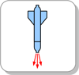 | Retro  The rocket fires a retro rocket (air/air & water) to slow itself just before impacting with the ground.

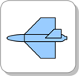 | Glide  The rocket is equipped with wings that generate lift and the rocket glides to a soft landing.

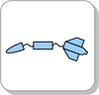 | Separation  The rocket separates into a number of parts each of which can use any other of the passive or active recovery systems.

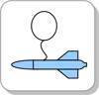 | Balloon  The rocket inflates a balloon to either increase drag or when combined with a lighter-than-air gas, produce lift.

Fuel/ Thruster

By using the bicycle pump to pressurize the air inside the rocket, we can increase the launch pressure of the fluid in the rocket, which will then increase the thrust available to the rocket for lift off. The rocket launchers you will use for this activity have been regulated to a maximum launch pressure of ‘80’ psi. Typically, you will want to use a pressure close to ‘80’psi. However, you need to remember that at high pressures there may be a tradeoff in rocket stability and rocket design considerations related to center of mass and center of pressure might need to be adjusted.

When water is added to the rockets, the effect of mass is demonstrated. Before air can leave the water rocket, the water has to be first be expelled. Because water has a much greater mass than air, it contributes to a much greater thrust (Newton’s 2nd Law). A rocket filled with water will fly much farther than a rocket filled only with air. By varying the amount of water and air in the rocket and graphing how high the rockets travel, you can see that the thrust of the rocket is dependent on the mass being expelled and the speed of expulsion. The best way to determine the fill ratio is to launch 3-4 test flights using differing amounts of fluid and graph the height of rocket flight for each.

…to achieve maximum height (approximately 100 ml in a 20 oz pop bottle).

Compressed Air + Water … Mother Nature doesn't like it when things aren't equal! When you pull the launch cord on the launch pad, and the latch holding your rocket to the launch pad pulls back, no force will be holding that rocket down! The unequal force of the HIGH air pressure inside of your rocket will instantly rush out of the rocket nozzle pushing your rocket into the sky!

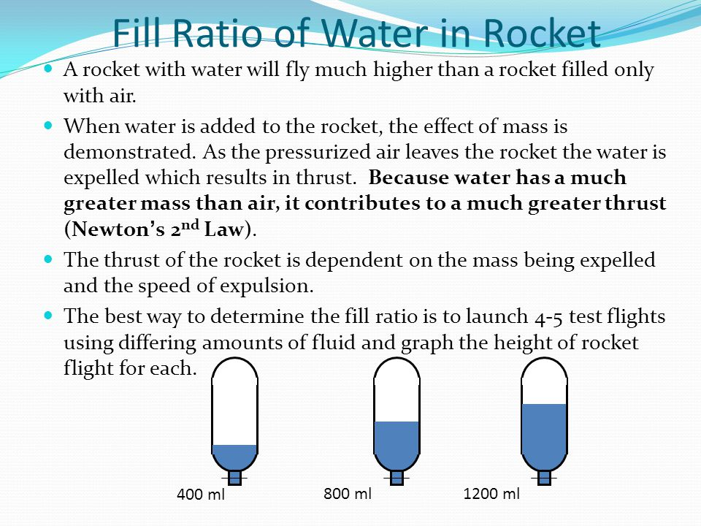

Scientific Principles

Determining the best water to air ratio needed to achieve maximum flight height for our rocket resembles the classic give and take situation. The less water placed into the rocket the lighter the rocket and the more air that can be applied (i.e. force). However, the water hurtling out of the nozzle provides the pulse that accelerates the rocket upward. If more water is applied to the rocket it is heavier, and contains less air…yet there will be more force generated when the rocket is launched. Will this force be enough to propel the rocket to greater heights??

A rocket in its simplest form is a chamber enclosing a gas under pressure. A small opening at one end of the chamber allows the gas to escape, and in doing so provides a thrust that propels the rocket in the opposite direction. A good example of this is a balloon. Air inside the balloon is compressed by the balloon's rubber walls. The air pushes back so that the inward and outward pressing forces are balanced. When the nozzle is released, air escapes through it and the balloon is propelled in the opposite direction.

Newton’s First Law: Objects at rest will stay at rest, or objects in motion will stay in motion unless acted upon by an unbalanced force.

When the rocket is sitting on the launcher, the forces are balanced because the surface of
the launcher pushes the rocket up while gravity pulls it down. When we pressurize the fluid inside the rocket and release the locking clamps the forces become unbalanced. A small opening in the bottom of the rocket will allow fluid to escape in one direction and in doing so provides thrust (force) in the opposite direction allowing the rocket to propel skyward. This force continues until the pressure forces the last of the fluid to leave the rocket.

Newton’s Second Law: The acceleration of an object is directly related to the force exerted on the object and oppositely related to the mass of that object.

For example: If you use the same amount of force, you can throw a baseball faster that a basketball because the baseball has less mass. To get your water bottle rockets to fly to great heights you will need to:

- Minimize the rocket’s mass while maximizing the amount of force.

- Be careful when minimizing the rocket’s. If the rocket is too light it will lose stability as soon as the water is expelled and turn end over end.

- The greater the mass of the fluid expelled from the rocket, and the faster the fluid can be expelled from the rocket, the greater the thrust (force) of the rocket.

- Increasing the pressure inside the bottle rocket produces greater thrust. This is because a greater mass of air inside the bottle escapes with a higher acceleration.

Newton’s Third Law: For every action there is always an opposite and equal reaction. Like a balloon full of air, the bottle rocket is pressurized. When the locking clamp is released, fluid escapes the bottle providing an action force that is accompanied by an equal and opposite reaction force which results in the movement of the rocket in the opposite direction.

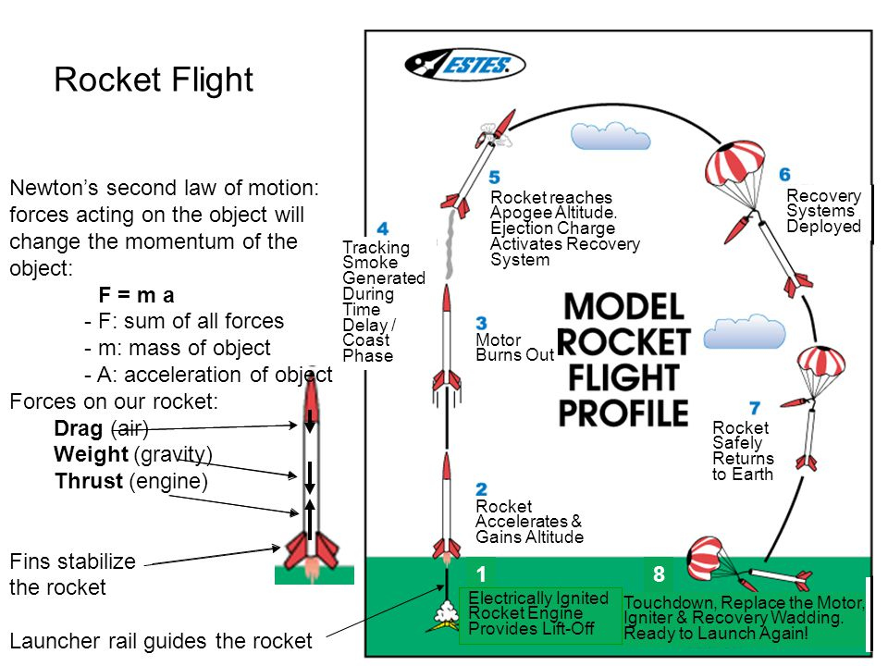

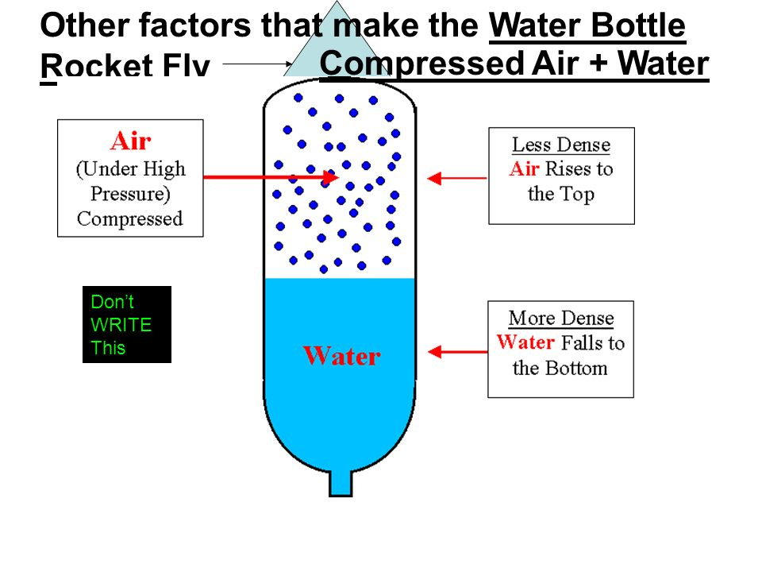

Construction

- Lengthening the rocket adds stability
- Experiment with different fin shapes
- Try different body shapes
- Try to make body smooth (no kinks with tape).
- Do not use hot glue gun to fasten parts of your rocket together.
- Use small pieces of tape (in case you mess up you can easily remove it).

Glossary Terms - Acceleration – Air Resistance – Average Speed – Balanced Force – Distance – Displacement – Drag – Force – Friction – Gravity – Inertia – Instantaneous Speed – Lift – Mass – Momentum – Net Force – Newton’s First Law of Motion – Newton’s Second Law of Motion – Newton’s Third Law of Motion – Speed – Thrust – Vector – Velocity – Weight –

References

History:
- https://www.nasa.gov/pdf/153410main_Rockets_History.pdf

Standard Parts, Function, and Construction; Scientific Principles:
- http://www.321rockets.com/model-rocket-parts.html
- https://www.quia.com/files/quia/users/mmitchel/OpenHouse/Rocket-Design-Information
- https://www.quia.com/files/quia/users/mmitchel/OpenHouse/Rocket-Design-Information
- http://sci4fun.com/thaiwaterrocket/fins/fin2.gif
- http://www.spacetimekids.com/projects/Soda_bottle_rocket_construction.pdf
- http://www.aircommandrockets.com/recovery_guide.htm
- http://4.bp.blogspot.com/-h29bhVUAjMk/UP8qeRL2kiI/AAAAAAAAAdc/eSRFbFYPyuY/s1600/x+Rocket+Thrust+Diagram.jpg
- http://www.uswaterrockets.com/construction_&_tutorials/Hybrid_Deploy/images/USWR_HDX.jpg
- http://www.uswaterrockets.com/construction_&_tutorials/bottle_nosecone/tutorial.htm
- https://www.quora.com/Whats-the-physics-behind-a-bottle-rocket-rocket-used-for-fireworks
- http://www.bioed.org/ECOS/inquiries/inquiries/water_bottle_rocket_inquiry.pdf
- www.carbonado.k12.wa.us/.../presentation%20on%20building%20.ppt

