Unit 1
Content Area: Guidance
Course(s): Diversity and Transitions
Time Period: September
Length: 6-8
Status: Published
Title Section
Department of Curriculum and Instruction


Belleville Public Schools
Curriculum Guide

Guidance
Grades 6-8

Belleville Board of Education
102 Passaic Avenue
Belleville, NJ 07109

Prepared by: Amanda Veniero

Dr. Richard Tomko, Superintendent of Schools
Mr. Thomas D’Elia, Director of Curriculum and Instruction
Ms. Diana Kelleher, District Supervisor of ELA/Social Studies
Mr. George Droste, District Supervisor of Math/Science

Board Approved: August 24, 2015

Unit Overview
- Diversity and Transitions
- Cultural Diversity
- Time Management
- Organizational Skills

ASCA Model
Standard A: Students will acquire the attitudes, knowledge, aptitudes and skills that contribute to effective learning in school and across the life span.

A:A1.5 Identify attitudes and behaviors leading to successful learning
A:A2.4 Apply knowledge and learning styles to positively influence school performance
A:A3.2 Demonstrate the ability to work independently, as well as the ability to work cooperatively with other students

Exit Skills
By the end of Unit 1 students should be able to:
- Asking the student what they experience
- Students will know their counselor and the procedures for seeking help
- Students’ ability to apply complete the activity
- Students demonstrate use of self-control skills and techniques on a regular basis
- Students should be able to transfer skills learning to school work
- Students are able to develop planning steps for achieving goals

Enduring Understanding
Diversity is the understanding that each individual is unique, and recognizing our individual differences, such as race, ethnicity, gender, sexual orientation, socio-economic status, age, physical abilities, religious beliefs, etc.

Transitions are the change of one place, situation, grade level, etc. to another.

Essential Questions
- How do I recognize the impact of change and transition?
- How do I recognize and accept the impact of individual similarities and differences?
- How do I learn what resources and services are available to me through the school counselor?
- How do I reach my full academic potential?
- How can I identify my learning style?
- How do I use my learning style to be a better student?

Learning Objectives
- Report name, role, and function of the school counselor.
- Identify situations when student should ask for help.
- Identify attitudes and behaviors that lead to successful learning.
- Demonstrate how effort and persistence positively affect learning.
- Demonstrate the ability to work independently and cooperatively.
- Apply knowledge of learning styles to school performance.

Interdisciplinary Connections
CCSS.ELA-Literacy.SL.6.1, 7.1, 8.1Engage effectively in a range of collaborative discussions (one-onone, in groups, and teacher-led) with diverse partners on grade 8 topics, texts, and issues, building on others’ ideas and expressing their own clearly.

CCSS.ELALiteracy.SL.6.2, 7.2, 8.2 Analyze the purpose of information presented in diverse media and formats (e.g., visually, quantitatively, orally) and evaluate the motives (e.g., social, commercial, political) behind its presentation.

CCSS.ELALiteracy.SL.6.3, 7.3, 8.3 Delineate a speaker’s argument and specific claims, evaluating the soundness of the reasoning and relevance and sufficiency of the evidence and identifying when irrelevant evidence is introduced

•

Alignment to 21st Century Skills & Technology
- English, reading or language arts
- Health

21st Century/Interdisciplinary Themes
- Global Awareness
- Health Literacy
.
.

21st Century Skills
- Communication and Collaboration | .
- Creativity and Innovation | .
- Critical thinking and Problem Solving | .
- Life and Career Skills | .
- Media Literacy | .

Technology Infusion
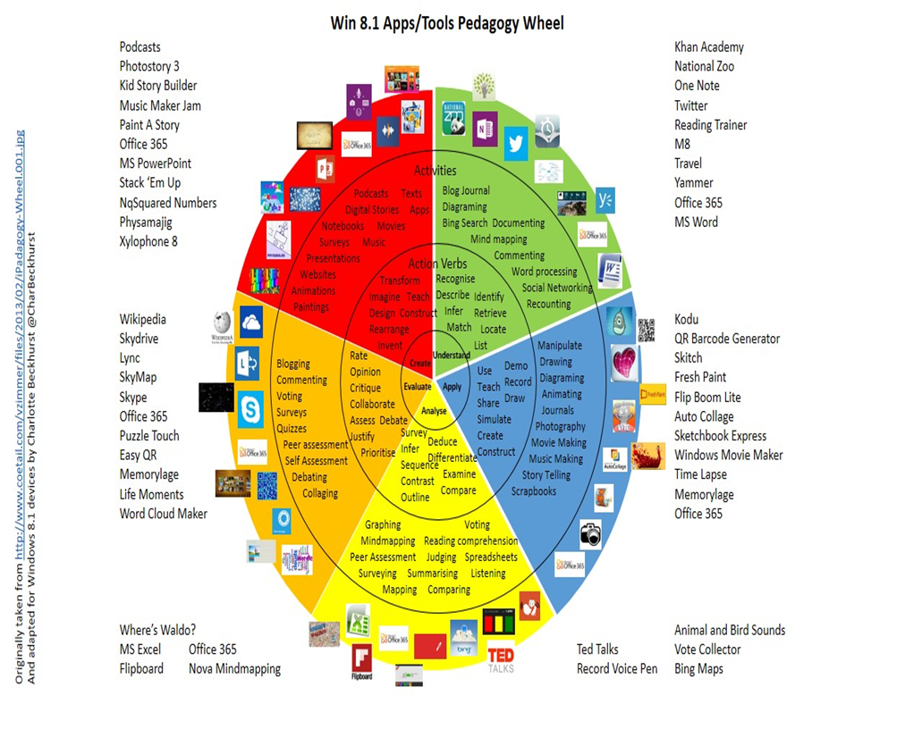

Differentiation
Resources:
- NJDOE: Instructional Supports and Scaffolds for Success in Implementing the Common Core State Standards http://www.state.nj.us/education/modelcurriculum/success/math/k2/

Special Education
- printed copy of board work/notes provided | .
- additional time for skill mastery | .
- assistive technology | .
- behavior management plan | .
- center-Based Instruction | .
- check work frequently for understanding | .
- computer or electronic device utilizes | .
- have student repeat directions to check for understanding | .
- highlighted text visual presentation | .
- modified assignment format | .
- multi-sensory presentation | .
- preferential seating | .
- preview of content, concepts, and vocabulary | .
- reduced/shortened reading assignments | .
- reduced/shortened written assignments | .
- secure attention before giving instruction/directions | .
- shortened assignments | .
- student working with an assigned partner | .
 | .
 | .

ELL
- teaching key aspects of a topic. Eliminate nonessential information | .
- using videos, illustrations, pictures, and drawings to explain or clarify | .
- allowing products (projects, timelines, demonstrations, models, drawings, dioramas, poster boards, charts, graphs, slide shows, videos, etc.) to demonstrate student’s learning; | .
- allowing students to correct errors (looking for understanding) | .
- decreasing the amount of work presented or required | .
- having peers take notes or providing a copy of the teacher’s notes | .

Intervention Strategies
- allowing students to correct errors (looking for understanding) | .
- teaching key aspects of a topic. Eliminate nonessential information | .
- allowing products (projects, timelines, demonstrations, models, drawings, dioramas, poster boards, charts, graphs, slide shows, videos, etc.) to demonstrate student’s learning | .
- allowing students to select from given choices | .
- collaborating (general education teacher and specialist) to modify vocabulary, omit or modify items to reflect objectives for the student, eliminate sections of the test, and determine how the grade will be determined prior to giving the test. | .
- decreasing the amount of work presented or required | .
- having peers take notes or providing a copy of the teacher’s notes | .
- using authentic assessments with real-life problem-solving | .
- using videos, illustrations, pictures, and drawings to explain or clarify | .

Evidence of Student Learning-CFU's
- Compare & Contrast | .
- Create a Multimedia Poster | .
- Define | .
- Describe | .
- Evaluate | .
- Evaluation rubrics | .
- Explaining | .
- Illustration | .
- Journals | .
- Pretests and Posttests
- Questionnaires
- Self- assessments | .
- Surveys

Primary Resources
- District Policies
- School Website
- Student/Parent Handbook
- Program of Studies

Ancillary Resources
Please list ALL other resources available to strengthen your lesson.

Sample Lesson
One Lesson per Curriculum must be in this lesson plan template. I.e. one lesson in one unit
Unit Name:
CCSS/NJCCCS:
Interdisciplinary Connection:
Statement of Objective:
Anticipatory Set/Do Now:
Learning Activity:
Student Assessment/CFU's:
Materials:
21st Century Themes and Skills:
Differentiation/Modifications:
Integration of Technology:

