Inquiry Activity • Paper and Pencil
Chapter 2 Working Trees
Problem What is the economic value of a tree to a community and its residents?
Background
Trees provide many services that benefit people and other organisms. Even urban trees—the trees that line streets in cities and towns—have environmental value, such as holding soil in place and giving food and shelter to wildlife. Urban trees also have important economic and social benefits.
Environmental, Economic, and Social Benefits of Trees
As part of an ecosystem, trees improve air quality, reduce stormwater runoff and atmospheric carbon dioxide, and release oxygen. In cities, they reduce energy consumption. For example, a house that is sheltered by trees requires less energy for heating in the winter and less energy for air conditioning in the summer. In addition, property values of homes surrounded by trees are higher than the values of homes without trees. The presence of trees even affects people's mental and physical health. Studies have shown that hospital patients recover from surgery more quickly when they can see trees through their window.
Economic Cost of Trees
What are the costs involved in having trees added to a community landscape? Costs include the initial cost of the tree plus the cost of planting, irrigation, pruning, pest control, and other maintenance throughout the life of the tree. Trees can also prove costly if and when they are knocked down by lightning or strong winds, and may fall onto homes, automobiles, or other vulnerable property.
Weighing the Costs and Benefits of Neighborhood Trees
Scientists have developed ways to measure the economic value of trees to the environment. Measuring the social benefits is much more difficult. In general, the economic benefits of an urban tree are between two and three times its cost. In this activity, you will learn how trees affect an urban neighborhood and estimate the value of an urban tree.
Procedure
Step 1 Examine the simple sketch of a neighborhood. Note the features that it shows.
Step 2 Suppose you have just been given 10 trees to plant in the neighborhood shown. “Plant” your trees on the neighborhood diagram below, by drawing 10 circles representing 10 trees, in locations where you think they will have the most value to you and your community. Consider environmental, economic, and social benefits when choosing locations for your trees. You may plant one or several trees at any location. Number your trees 1–10.
Step 3 On a separate piece of paper, write each tree’s number, type (You may choose the types—deciduous, evergreen, fruit tree, etc.), location, and the environmental, economic, and/or social benefits of that planting. List as many benefits as you can think of for each planted tree. At least one benefit should be specific to the location you chose.
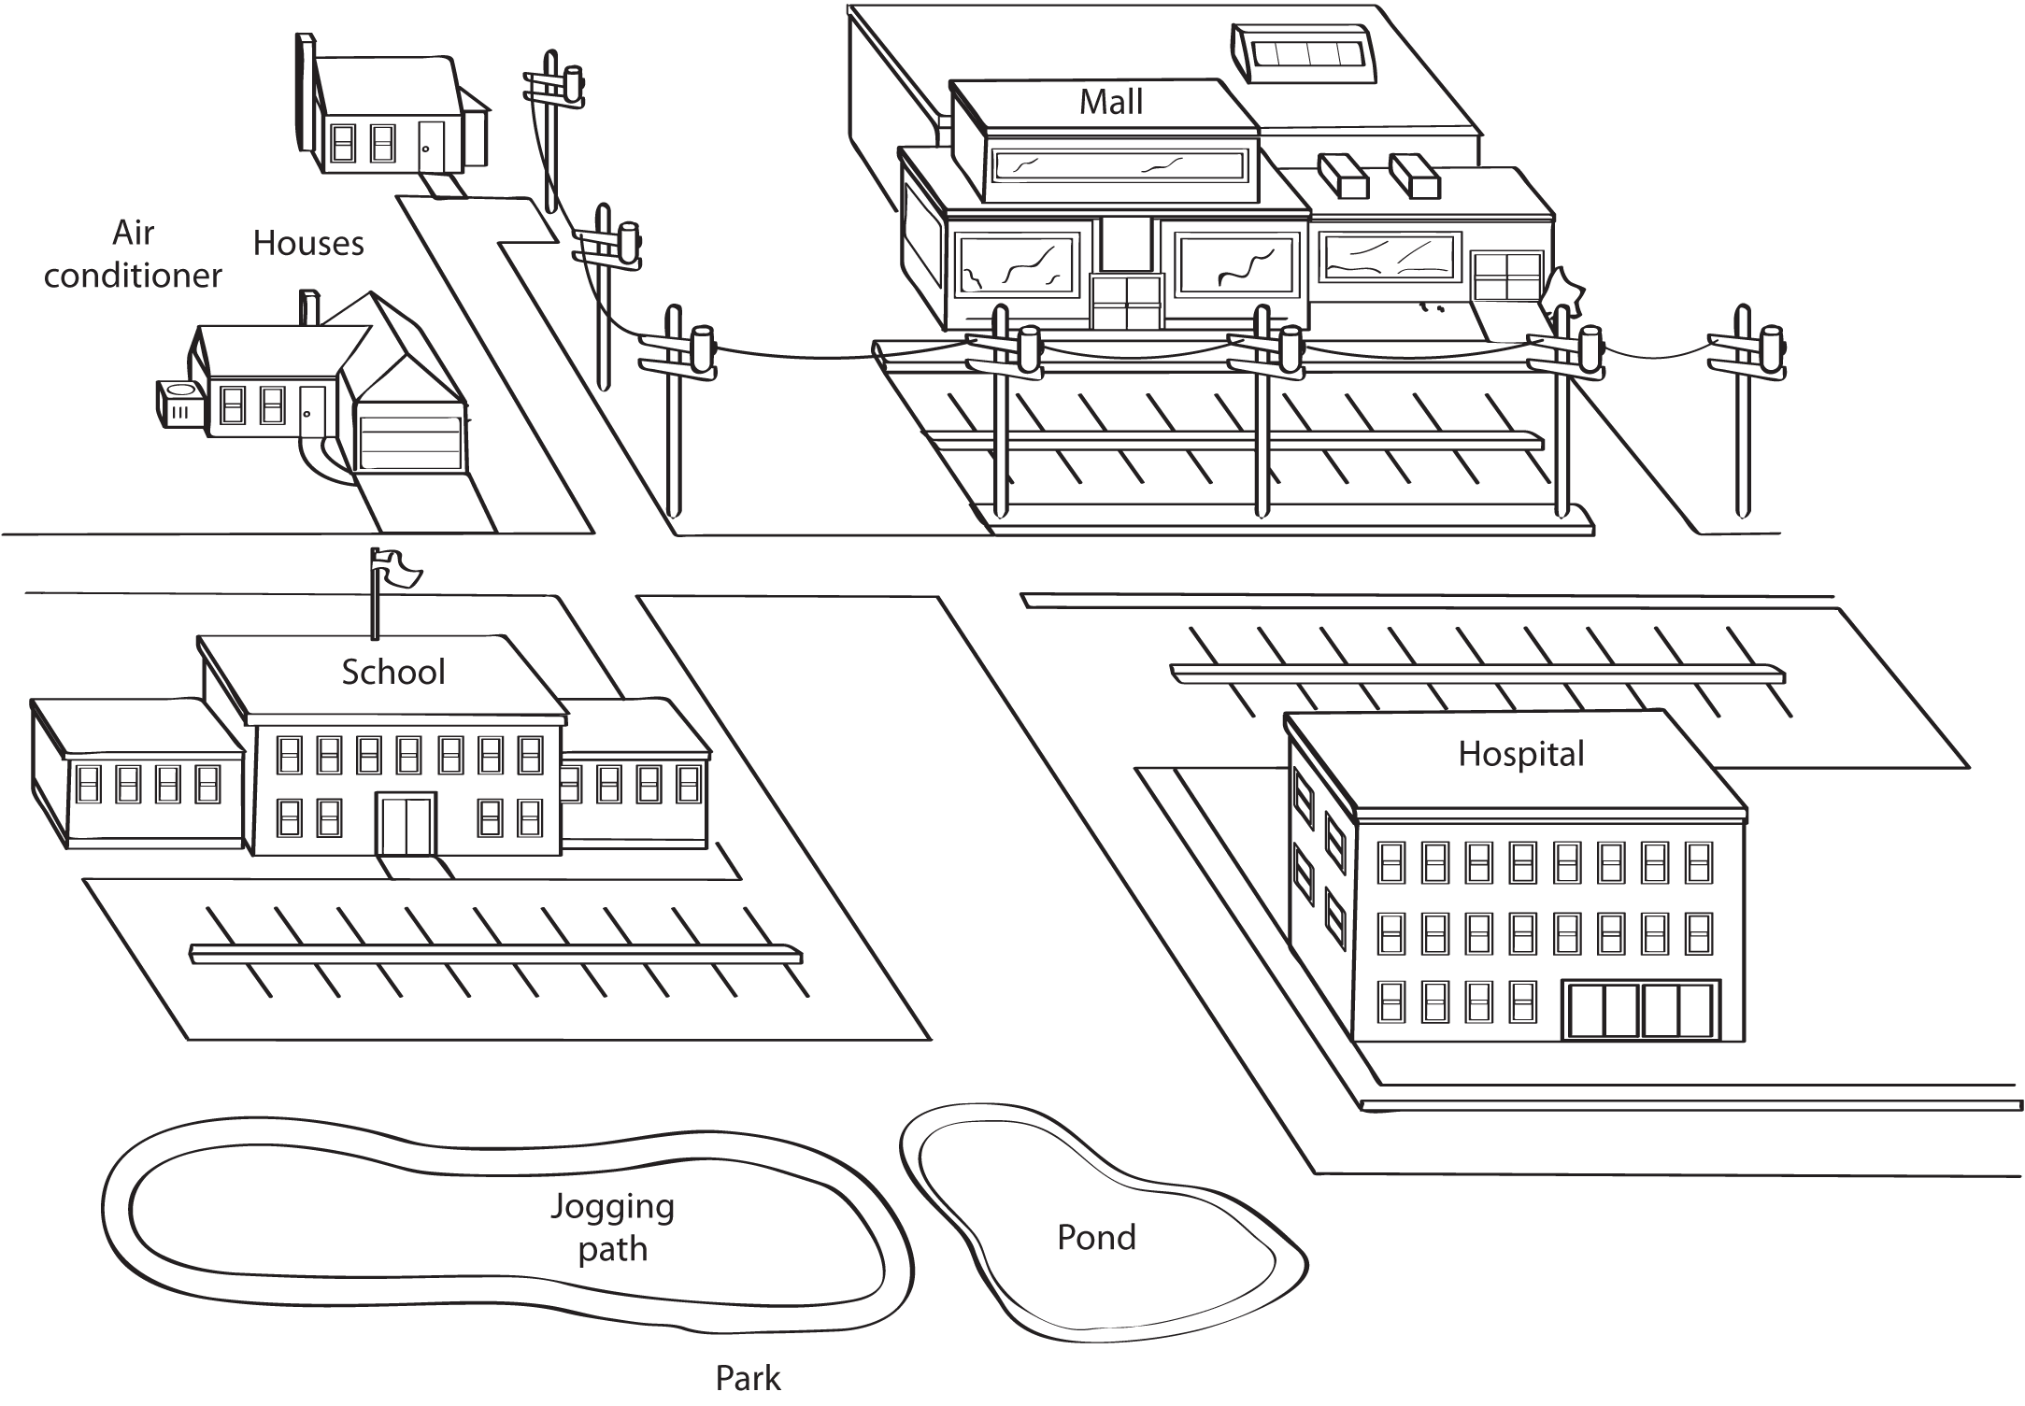

Analyze and Conclude
2. Calculate An urban tree has a national average economic value of $525 per year. What is the total annual economic value of the trees you planted? (Show your work.)

3. Predict What will be the total economic value of your trees after ten years? (Show your work.)

4. Infer Why might it be important to plant only certain kinds of trees—such as evergreens—in some locations but not in others?

5. Relate Cause and Effect The leafy canopy of a tree slows the impact of raindrops and the root system of a tree absorbs water and holds soil in place. What might be the environmental benefit of these characteristics?

6. Relate Cause and Effect Studies have shown that people spend more money in shopping areas with trees than in shopping areas without trees. Explain how this is a social or economic benefit of trees.

7. Extension Suppose you planted 3 trees around the north and west sides of one of the houses worth $100,000 on the map. You have increased the property value of the house by $10,000. In addition, the owner will save an average of $50 per year in heating costs. Assuming that the homeowner lives in the house for another 20 years, what is the total dollar value of the trees to the homeowner and the community? (Show your work.)

