Name Class Date

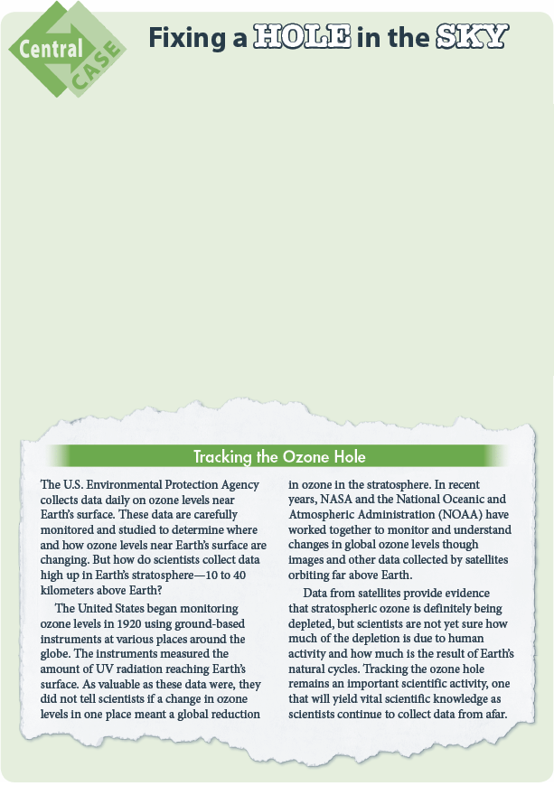

Depletion of Ozone
Ozone is both harmful and beneficial. Ozone
near Earth’s surface is a damaging pollutant.
But in the stratosphere, ozone protects Earth
from harmful UV radiation. Depletion of
ozone in the stratosphere concerns scientists
because it allows too much UV radiation to
reach Earth.
Overexposure to UV radiation may harm
the body’s immune system and cause skin
cancer and cataracts. Scientists also believe
excess UV radiation reaching Earth’s surface
disrupts the reproductive cycle of phyto-
plankton. These single-celled organisms are
found in the top 2 meters of ocean water and
are the bottom level of the food chain for
many other marine organisms. Scientists also
believe excessive ultraviolet radiation
disrupts the reproductive rates of young fish,
shrimp, crabs, frogs, and salamanders.
The Montreal Protocol was signed in
1987, with the goal of phasing out the
production and use of substances that
deplete the stratospheric ozone layer. Since
then, the world’s scientific community has
met several times to accelerate and adjust
its provisions. Targeted substances include
CFCs, halons, carbon tetrachloride, methyl
bromide, and methyl chloroform. Phaseout
schedules differ among nations and for
different substances. The ultimate goal,
however, is the worldwide elimination of
ozone-depleting substances by the middle of
the twenty-first century.

16
Name Class Date

Use the information in Depletion of Ozone to answer the questions below.
1. Why are scientists concerned about the depletion of ozone levels in the stratosphere?

2. How were ozone levels monitored in 1920?

3. How is information on ozone levels in the stratosphere tracked today?

4. The data collected over the years clearly confirm a depletion of ozone in the stratosphere.
What do scientists still need to learn about the ozone hole?

5. How does the information in Depletion of Ozone affect your answer to the
Big Question: “How do scientists uncover, research, and solve environmental problems?”

Use the Internet to find out more about the ozone hole and how scientists track its status.
Work with a partner to research the ozone hole over Antarctica. Create a poster that explains
what you learned about the ozone hole. Your poster should include images of the hole when it
was first identified and at regular intervals since.
The 21st Century Skills used in this activity include Information Literacy, Initiative and
Self-Direction, and Information, Communication, and Technology (ICT) Literacy.


Log on for more information and activities on the Central
Case, Fixing a Hole In the Sky.

17

