Name Class Date



“Overshooting” Ecological Resources
About 1.8 hectares of functioning ecosystem are available per person in the world. However,
the average person has an ecological footprint of about 2.2 hectares. In this activity, you will
calculate the percentage by which people in the world and people in various nations are using
more than the resources available per person.
To find the percentage by which people in the world are “overshooting” available
resources, use the steps shown below.
Step 1 Find the difference between the number  of hectares required per person and the  number of hectares available per person. | 2.2 – 1.8 = 0.4 hectare
Step 2 Write a ratio that compares the difference
found in Step 1 to the number of hectares
available per person.
Step 3 Write the ratio as a percentage, rounding  to the nearest tenth. | 0.2222 = 22.2%

1. For each nation listed in the table below, calculate the difference between the ecological
footprint, or the number of hectares required per person, and the number of hectares
available per person. Write your answers in the third column.

2. Which nations have an ecological footprint greater than the resources available per
person?

3. By what percentage are these nations “overshooting” available resources? Round your
answers to the nearest tenth and add them to the fourth column in the table.

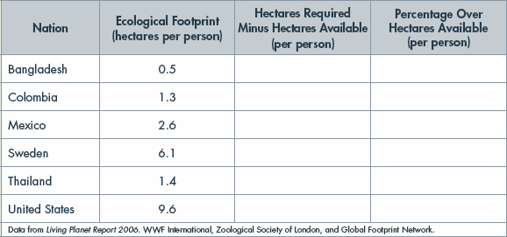

15

