Name Class Date

1.3 The Community of Science
Key Concepts
The scientific community, through peer review and replication, helps to verify the
accuracy of results and contributes to the establishment of scientific theories.
Environmental ethics explores how environmental science interacts with, and is guided
by, a society’s morals and principles.

Vocabulary Preview

Define each vocabulary term in your own words. Then, write yourself a quick note on
how you will remember each. One term has been done for you.

Term | Definition | How I Remember
Peer review
Theory | A broad explanation that applies  to a wide range of situations and  observations and that is supported by  several lines of evidence and broadly  accepted by the scientific community | I remember reading about the Big  Bang theory in a science magazine.
Ethics
Environmental
ethics
Community Analysis and Feedback
1. How does peer review benefit the scientific community?

10
Name Class Date
2. What happens to a scientific article that is rejected by a panel of other scientists?

3. Why is the replication of results important?

4. Explain the following statement: “Science is self-correcting.”

5. Give an example of a self-correction in science.

6. What is the difference between a hypothesis and a theory?

7. How does popular use of the word theory differ from use of the word theory in science?

8. Give one reason why an idea is not a theory.


9. Fill in the diagram by writing three ways the scientific community
reviews scientific results.


Scientific Results

11
Name Class Date
Benefits and Outcomes
10. Give an example of how ethics could impact a government’s policy on science.

11. Briefly explain the relationship between culture and worldview.

12. What role do a society’s beliefs play in an objective process like science?

13. What led to the application of ethical standards to relationships between people and their
environment?

14. What does the environmental justice movement promote?


15. Anthropocentrism, biocentrism, and ecocentrism are ethical standards
in environmental ethics. Think about what they mean. Then, label each of the circles
below with the name of the ethical standard it represents and a description of what that
standard places the highest value on.
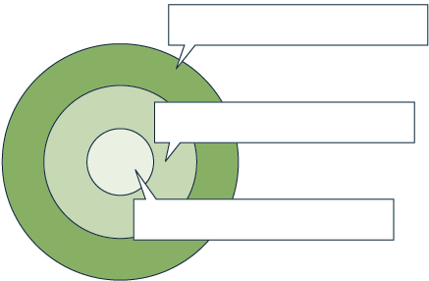
Ethical standard:
Values most:
Ethical standard:
Values most:
Ethical standard:
Values most:

12
Name Class Date

Organize Information

16. Write each term from the word bank in the correct column of the table below.

build knowledge | develop technologies | inform policy
peer review replication satisfy curiosity self-correction

Analysis and Feedback  of Scientific Knowledge | Benefits and Outcomes  of Scientific Knowledge
EXTENSION Use the Internet to research a group or organization that works for environ-
mental justice. On a separate sheet of paper, write a short report on the group’s recent
environmental initiatives.

Answer the questions to test your knowledge of lesson concepts. You can check your
work using the answers on the bottom of the page.
17. How do peer review of scientific articles and replication of test results contribute to the
development of scientific theories?
18. Give an example of how ethical standards have been applied to a worldwide environmental
issue.
19. Give an example of an ethical question related to people and their interactions with the
environment.
20. Name three ethical standards that are applied to environmental issues.



13

