Name Class Date

1.1 Our Island, Earth
Key Concepts
Environmental scientists study how the natural world works, and how humans and the
environment affect each other.
In the last several hundred years, both human population and resource consumption
have increased dramatically.


Vocabulary Preview

Define each vocabulary term in your own words. Then, write yourself a quick note on
how you will remember each. One term has been done for you.

Term | Definition | How I Remember
Environment
Environmental
science
Environmentalism
Natural  resource | A material or energy source provided  by nature that people need to survive | I think of all the resources in my  school library and then think of what  that means in a natural environment.
Renewable
natural
resource

2
Name Class Date
Term | Definition | How I Remember
Nonrenewable
natural
resource
Sustainable
Fossil fuel
Ecological
footprint
Our Environment
1. List three examples of nonliving things in the environment.

2. Give two reasons why environmental science is important.

3. Name four of the disciplines that contribute to the study of our interactions with the
environment.

4. What is the difference between environmental science and environmentalism?

3
Name Class Date

Population Up, Resources Down
For Questions 5–10, write True if the statement is true. If the statement is false, replace
the underlined word to make the statement true. Write your changes on the line.
5. Nature makes natural resources at similar speeds.
6. Fruit is an example of a renewable resource.
7. For most of human history, population has been high and
relatively stable.
8. The Industrial Revolution marked a shift from a rural society to
an urban society powered by renewable resources.
9. Our ecological footprint is affected by the number of people on
Earth and how much we consume.
10. The tragedy of the commons refers to the overuse of unregulated
resources.
11. In what way is living on Earth similar to living on an island?

12. Why are sunlight and oil on opposite sides of the renewability continuum?

13. What could cause a renewable natural resource to become a nonrenewable resource?

14. How can a nonliving thing have an ecological footprint?

15. What is one way the tragedy of the commons could be avoided?

4
Name Class Date

Think Visually
Use the graph below to answer Questions 16 and 17.
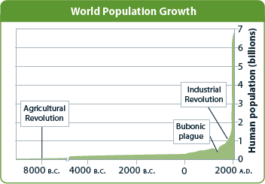

16. Which event shown on the graph signaled the biggest change in human population
growth?
17. Explain how understanding environmental science can help people solve problems related
to human population growth.

EXTENSION Choose two different organisms or objects. Think about the relationship
they have with other organisms or objects in their environment. Compare their ecological
footprints by listing the ways they affect the environment.

Answer the questions to test your knowledge of lesson concepts. You can check your
work using the answers on the bottom of the page.
18. Why is it important to remember that people are part of the environment, too?

19. Why is natural gas considered a nonrenewable resource?

5

