Name Class Date

An Introduction to Environmental
Science

Before you read the chapter, answer each question with information you know. After
you complete the chapter, re-answer the questions using information you learned.

How Do Scientists Uncover, Research,
and Solve Environmental Problems?
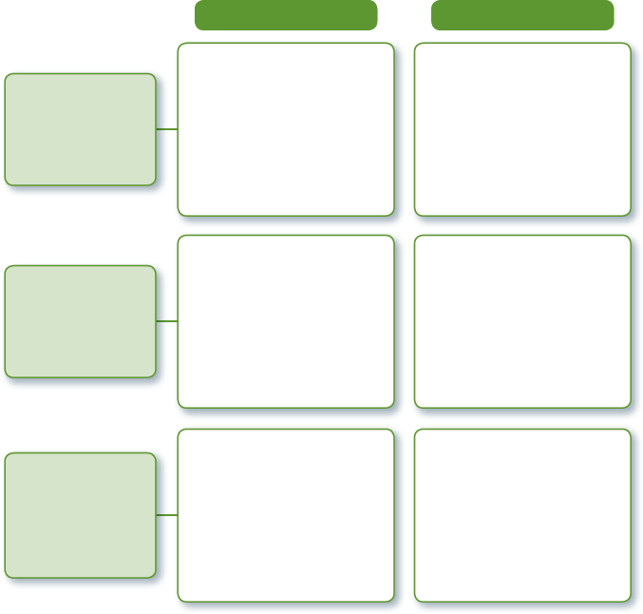
What I Know
What I Learned

1.1 How does
environmental science
help us understand
the natural world?

1.2 What does
it mean to “do
science”?

1.3 What happens
to a scientific study
after data have been
gathered and the
results are analyzed?

1

